Supplementary Material

Supplementary Methods
Additional sensitivity analyses were performed using the same filtered cohort, dual-surface normalization framework, and discovery-replication split described in the main manuscript. The supplementary material reports the prespecified spherical k-means cluster-number metrics across K = 2 to 6 (Table S1; Figure S2), the full-feature and HOA-only K = 4 over-segmentation probe with post-hoc clinical summaries and pairwise distinguishability analyses (Figures S3-S4; Tables S2-S5), discovery-replication centroid concordance after centroid matching (Table S6), composite-score robustness to alternative weighting schemes (Table S7), and cosine-versus-Euclidean silhouette behavior across K = 2 to 6 (Table S8). The HOA-only feature set was used specifically to test whether the K = 4 over-segmentation pattern persisted in an independent subset of aberration features.

Supplementary Figures
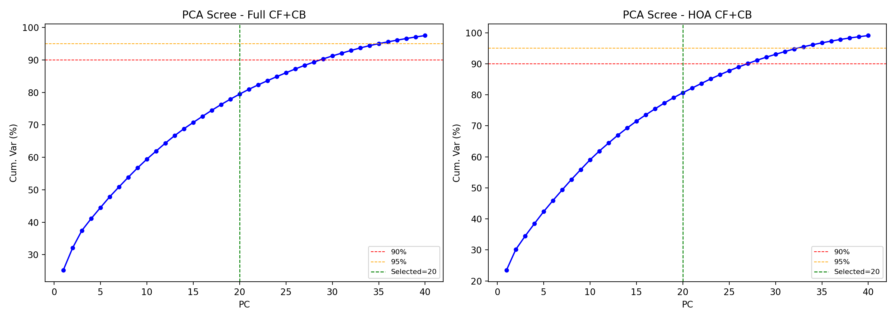
Supplementary Figure S1. Cumulative explained variance of PCA fitted on the discovery set for the full dual-surface feature set (left) and the HOA-only feature set (right). Vertical dashed lines indicate the retained 20-component threshold; horizontal dashed lines indicate the 90% and 95% reference levels.

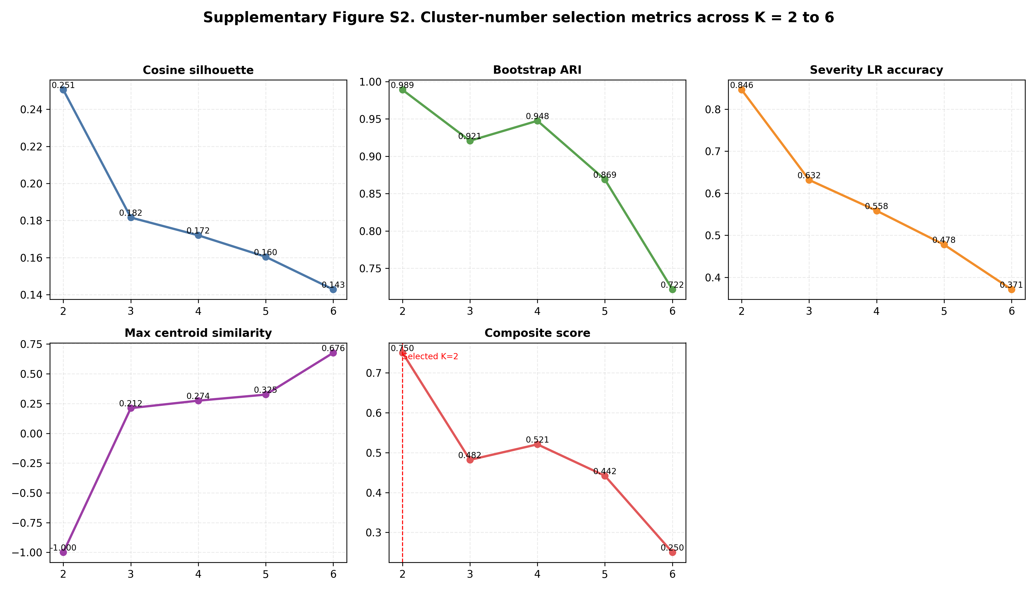
Supplementary Figure S2. Cluster-number selection metrics across K = 2 to 6 in the discovery set. Panels show cosine silhouette, bootstrap stability, severity predictability from total RMS alone, maximum pairwise centroid similarity, and the composite score used for cluster-number selection.

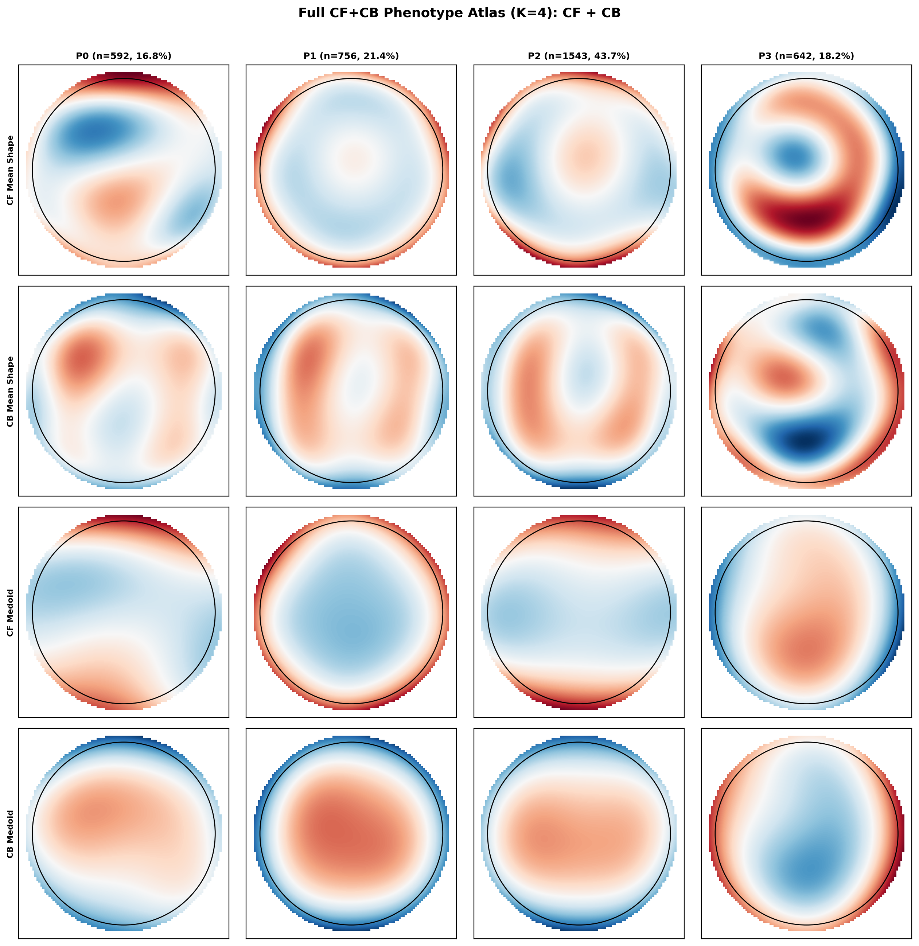
Supplementary Figure S3. Full-feature K = 4 over-segmentation atlas. The four-group probe was used to test whether forcing additional resolution produced clinically distinct morphologies; the associated pairwise post-hoc comparisons are summarized in Supplementary Table S3.

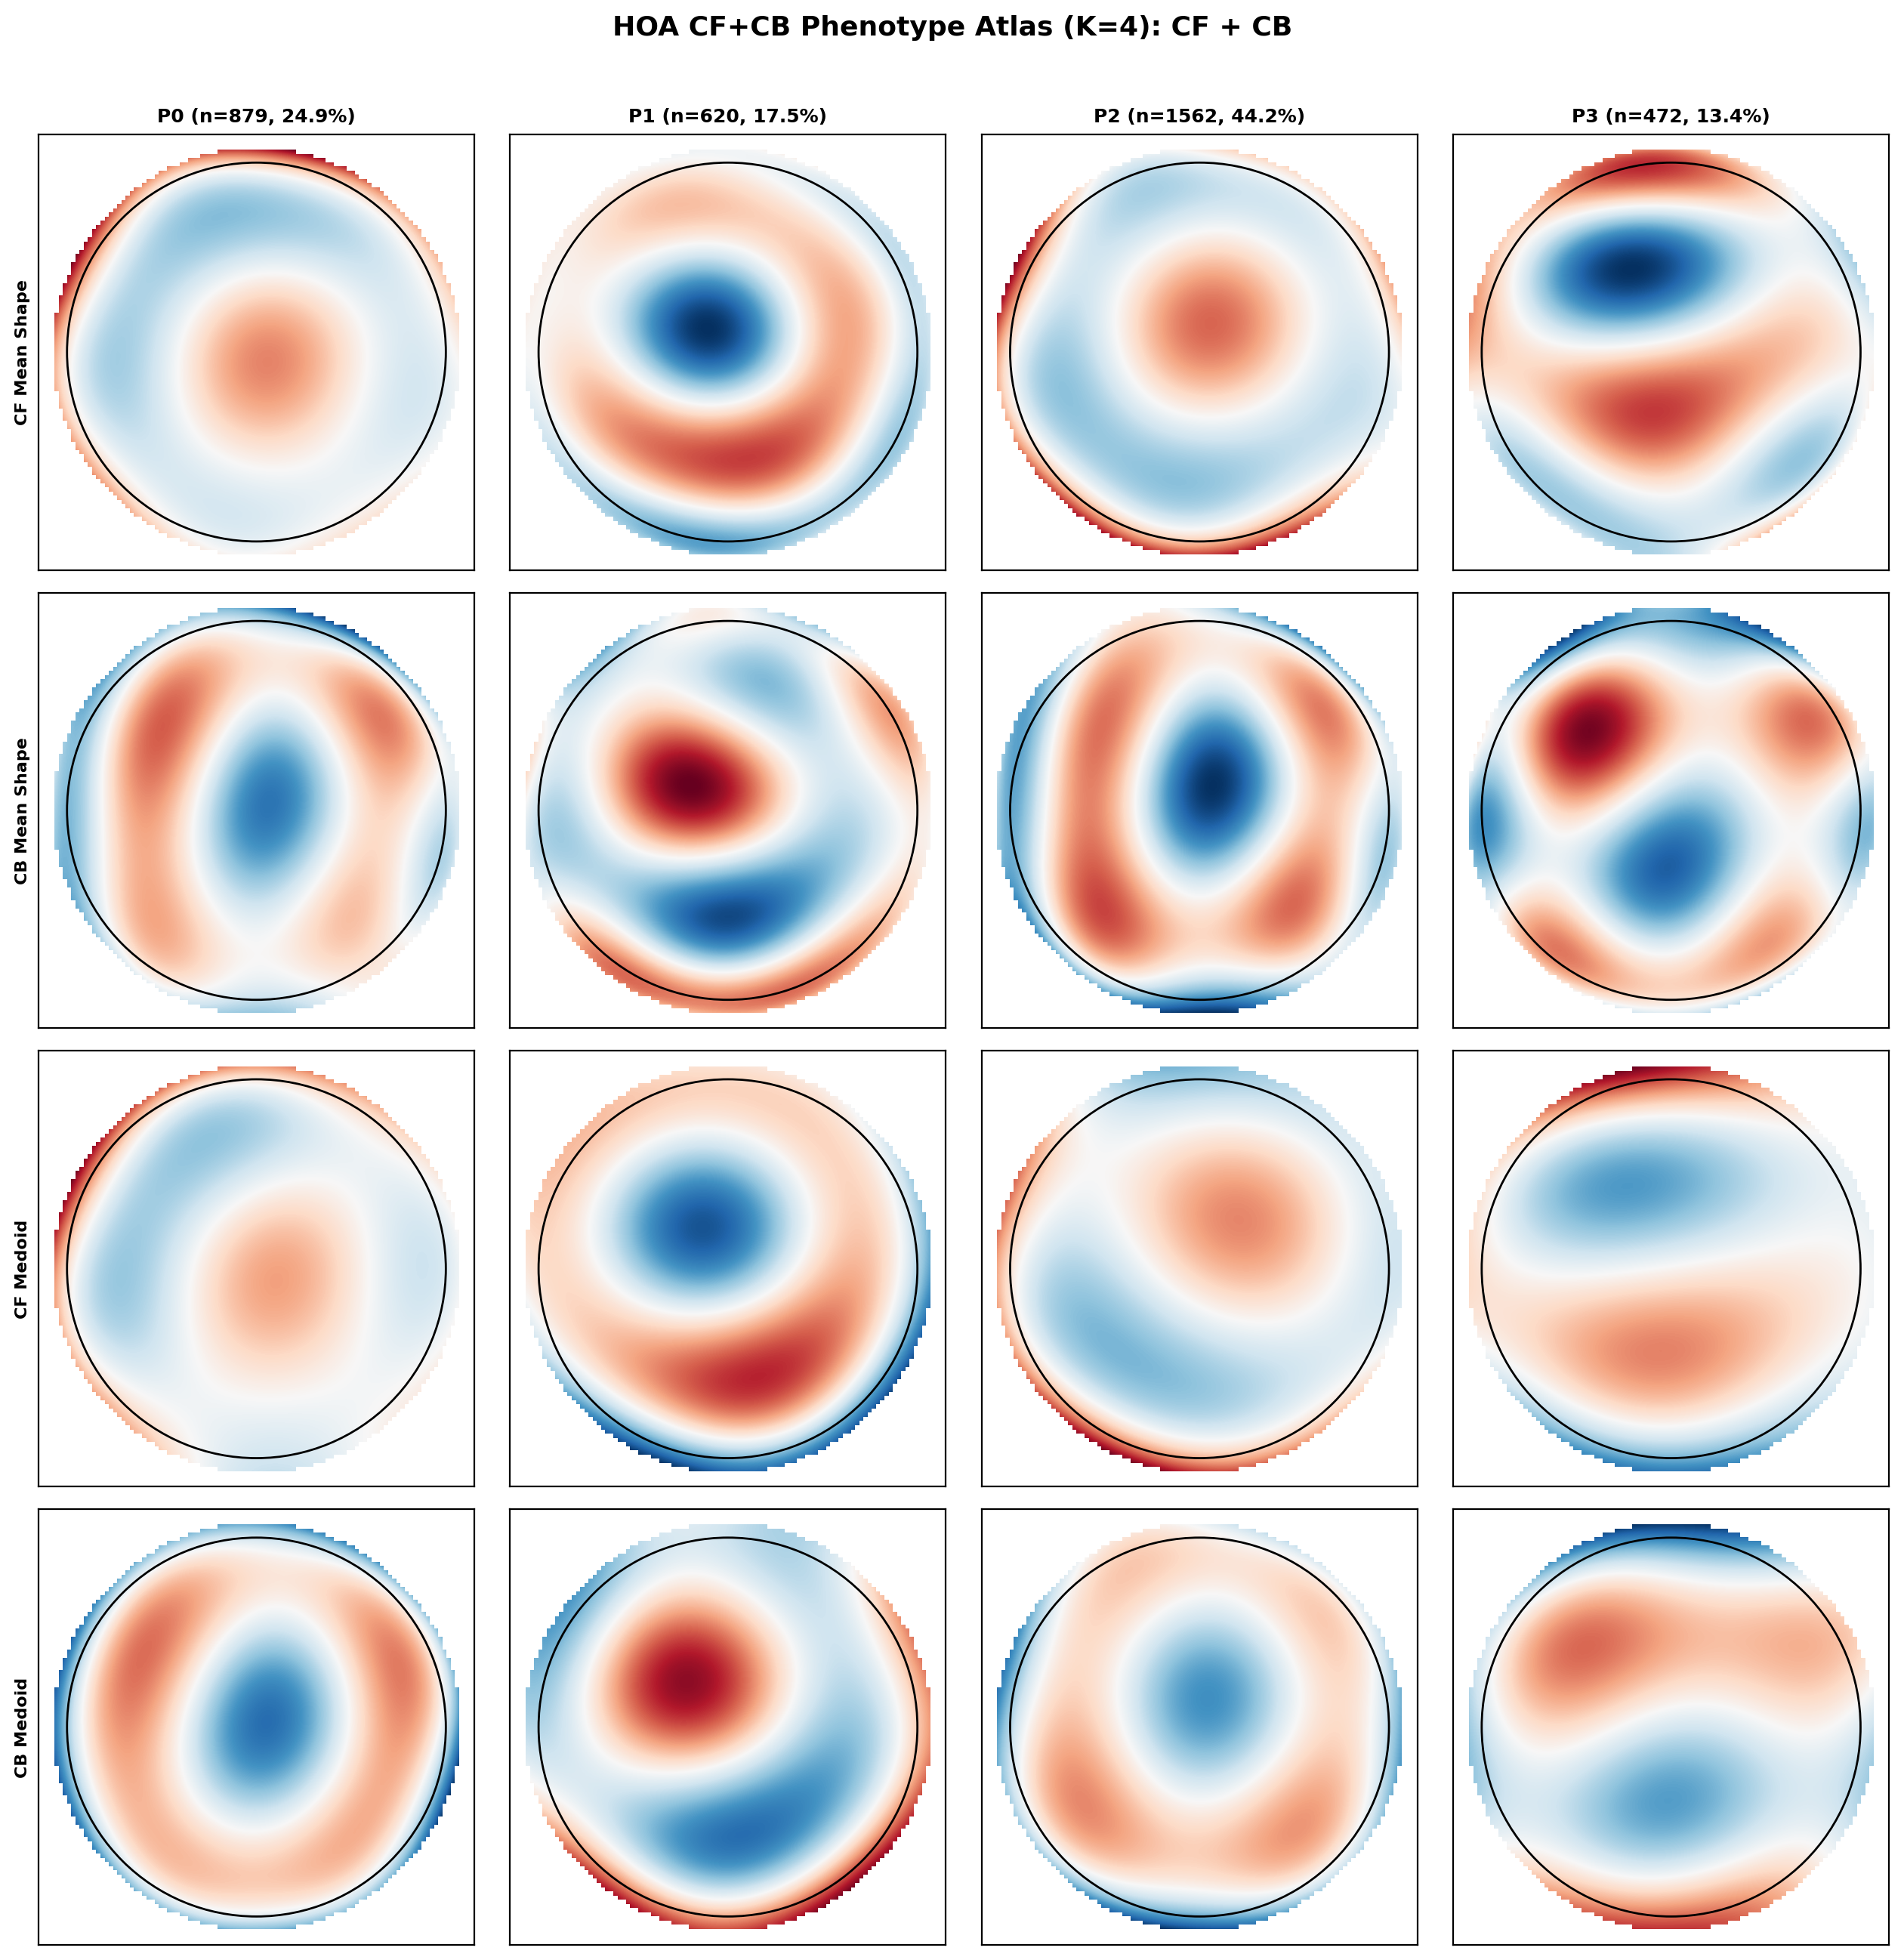
Supplementary Figure S4. HOA-only K = 4 over-segmentation atlas. The same probe was repeated using orders 3 to 6 only, providing an independent sensitivity analysis of the four-group solution.

Supplementary Tables
Supplementary Table S1. Cluster-number comparison across K = 2 to 6 for the primary spherical k-means analysis in the discovery set.
K | Cluster sizes | Smallest cluster (%) | Cosine silhouette | Euclidean silhouette | Bootstrap ARI mean | Bootstrap ARI SD | RMS-only LR accuracy | Max centroid similarity | Mean centroid similarity | Chance level
2 | [1597, 876] | 35.4 | 0.2505 | 0.2336 | 0.9889 | 0.0068 | 0.8459 | — | — | 0.5
3 | [1031, 654, 788] | 26.4 | 0.1816 | 0.1413 | 0.9207 | 0.122 | 0.6316 | 0.2118 | -0.4393 | 0.3333
4 | [388, 964, 575, 546] | 15.7 | 0.172 | 0.1381 | 0.9475 | 0.0207 | 0.5584 | 0.2744 | -0.2927 | 0.25
5 | [792, 371, 524, 480, 306] | 12.4 | 0.1604 | 0.1161 | 0.8688 | 0.0886 | 0.4776 | 0.3252 | -0.1981 | 0.2
6 | [297, 487, 507, 295, 448, 439] | 11.9 | 0.1428 | 0.0964 | 0.7217 | 0.0762 | 0.3712 | 0.6763 | -0.1395 | 0.1667

Supplementary Table S2. Post-hoc clinical summary of the full-feature K = 4 over-segmentation probe.
Variable | Phenotype | N | Median | IQR | Mean | SD
ISV | P0 | 592 | 44 | [30.00-61.25] | 48.84 | 25.79
 | P1 | 756 | 18.5 | [14.00-27.00] | 26.42 | 23.37
 | P2 | 1543 | 26 | [19.00-34.00] | 28.18 | 13.99
 | P3 | 642 | 84 | [63.00-108.00] | 87.32 | 32.46
IVA | P0 | 592 | 0.43 | [0.24-0.68] | 0.51 | 0.34
 | P1 | 756 | 0.15 | [0.11-0.24] | 0.23 | 0.23
 | P2 | 1543 | 0.14 | [0.10-0.20] | 0.17 | 0.12
 | P3 | 642 | 0.77 | [0.53-1.06] | 0.82 | 0.39
KI | P0 | 592 | 1.1 | [1.05-1.16] | 1.12 | 0.09
 | P1 | 756 | 1.01 | [0.99-1.03] | 1.01 | 0.05
 | P2 | 1543 | 1.01 | [1.00-1.02] | 1.01 | 0.03
 | P3 | 642 | 1.2 | [1.14-1.28] | 1.22 | 0.11

Supplementary Table S2. Post-hoc clinical summary of the full-feature K = 4 over-segmentation probe. (continued)
Variable | Phenotype | N | Median | IQR | Mean | SD
CKI | P0 | 592 | 1.01 | [1.00-1.02] | 1.01 | 0.02
 | P1 | 756 | 1 | [0.99-1.00] | 1 | 0.01
 | P2 | 1543 | 1.01 | [1.00-1.01] | 1.01 | 0.01
 | P3 | 642 | 1.07 | [1.05-1.10] | 1.08 | 0.05
IHA | P0 | 592 | 16.35 | [8.07-31.62] | 22.67 | 19.85
 | P1 | 756 | 5.25 | [2.40-9.40] | 7.92 | 9.66
 | P2 | 1543 | 6.2 | [2.60-11.30] | 8.19 | 8.1
 | P3 | 642 | 28.35 | [13.72-45.88] | 31.94 | 23.15
IHD | P0 | 592 | 0.05 | [0.02-0.08] | 0.06 | 0.04
 | P1 | 756 | 0.01 | [0.01-0.02] | 0.02 | 0.03
 | P2 | 1543 | 0.01 | [0.01-0.02] | 0.02 | 0.01
 | P3 | 642 | 0.11 | [0.07-0.15] | 0.11 | 0.06

Supplementary Table S2. Post-hoc clinical summary of the full-feature K = 4 over-segmentation probe. (continued)
Variable | Phenotype | N | Median | IQR | Mean | SD
BAD-D | P0 | 592 | 4.25 | [2.65-5.86] | 4.41 | 2.39
 | P1 | 756 | 1.52 | [0.98-2.27] | 2.04 | 2.2
 | P2 | 1543 | 1.46 | [0.99-2.05] | 1.6 | 1.06
 | P3 | 642 | 9.34 | [7.07-12.29] | 9.98 | 3.96
Kmax | P0 | 592 | 48.51 | [46.41-51.04] | 48.92 | 3.66
 | P1 | 756 | 45.38 | [44.10-47.02] | 46.17 | 3.68
 | P2 | 1543 | 45.75 | [44.34-47.14] | 45.91 | 2.48
 | P3 | 642 | 56.32 | [52.80-61.01] | 57.31 | 6.32
CCT | P0 | 592 | 487 | [459.00-515.00] | 489.07 | 45.33
 | P1 | 756 | 536 | [510.00-562.00] | 533.76 | 48.91
 | P2 | 1543 | 534 | [510.00-560.00] | 534.76 | 39.71
 | P3 | 642 | 441.5 | [411.00-466.00] | 438.83 | 44.21

Supplementary Table S3. Pairwise distinguishability analysis for the full-feature K = 4 solution.
Pair | Significant variables (n) | Non-significant variables (n) | Non-significant variables | Mean |Cohen's d| | Max |Cohen's d| | Interpretation
P0-P1 | 9 | 0 | — | 0.998 | 1.453 | Strong separation
P0-P2 | 9 | 0 | — | 1.339 | 2.08 | Strong separation
P0-P3 | 9 | 0 | — | 1.225 | 1.935 | Strong separation
P1-P2 | 3 | 6 | KI, IHA, IHD, BAD-D, Kmax, CCT | 0.228 | 0.748 | Artificial split
P1-P3 | 9 | 0 | — | 2.125 | 2.532 | Strong separation
P2-P3 | 9 | 0 | — | 2.757 | 3.599 | Strong separation

Supplementary Table S4. Post-hoc clinical summary of the HOA-only K = 4 over-segmentation probe.
Variable | Phenotype | N | Median | IQR | Mean | SD
ISV | P0 | 879 | 23 | [17.00-34.00] | 28.97 | 20.24
 | P1 | 620 | 83 | [61.00-108.00] | 86.53 | 32.74
 | P2 | 1562 | 24 | [17.00-33.00] | 27 | 15.62
 | P3 | 472 | 51 | [38.00-72.00] | 57.51 | 27.63
IVA | P0 | 879 | 0.15 | [0.11-0.22] | 0.21 | 0.19
 | P1 | 620 | 0.76 | [0.51-1.03] | 0.81 | 0.38
 | P2 | 1562 | 0.15 | [0.10-0.21] | 0.18 | 0.14
 | P3 | 472 | 0.56 | [0.37-0.85] | 0.64 | 0.37
KI | P0 | 879 | 1.03 | [1.02-1.05] | 1.04 | 0.04
 | P1 | 620 | 1.2 | [1.13-1.28] | 1.21 | 0.11
 | P2 | 1562 | 1 | [0.99-1.02] | 1 | 0.03
 | P3 | 472 | 1.12 | [1.08-1.19] | 1.14 | 0.09

Supplementary Table S4. Post-hoc clinical summary of the HOA-only K = 4 over-segmentation probe. (continued)
Variable | Phenotype | N | Median | IQR | Mean | SD
CKI | P0 | 879 | 1 | [1.00-1.01] | 1 | 0.01
 | P1 | 620 | 1.07 | [1.05-1.11] | 1.08 | 0.05
 | P2 | 1562 | 1 | [1.00-1.01] | 1 | 0.01
 | P3 | 472 | 1.02 | [1.01-1.03] | 1.02 | 0.02
IHA | P0 | 879 | 6 | [2.60-10.80] | 8.37 | 9.52
 | P1 | 620 | 27.4 | [13.93-45.60] | 31.5 | 22.84
 | P2 | 1562 | 6 | [2.52-11.60] | 8.34 | 8.48
 | P3 | 472 | 22.1 | [9.78-38.52] | 26.76 | 21.6
IHD | P0 | 879 | 0.01 | [0.01-0.02] | 0.02 | 0.02
 | P1 | 620 | 0.11 | [0.06-0.15] | 0.11 | 0.06
 | P2 | 1562 | 0.01 | [0.01-0.02] | 0.02 | 0.02
 | P3 | 472 | 0.06 | [0.04-0.10] | 0.07 | 0.05

Supplementary Table S4. Post-hoc clinical summary of the HOA-only K = 4 over-segmentation probe. (continued)
Variable | Phenotype | N | Median | IQR | Mean | SD
BAD-D | P0 | 879 | 1.69 | [1.10-2.40] | 2 | 1.7
 | P1 | 620 | 9.3 | [6.98-12.29] | 9.92 | 4.09
 | P2 | 1562 | 1.42 | [0.96-1.99] | 1.65 | 1.45
 | P3 | 472 | 5.08 | [3.87-6.64] | 5.39 | 2.44
Kmax | P0 | 879 | 45.75 | [44.31-47.22] | 46.16 | 3.18
 | P1 | 620 | 56.23 | [52.66-61.05] | 57.25 | 6.47
 | P2 | 1562 | 45.61 | [44.24-47.14] | 45.96 | 2.78
 | P3 | 472 | 49.66 | [47.52-52.29] | 50.11 | 3.89
CCT | P0 | 879 | 529 | [503.00-557.00] | 527.67 | 43.8
 | P1 | 620 | 441.5 | [411.00-466.25] | 439.85 | 46.86
 | P2 | 1562 | 537 | [512.00-561.00] | 536.12 | 42.63
 | P3 | 472 | 477.5 | [453.00-501.00] | 478.74 | 42.63

Supplementary Table S5. Pairwise distinguishability analysis for the HOA-only K = 4 solution.
Pair | Significant variables (n) | Non-significant variables (n) | Non-significant variables | Mean |Cohen's d| | Max |Cohen's d| | Interpretation
P0-P1 | 9 | 0 | — | 2.162 | 2.699 | Strong separation
P0-P2 | 3 | 6 | ISV, IVA, CKI, IHA, IHD, Kmax | 0.229 | 1.131 | Artificial split
P0-P3 | 9 | 0 | — | 1.344 | 1.703 | Strong separation
P1-P2 | 9 | 0 | — | 2.666 | 3.305 | Strong separation
P1-P3 | 9 | 0 | — | 0.905 | 1.746 | Strong separation
P2-P3 | 9 | 0 | — | 1.74 | 2.758 | Strong separation

Supplementary Table S6. Discovery-replication centroid concordance after centroid matching for the K = 4 over-segmentation probe.
Cosine similarity matrix between discovery (D rows) and replication (R columns) centroids.
Discovery | R0 | R1 | R2 | R3
D0 | -0.3053 | 0.1467 | 0.9771 | -0.4359
D1 | 0.2954 | -0.8399 | -0.4052 | 0.9912
D2 | -0.6373 | 0.9974 | 0.0384 | -0.8435
D3 | 0.9824 | -0.6697 | -0.0972 | 0.3197

Matched centroid pairs after one-to-one assignment.
Discovery phenotype | Matched replication phenotype | Matched cosine similarity
D0 | R2 | 0.9771
D1 | R3 | 0.9912
D2 | R1 | 0.9974
D3 | R0 | 0.9824

Mean matched cosine concordance = 0.987; ARI between projected and independently refit replication labels = 0.9.

Supplementary Table S7. Composite-score sensitivity to alternative weighting schemes across K = 2 to 6.
Weighting scheme | Silhouette weight | Stability weight | Severity weight | Redundancy weight | Composite K=2 | Composite K=3 | Composite K=4 | Composite K=5 | Composite K=6 | Optimal K
Original (0.25/0.30/0.25/0.20) | 0.25 | 0.3 | 0.25 | 0.2 | 0.75 | 0.4818 | 0.5207 | 0.4418 | 0.25 | 2
Equal (0.25/0.25/0.25/0.25) | 0.25 | 0.25 | 0.25 | 0.25 | 0.75 | 0.4584 | 0.4904 | 0.4247 | 0.25 | 2
Stability-heavy (0.15/0.50/0.15/0.20) | 0.15 | 0.5 | 0.15 | 0.2 | 0.85 | 0.5495 | 0.602 | 0.458 | 0.15 | 2
Silhouette-heavy (0.40/0.20/0.20/0.20) | 0.4 | 0.2 | 0.2 | 0.2 | 0.8 | 0.4388 | 0.4465 | 0.3724 | 0.2 | 2
Severity-heavy (0.20/0.20/0.40/0.20) | 0.2 | 0.2 | 0.4 | 0.2 | 0.6 | 0.457 | 0.5135 | 0.495 | 0.4 | 2

Supplementary Table S8. Cosine-versus-Euclidean silhouette comparison across K = 2 to 6.
K | Cosine silhouette | Euclidean silhouette | Difference
2 | 0.2505 | 0.2336 | 0.0169
3 | 0.1816 | 0.1413 | 0.0404
4 | 0.172 | 0.1381 | 0.0339
5 | 0.1604 | 0.1161 | 0.0443
6 | 0.1428 | 0.0964 | 0.0465

