Tackle Hub Addon Installation steps
Install minikube https://minikube.sigs.k8s.io/docs/start/ and run it using minikube start
- Install tackle2-operator - https://github.com/konveyor/tackle2-operator

Minikube:
- $ minikube addons enable olm
- $ minikube addons enable ingress

Kubernetes:
- $ kubectl apply -f https://raw.githubusercontent.com/operator-framework/operator-lifecycle-manager/master/deploy/upstream/quickstart/crds.yaml
- $ kubectl apply -f https://raw.githubusercontent.com/operator-framework/operator-lifecycle-manager/master/deploy/upstream/quickstart/olm.yaml

Tackle Operator Installation on k8s
- $ kubectl apply -f https://raw.githubusercontent.com/konveyor/tackle2-operator/main/tackle-k8s.yaml

Creating Tackle CR
cat << EOF | kubectl apply -f -
kind: Tackle
apiVersion: tackle.konveyor.io/v1alpha1
metadata:
name: tackle
namespace: konveyor-tackle
spec:
feature_auth_required: false
EOF
Verify Tackle Deployment
- $ kubectl get pods -A

UI
$ minikube tunnel (127.0.0.1)
Username: admin
Password: password

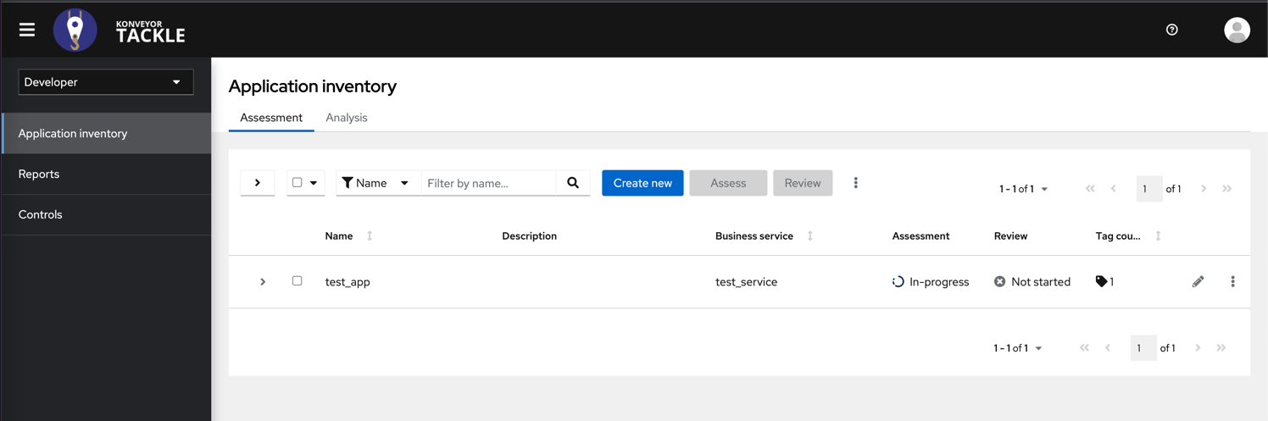

Run Example Addon
- Create a Business Service in Tackle UI (e.g. test)
- Create a new application in the UI with the already created business service (e.g. test)
- Call the API to get the application ID –
curl -i localhost/hub/applications
- Run the command eval $(minikube -p minikube docker-env) in terminal
- Build the docker file - $docker build -t tackle-addon .
- Push image to quay.io and update addon.yml (/hack/add) to point to your image
- Run kubectl apply -f addon.yml -n konveyor-tackle to apply the changes and configure tca addon
- Provide the same addon name in task-ready.sh as in the addon.yaml
- Run the task-ready.sh script

For hello-world addon: View the list of files in UI - http://127.0.0.1/hub/applications/1/bucket/list/

