INSPECTION REPORT
(NOT FOR NEGOTIATION)
Report No | Bjorna-FRI-2026-78
Customer Name | Bjorna | Destination Country | Denmark
Inspection Type | Final Inspection Report | Inspection Date | 06th April 2026
Manufacturer Name | Gohar Textile | Inspection Location | 3.5-K.M. Jhumra Road, Khurianwala, Faisalabad, Punjab 38000, Pakistan.
Factory Representative Name | Mr. Imran | Inspector's Arrival Time | 10:00 A.M.
Inspector(s) Name | Mr. Hamid / Ms. Areeba | Inspector’s Departure Time | 15:30 P.M.

PRODUCT CATEGORY | Coca Cola (Duvet Set)
BATH | KITCHEN / UTILITY | TABLE | BEDDING | WINDOW | OTHER
Fabric Construction  Required | 100% cotton, 30x30/76x68/110 GSM |  | Fabric Construction  Found | 100% cotton, 30x30/77x65
Polyester Filling  Required | N/A |  | Polyester Filling  Found as per Sample | N/A

PO Number | SKU / UPC # | Item Description | Design/ Color | Size (cm) | Pcs / Set / CTN | PO Qty (Sets) | Offer Qty |  | +/- Then PO (%)
 |  |  |  |  |  |  | Sets | Carton
13320 | 5710348115285 | Duvet Set Assorted | RED COB80190 | 135x200+ 80x80 | 2 | 11304 | 11304 | 1884 | 100%
 | 5710348118385 |  | White COB80203 | 135x200+ 80x80 | 2
 | 5710348115278 |  | Black COB80194 | 135x200+ 80x80 | 2
Total: - |  |  |  |  | 6 | 11304 | 11304 | 1884 | 100%

Sampling Method: ASNI-ASQC Z1.4; Single Sampling plan, General inspection Level-II, AQL: 2.5 Major / 4.0 Minor (Sample Size: 315 Sets)

Item Description | Size (cm) | SAMPLE SIZE | CRITICAL DEFECTIVE FOUND | CRITICAL DEFECTIVE ALLOWED | MAJOR DEFECTIVE FOUND | MAJOR DEFECTIVE ALLOWED | MINOR DEFECTIVE FOUND | MINOR DEFECTIVE ALLOWED | PASS / FAIL
Duvet Set Assorted | 135x200+ 80x80 | 315 | 00 | 00 | 11 | 14 | 18 | 21 | Pending
 | 135x200+ 80x80
 | 135x200+ 80x80
Total: - |  | 315 | 00 | 00 | 11 | 14 | 18 | 21 | Pending

INSPECTION CONCLUSION |  |  | CONFORM |  |  | NOT CONFORM |  |  | PENDING

Additional Comments (if any):

PO Number | SKU / Style # | Color | Comments
13320 | 135x200+ 80x80 | Multi
 | 135x200+ 80x80 | Multi
 | 135x200+ 80x80 | Multi
REFERENCE SAMPLES & SPECIFICATIONS:
STANDARD & REFERENCE | Provided by Customer to Cot-House Office | Provided by Customer to Supplier | Supplier's Counter / Record | Not Available (Actual findings Reported) | WITH Customer's Authentication (Sign/Stamp) | WITHOUT Customer's authentication (Sign/Stamp)
Reference Samples
Specification File/Details

Standards vs Production Photos
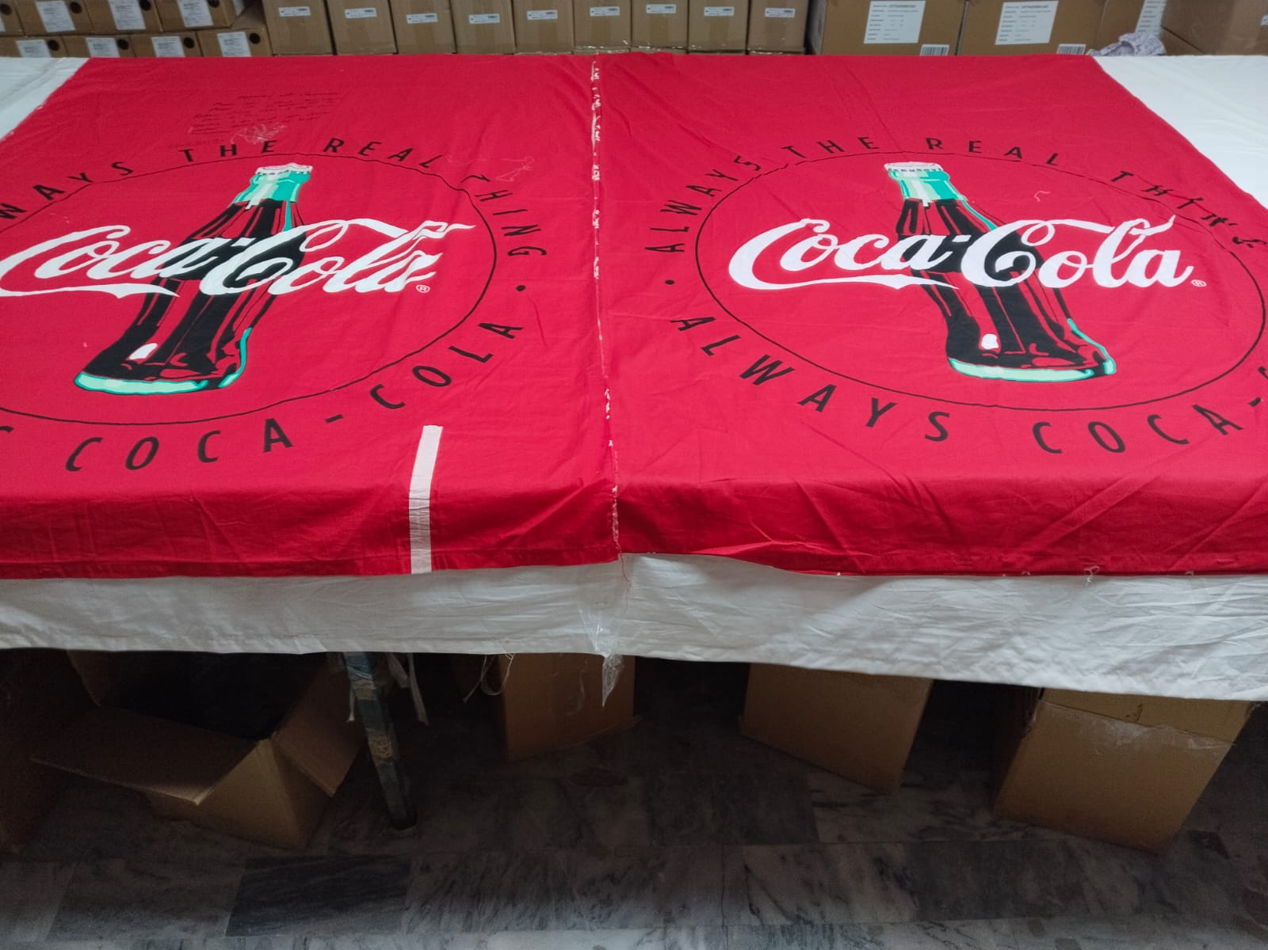 | 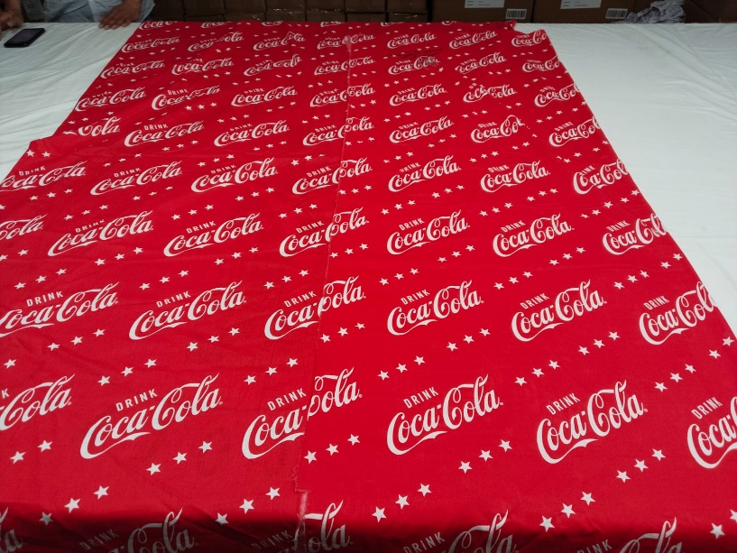
Shade Comparison View with Approved Standard | Shade Comparison View with Approved Standard
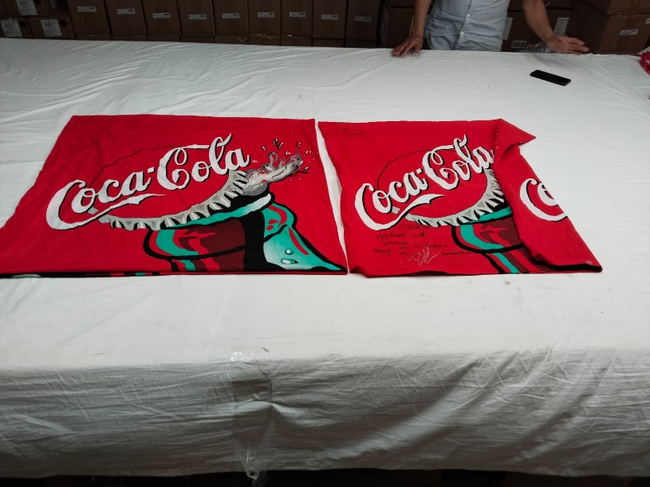
Shade Comparison View with Approved Standard
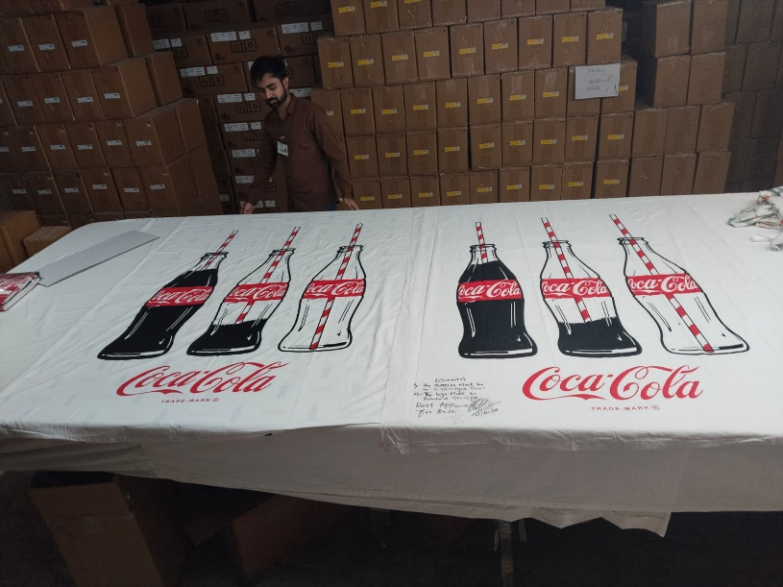 | 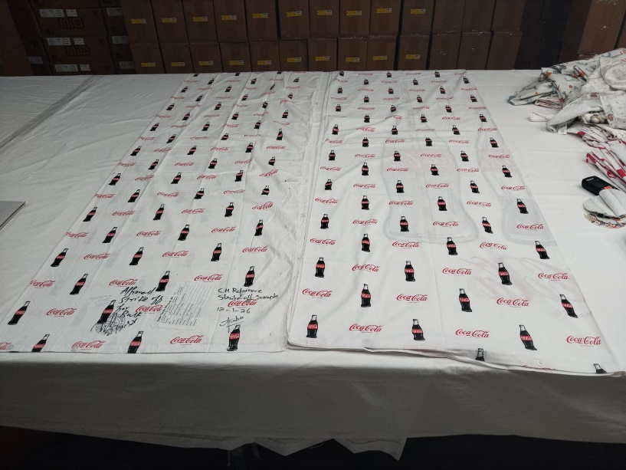
Shade Comparison View with Approved Standard | Shade Comparison View with Approved Standard
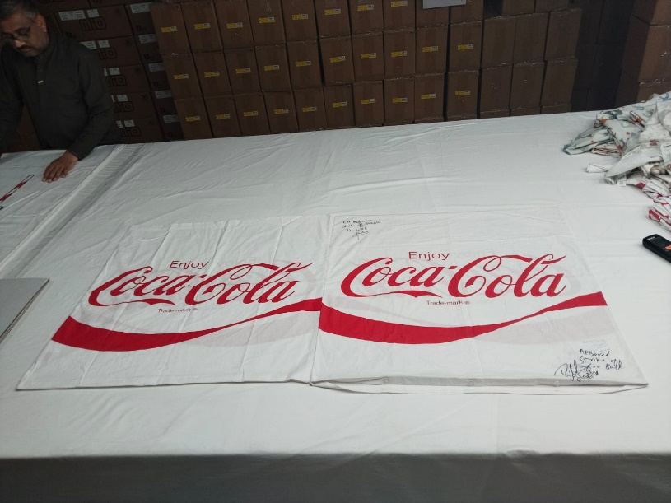
Shade Comparison View with Approved Standard
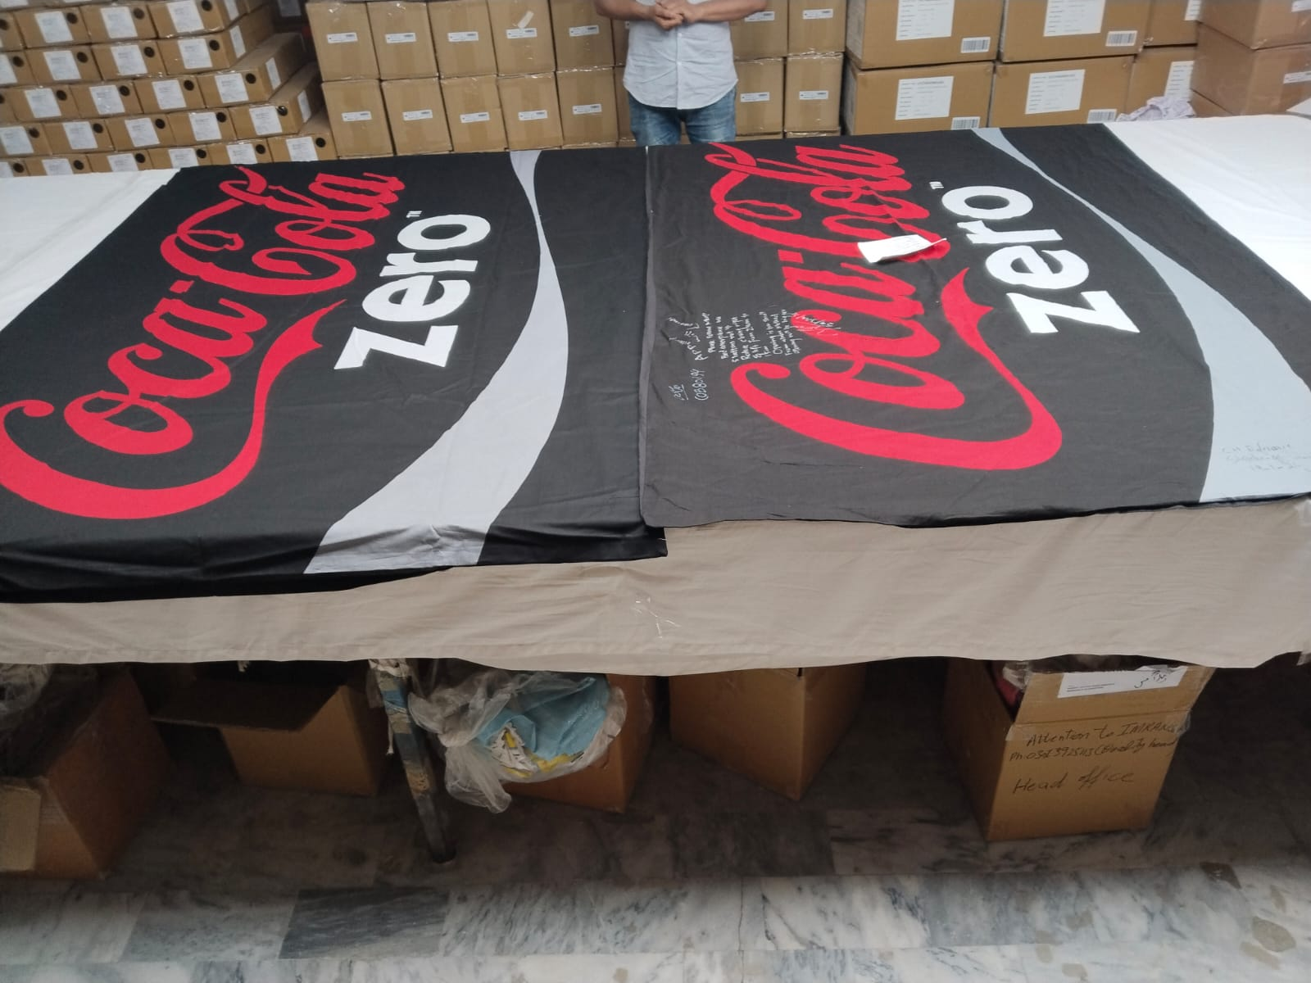 | 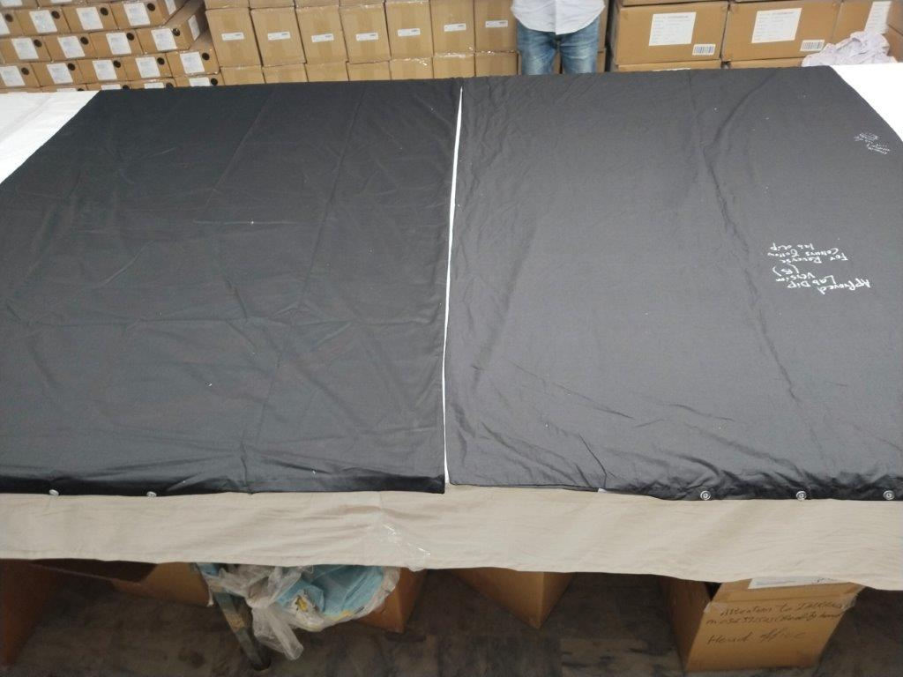
Shade Comparison View with Approved Standard | Shade Comparison View with Approved Standard
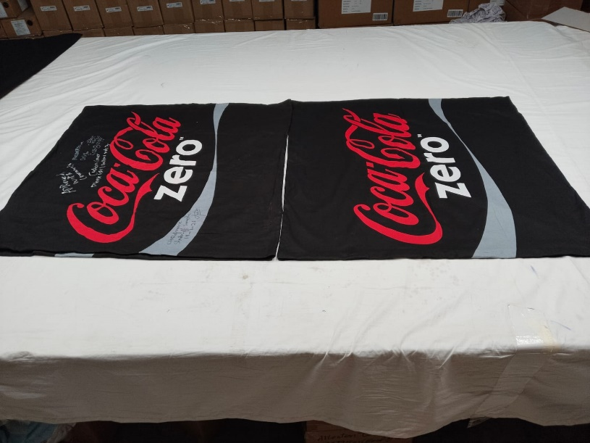
Shade Comparison View with Approved Standard

LAB TEST REPORT:
LAB TEST REQUIREMENTS | YES | NO | N/A | TEST EQUIPMENT NOT AVAILABLE | REMARK
Lab Test Exist
Lab Report Reviewed
Lab Report as per Protocols
Any Deviation
Result (Under Commercial Tolerance or Not) | Pass | Fail

PACKING:
Bag Description | PL | PE |  | LDPE | PVC | PEVA |  |  |  |  | Fabric |  | Others
Bag Closures | Self-Adhesive |  |  | Studs  Buttons  Poppers |  | Zipper  Branded  Non-Branded |  |  |  |  | Others
Certification | PROP-65 |  |  |  |  | BE |  |  |  |  | Others |  | NA
Inlay Card | U/J Shape |  | Hang Tag |  | Belly Band / Banderole | Book Fold |  |  | Insert | Header with Hanger |  |  | OTHERS
Stickers & Barcode | Size |  | Break Pack |  | Barcode | Poly Bag |  |  |  | Holograms
 | Pre-Tickets |  | Kimball Labels |  |  | Price Stickers |  |  |  | Printed Safety & Recycled Logo
Pack Description | Individual |  |  | Set | Master Poly | Inner as Poly Bag |  |  | Zipper Closure | String / Draw Cord |  |  | Other Closures
Inner Pack | Polybag Holes |  |  | Polybag Suffocation Warning |  | Inner Pack Marking/Sticker |  |  |  |  | Inner Pack sealed by:
Stiffener | 3 Ply |  |  | 5 Ply |  | White |  | Brown |  | Cutting Protector: YES NO
Shipping Carton | Carton Ply: 5 Ply |  |  |  | Carton Poly Lining: YES NO |  |  |  |  |  | Printed  Non-Printed
Shipping Marks | Printed on Carton |  |  |  | Carton Stickers |  | 4 Side |  |  |  |  | 2 Side
Pallets | Wooden |  |  |  | Corrugated |  | PDQS  No of Pieces/Sets |  |  |  |  | Others

PACKING PHOTOS
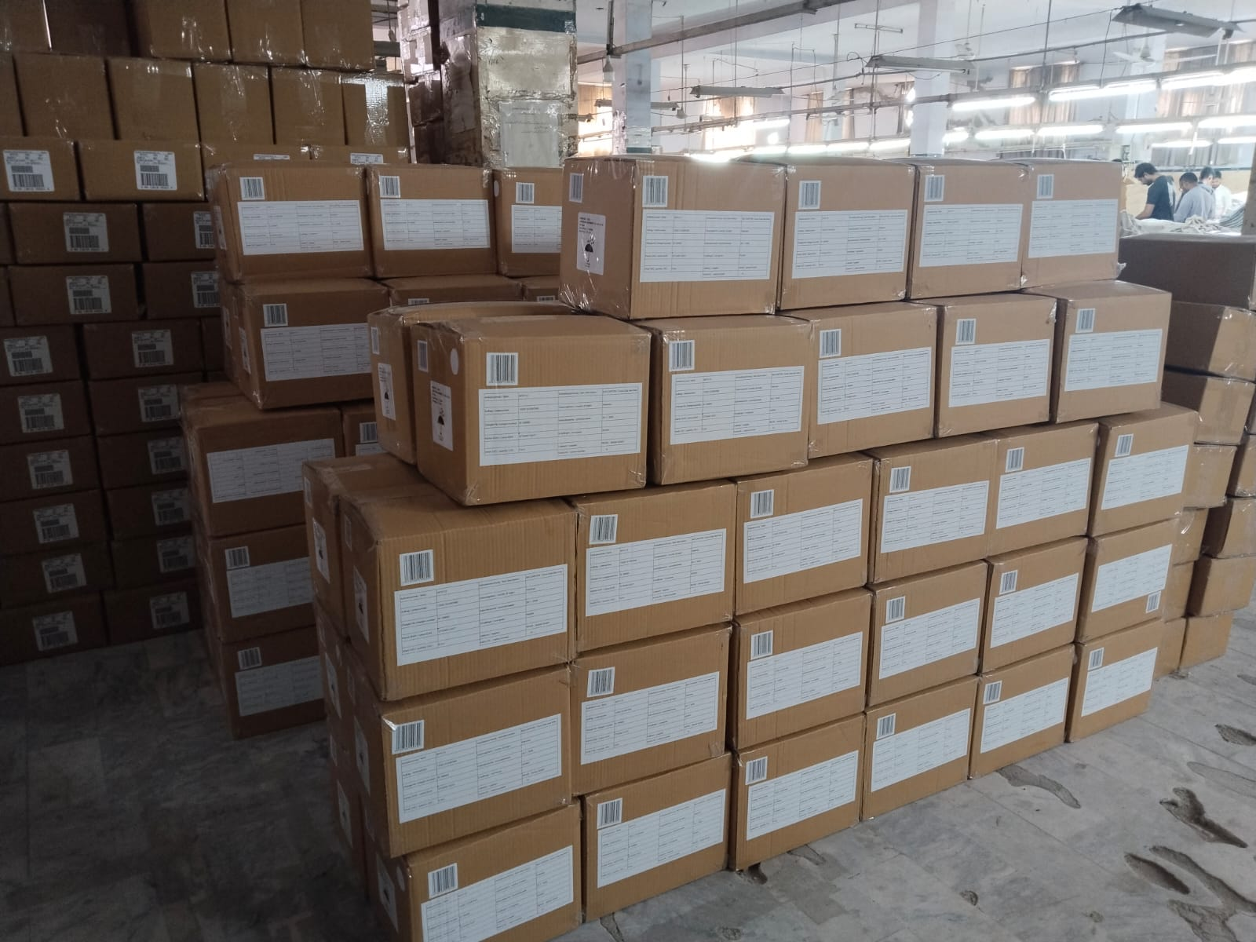 | 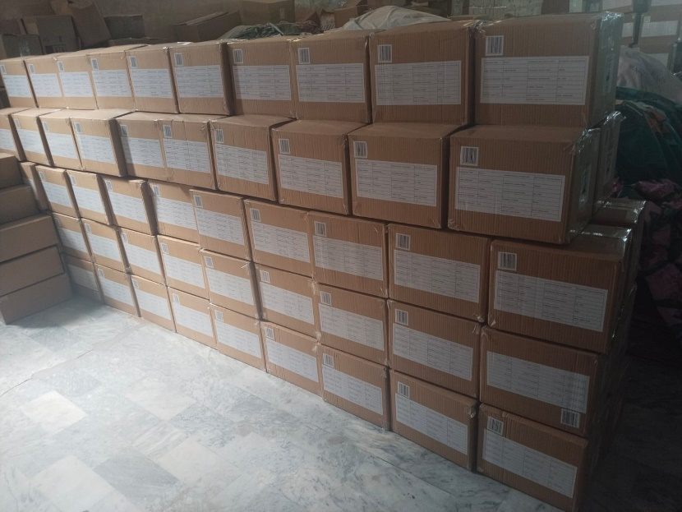
Cartons Stacking View | Cartons Stacking View
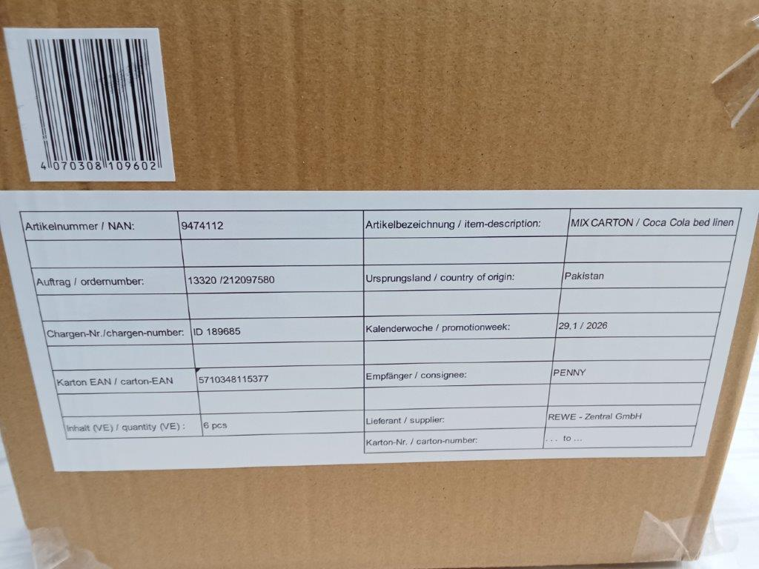 | 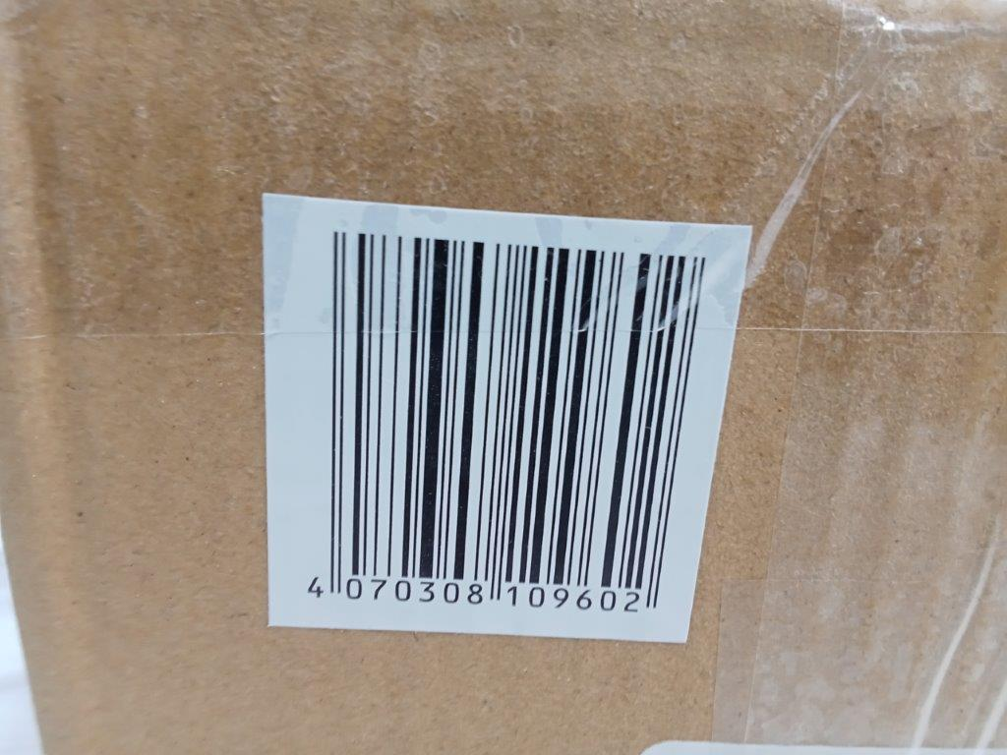
Packed Carton Shipping Mark View | Packed Carton Barcode Sticker View
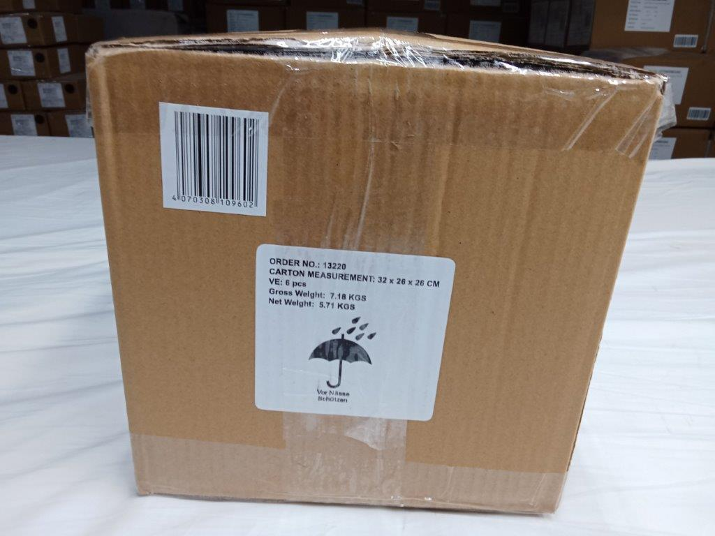
Packed Carton Sticker View
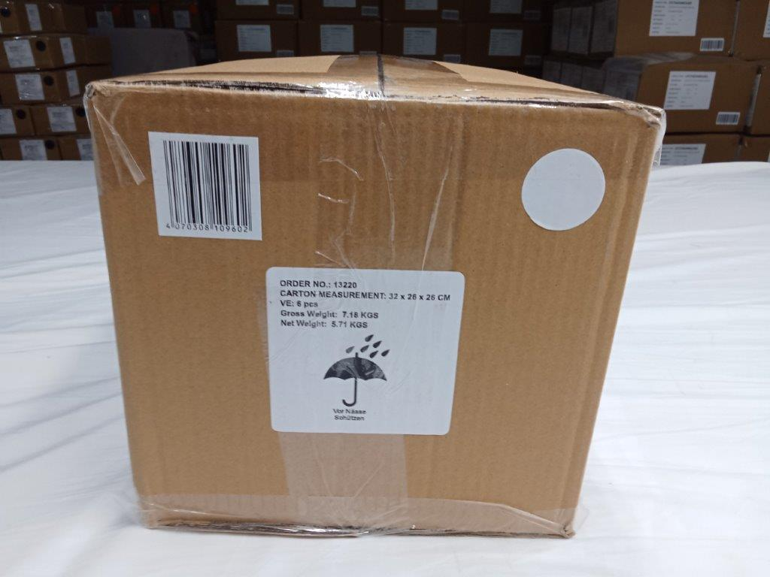 | 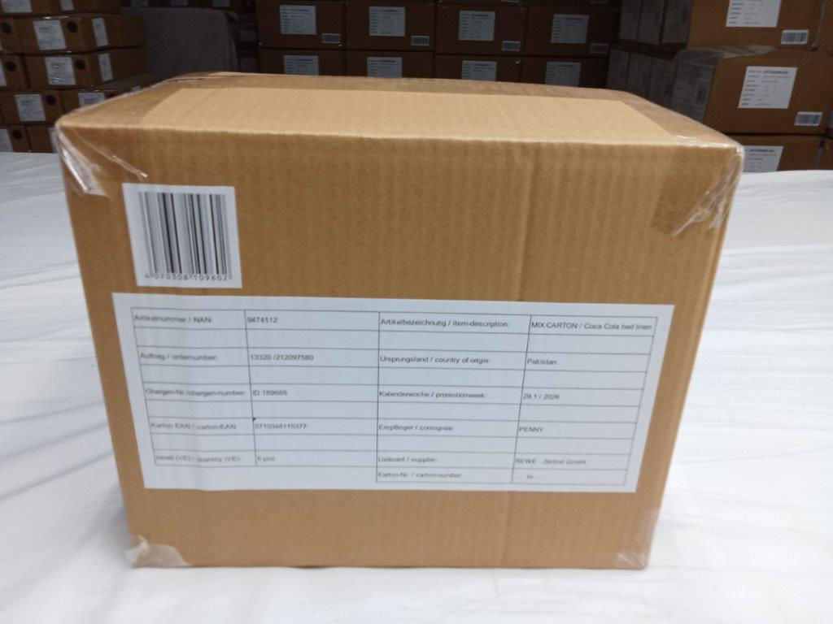
Packed Carton Shorter Side View | Packed Carton Longer Side View
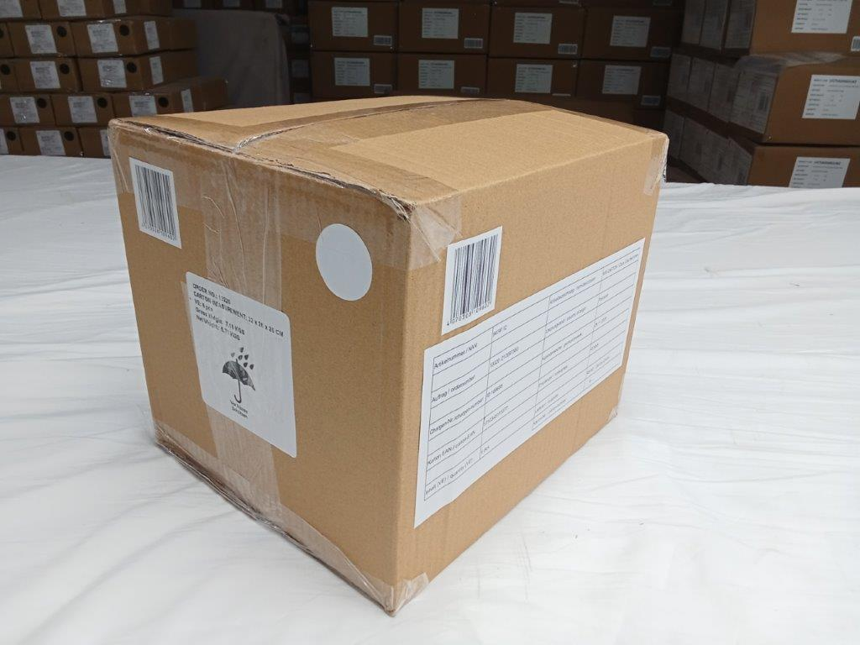
Packed Carton Corner Side View
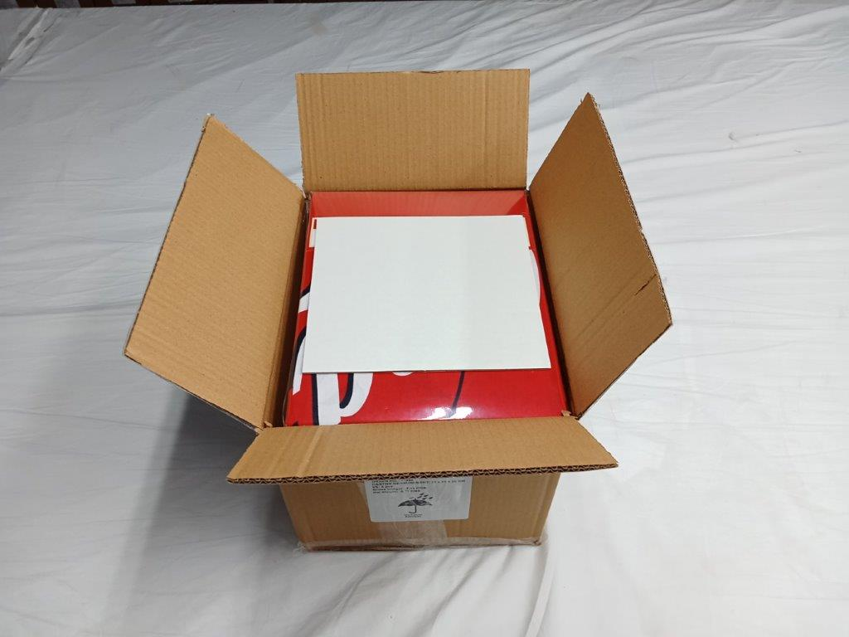 | 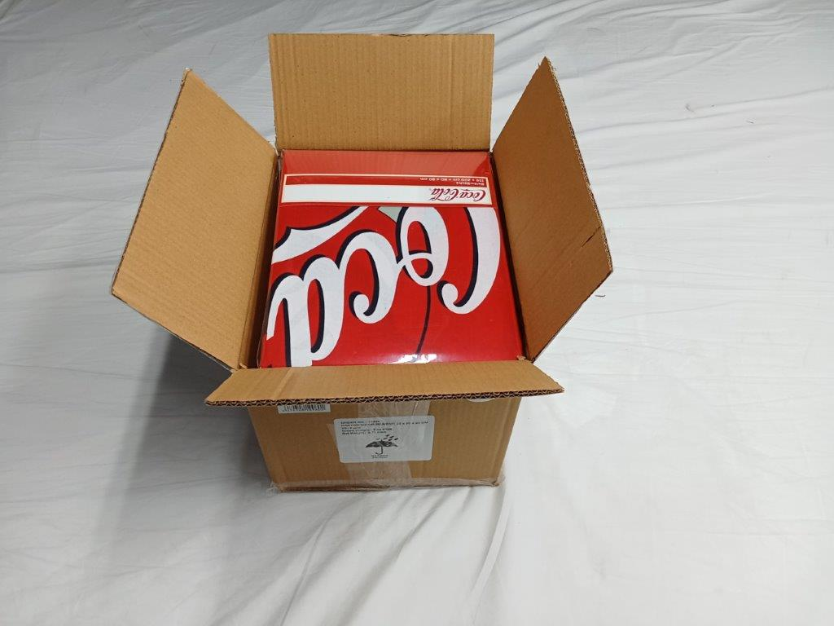
Carton Open View with Protector Sheet | Carton Open View without Protector Sheet
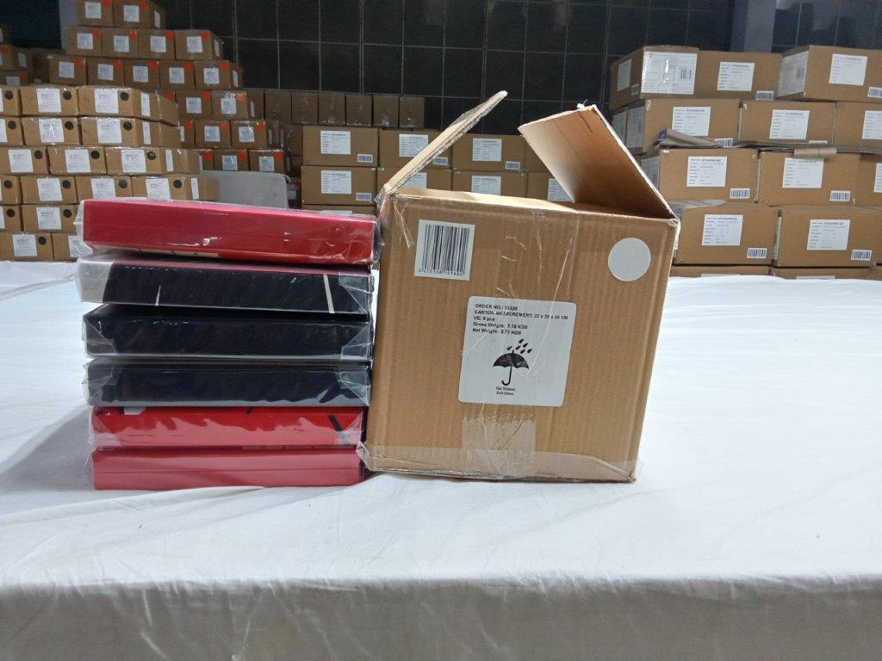 | 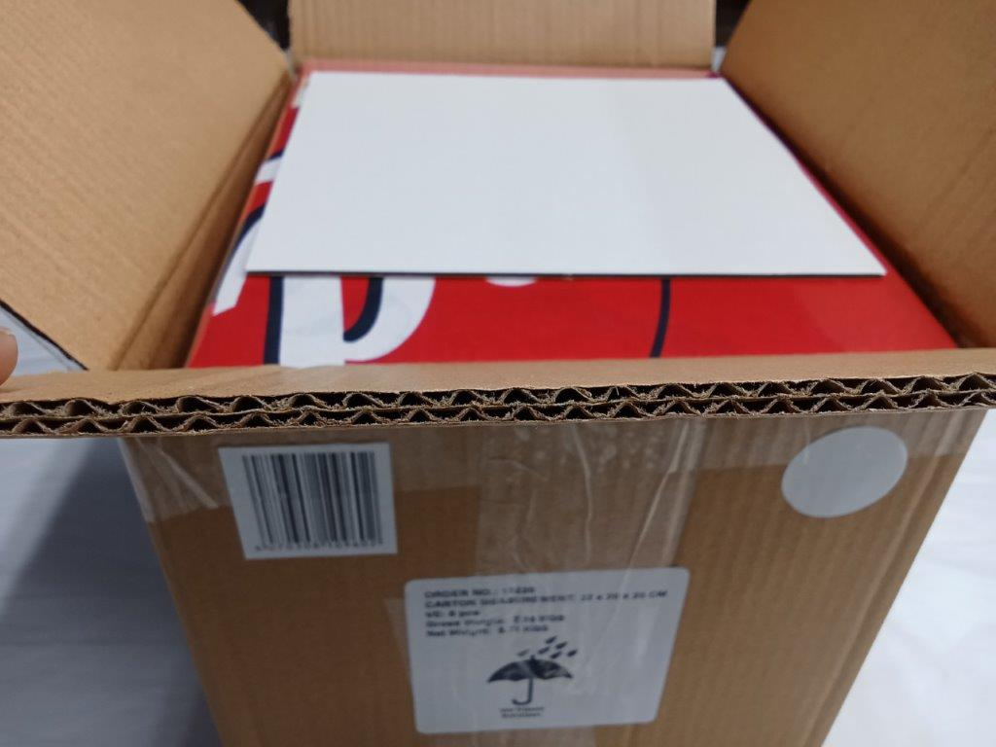
Carton Packing Style View | 5Ply Carton Quality View
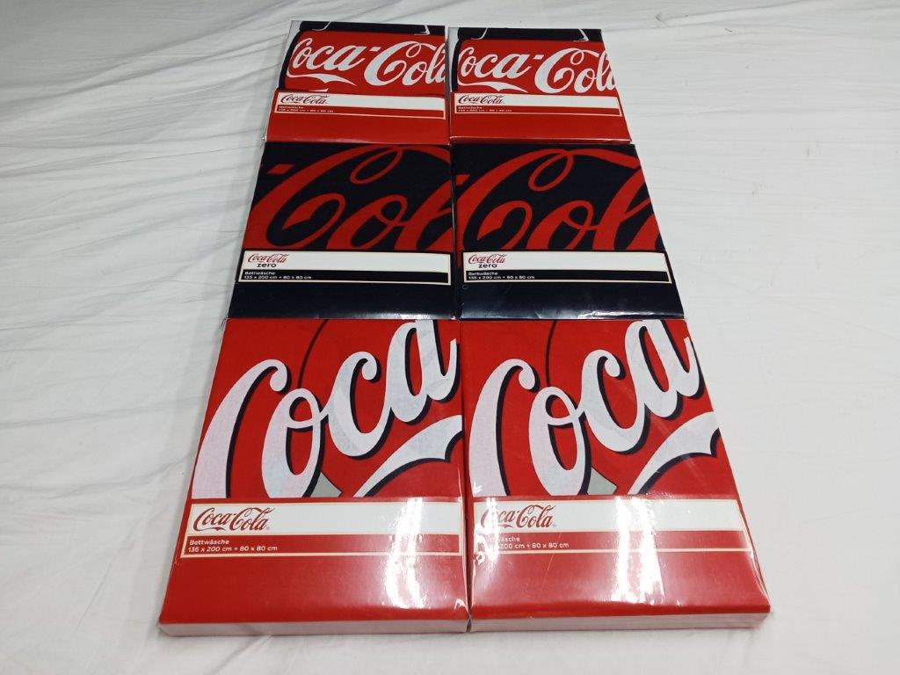 | 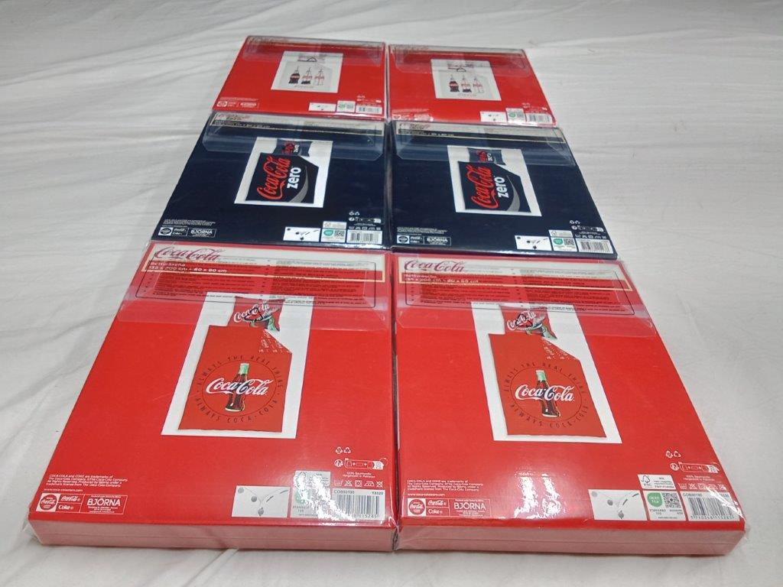
Packed Sets Front Side View | Packed Sets Back Side View
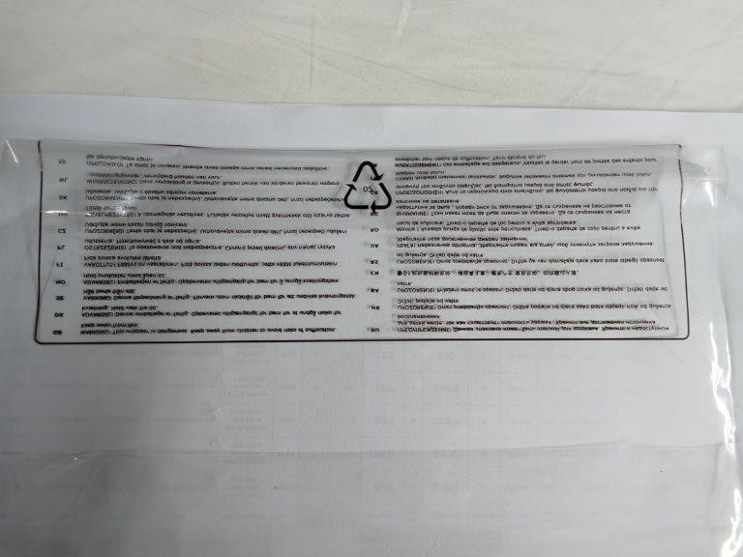
Poly Bag Printed Safety View & Recycled Logo View
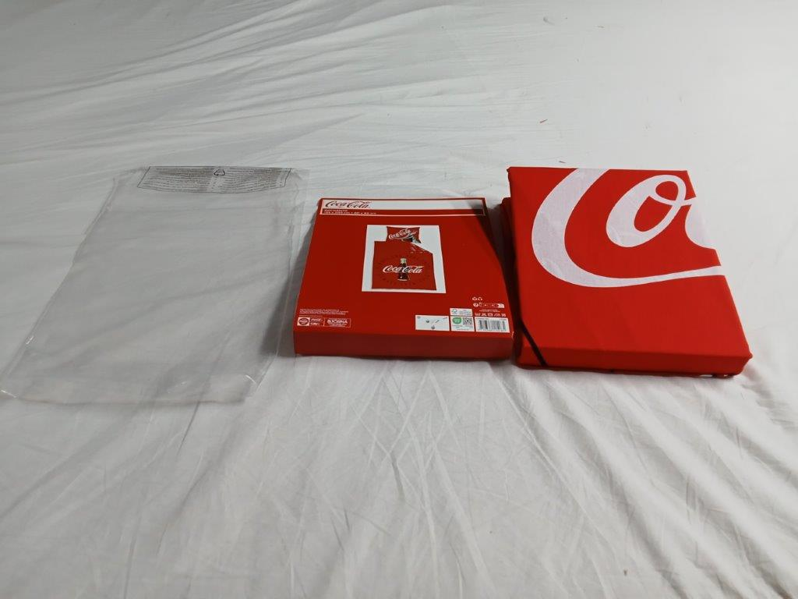 | 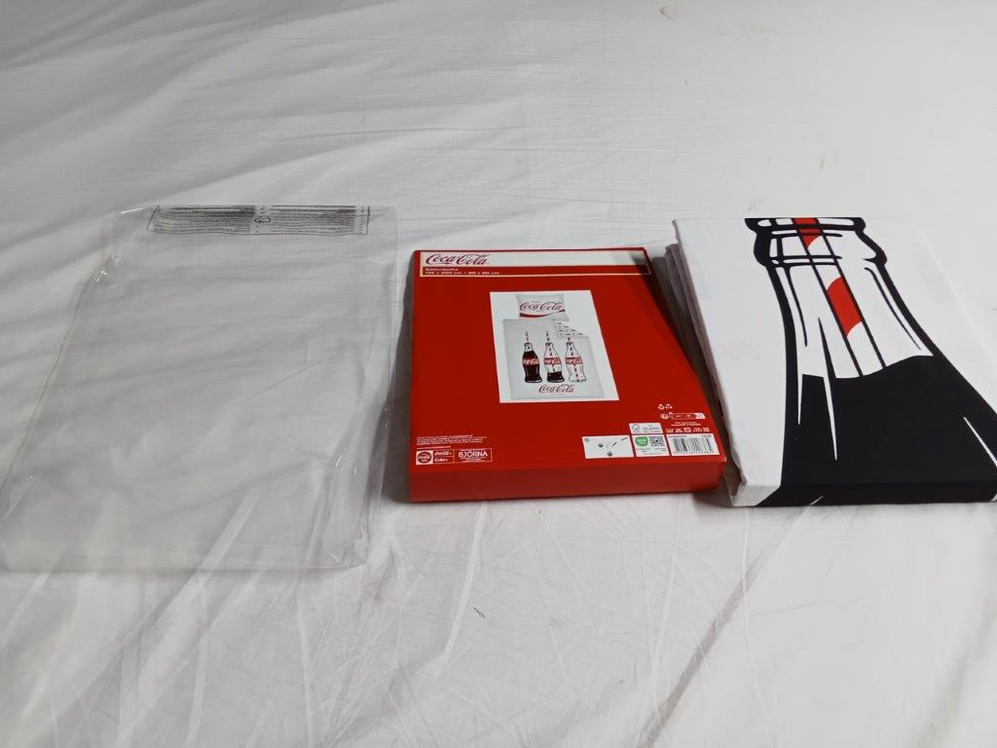
Set with Loose Card & Poly Bag View | Set with Loose Card & Poly Bag View
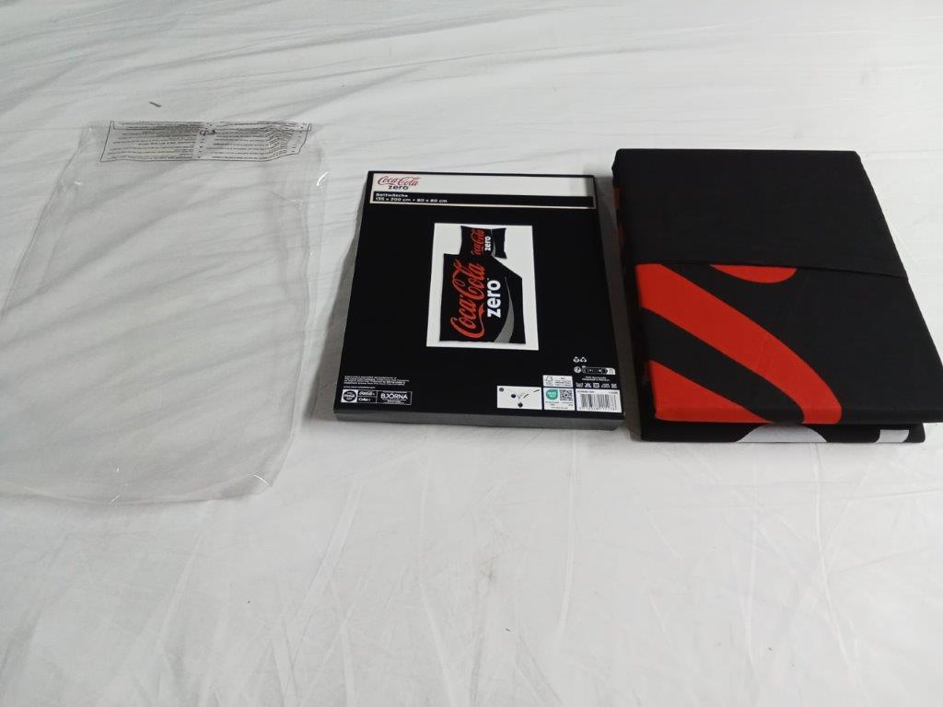
Set with Loose Card & Poly Bag View
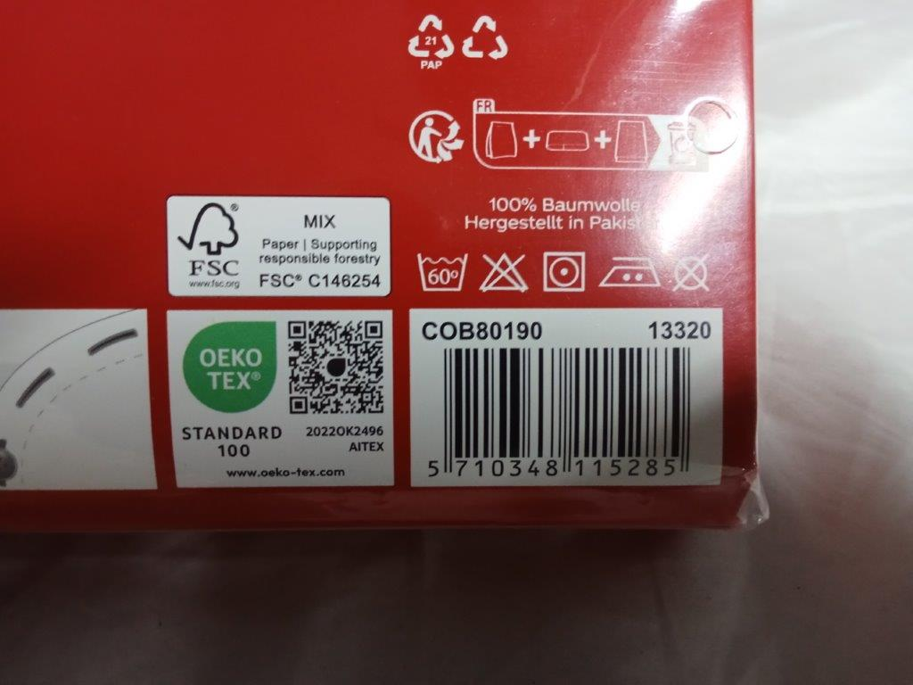 | 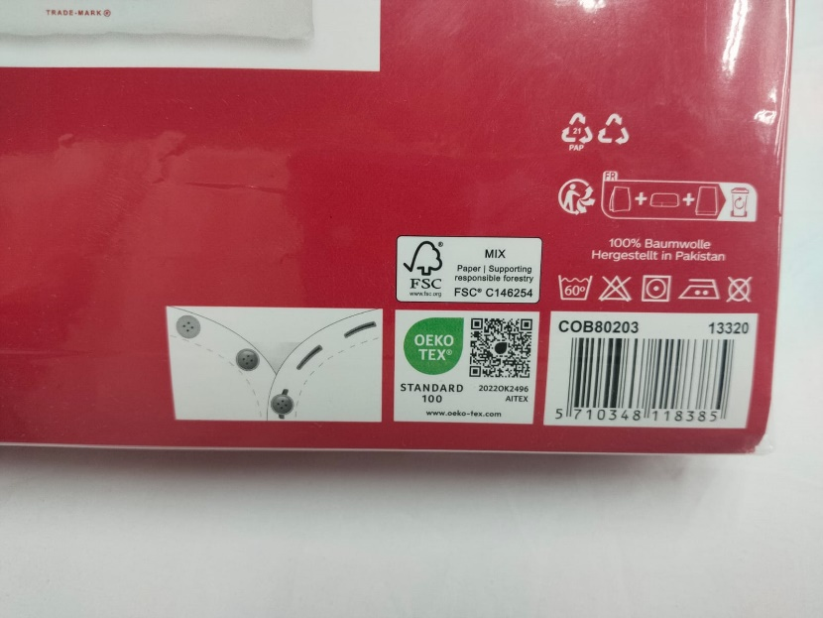
Printed Barcode View | Printed Barcode View
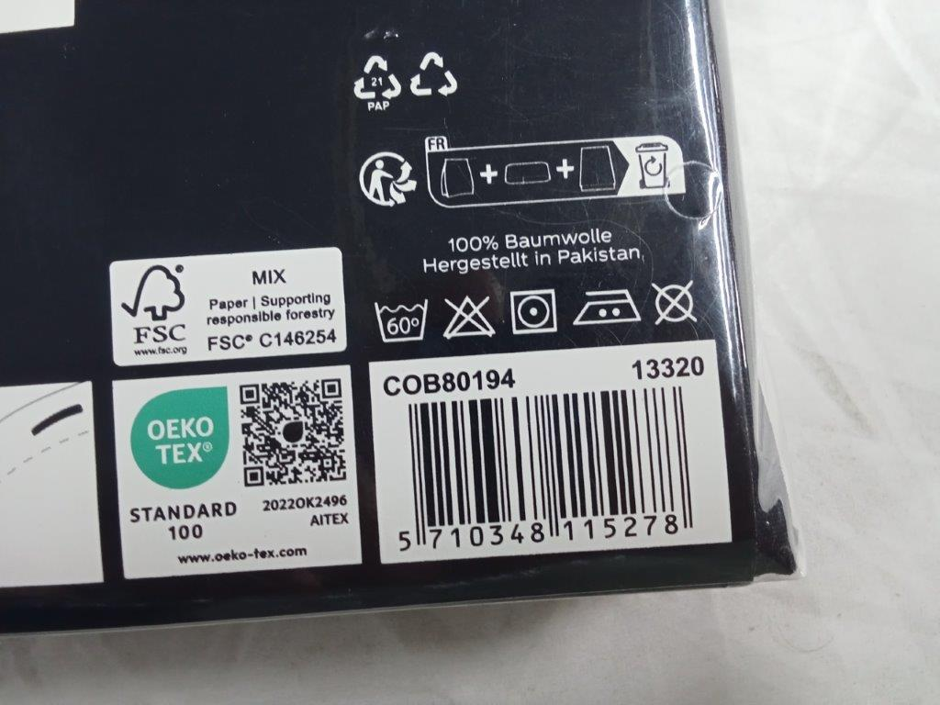
Printed Barcode View

MARKING / LABELING:
Description | Conform | Not Conform | NA | Observations
Shipping Mark - Carton Sticker
Presence
Position
Information
Batch Number
Customer Order Number
Customer Article Number
Description
Product Size: Inch, (Cm.), lbs/DZ
Quantity: Pcs, (DZ)
Carton Size: Inch, (Cm.)
Gross Weight: ___ KG |  |  |  | Printed on Shipping Mark
Net Weight: ___ KG |  |  |  | Printed on Shipping Mark
Carton Number |  |  |  | No Carton# found during inspection.
Barcode Sticker
FSC Carton Printing
Polybag Warning
Presence [mention if Print or Sticker]
Position
Information
Brand Label & Care Label / Content / Origin Label / Logo Label
Presence
Position
Information
Inner Pack / Polybag Label / Recycled Logo
Presence
Position
Information
Photo Insert / Text Insert / Bellyband Card /Lodret Banderols / U-Card / Insert Card / Hang Tag
Presence
Position
Information
Other Label or Tag [Specify: ____Round Size Sticker_________]
Presence
Position
Information

PO # | Item Description | Size (cm) | UPC Number as per PO | UPC Number as Observed & Scanned
13320 | Duvet Set Assorted | 135x200+ 80x80 | 5710348115285 | 5710348115285
 |  | 135x200+ 80x80 | 5710348118385 | 5710348118385
 |  | 135x200+ 80x80 | 5710348115278 | 5710348115278

Cartons Selected for Inspection:
Sampling Method: ASNI-ASQC Z1.4; Single Sampling plan, General inspection Level-II, AQL: 2.5 Major / 4.0 Minor (Sample Size: 315 Sets)

Item / Size (cm) | Total Cartons | Serial Number (from-to) | Numbers of Cartons Selected | Serial Number of the Cartons randomly Selected for Inspection
135x200+ 80x80 | 1884 | Not Printed/Written | 188 | -
 |  |  |  | -
 |  |  |  | -
Total: - | 1884 | Not Printed/Written | 188 | -

AVERAGE WORKMANSHIP AND FINISH CONTROL RECORD:
Sr. Nos. | ERROR DESCRIPTION | PRODUCT | Duvet Set
 |  | SIZE / STYLE | 135x200+ 80x80
 |  | SAMPLE SIZE | 315
 |  | COLOR | Multi
 |  |  | Major | Minor
1 | Uneven Stitch |  |  | 1
2 | Open Seam |  | 1
3 | Color Stain |  | 1 | 1
4 | Off Registration |  | 1 | 1
5 | Pleat |  | 1 | 2
6 | Weaving Defect |  |  | 1
7 | Hanging Thread |  | 1
8 | Shade Within Set |  | 1 | 1
9 | Stain |  | 1 | 2
10 | Uncut Thread |  |  | 2
11 | Puckering |  |  | 1
12 | Touching |  |  | 1
 | TOTAL |  | 07 | 13
 | ALLOWABLE |  | 14 | 21
 | RESULT |  | Pending

DEFECT PHOTOS
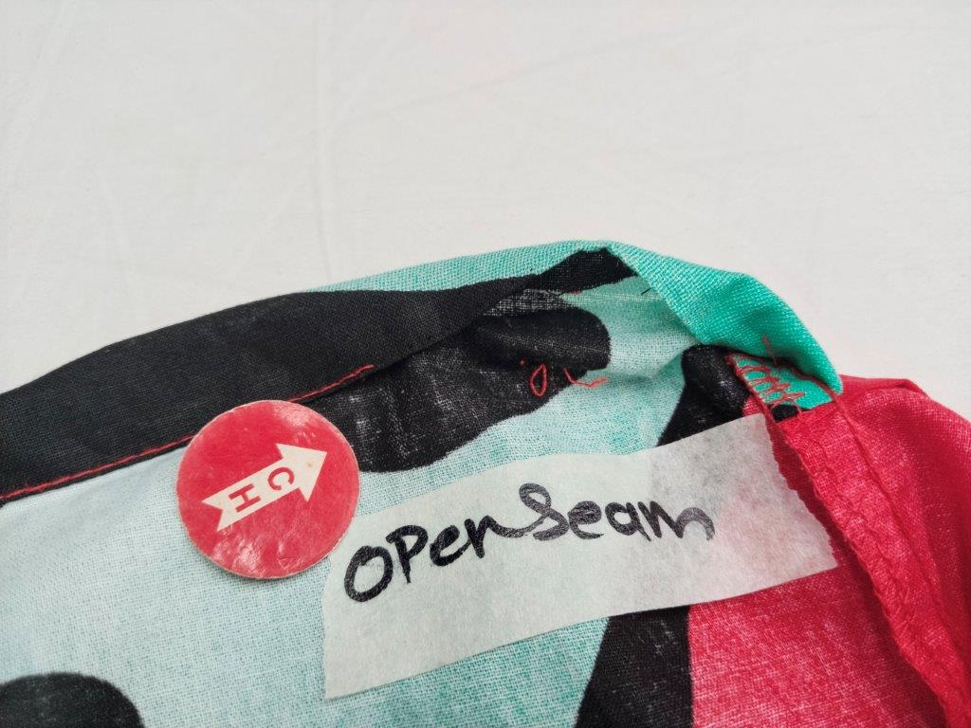 | 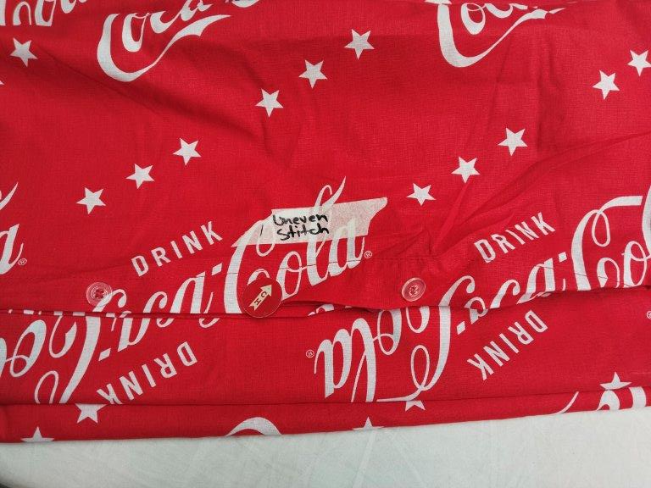
Open Seam | Uneven Stitch
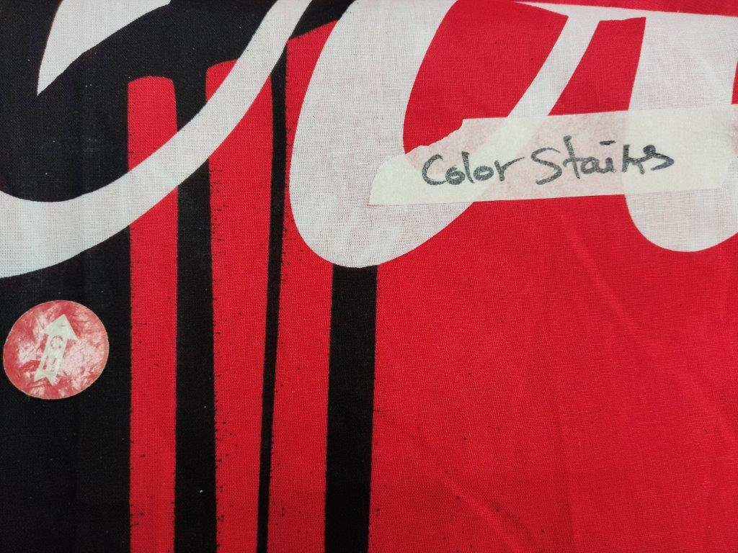 | 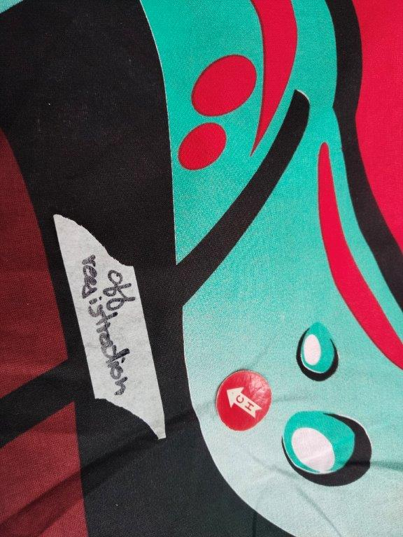
Colour Stain | Off Registration
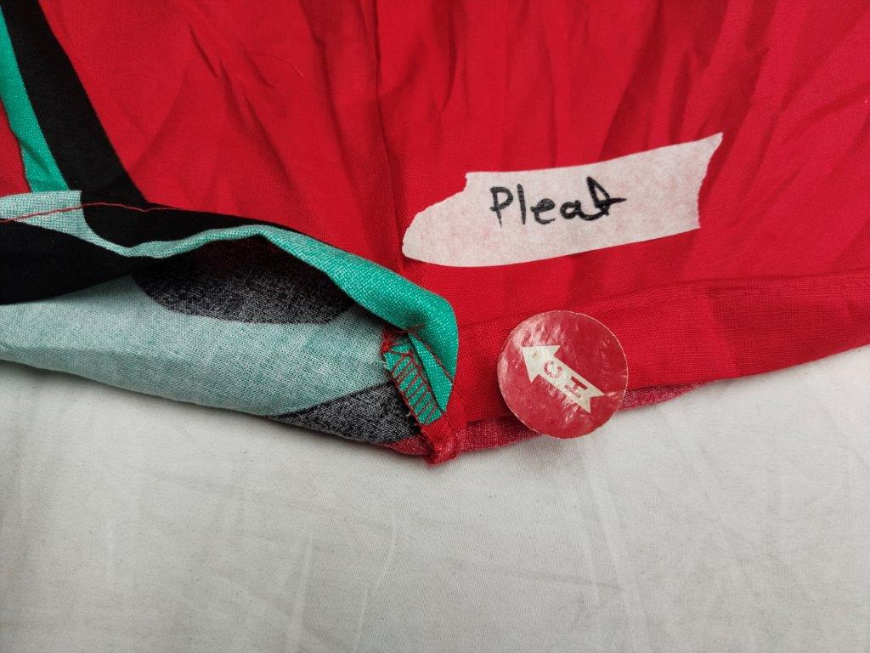 | 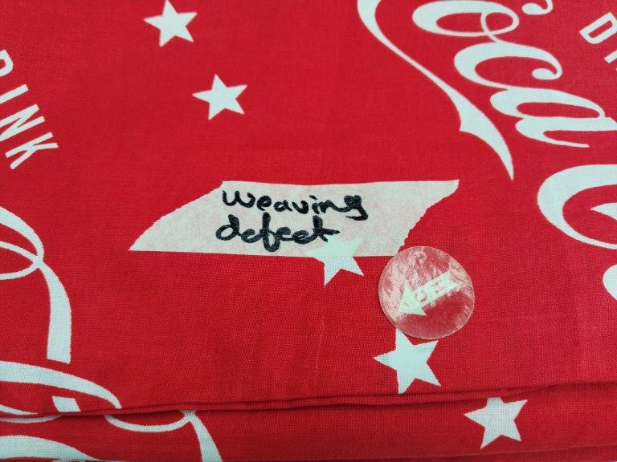
Pleat | Weaving Defect
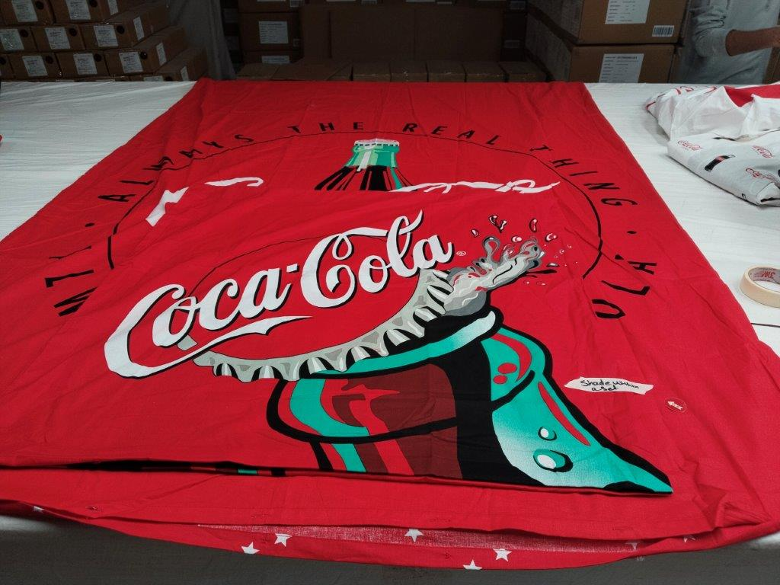 | 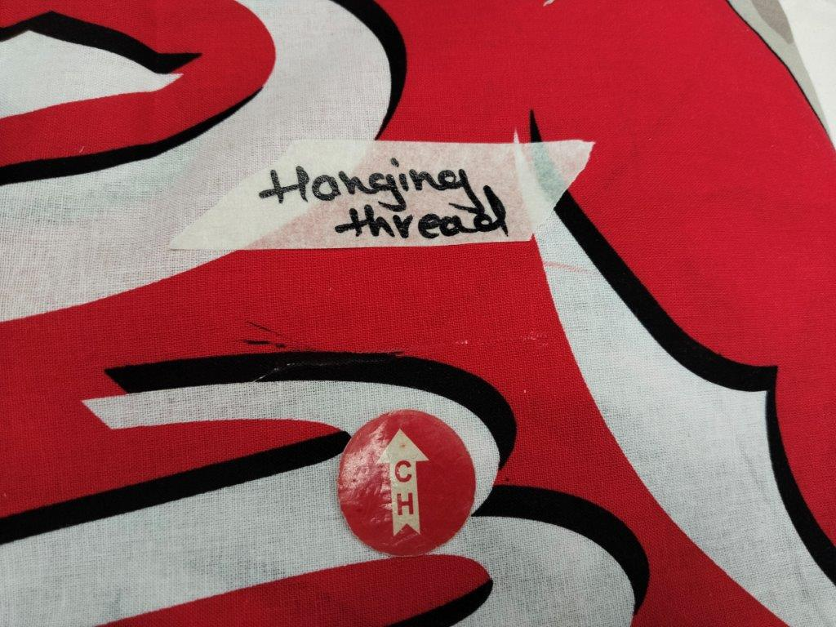
Shade Within Set | Hanging Thread
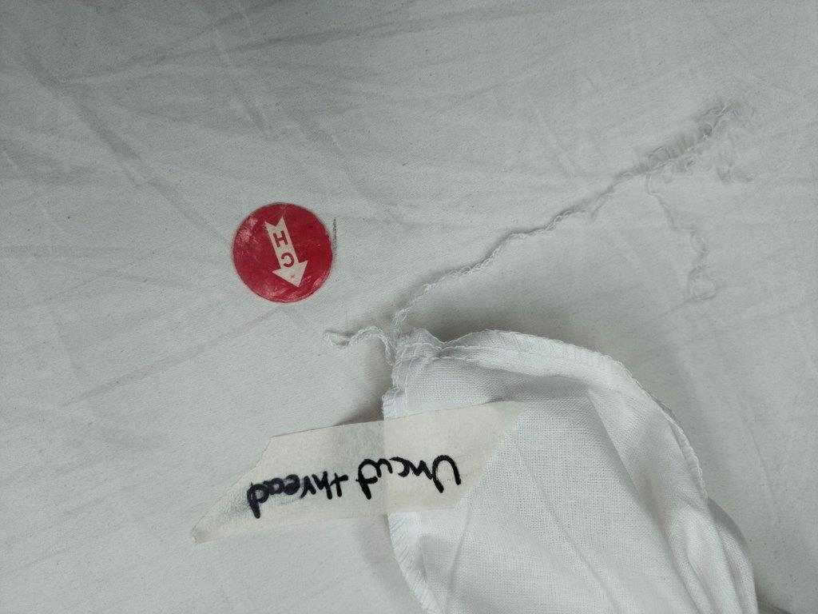 | 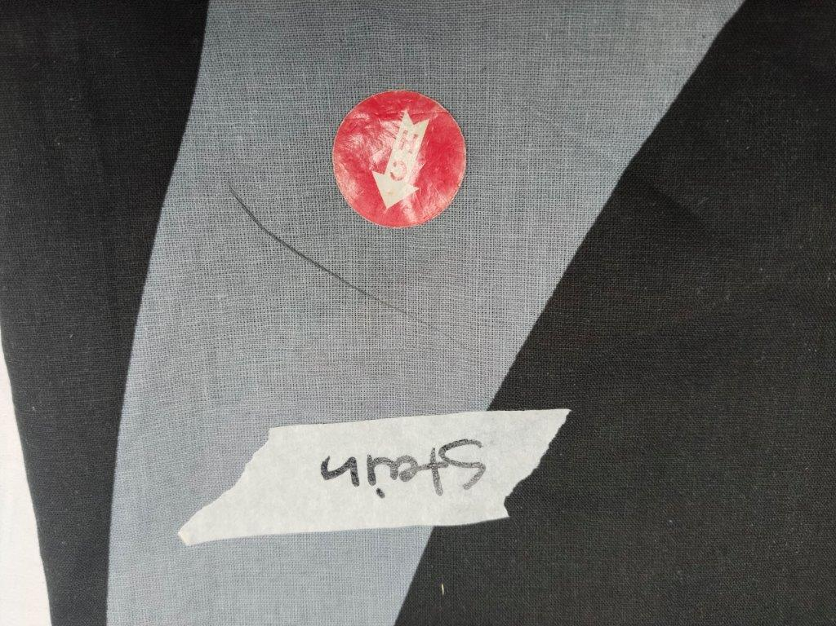
Uncut Thread | Stain
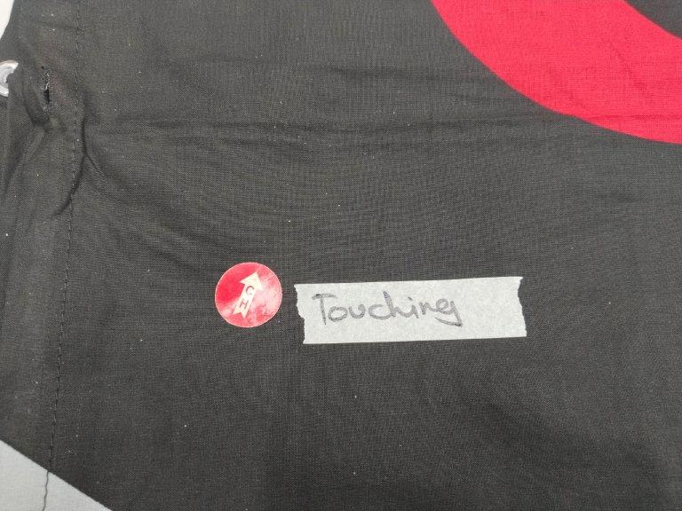 | 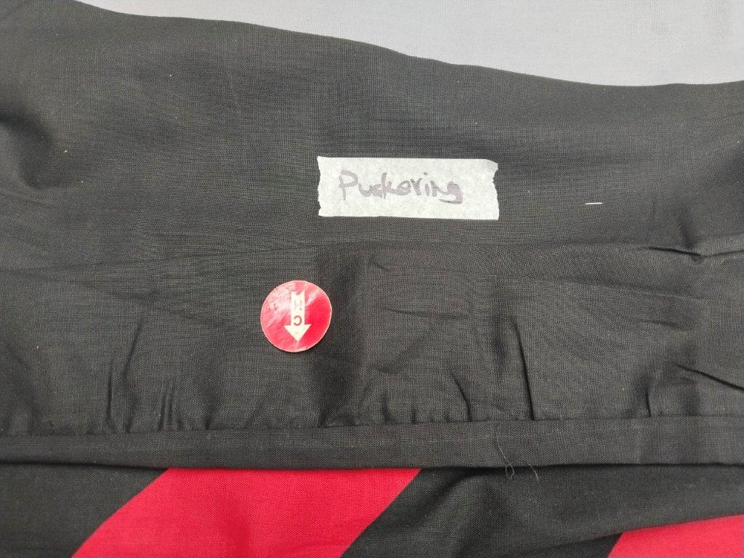
Touching | Puckering

PRODUCT-MEASURMENTS: On 15% of Sample Size (min 3 per size/color)
Buyer Measurement Chart Supplier’s Measurement Chart
Within Tolerance Beyond Tolerance Actual Findings
Item & Size | Measurement Point | Specs (cm) | 1 | 2 | 3 | 4 | 5 | 6 | 7 | 8 | 9 | 10
13320 | (Red)
Duvet Set | Width | 135 | 136 | 137.5 | 136 | 135.5 | 136 | 135.5 | 137 | 136.5 | 136 | 135.5
 | Length | 200 | 200 | 201.5 | 201 | 200 | 201 | 200 | 199 | 201 | 200 | 200
 | Width | 80 | 81 | 80.5 | 80 | 81 | 80 | 79.5 | 80 | 80 | 80.5 | 80
 | Length | 80 | 80.5 | 81 | 80.5 | 81 | 81.5 | 80.5 | 80.5 | 80.5 | 81 | 80.5
13320 | (White)
Duvet Set | Width | 135 | 136 | 135 | 136.5 | 136 | 137 | 136.5 | 135 | 136 | 135.5 | 135
 | Length | 200 | 202 | 200 | 201.5 | 200 | 202 | 201.5 | 200 | 201 | 200 | 199
 | Width | 80 | 81 | 80 | 80 | 81.5 | 81 | 80.5 | 81.5 | 82 | 80.5 | 80
 | Length | 80 | 80.5 | 80 | 81.5 | 80 | 79 | 79.5 | 79 | 80 | 81 | 80.5
13320 | (Black)
Duvet Set | Width | 135 | 136.5 | 135.5 | 137 | 136 | 136.5 | 135 | 137.5 | 136 | 137 | 136
 | Length | 200 | 201 | 200 | 200 | 201.5 | 202 | 200 | 200.5 | 199.5 | 202 | 201
 | Width | 80 | 79 | 81 | 80.5 | 80 | 81 | 80.5 | 80 | 81 | 79 | 79
 | Length | 80 | 80 | 81.5 | 79.5 | 80 | 80.5 | 81 | 80.5 | 80 | 80.5 | 80

 | Measurement Photos
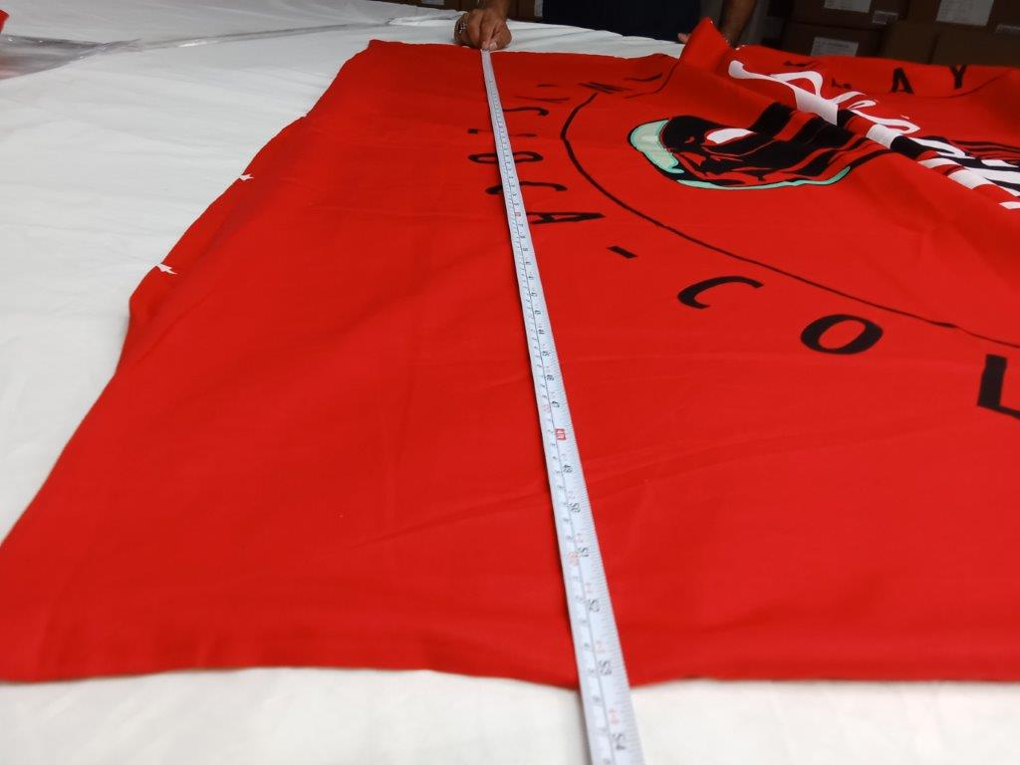 |  | 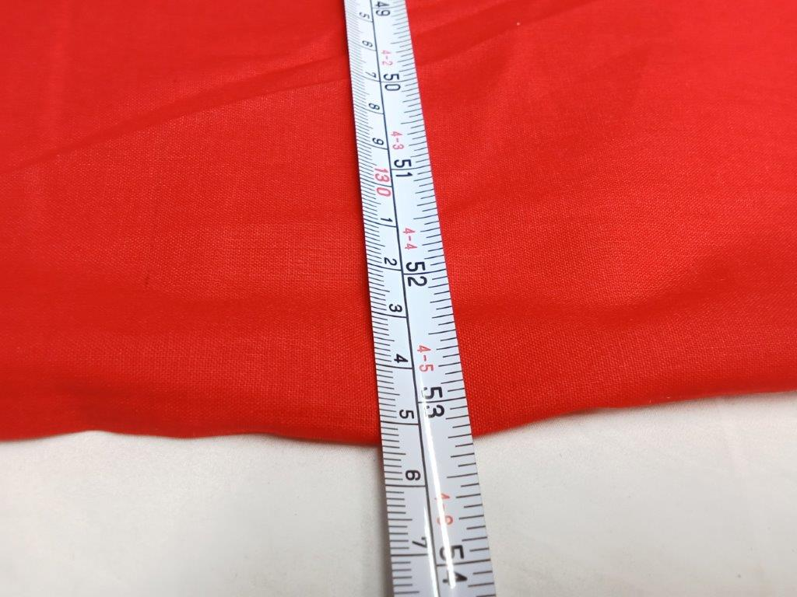
Measurement View |  | Measurement View
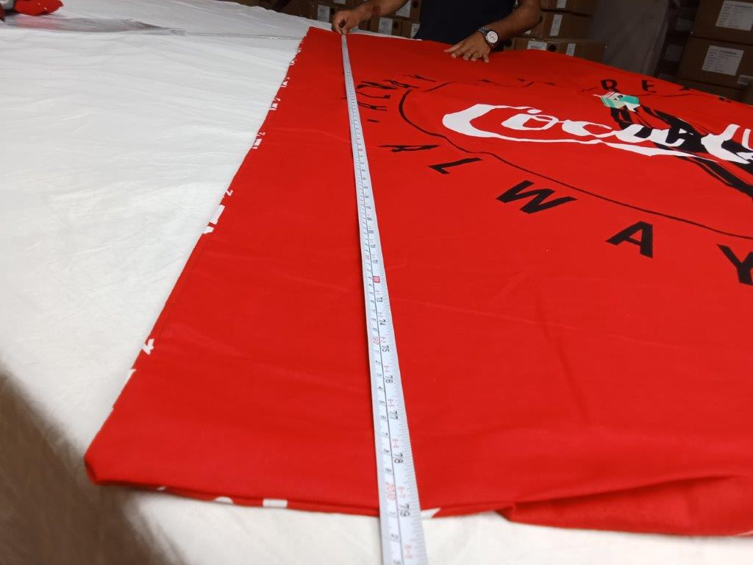 |  | 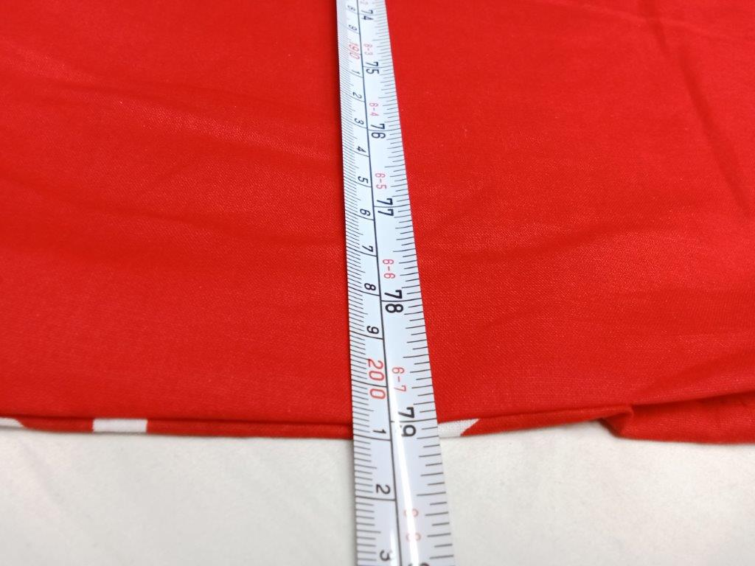
Measurement View |  | Measurement View
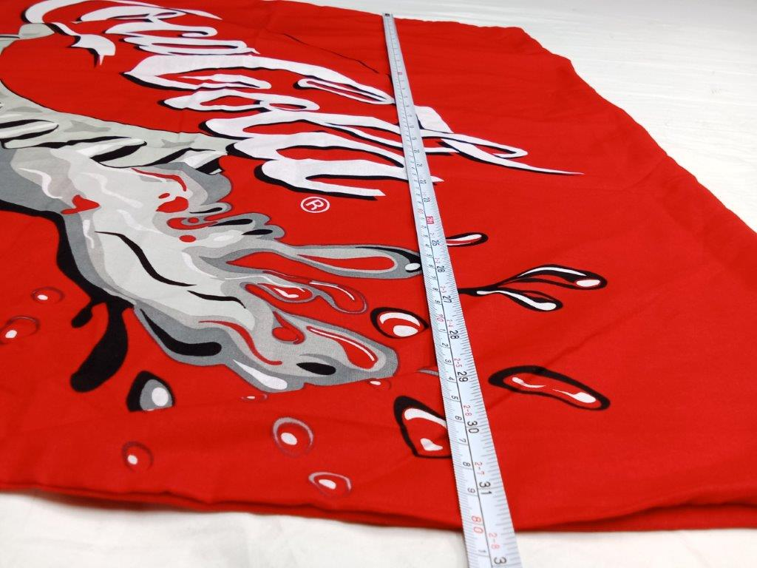 |  | 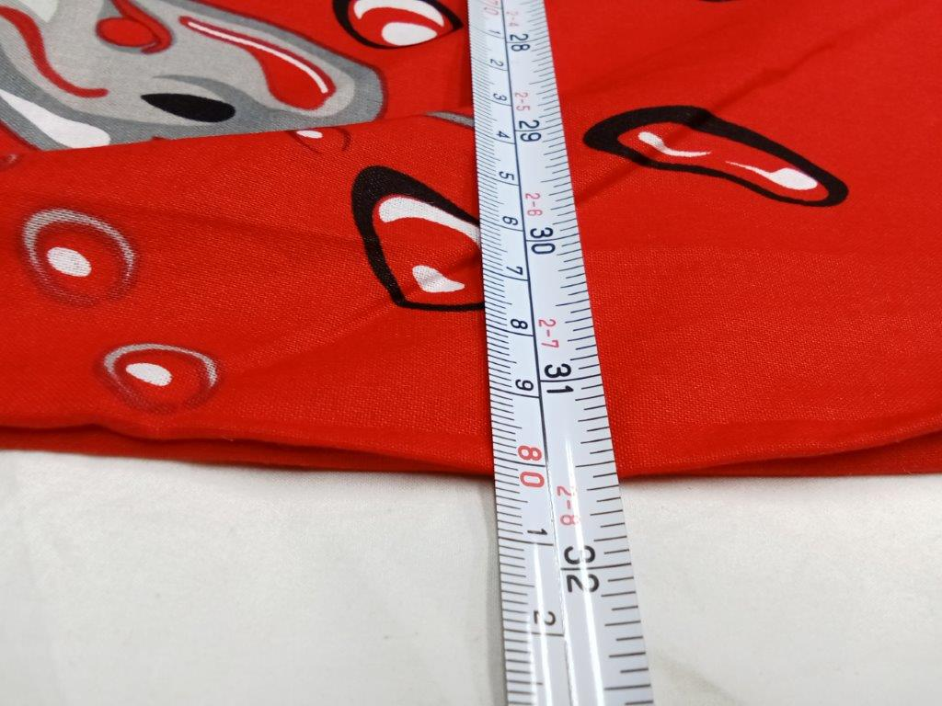
Measurement View |  | Measurement View
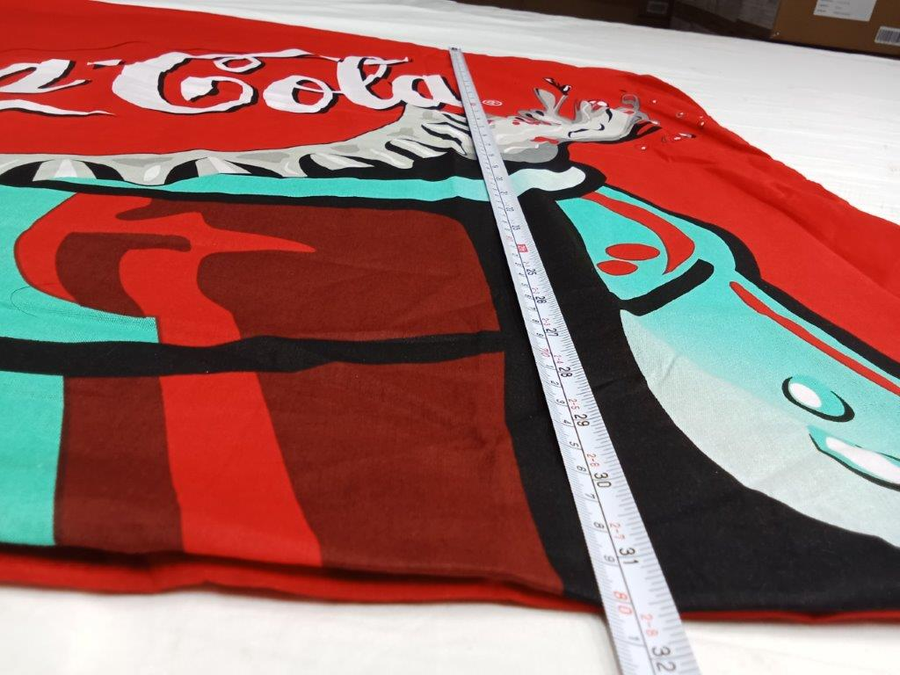 |  | 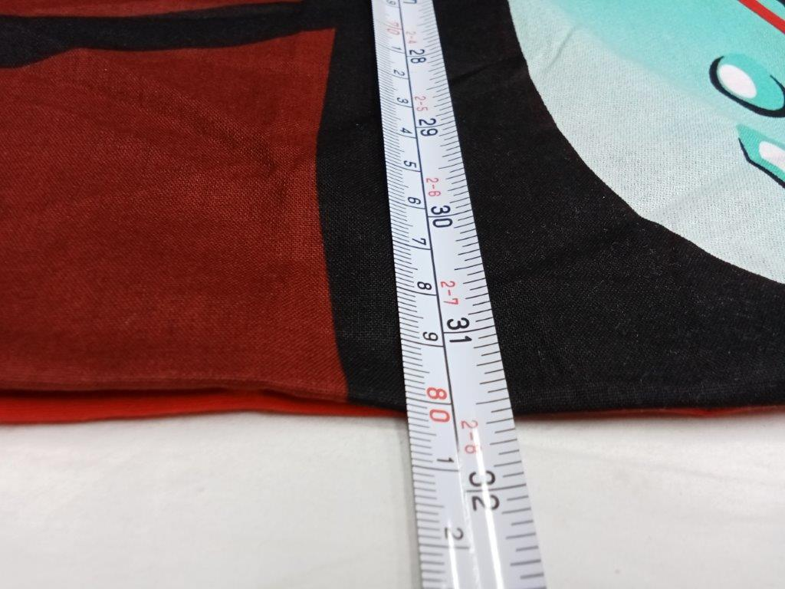
Measurement View |  | Measurement View
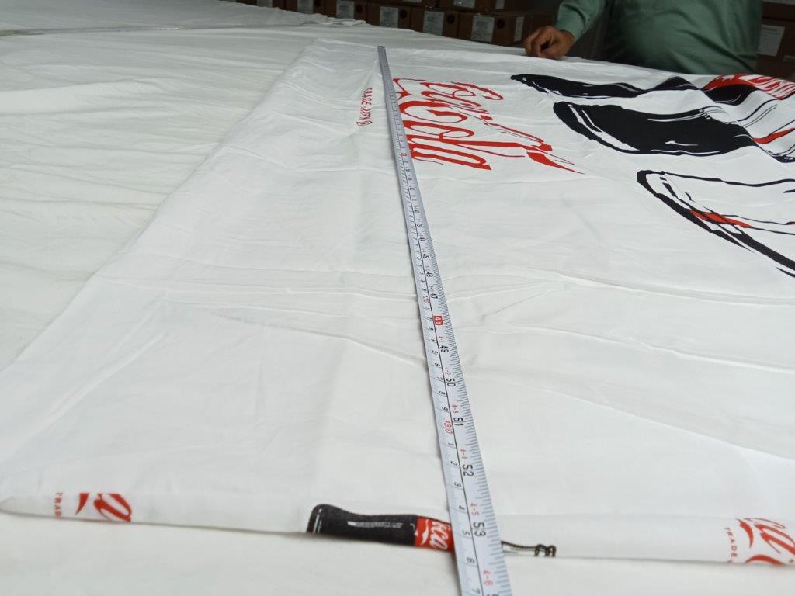 |  | 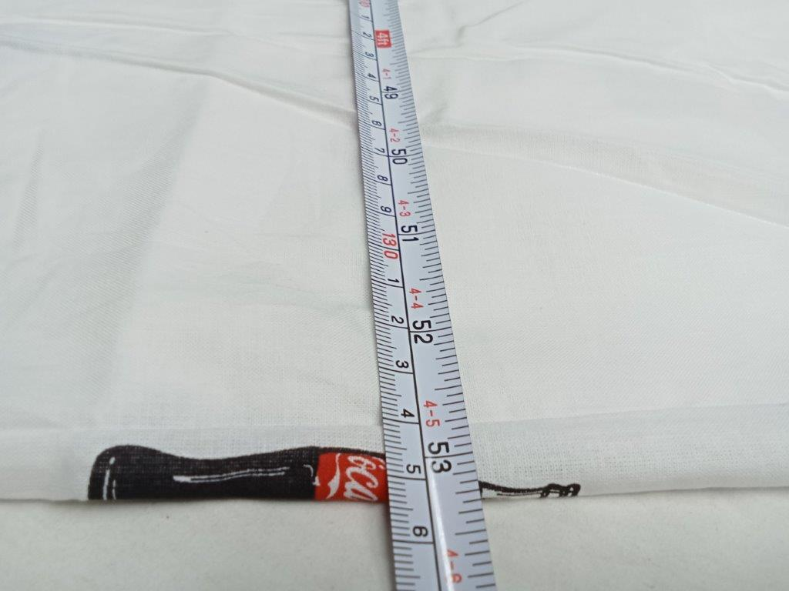
Measurement View |  | Measurement View
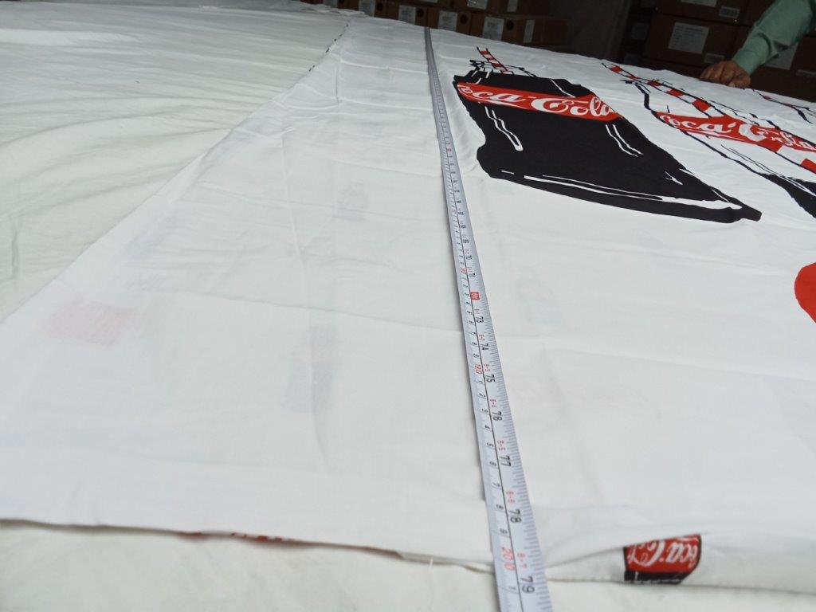 |  | 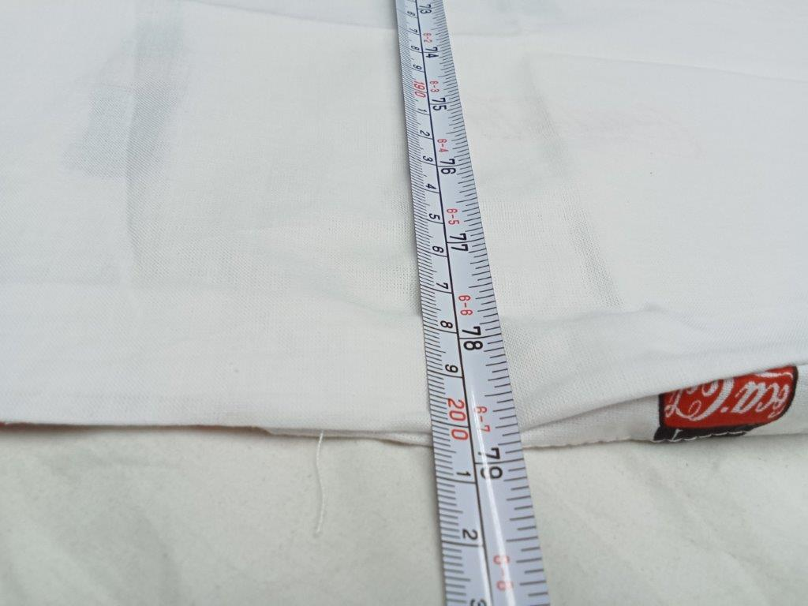
Measurement View |  | Measurement View
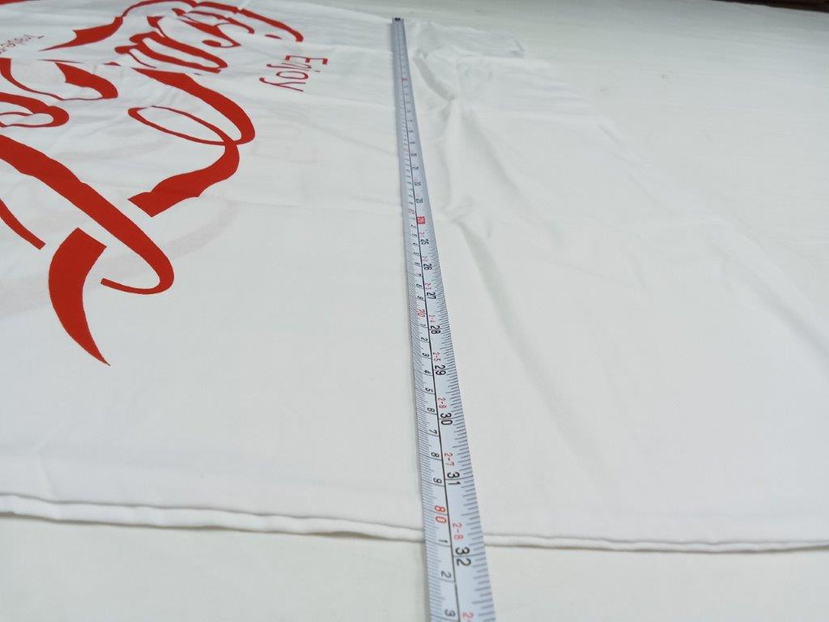 |  | 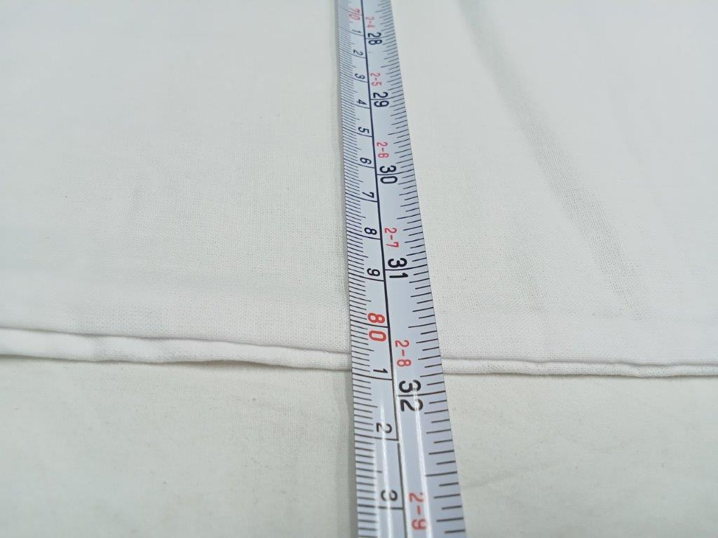
Measurement View |  | Measurement View
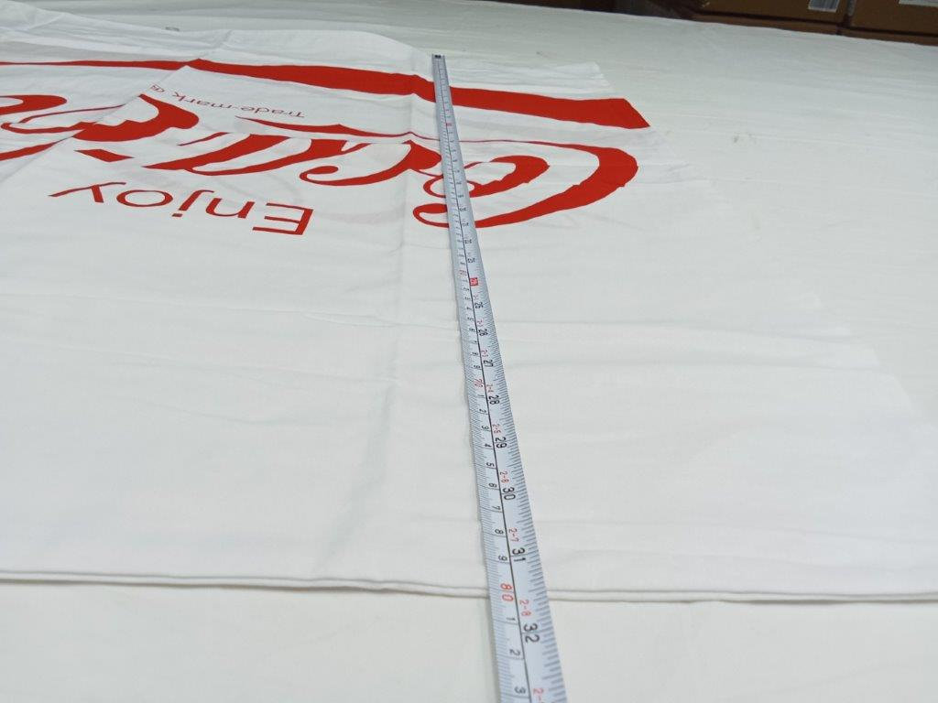 |  | 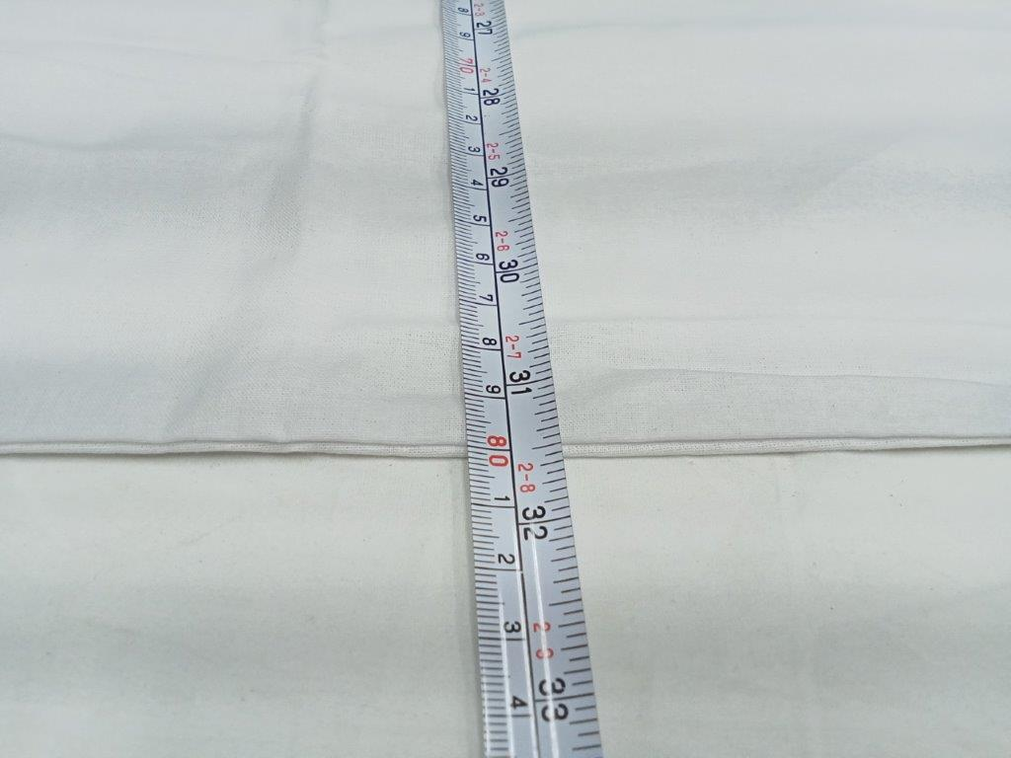
Measurement View |  | Measurement View
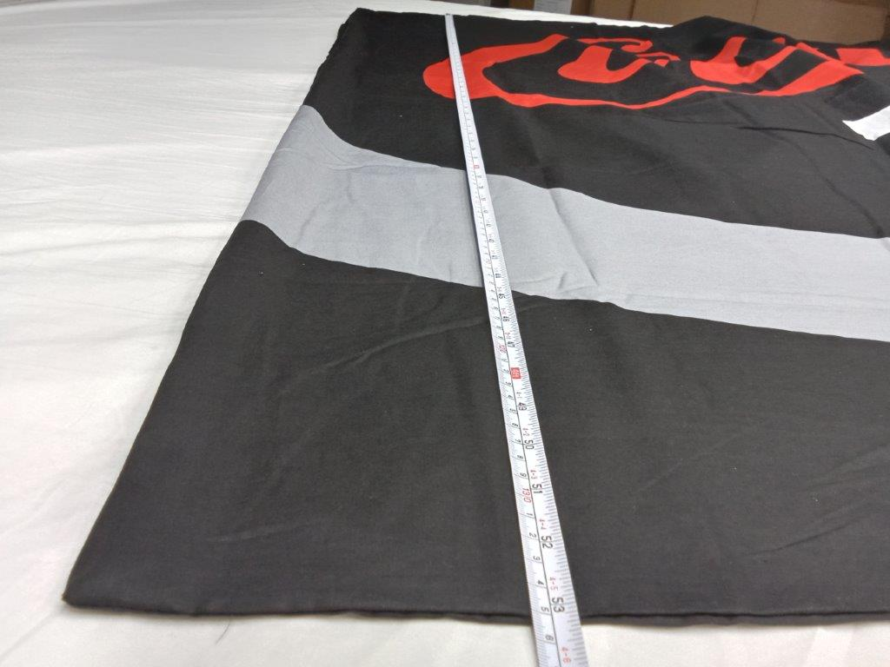 |  | 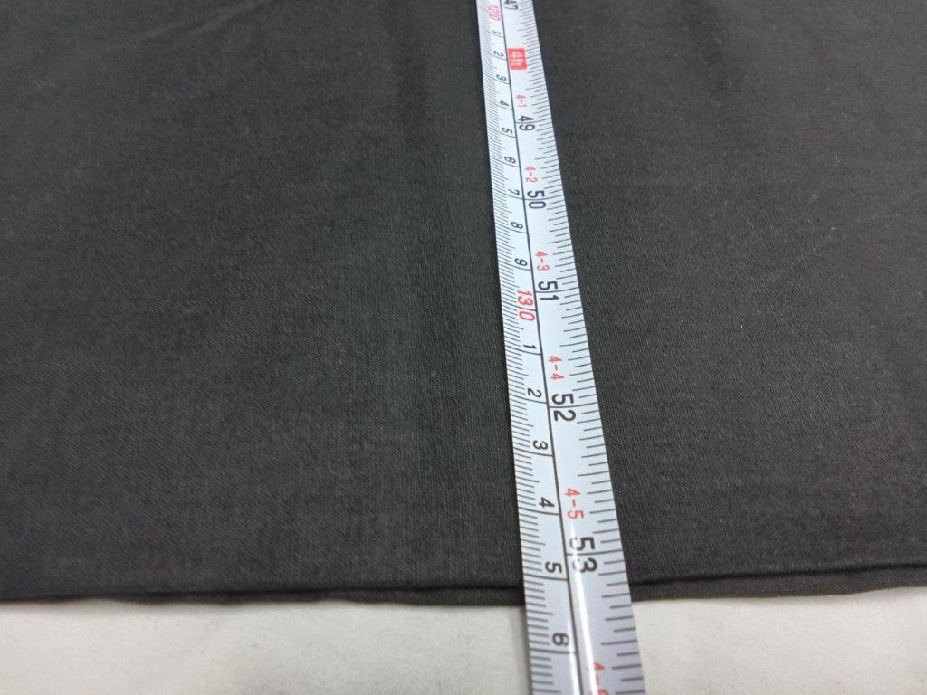
Measurement View |  | Measurement View
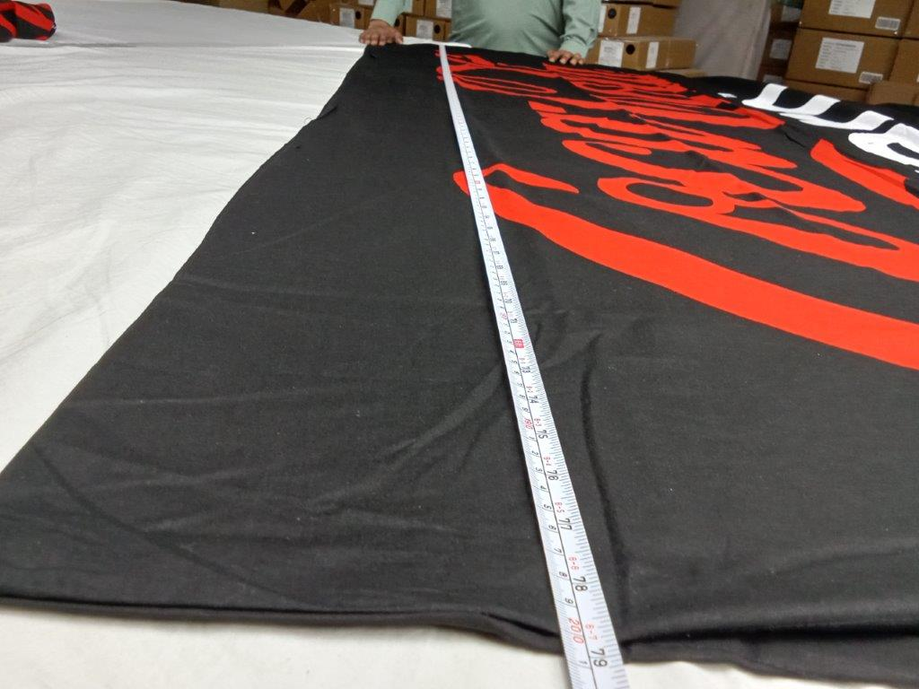 |  | 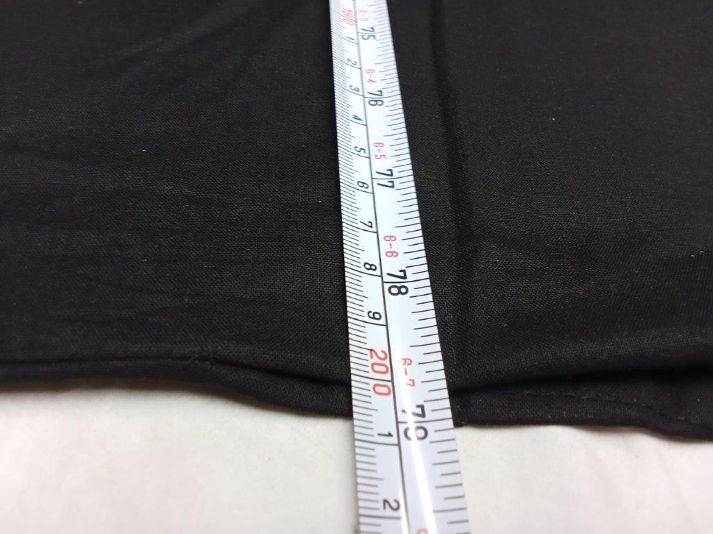
Measurement View |  | Measurement View
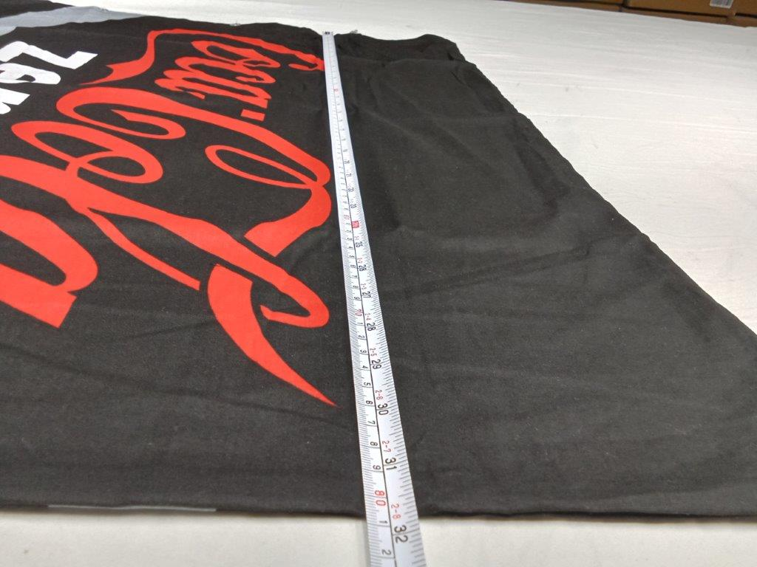 |  | 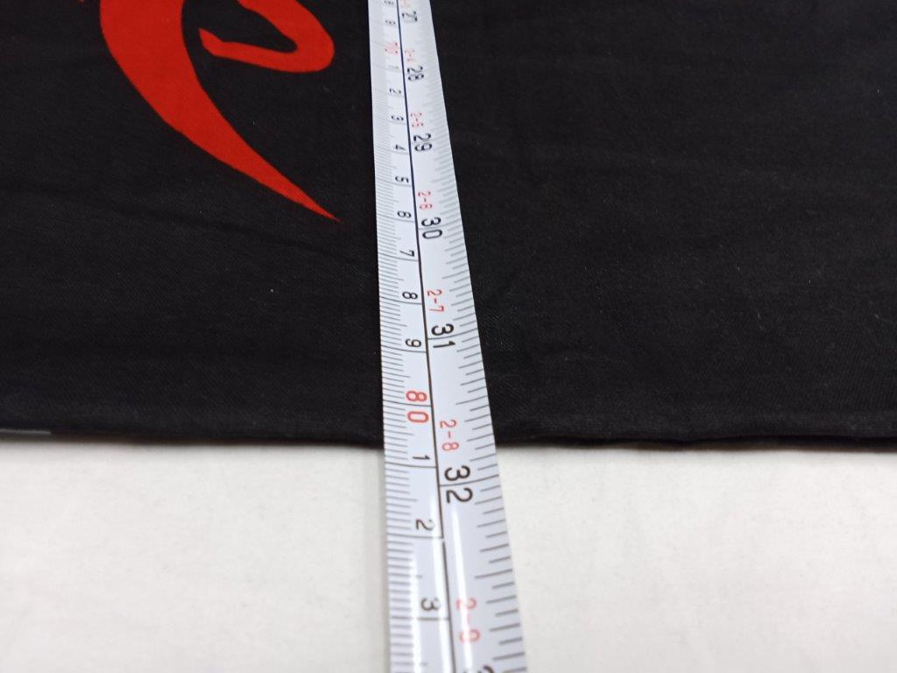
Measurement View |  | Measurement View
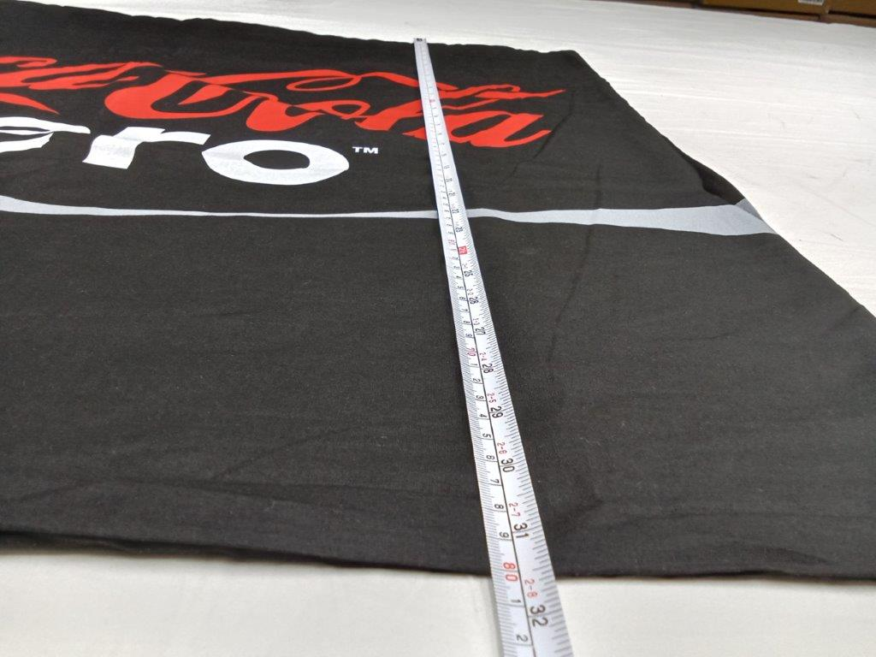 |  | 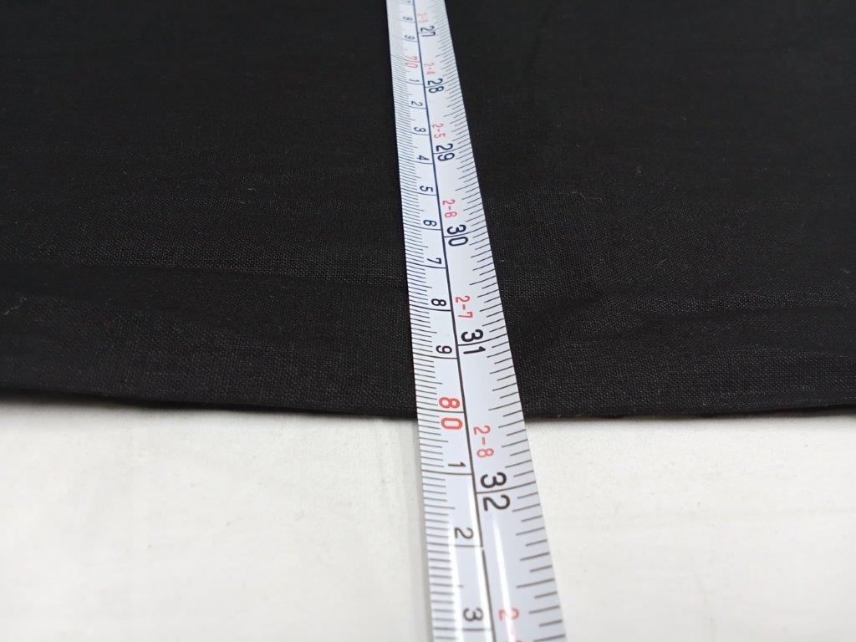
Measurement View |  | Measurement View

ONSITE TESTS:
TYPE OF TEST | PASS |  | FAIL | N/A | TEST EQUIPMENT NOT AVAILABLE | REMARK
Needle Detection [On 30% of Sample Size] |  |  |  |  |  | 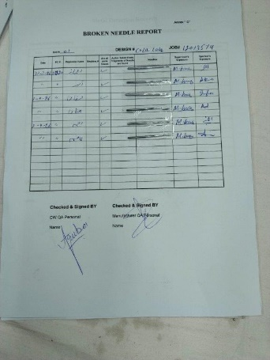
Metal Detector [1 Sample per SKU, Imitate AATCC -79, Limit: 1 Drop- from 1cm height, <10 Seconds] |  |  |  |  |  | 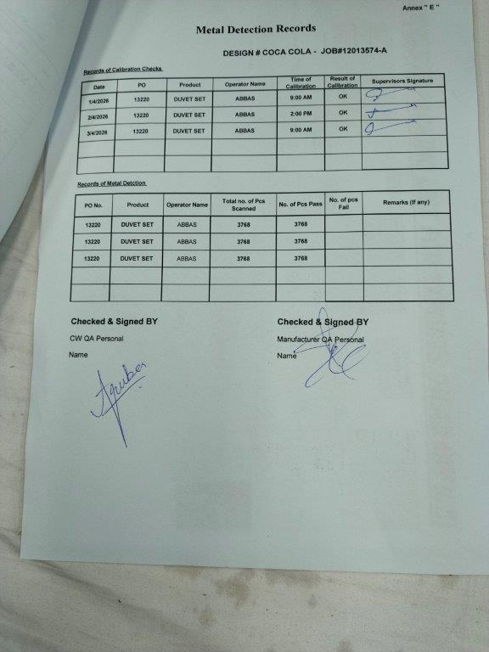
Carton Drop Test [2 Cartons per SKU, Manual drop, Simulate ISTA] |  |  |  |  |  | 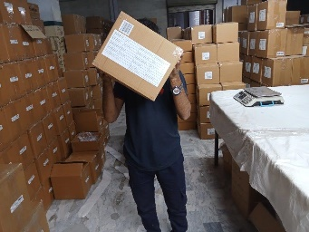 | 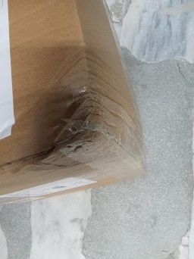
GSM [1 Sample per SKU, Imitate ASTM D3776, Refer Spec Sheet for STD, Limit -3%, +10%] |  |  |  |  |  | 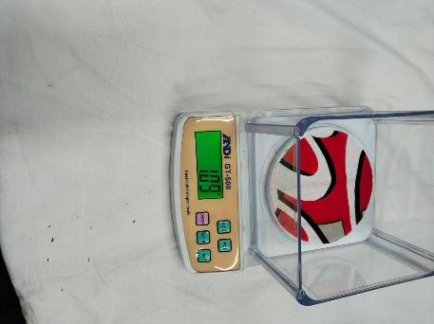 | 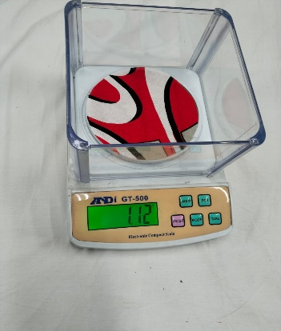
 |  |  |  |  |  | 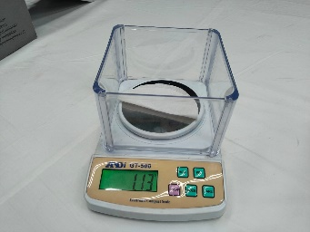 | 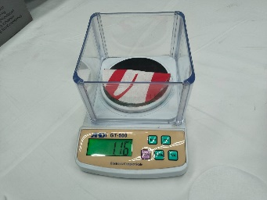
 |  |  |  |  |  | 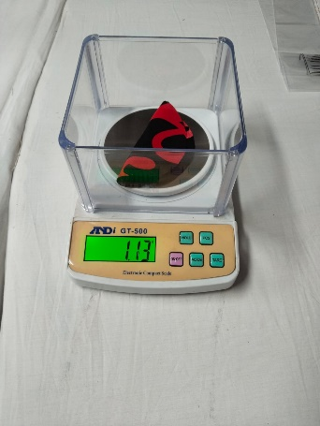 | 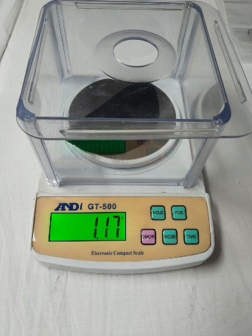
Barcode Scan [Physically] |  |  |  |  |  | 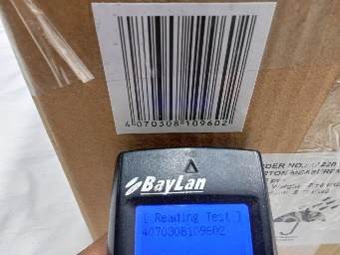 | 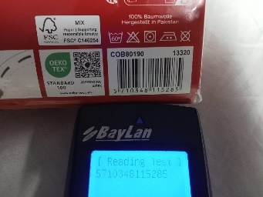
 |  |  |  |  |  | 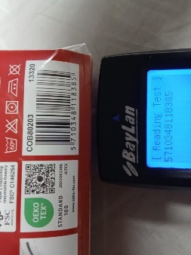 | 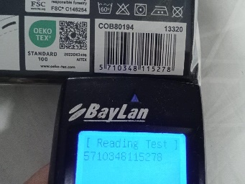

PRESENTATIONS / PHOTOS
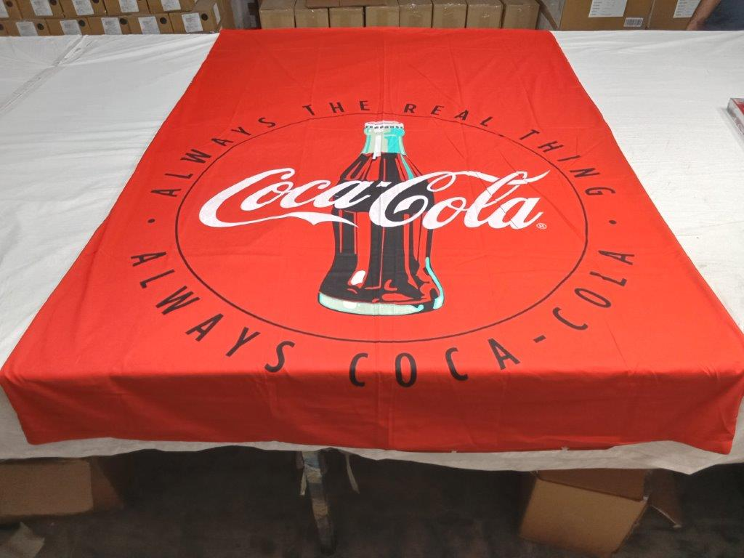 | 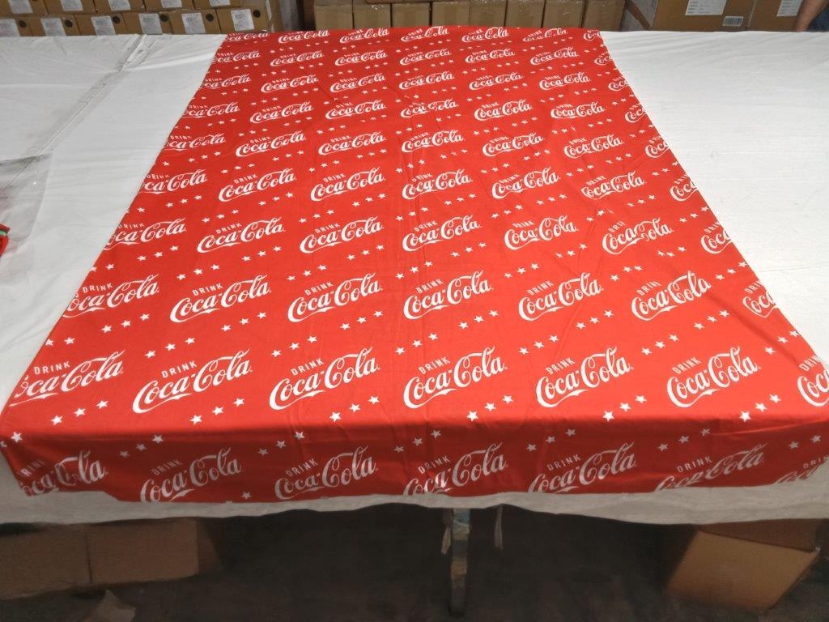
Open Product Front Side View | Open Product Back Side View
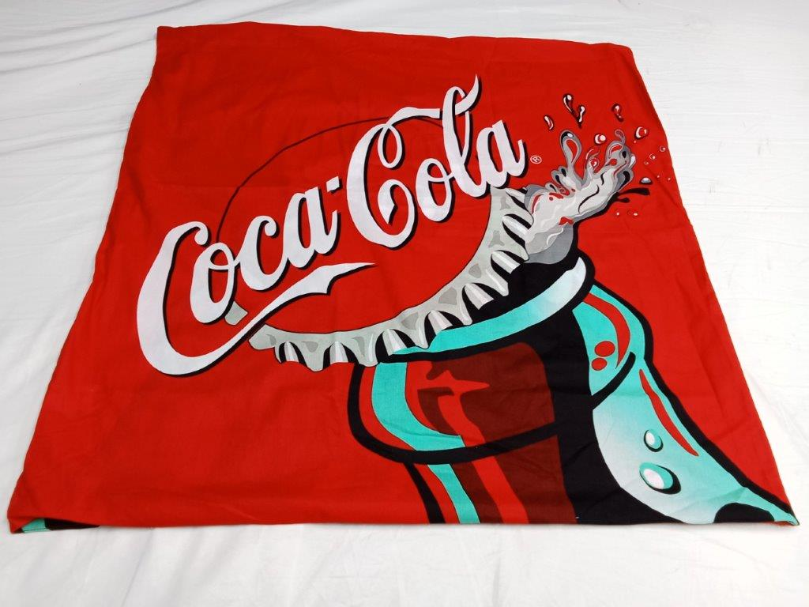 | 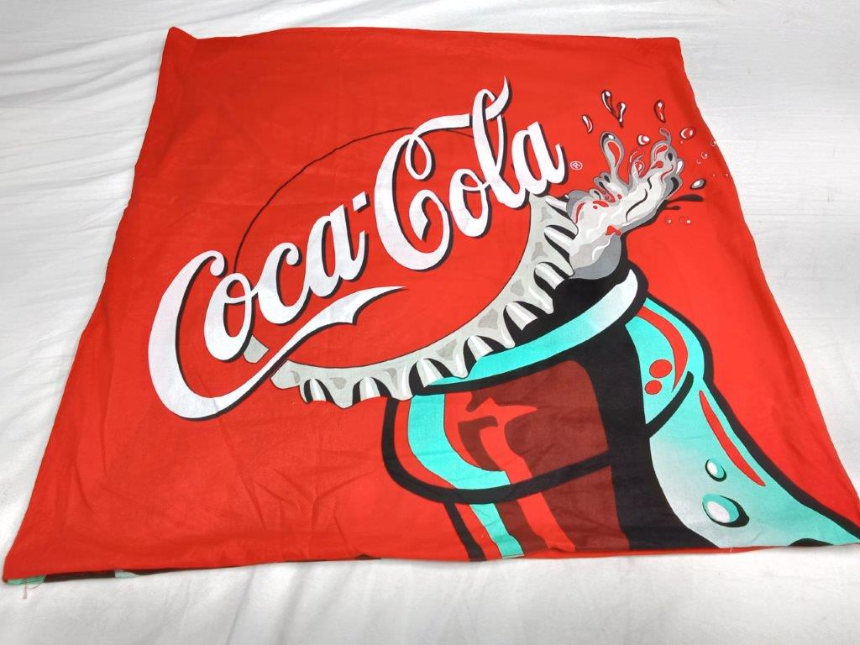
Open Product Front Side View | Open Product Back Side View
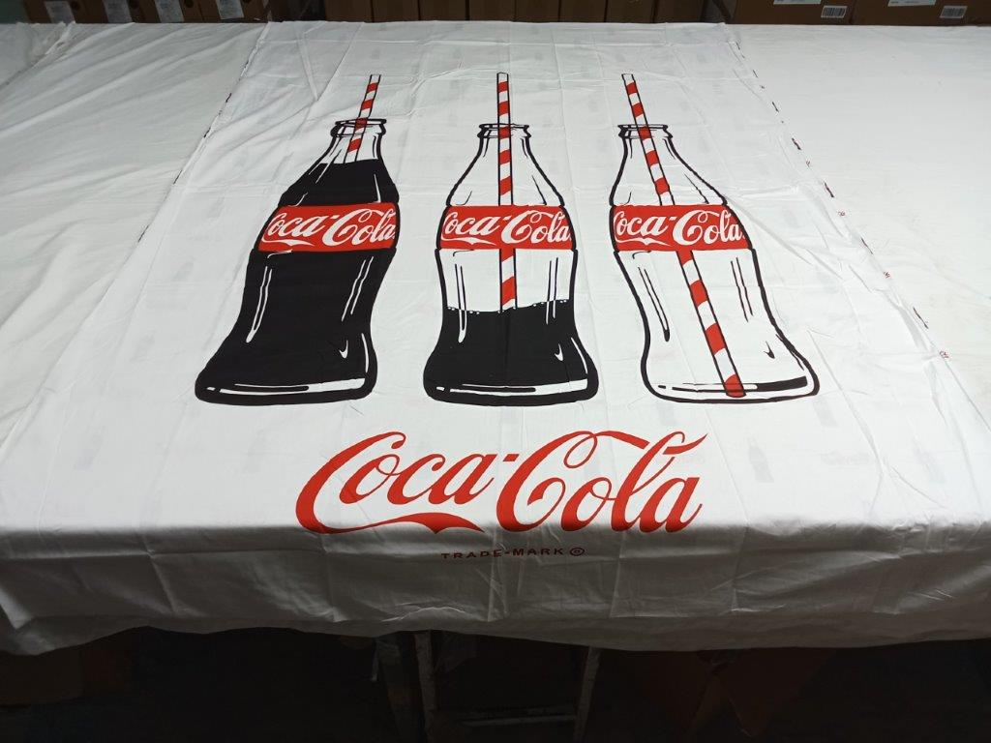 | 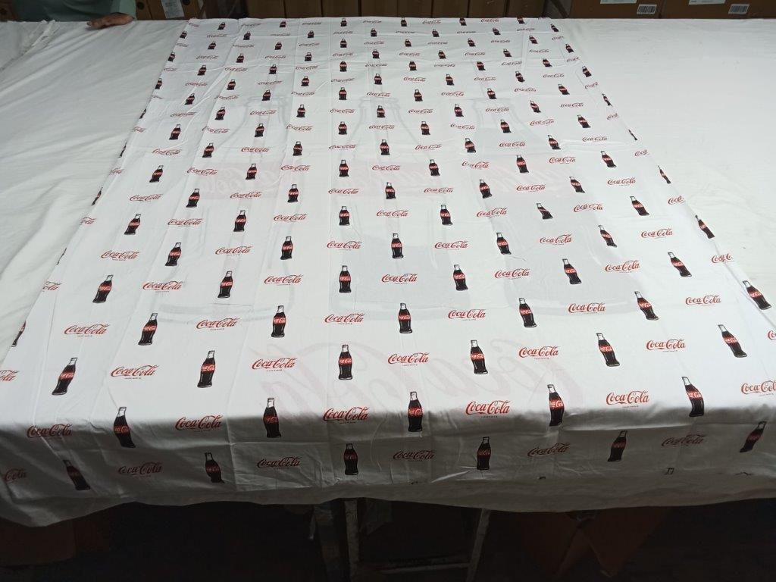
Open Product Front Side View | Open Product Back Side View
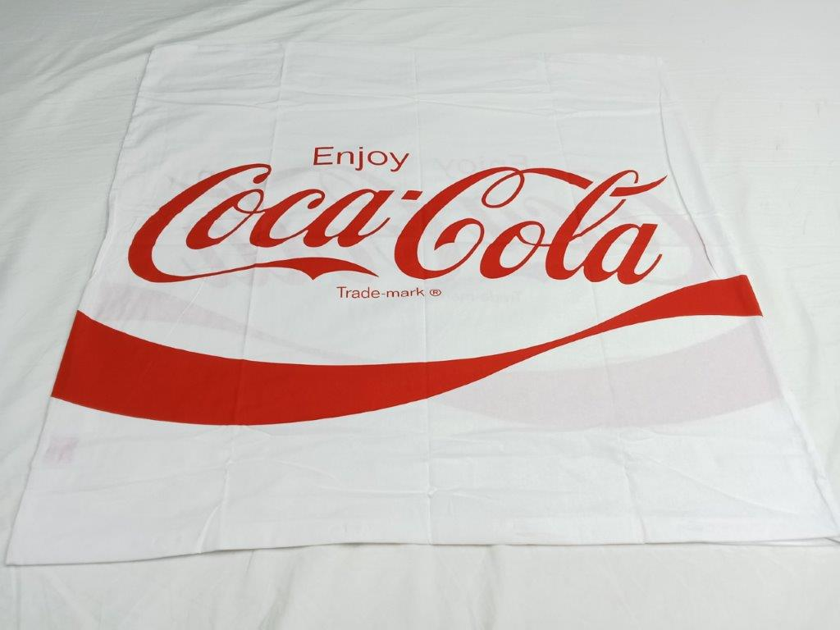 | 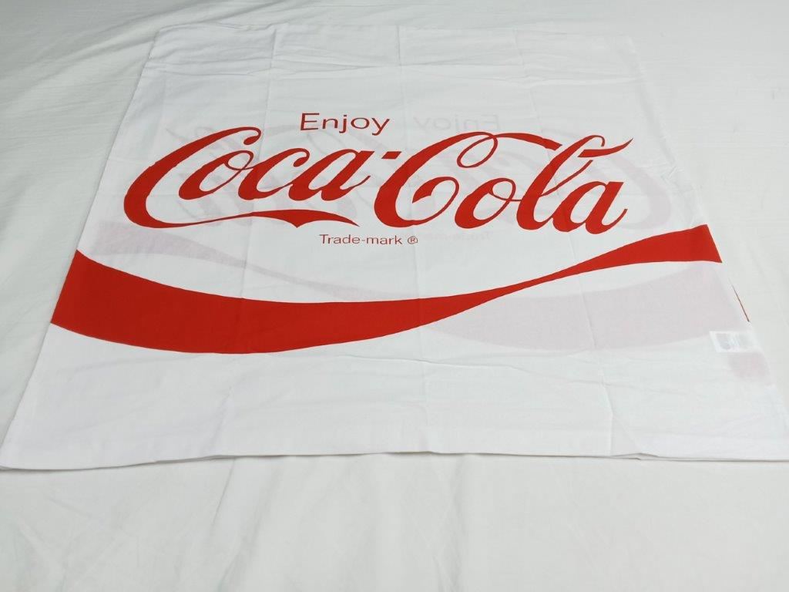
Open Product Front Side View | Open Product Back Side View
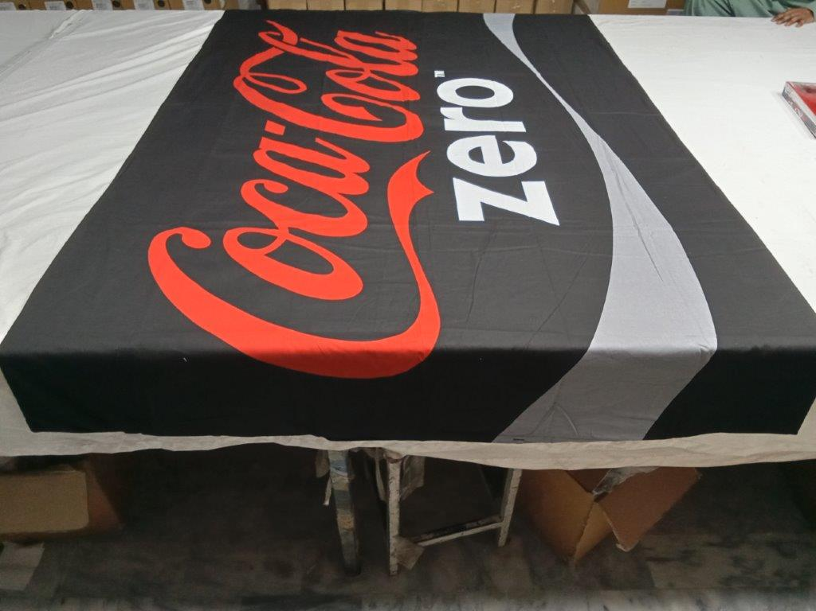 | 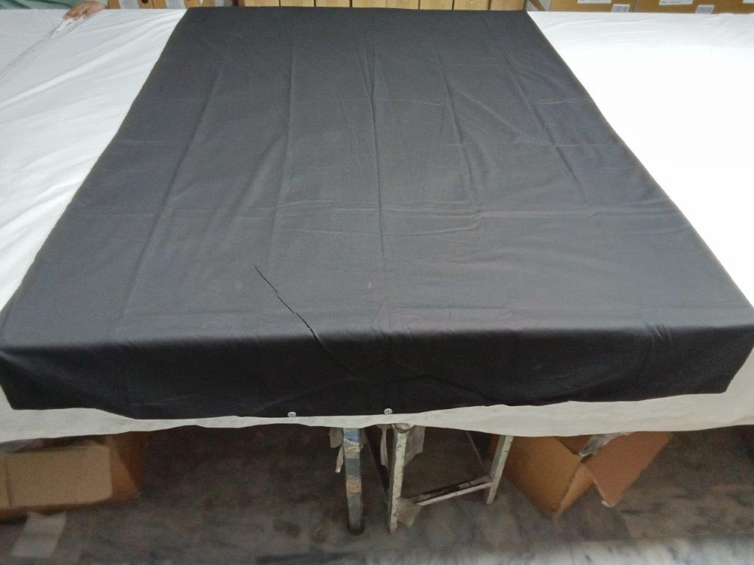
Open Product Front Side View | Open Product Back Side View
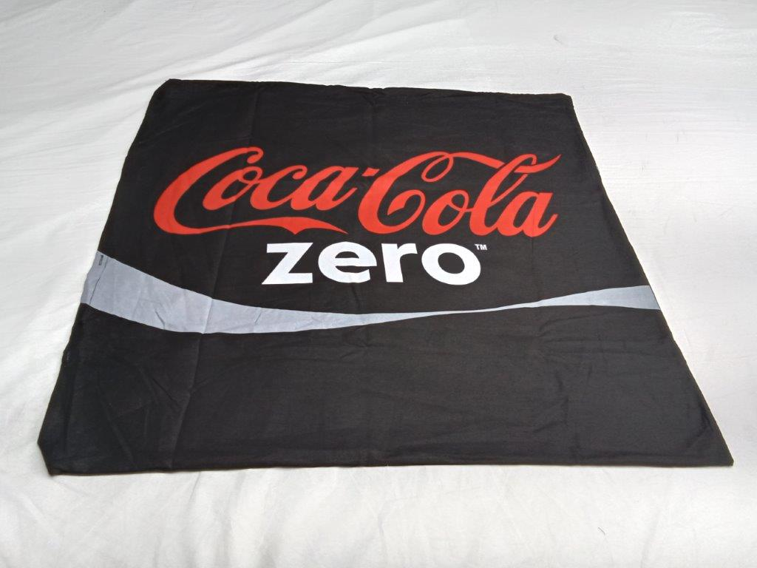 | 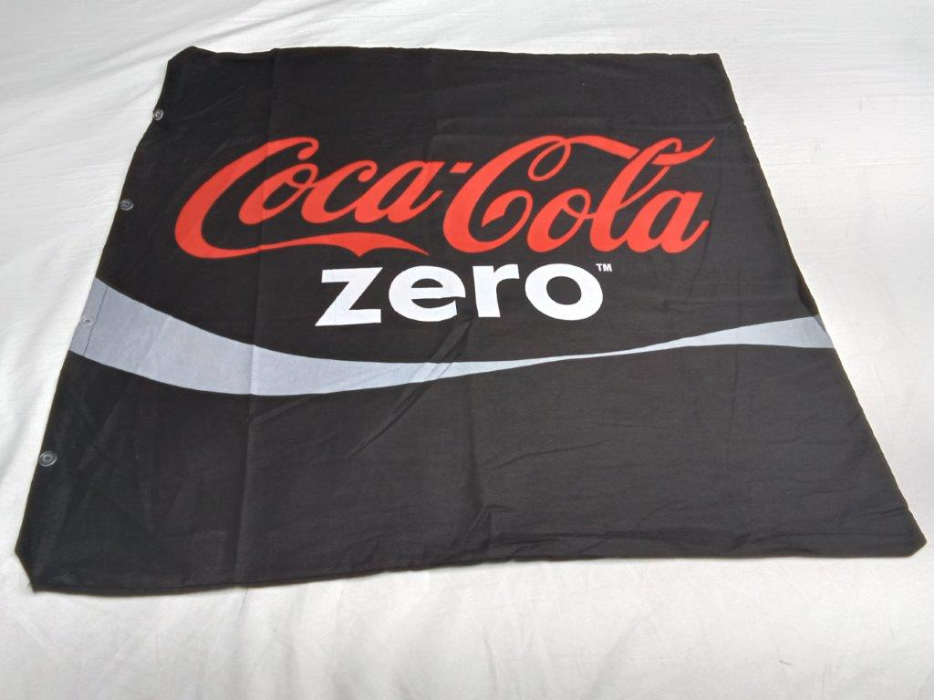
Open Product Front Side View | Open Product Back Side View
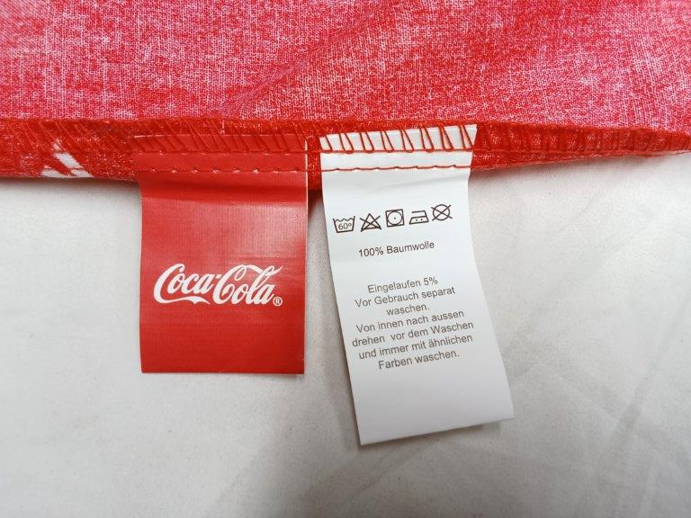 | 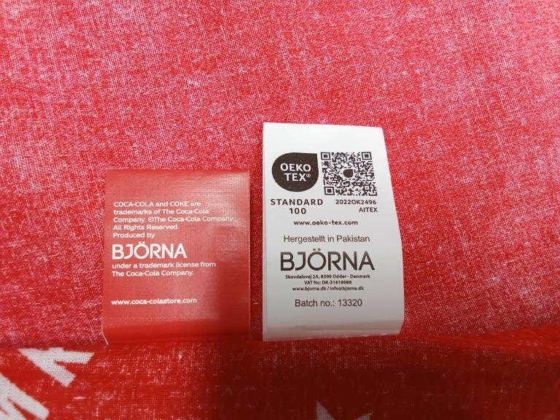
Care Label Front Side View | Care Label Back Side View
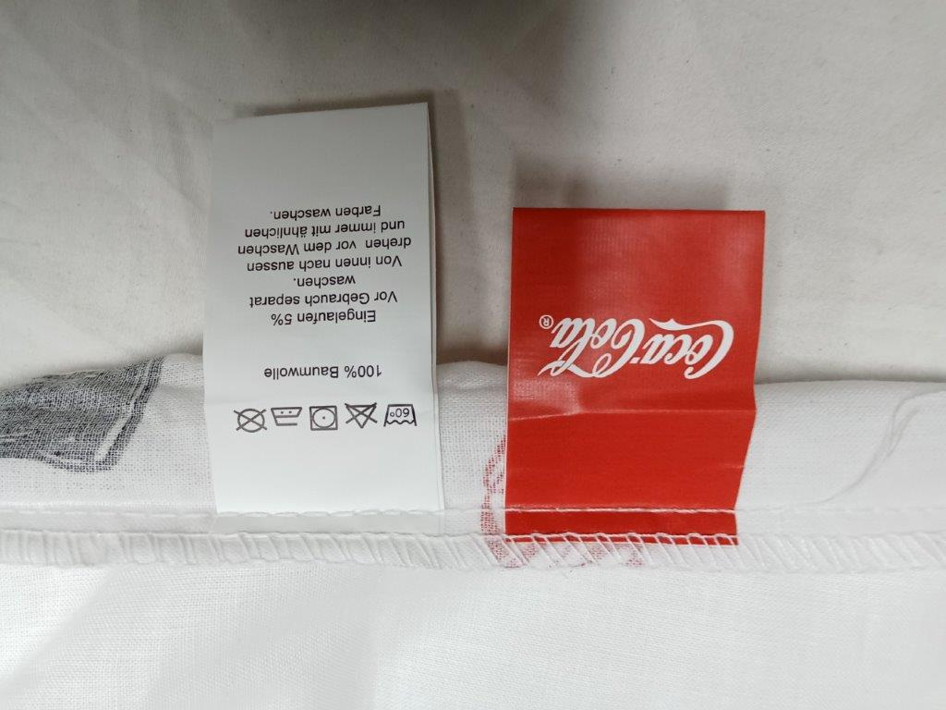 | 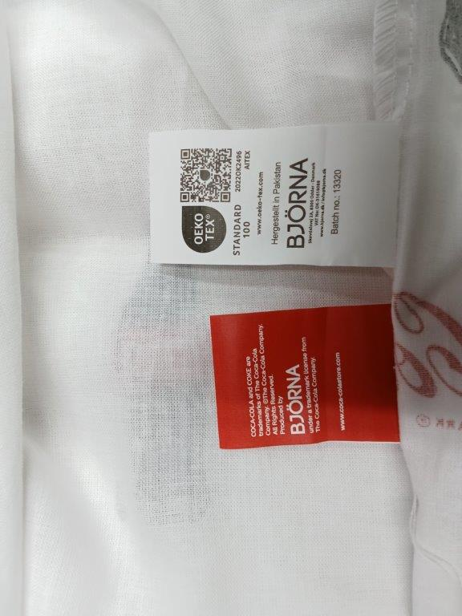
Care Label Front Side View | Care Label Back Side View
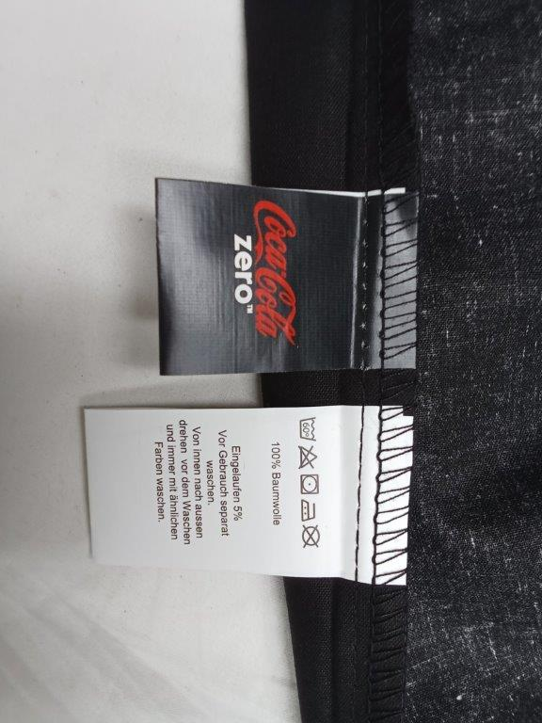 | 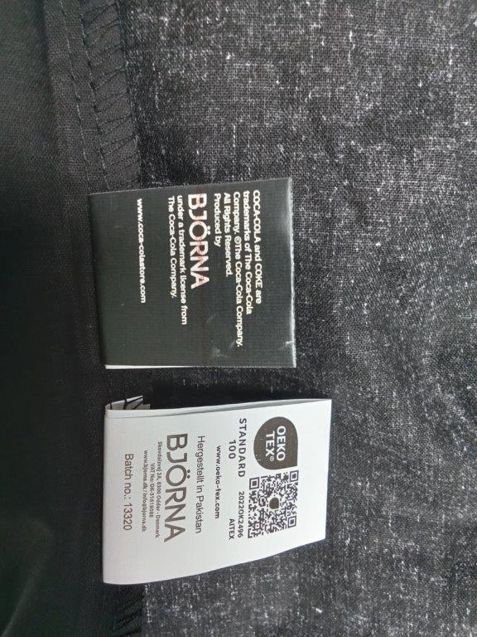
Care Label Front Side View | Care Label Back Side View

Shrinkage Test (Before Wash & After Wash Result)
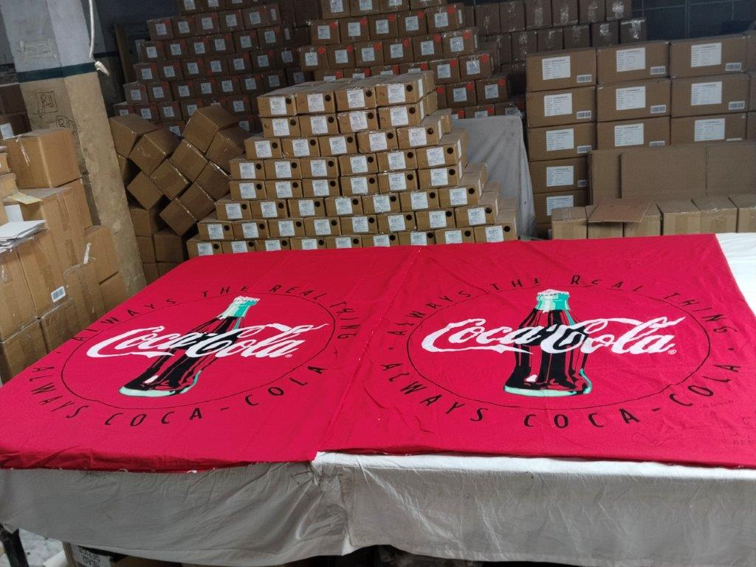 | 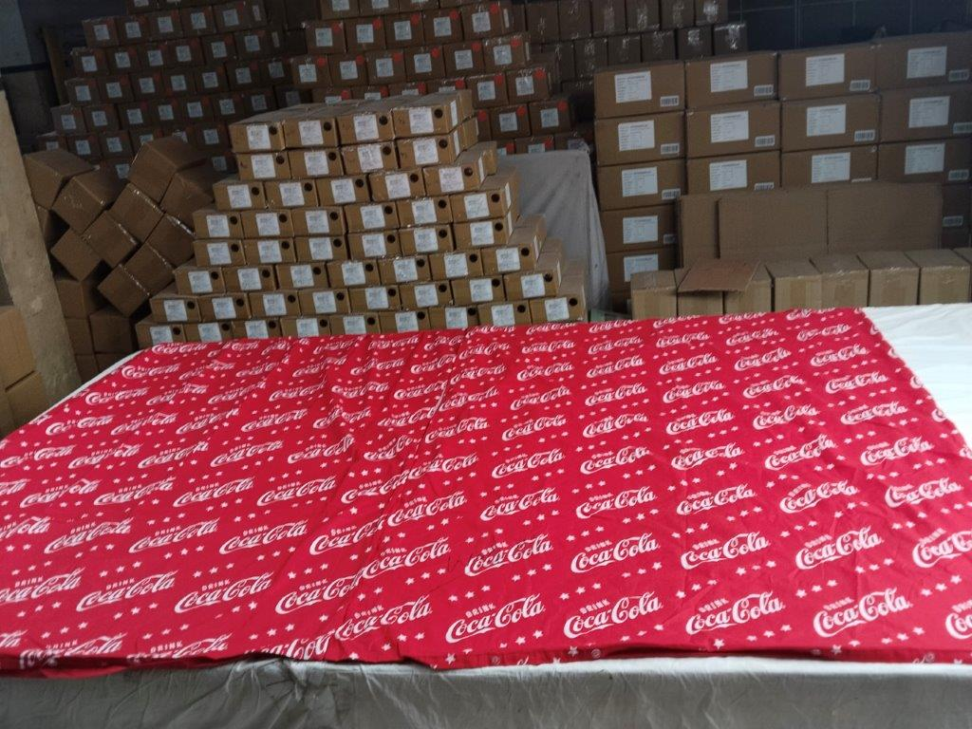
Before & After wash effect | Before & After wash effect
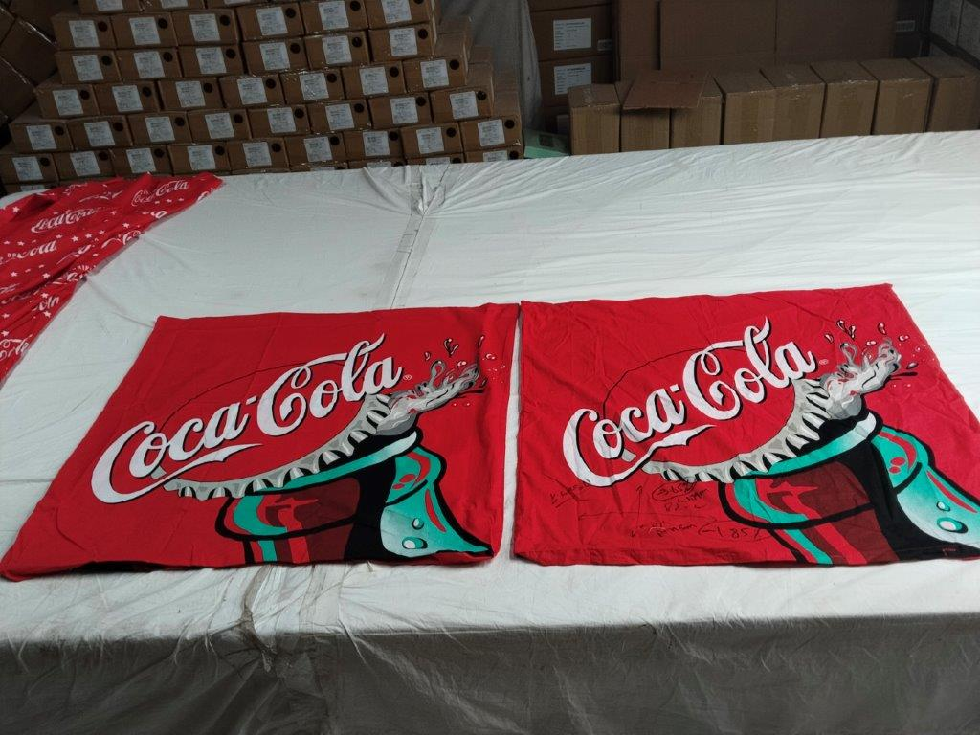
Before & After wash effect
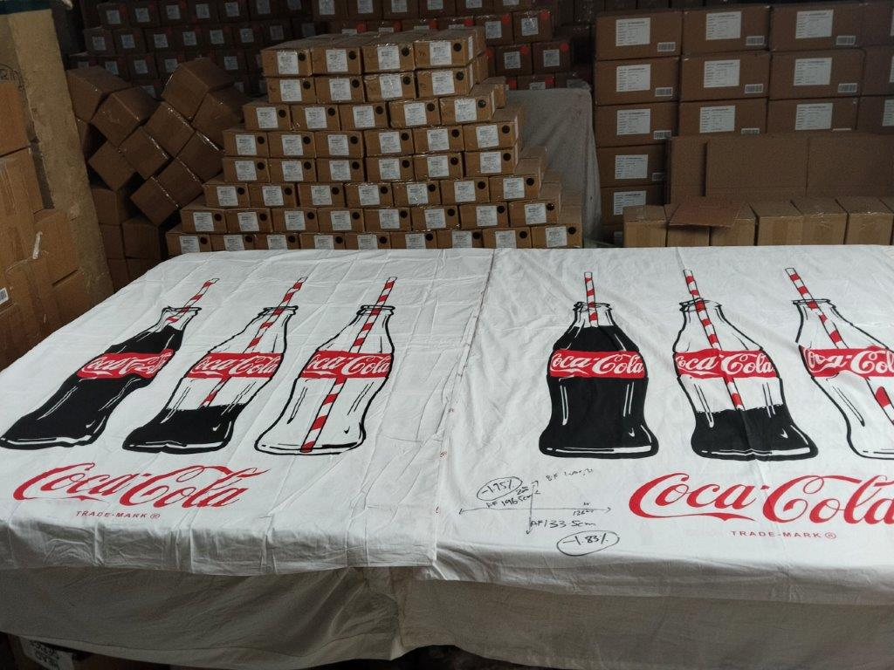 | 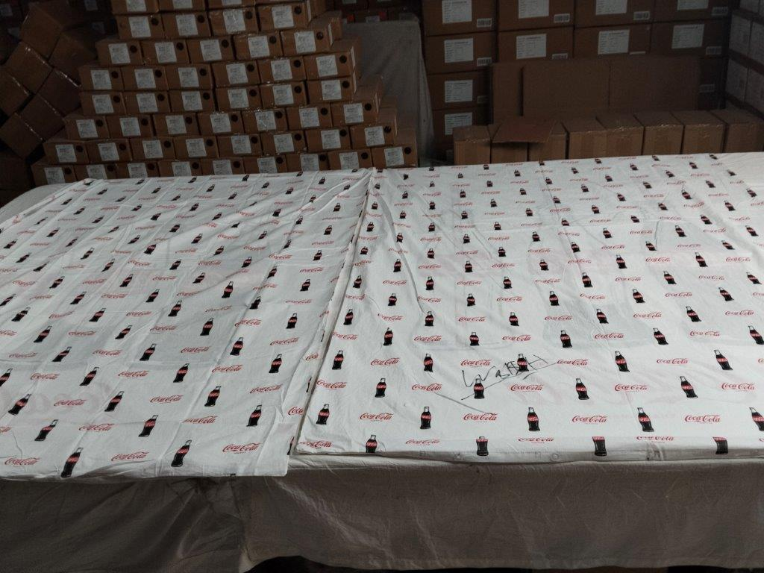
Before & After wash effect | Before & After wash effect
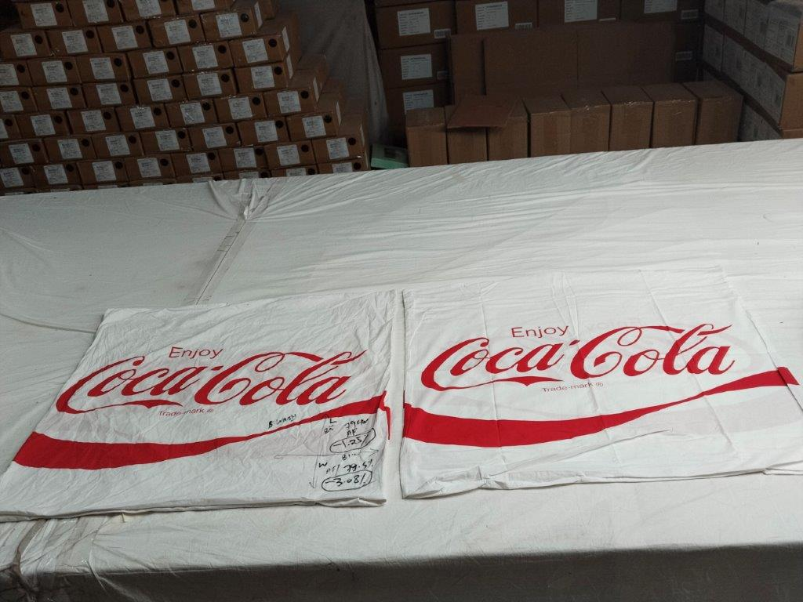
Before & After wash effect
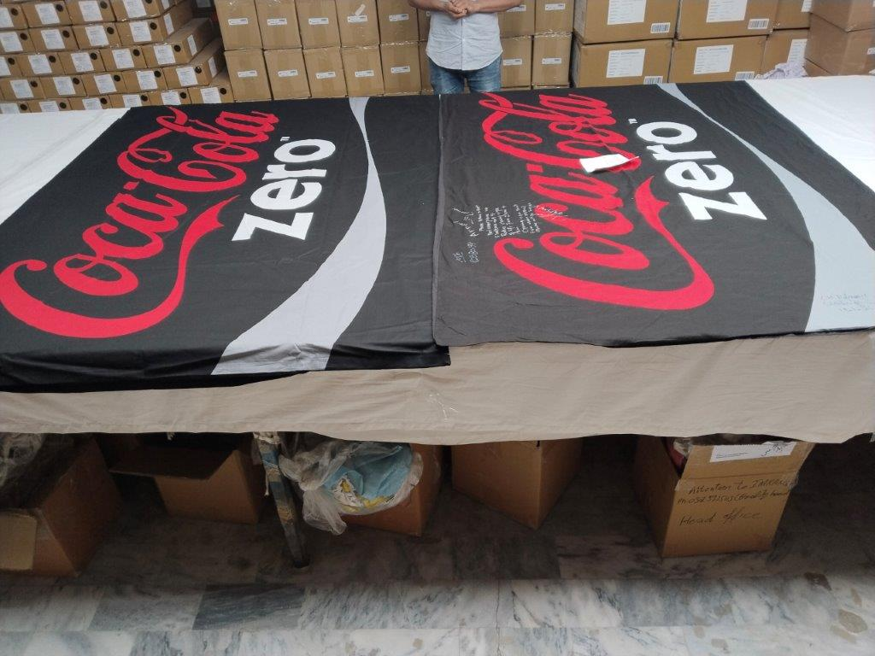 | 
Before & After wash effect | Before & After wash effect
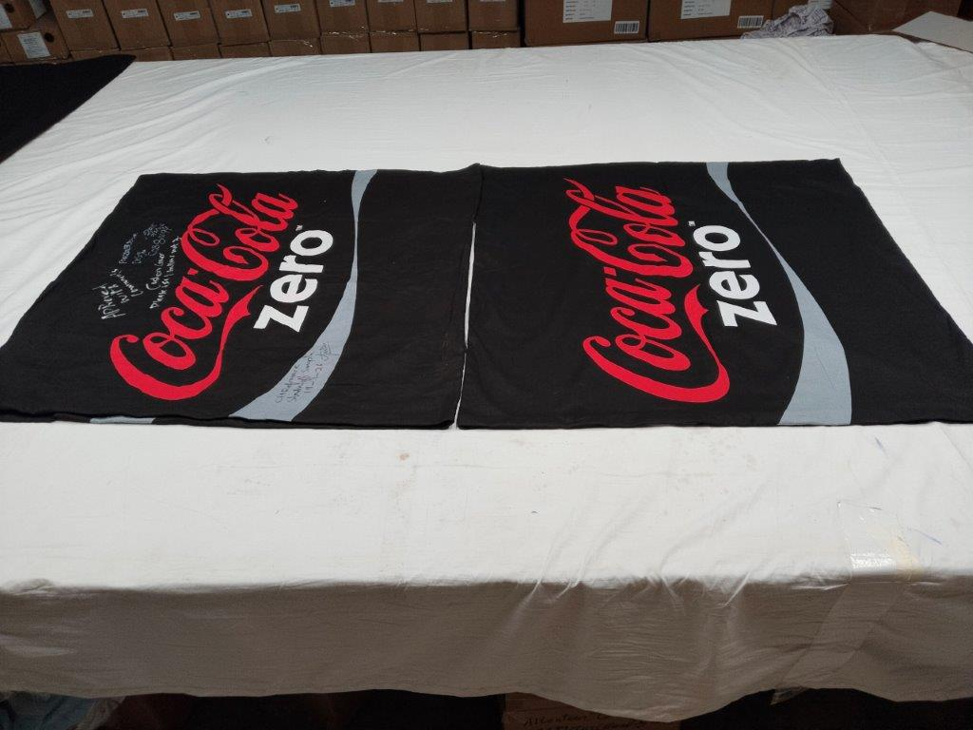
Before & After wash effect
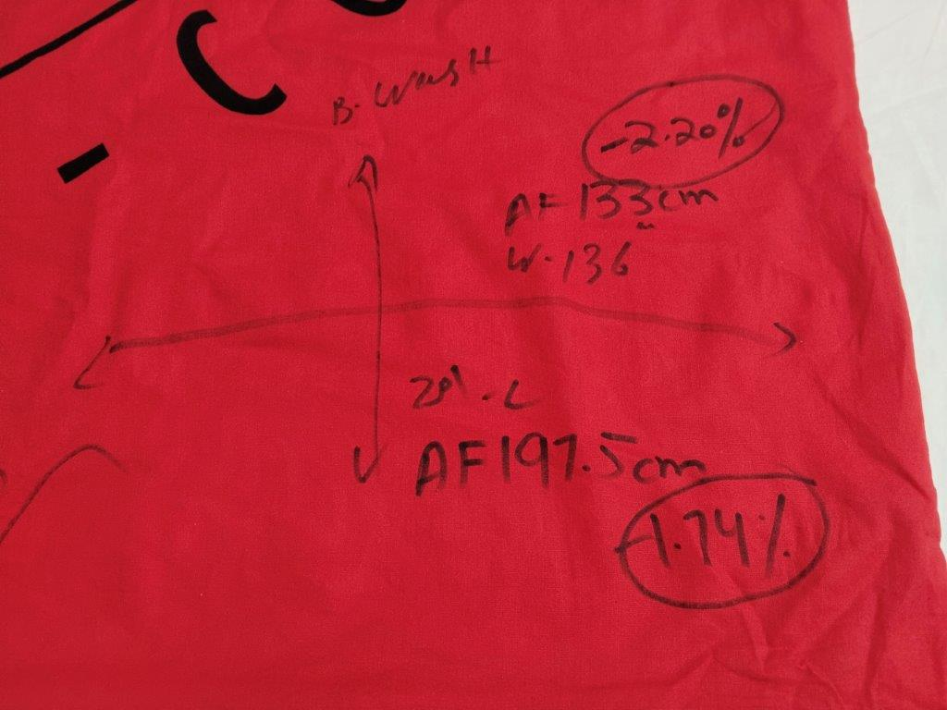 | 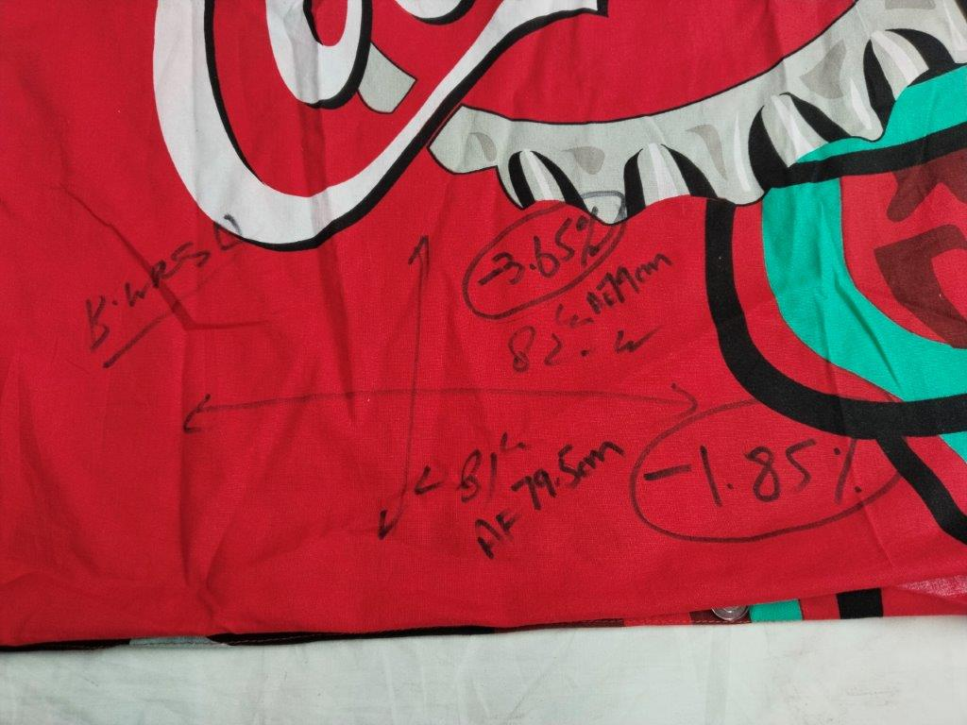
Before Wash & After Wash Measurement View | Before Wash & After Wash Measurement View
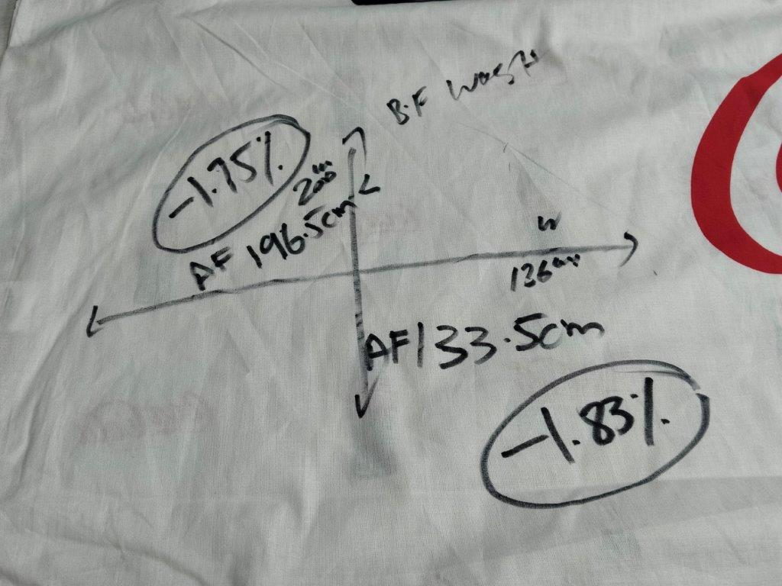 | 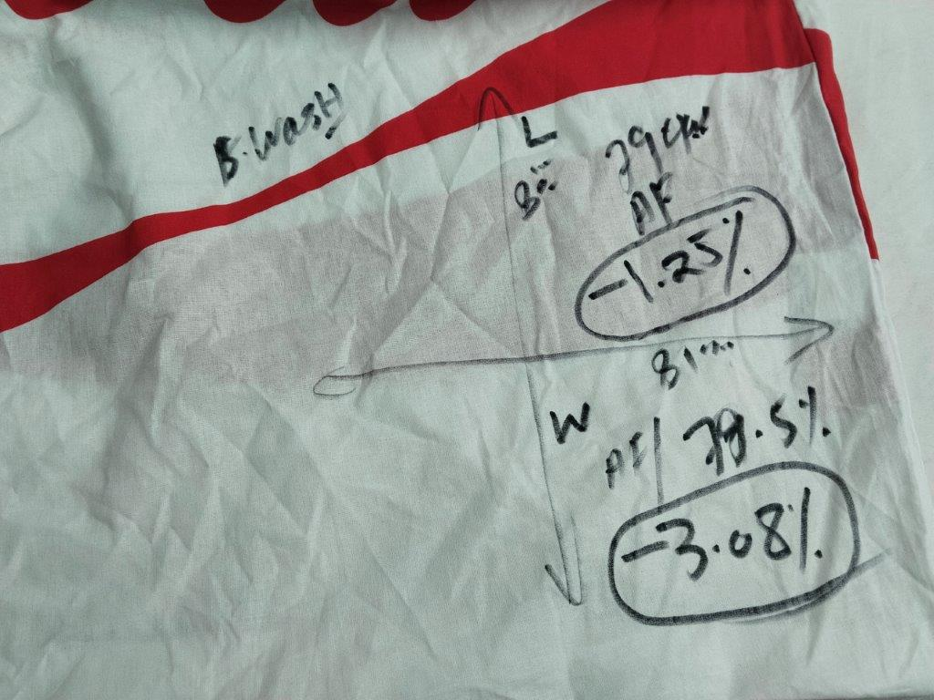
Before Wash & After Wash Measurement View | Before Wash & After Wash Measurement View
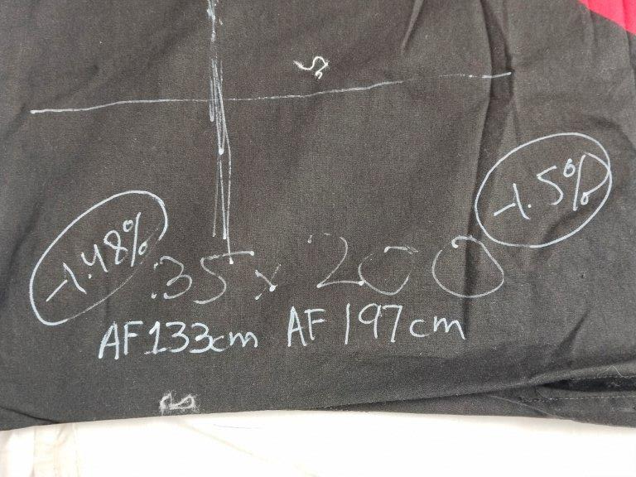 | 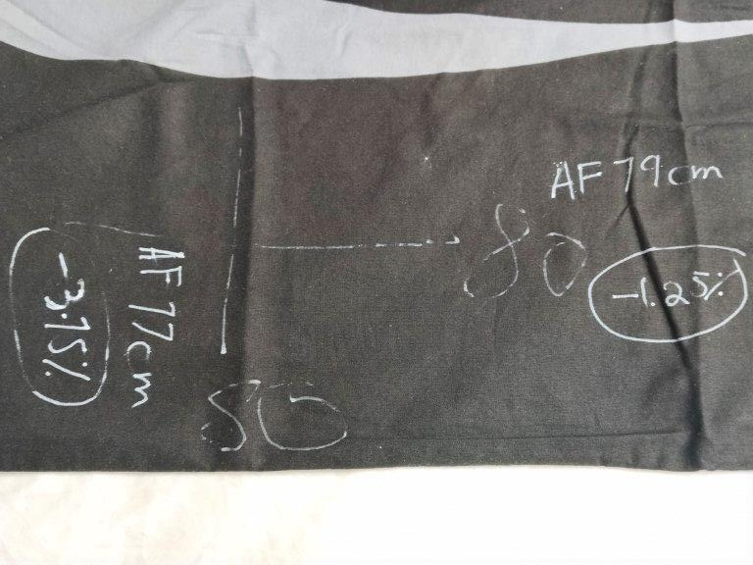
Before Wash & After Wash Measurement View | Before Wash & After Wash Measurement View

Shrinkage Chart
Before Wash (cm) | After Wash (cm) | Shrinkage %
Red
136 | 133 | -2.21%
201 | 197.5 | -1.74%
82 | 79 | -3.66%
81 | 79.5 | -1.85%
White
136 | 133.5 | -1.84%
200 | 196.5 | -1.75%
81 | 79.5 | -1.85%
80 | 79 | -1.25%
Black
135 | 133 | -1.48%
200 | 197 | -1.50%
80 | 77 | -3.75%
80 | 79 | -1.25%
*******THE END*******

