

KONZA NATIONAL DATA CENTRE BROCHURE CONTENT
Page 1
Konza Technopolis is a key flagship project of Kenya’s Vision 2030 economic development portfolio. Konza will be a world-class city, powered by a thriving information, communications and technology (ICT) sector, superior reliable infrastructure and business friendly governance systems.

Vision
To be a global technology and innovation hub.

Mission
To develop a sustainable smart city and innovation ecosystem contributing to Kenya’s knowledge-based economy.

As a smart city, Konza Technopolis will incorporate the use of technology leveraging on human and social capital to develop a self-sustaining city with an integrated urban information and communication technology (ICT) network that supports delivery of connected urban services to allow for efficient management of those services on a large scale. As a self-sustaining technopolis, Konza is deploying the latest technologies including waste management, recycling, energy efficiency and a mix of renewable and on grid energy solutions.

Page 2

THE KONZA NATIONAL DATA CENTRE
The Konza National Data Centre is located within Konza Technopolis and has the following attributes:
- Uptime certified Tier III DC by Design & Construction Facility & TIA-942 Standard.
    - UPS Power 2N redundancy.
    - 2N+1 generator redundancy.
    - N+1 redundancy in row cooling system.
    - FM200 gas fire suppression system.
    - 99.98 Availability.
- Multiple diverse fiber connectivity though various ISP’s for redundancy and reliability.
- Offers cloud computing solutions including Virtual Machines, Bare Metal Servers, storage, Disaster Recovery as a Service (DRaaS), Backup as a Service (BaaS), Co-location, PaaS and cutting edge SaaS solutions.
- Located in highly secure environment with CCTV, biometric access, rack level control.
- Located within a sustainable green environment to match Konza sustainability guidelines.

Data Center Physical Security Measures
Compliant with Data Center Security Requirement in TIA-942 with multiple security layers which include:
- Level 1 – Campus Access Control (Vehicle Inspection System, Security Booths/Mantrap System, One-way turnstile, X-ray Baggage Scanner and Register Station)
- Level 2 – Room Access Control (All entries with Fingerprint, Password, Card Security and CCTV Security)
- Level 3 – IT Module Access Control (IT Module Cold Aisle and Racks Level Access Control)
- Level 4 - Remote Management (APP view and management, Monitoring Center view & management and Remotely control)

Konza Cloud Security Features
- Virtual Private Cloud (VPC) and Virtual Firewall at network level, Security Groups and Elastic Load Balancer.
- VM Isolation, user management, data storage security, cloud infrastructure security, O&M (Operation & Management).
- Integration with leading security vendors to protect data up to application level.
Page 3
SERVICES OFFERED AT THE KONZA NATIONAL DATA CENTER.
- The Data Center will host both Government cloud and Enterprise cloud which are physically and logically isolated for security purposes.

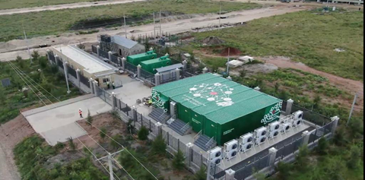
View of Phase 1 Data Center

Services available:
- Bare Metal Servers
- Physical Server Renting
- Cloud Computing
- Virtual Machine (For applications, Email services, databases, ERP’s systems, CRM’s etc.)
- Cloud Storage - Additional disk for Cloud Computing (Storage as a Service).
- Business Protection
- Data Backup (Backup as a Service)
- Data Center Co-location
- Rack Space Renting – we offer space for clients who would wish to bring their own racks and equipment to the data center.
- Professional service
- Partnership – We are partners with leading technology vendors and solution providers to offer services to customers.
- Managed Service – We are in partnership with other software vendors who shall be offering their services to customers.
- Consulting Service – We offer consultancy services and advice to customers on emerging technologies and solutions.

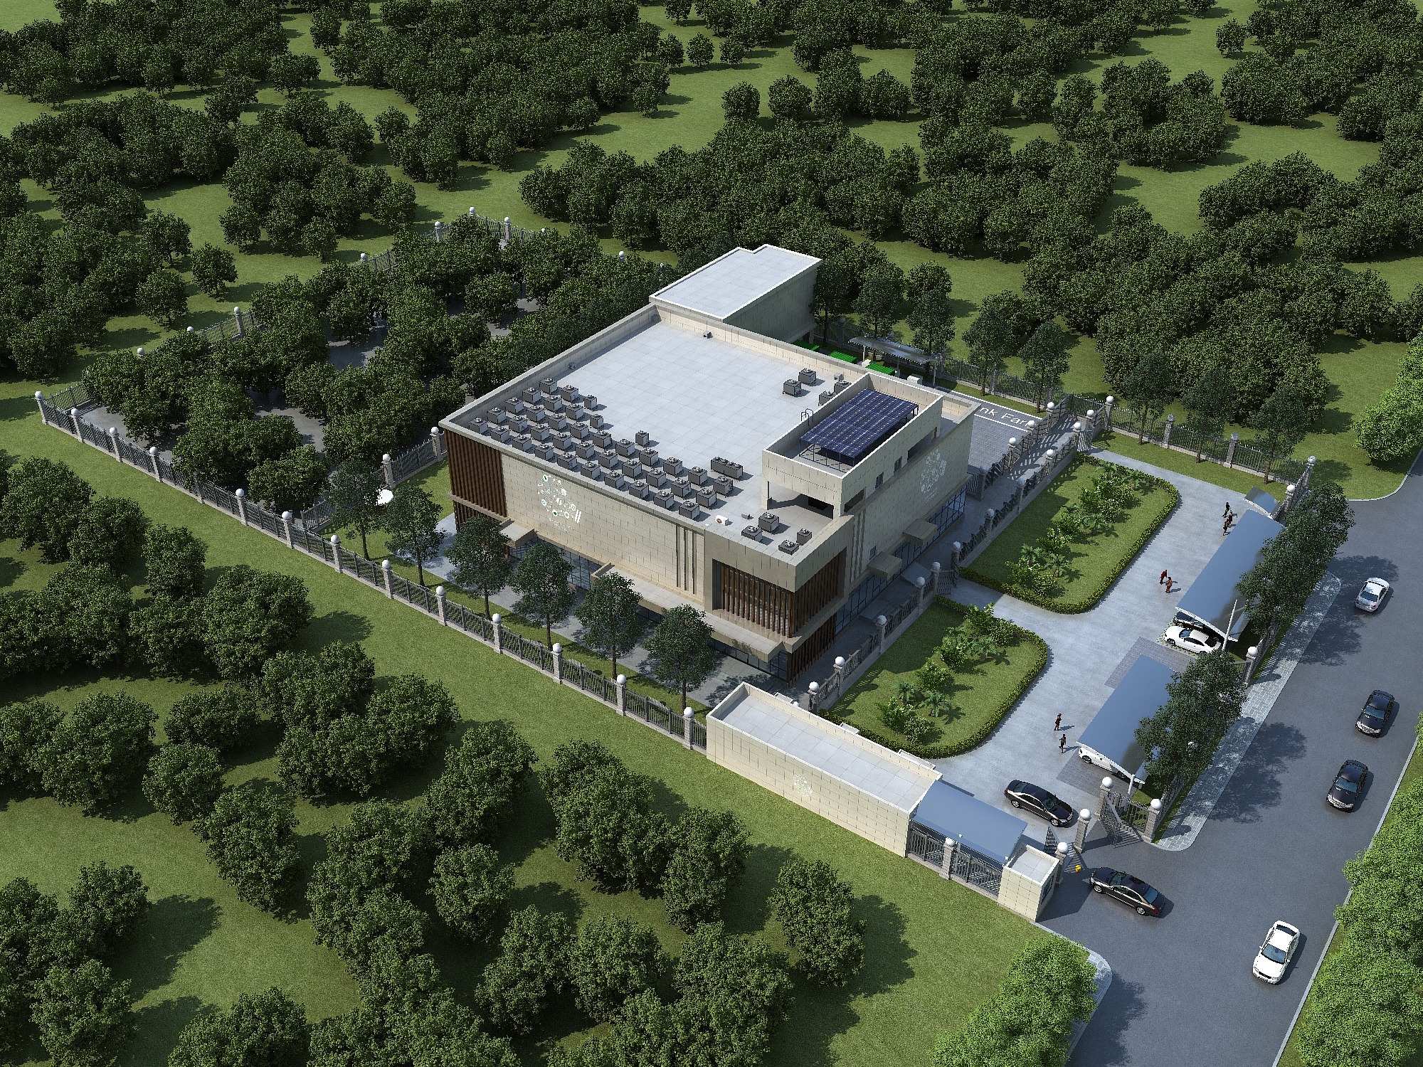
View of Phase II Data Center

Page 4

CONTACT US
Konza Technopolis Development Authority
7th floor, Konza Complex
P.O Box 1 – 90150 Konza
Technopolis, Kenya
Office Tel: +254 20 434 3013 | +254 20 434 3014
Email konza@konza.go.ke
www.konza.go.ke

