**KONZA TECHNOPOLIS RESOURCE CENTRE SPECIFICATION DOCUMENT.**

**Contents**

**INTRODUCTION.** 1

**SPECIFICATION DOCUMENT.** 2

**PURPOSE.** 2

**SCOPE.** 2

**STAKEHOLDERS.** 2

**HARDWARE INTERFACES.** 2

**SOFTWARE INTERFACES.** 2

**COMMUNICATION INTERFACES.** 3

**USER CHARACTERISTICS.** 3

**HOME PAGE COMPONENTS.** 3

**SUMMARY OF VISUALIATION OF THE MINI-WEB PAGE.** 4

**1.LEARNING PORTAL.** 4

**2.ARCHIEVE.** 4

**3.ORGANIZATIONAL POLICIES.** 4

**4.INSTITUTIONAL RESOURCES.** 4

**5. INDEXING.** 5

**6.EXTERNAL LINKS.** 5

**7.FEEDBACK SERVICES.** 5

**VISUALIZATION WHAT WE WANT.** 6

# **INTRODUCTION.**

Following the resource centre survey, we would like to proceed to our next stage. The implementation phase will be guided by the resource centre framework document and insights gathered from the survey.

# **SPECIFICATION DOCUMENT.**

This document contains information about the intent of KOTDA to have a digital platform to power the resource center needs. The proposal is to implement a website site designed and implemented in a responsive, flexible, and interactive manner with an aim of:-

1. Ensuring the content is accessible everywhere to approved segments of the Konza Ecosystem.
2. To structure the content in a well-designed, presented, and easy to navigate manner.

This document therefore serves as a basis for the design, development, implementation, and acceptance phases.

# **PURPOSE.**

This document aims at describing the details of requirements such as functionalities features, and user interfaces of KOTDA resource centre Website. In this document, the behaviours, user interface and interactivity details of the website will be fully described. By using this document, project team, Partner organizations team, website design and development team will have a full view about the interface and functions of the KOTDA resource centre mini -Website.

# **SCOPE.**

The scope of the solution implemented will be limited to the functional and non-functional requirements mentioned in this document.

Non-functional requirements define system attributes such as security, reliability, performance, maintainability, scalability, and usability. These requirements will be scoped according to the general organization standards on website performance.

# **STAKEHOLDERS.**

Stakeholders for the KOTDA resource centers include

**End-users**, we would like the end users to have a user -friendly interface ( across mobile, tablets and computers) that comply with the guidelines provided by KOTDA.

**Content managers**, the role of the content managers will be to Upload, Maintain and Approve the content on resource centre mini website. Content managers should be able to update content seamlessly.

# **HARDWARE INTERFACES.**

KOTDA resource center will be deployed over the cloud so users will rely on their own devices to access content online.

# **SOFTWARE INTERFACES.**

Software required to use the system will be a modern web browser.

# **COMMUNICATION INTERFACES.**

No specific hardware interfaces will be required except for the device being used to open the website should relate to the Internet.

# **USER CHARACTERISTICS.**

They are three types of users of the resource centre.

1. **Administrator.**
   * Administrators will be able to manage permissions for the website
2. **Content Managers.**

* Content Managers will have permission to add/update content in the system that is visible to the normal users / viewers. Information added by content managers will be approved by Administrators/Approvers to approve/reject the content Viewers of the website will only use the website to obtain information.

**3. Users / Viewers.**

* The whole site will be read-only to users except for the following forms where they will only be able to submit information to

1. Feedback forms

2. Services section forms

# **HOME PAGE COMPONENTS.**

Details of all the components on the home page are listed below.

The home page will include the goals, objectives, and purpose of the formation of the resource centre.

1. **The purpose:**
   * To provide a learning platform for the growth needs of KOTDA staff and stakeholders.
   * To create an information repository that plays a role in preserving the history of KoTDA by improving access to information for the benefit of the organization and key stakeholders.
2. **Goals:** Create a pleasant environment for learning, by providing relevant and accessible information services thereby encouraging people to use the resource centre to gain useful knowledge.

* **Objectives:** Make information accessible by encouraging the use of information and production of materials to enable us strengthen links with other organizations.

# **SUMMARY OF VISUALIATION OF THE MINI-WEB PAGE.**

# **1.LEARNING PORTAL.**

Additional tab in the KOTDA drop down list in the resource centre tab.

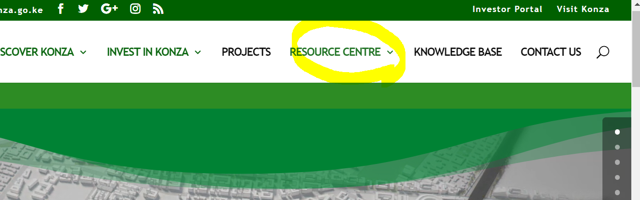

Press Release,

News and updates

Learning portal

The landing page for the Resource center.

Role: To provide a dashboard including Goal of the resource centre,

Include links on the learning material: (Personal development), (Professional development), Magazines,

* It will be link to other places
* Accessibility should be categorized for KOTDA staff and the General public.

- Book of the month

# **2.KOTDA REPOSITORY.**

the repository for the organisation material.

KOTDA REPOSITORY

(Investor Journeys). (KOTDA key events). (Major Project milestones.) : (innovation Ecosystem)

# **3.ORGANIZATIONAL POLICIES.**

KOTDA Policies

-we would a tab that leads to all the organizations policies this will make them easily accessible to all the staff and other interested stakeholders.

# **4.INSTITUTIONAL RESOURCES.**

Institutional Resources.

-videos, photos, articles.

**Videos**

Videos of guests, projects, Key milestones, timeline of projects. Investor meetings, documentaries etc.

**Photos**

Projects, infrastructure, programmes e.g. tree planting, kids innovation /kids tech programs

**Articles**

KoTDA newsletters,

# **5. INDEXING.**

KOTDA resource centre will work with information management professionals to incorporate a proper indexing plan for the We need a way of indexing the institutional resources in days/months or years.

# **6.EXTERNAL LINKS.**

We would like external links to key informational websites for resource access. Such as:

<https://www.coursera.org/>

<https://www.udacity.com/>

<https://www.lynda.com/>

<https://www.codecademy.com/>

# **7.FEEDBACK SERVICES.**

For feedback in Services, there can be three types of feedback:

* Suggestions
* Feedback
* Complaint.

The form for Feedback web part is as follow

We can emulate a feedback example as shown below.

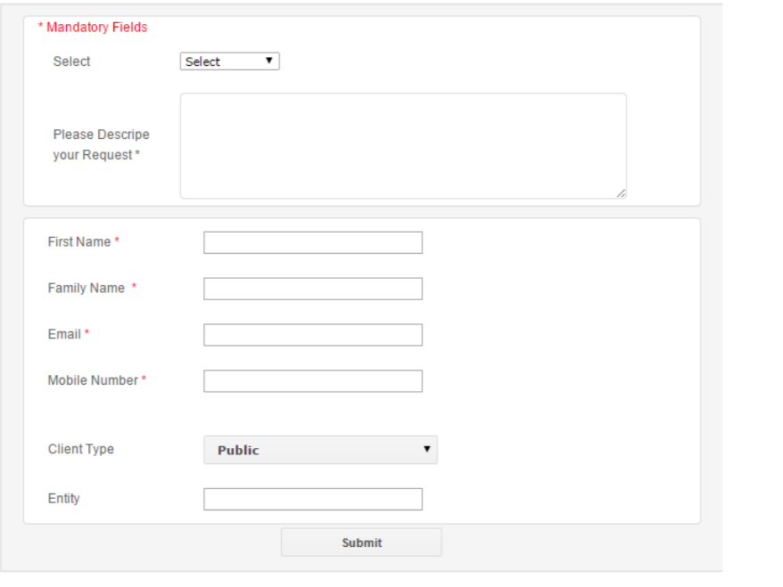

# **VISUALIZATION WHAT WE WANT.**

RESOURCE CENTRE

HOME PAGE

OBJECTIVES

PURPOSE

GOAL

LEARNING PORTAL

GENERAL ACCESS

BOOK OF THE MONTH

STAFF ACCESS

The world bank

HOT OFFERS

LEARNING MATERIAL

RESOURCE CENTRE

KOTDA REPOSITORY

COURSERA LINK

COURSERA LINK

UDACITY LINK

PUBLICATIONS

PHOTOS

VIDEOS

RELATED RESEARCH

POLICIES

All KOTDA POLICIES

FEEDBACK

OUR PARTNERS