FF



**2021**

**STAFF PORTAL**

**APPRAISAL MODULE USER MANUAL**

Contents

Log In 3

Services 4

Dashboard 5

My Profile 5

Starting your Appraisals 6

Staff Appraisal 6

Performance 6

Filling Subsequent Sections 8

Financial Stewardship & Discipline Section 8

Service Delivery Section 8

Cross Cutting Section 9

Job Duties and Responsibilities 9

Core Mandate 10

Implementation of President Directives 11

Access To Government Opportunities 11

Promotion of Local Content 12

Implementation of Strategic Plan and Departmental Priorities 12

Submitting Appraisal 13

Edit/Delete Appraisal 14

# Log In

To login a staff will be sent initial login credentials by the system administrator. This is in form of a link sent to the staff email/company email. On clicking an activation link in the email, a staff is prompted to enter their initial private password which they will be using to login to the portal. Below is the login page:

# Services

The staff portal offers the services listed below.

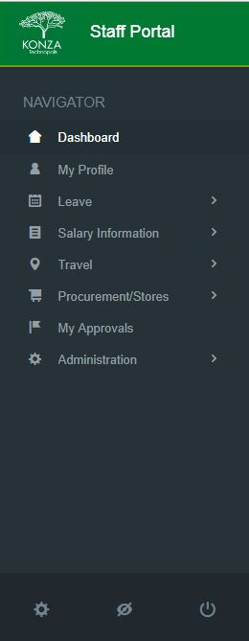

# Dashboard

On initial login you will be redirected to user Dashboard, as shown below. It displays a summary of common processes

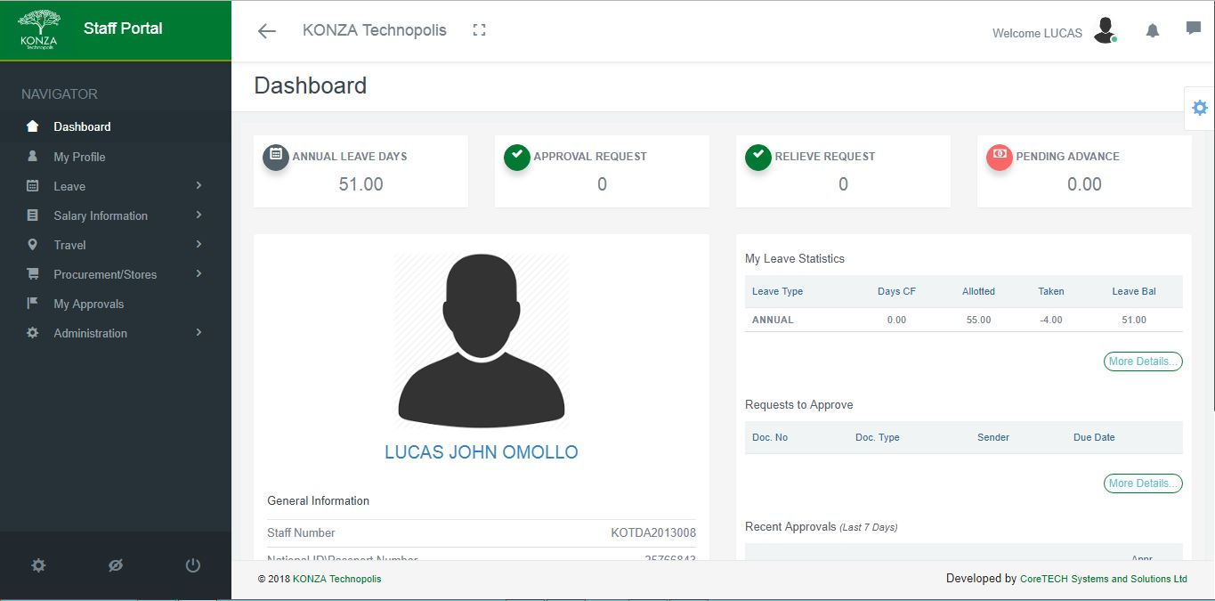

# My Profile

To view your Profile click on ***my profile*** to open a page similar to the one displayed below:

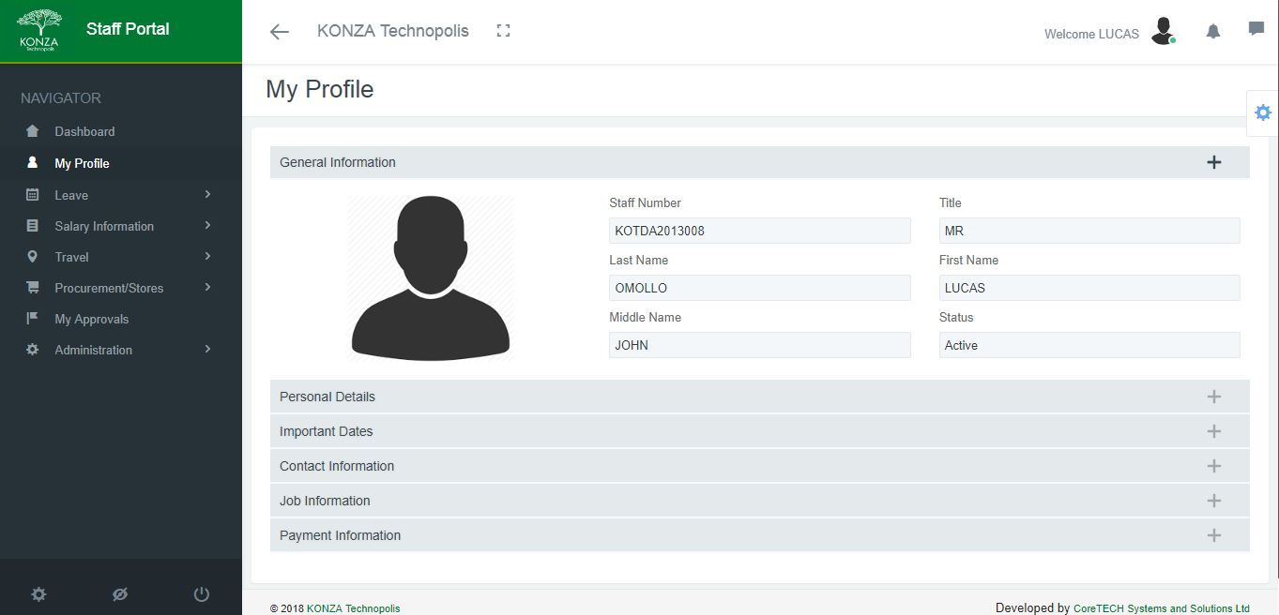

# Starting your Appraisals

## Staff Appraisal

### Performance

To access performance appraisal, click the Performance menu to expand a page similar to the one displayed below.

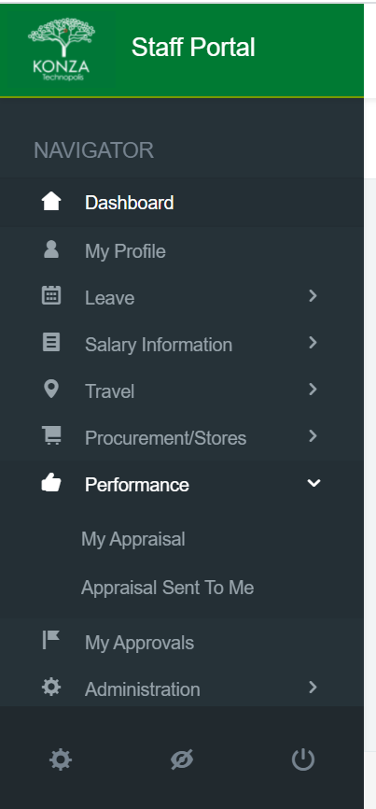

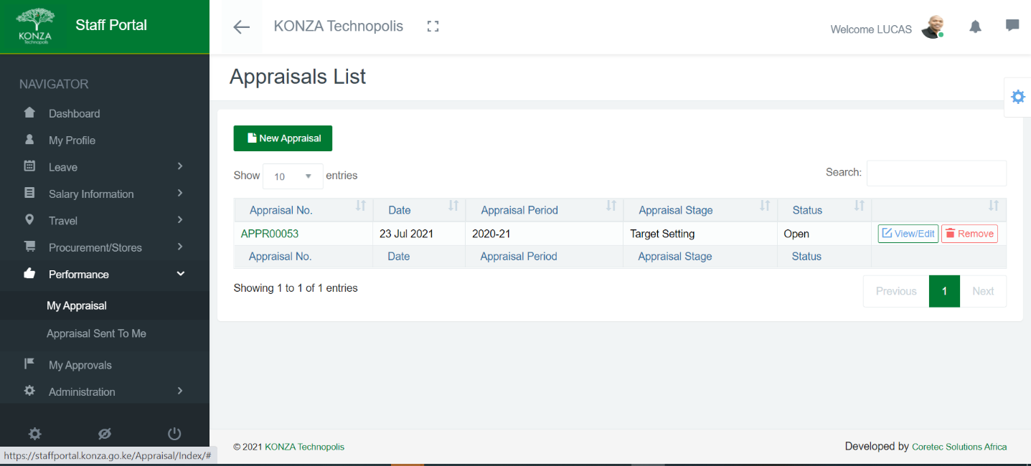Click on **My Appraisals** to open a page like the one displayed below. Click on **New Appr**

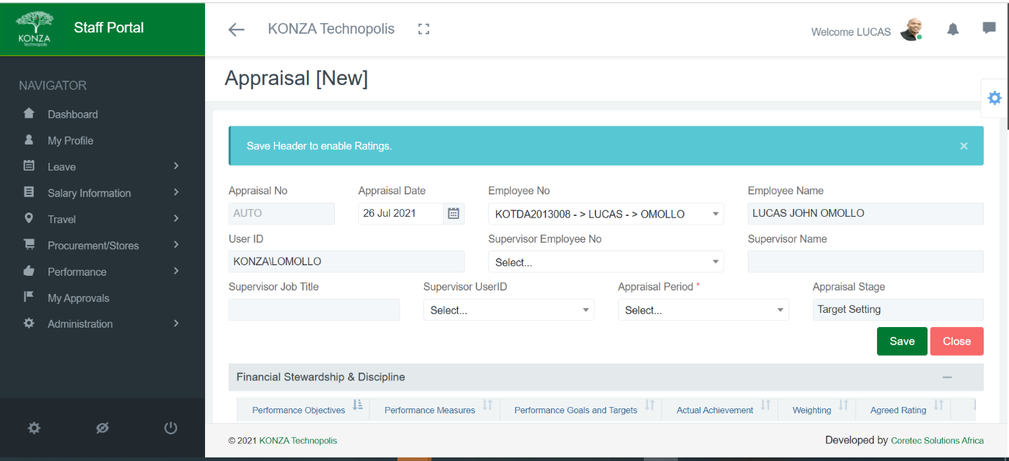Fill all the details required on this page such as selecting **the Employee No, Supervisor Employee No, Supervisor User ID, and Appraisal Period** from the dropdown menu in each section as shown in the image below. Click SAVE to continue.

# Filling Subsequent Sections

### Financial Stewardship & Discipline Section

Click on Add Line, a pop-up window will appear as shown below. Fill the details and click save.

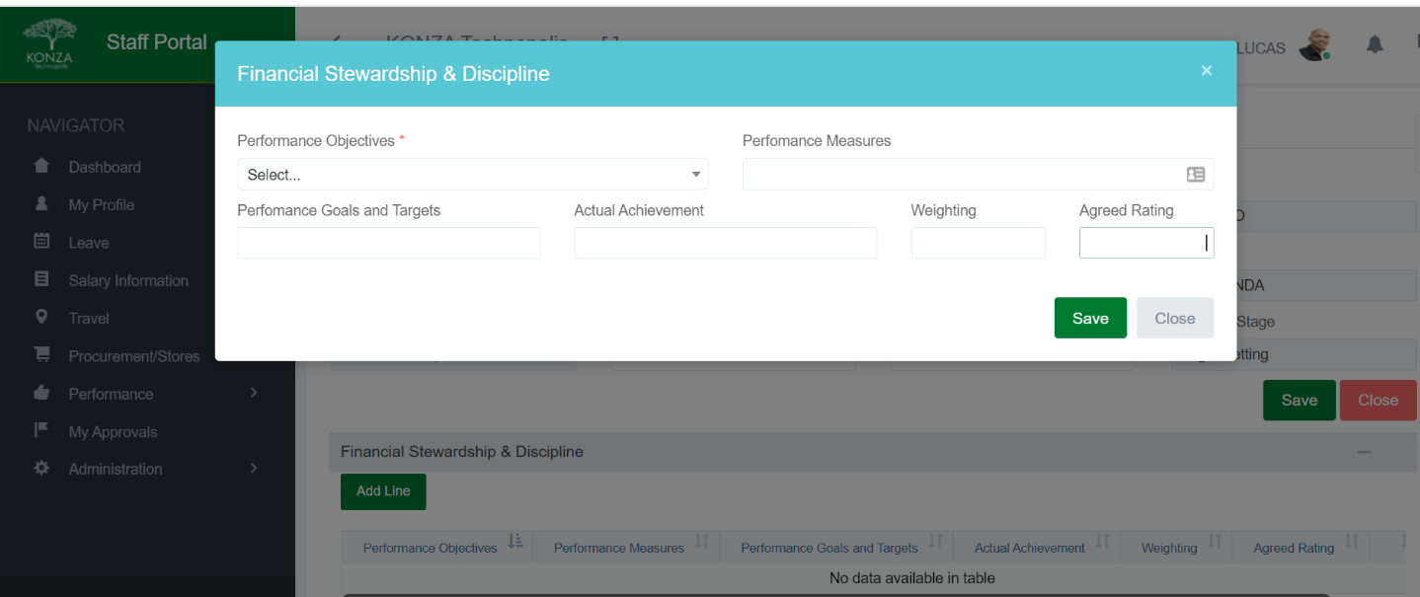

### Service Delivery Section

Under service delivery, click Add Line, a new window pops up. Fill the details and SAVE as shown below.

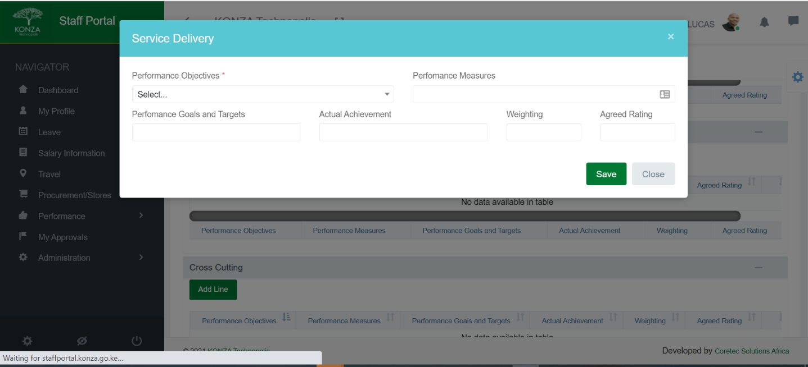

### Cross Cutting Section

Under cross cutting, click Add Line, a pop window will show as shown below. Fill all the details and click save.

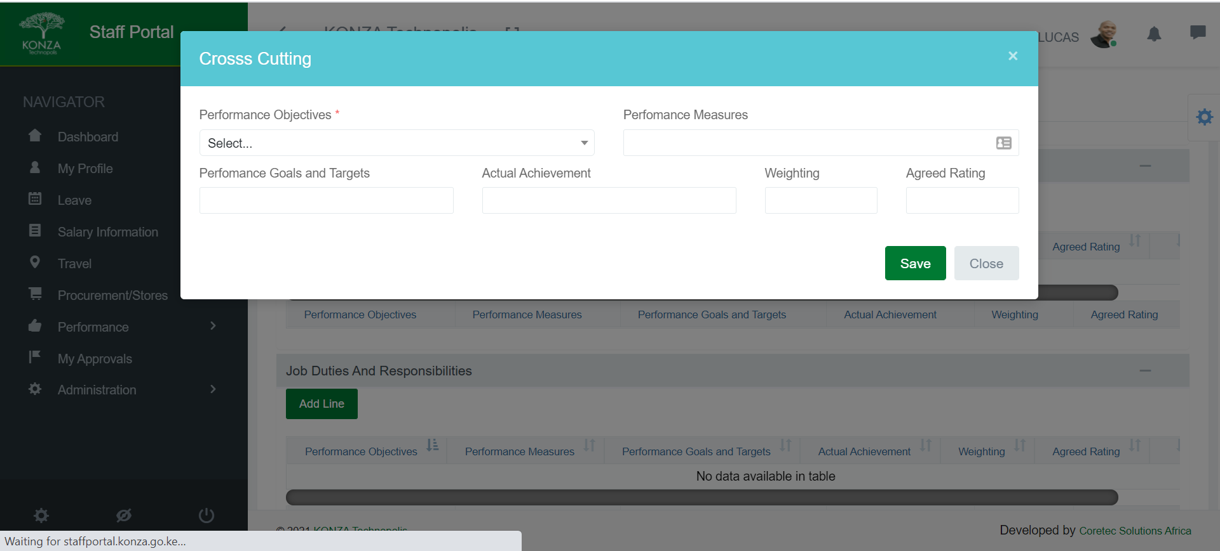

### Job Duties and Responsibilities

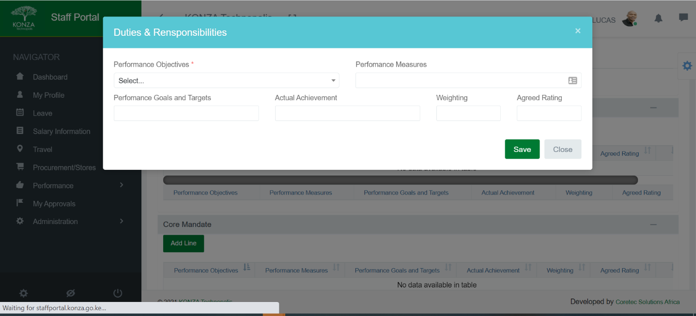Under Job Duties and Responsibilities, click Add Line, a pop window will show as shown below. Fill all the details and click save.

### Core Mandate

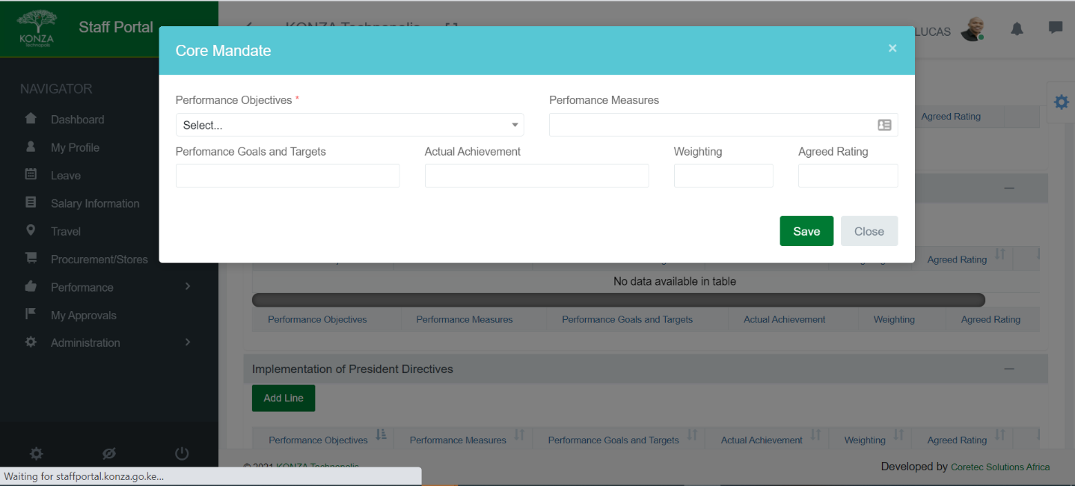Under core mandate, click Add Line, a pop window will show as shown below. Fill all the details and click save.

### Implementation of President Directives

Under Implementation of president directives, click Add Line, a pop window will show as shown below. Fill all the details and click SAVE.

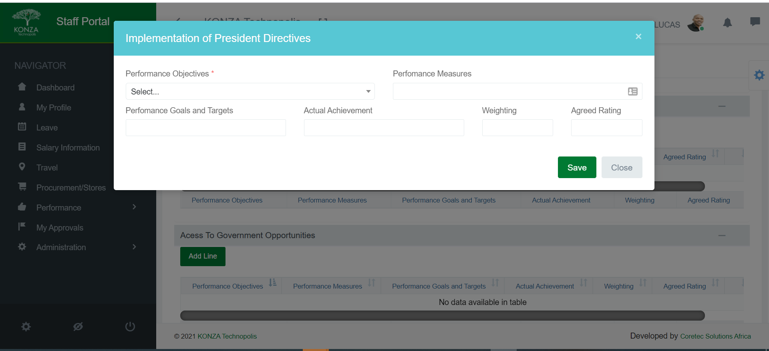

### Access To Government Opportunities

Under Access To Government Opportunities, click Add Line, a pop window will show as shown below. Fill all the details and click SAVE.

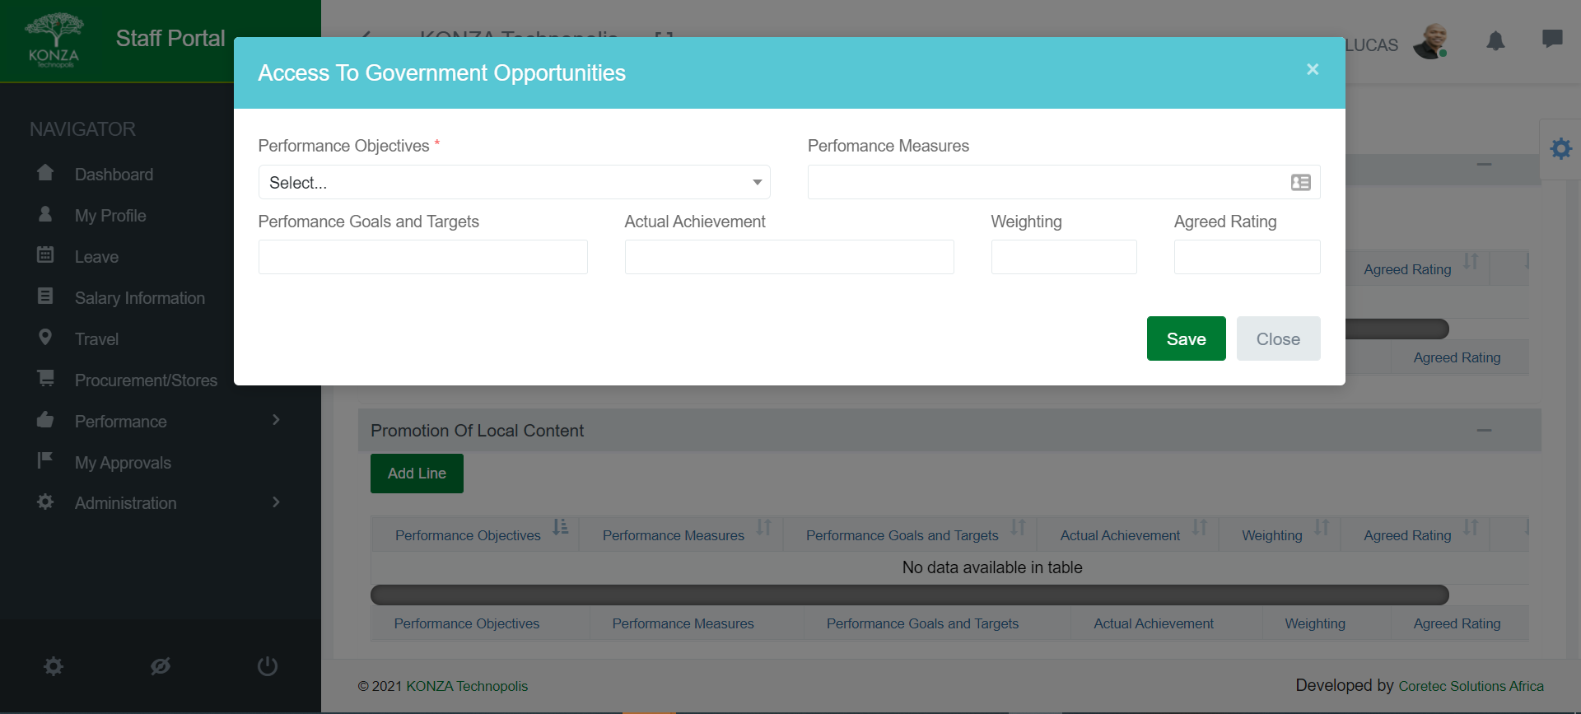

### Promotion of Local Content

Under Promotion of Local Content, click Add Line, a pop window will show as shown below. Fill all the details and click SAVE.

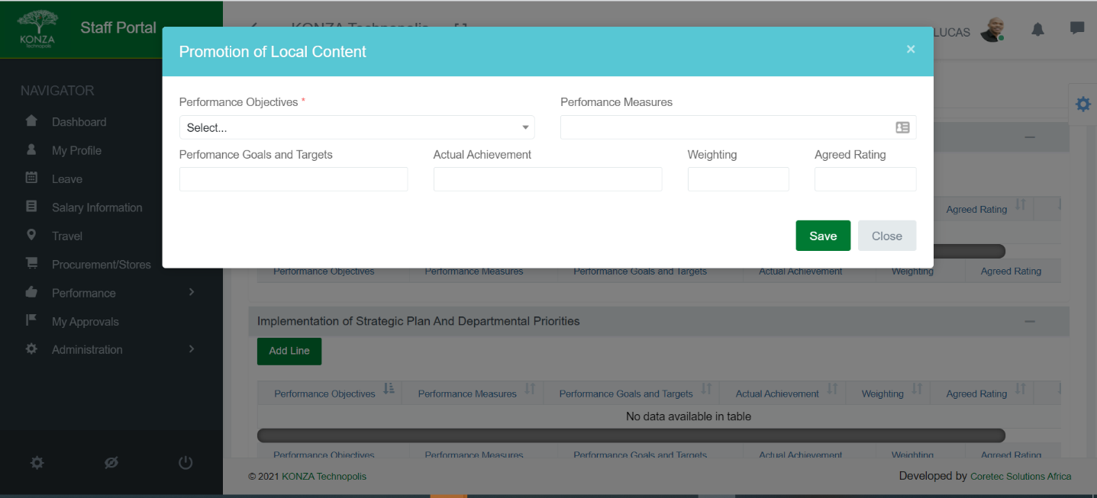

### Implementation of Strategic Plan and Departmental Priorities

Under this section, click Add Line, a pop window will show as shown below. Fill all the details and click SAVE.

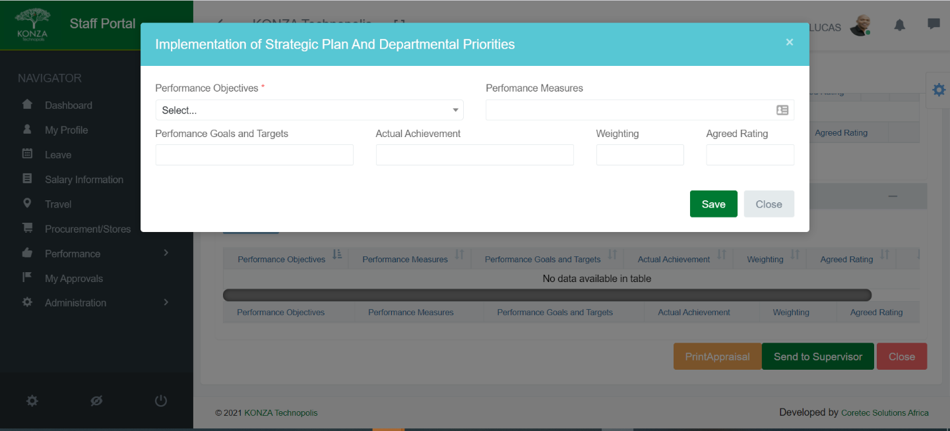

### Submitting Appraisal

When all outlined sections above are completed, click Send to Supervisor button to submit your appraisal, as shown below.

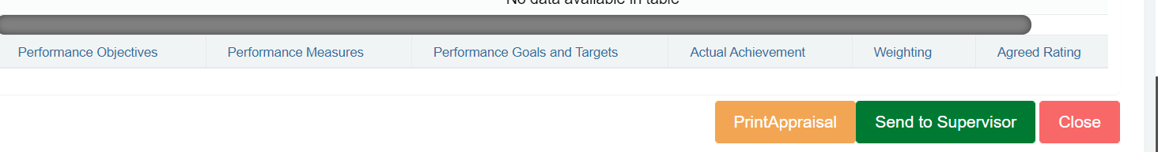

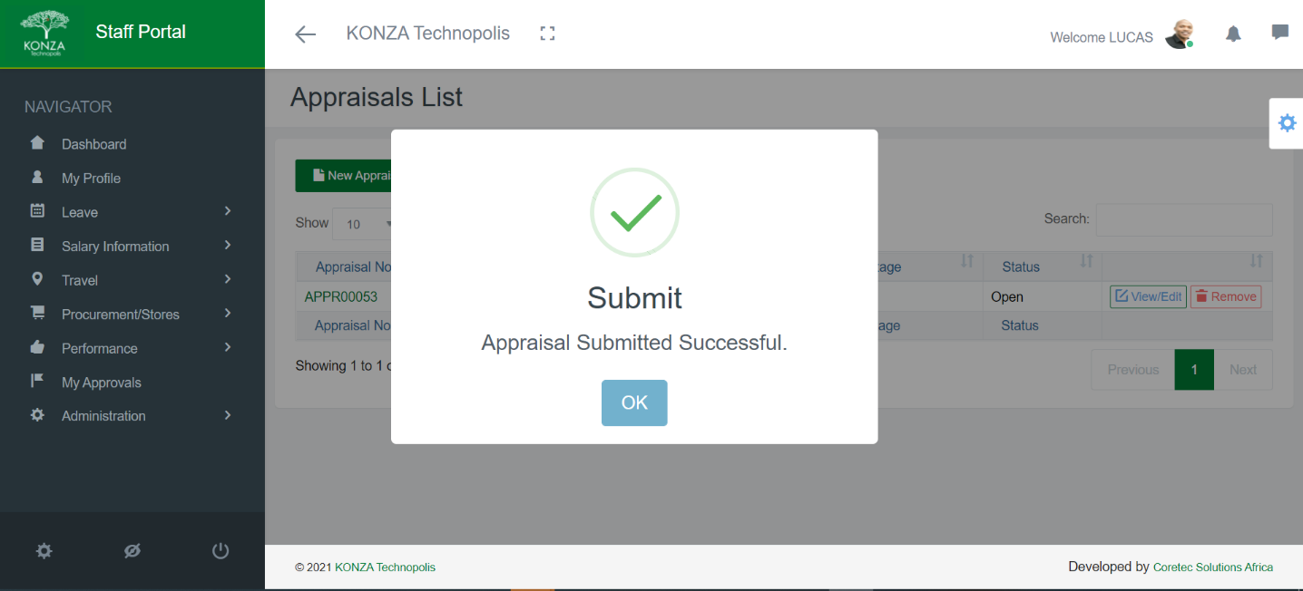

### Edit/Delete Appraisal

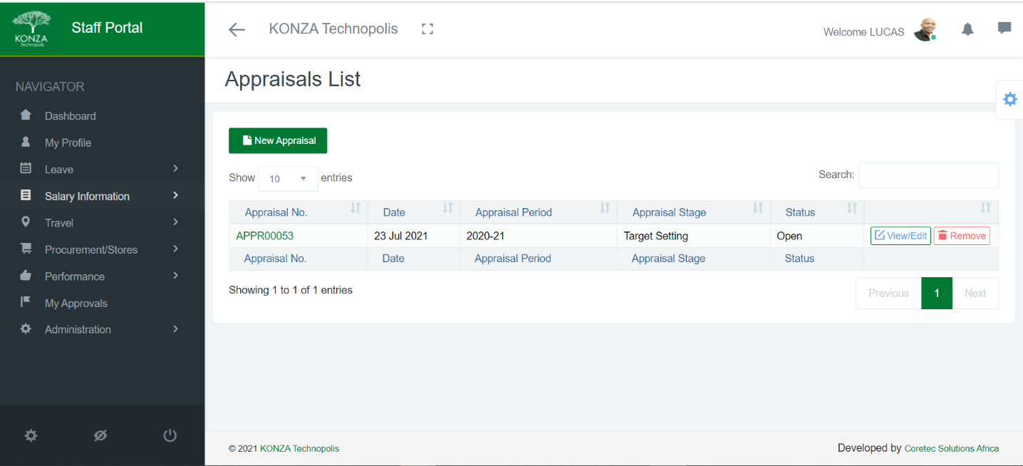To edit a submitted appraisal, navigate to your appraisals dashboard and click the edit button as shown below.