

**Resource Center**

user manual

<https://resourcecenter.konza.go.ke/>

please contact us through:

Phone: XXXXXXXXXXX

Email: [Konza.konza@go.ke](mailto:Konza.konza@go.ke)

Accessing the site

1. Visit <https://resourcecenter.konza.go.ke>
2. Login from the login button at the top right

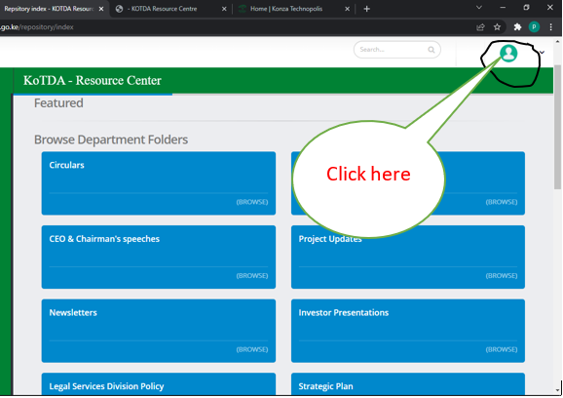

1. Input the credentials

