

**Resource Center**

user manual

<https://resourcecenter.konza.go.ke/>

please contact us through:

Phone: XXXXXXXXXXX

Email: [Konza.konza@go.ke](mailto:Konza.konza@go.ke)

Accessing the site

1. Visit <https://resourcecenter.konza.go.ke>
2. Login from the login button at the top right

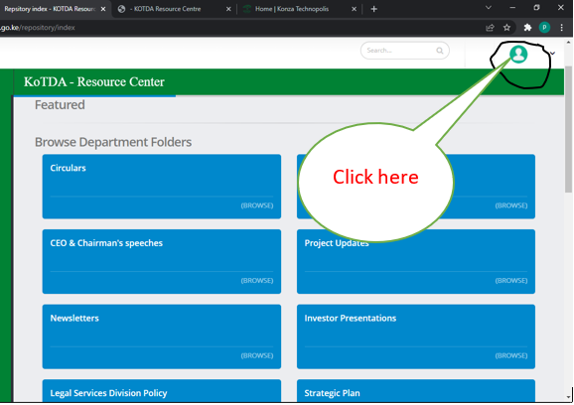

1. Input the credentials

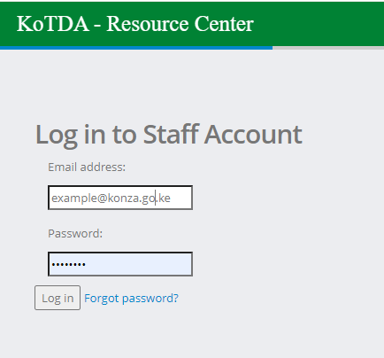

Once you are login you are directed to this dashboard with various sections as labeled 1 – 7. Each section is explained below.

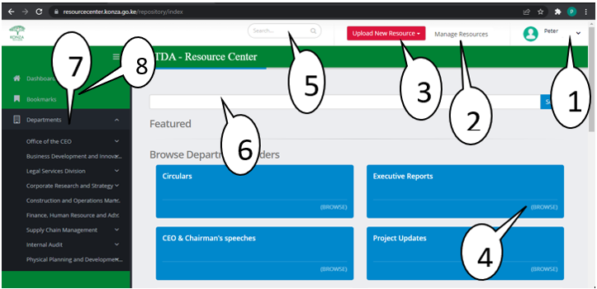

1. Profile, shows the staff image, name, and role.

When you click the drop-down, you will be taken to:

My profile. Once you click, you will be taken to the page below.

The profile dashboard consists of different tabs labeled 1.1, 1.2, 1.3, 1.4, 1.5

From 1.1 to 1.4 contains the respective files the staff has uploaded in terms of documents, images, and videos where one can delete the sent file from the recipient folder and from his/her dashboard. 1.5 (Edit) from this tab, give rights to update your profile details and change your password.

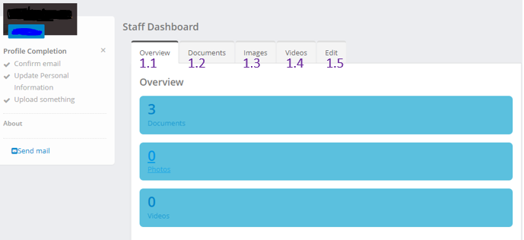

1. Manage Resources: Is a shortcut of the profile (1 above)
2. Upload new resource: it is button with a feature that allows one to add resources (document, images, and videos)

Procedure:

1. Click the Upload new resource button and then select the file type you want to upload 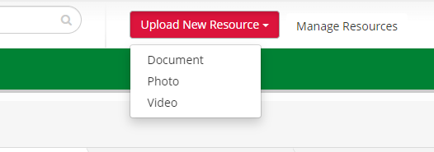
2. Click upload files button to select the file from your directory or one can chise to drag and drop the file directly and then click next from the bottom right of the scren. 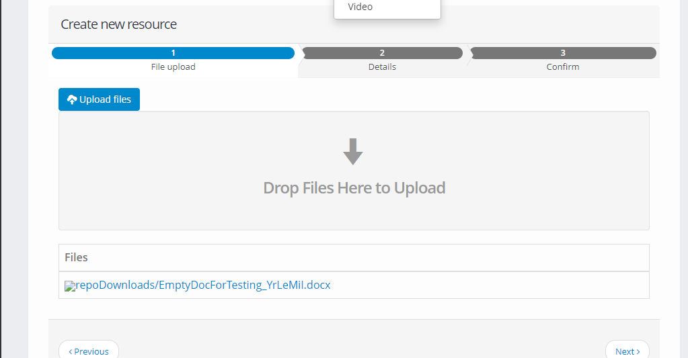
3. File details: provide a file name, select department folder, give a short description of the file, select the privacy level required, give the file a Tag for quick retrieval, select the Host department and then click save and continue. N/B when the document is saved and not published, it is only available on the senders’ dashboard. Lastly, publish the file to go to the respective recipient or you can remove the file before publishing.
4. Brows: by clicking the browse button, you will be taken to the respective folder and have access to the files saved there and one can filter all files or the respective files like documents, images, and videos.
5. Search: give one a chance to search a document across all the folders. N/B you must have the tag name or a name of the file.
6. Works as the above (5) search.
7. Departments: gives a list of all departments available. Each department gives a sub-menu that can be used to view all the file types (documents, images, and videos) and all the folders associated with that department. The system allows users to create a folder in their respective departments.
8. Bookmark: once you open a document from different folders, you can bookmark it at the end of the document, and thereafter it can be filtered from the bookmark button which will display all the files which have been bookmarked.