

**Resource center**

**User Manual**

For any queries, please contact Konza Technopolis through:

**Tel No**: +2540204343013 or +2540204343014

**E-mail**: [konza@konza.go.ke](mailto:konza@konza.go.ke)

**Access Link**: <https://resourcecenter.konza.go.ke/>

TABLE OF CONTENT

Contents

**Introduction** 3

**1.** **Staff Login** 3

**Browse Department Folder Page**: 4

**2.** **Staff Dashboard** 4

**Changing password** 5

**Deleting unwanted files** 5

**3.** **Upload New Resource** 5

**Uploading a new file procedure** 6

**4.** **Search** 6

**5.** **Dashboard** 6

**6.** **Departments** 6

**7.** **Browse** 7

**Add Folder:** 8

**8.** **Bookmark** 8

# **Introduction**

The resource center is a web-based system that allows the sharing of files among different departments under KOTDA. The system has various users right from the Admin, the Staffs, and the visitors.

The system users have different levels of rights given by the Admin.

Visitors will only have the privilege of consuming the files which are published for the public from different departmental files.

# **Staff Login**

For one to log in, He/she must request the account creation from the relevant Admin for his or her department and once the account is created and the credentials for login shared, from the top right corner of the screen, click on the dropdown arrow next to the profile image and the button for login will pop up as shown below. Click login and enter the provided credentials from the new window that will be opened and follow the procedure to change your Password and add upload your image for the profile picture.

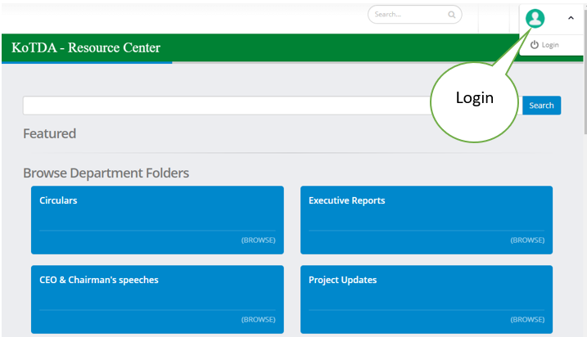

## **Browse Department Folder Page**:

Once you log in, the page below will open where you can do some functions to complete the process in need by use of various tabs from the dashboard labeled from 1 to 7.

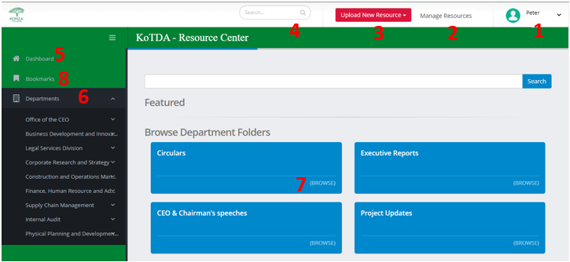

# **Staff Dashboard**

Click the drop-down arrow on the top right corner of the window. From the pop-up, click **My profile** button to go to the staff Dashboard.

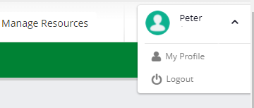

From the staff dashboard, you will be able to see all the types of files for example documents, images, and videos you have shared within the system.

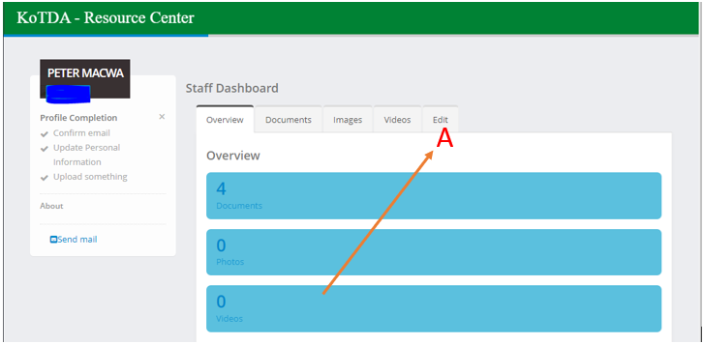

**Changing password**:

click on **edit** from the staff dashboard, go under change password and follow the procedure then save the changes for the new password to apply.

**Deleting unwanted files**:

Click on the respective file-like document and delete any which is not needed. N/B remember to check if the selected file is correct.

This button works the same as the one discussed above: **Staff Dashboard**.

1. **Upload New Resource:**

Once you click on **Upload New Resource** and select the type of file you want to upload that is document, Images, and Video.

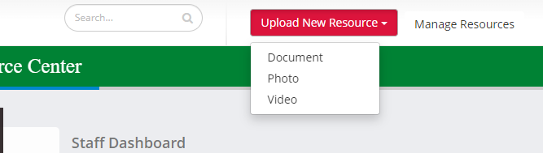

Select for example Document: click on upload files and select the file from your directory or drag the file from your desktop as shown by the two-sided arrow meaning either of the processes, the file will be loaded on the system and then click on next to continue.

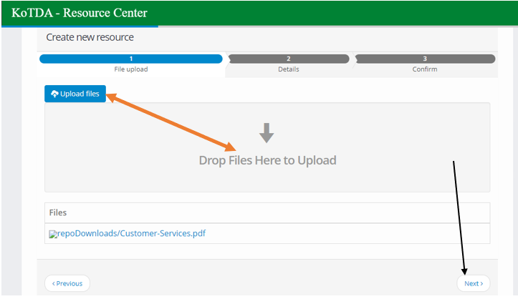

**Uploading a new file procedure:**

1. Title: give your document a name.
2. Chose the department folder where you want to send the selected file.
3. Write a short description of the file
4. Select the privacy level required for the file.
5. Give your file a Tag name for Easy retrieval or quick search.
6. Select Host Department.
7. Click on **SAVE AND CONTINUE** button from the bottom right corner. N/B the saved file is not sent until it is published. When only saved, it is only available on the staff dashboard.
8. Click on publish for the file to be sent to the selected destination.
9. **Search:**

for quick retrieval of the file, enter the name of the file you need to search across the department folders or use the Tag name. N/B the tag name or the name used must be correct for the file to display.

1. **Dashboard:**

Click on this button to go back to the login staff landing page.

1. **Departments**:

Click on this button to view the folders and the internal files published in that specific department and click on the resources for them to display on the right-hand side.

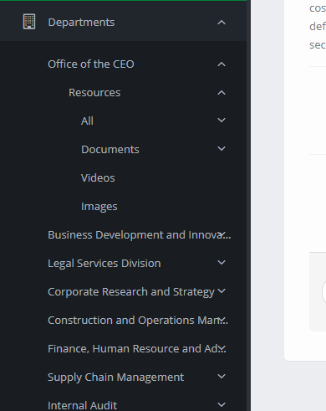

1. **Browse:**

Under the departmental folders, the browse button opens the available files for example Documents, images, and, videos from that specific folder as shown below someone clicked on brows for circulars.

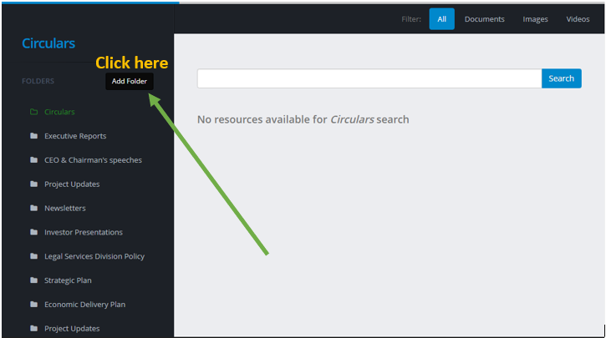

## **Add Folder:**

Once the folders are opened, the staff has the right to create a folder by clicking on Add folder button as shown above and follow the procedure, and then publish for the process to be complete.

1. **Bookmark:**

How to bookmark: open the relevant file, click on more, and then click bookmark under the file.

The **bookmark** button opens all the files which have been bookmarked.