https://github.com/koo5/new_shit
irc://irc.freenode.net/lemonparty

status
18.7:
something like a type system added! Playing with Unipycation, there is life on the channel - wow. Lemon is at a point where the natlike structural editing is somewhat presentable (as a demo, with explanation). Im trying to figure out new priorities. Logic programming for the typesystem, compiler etc? enhance gui with widgets? core language features?
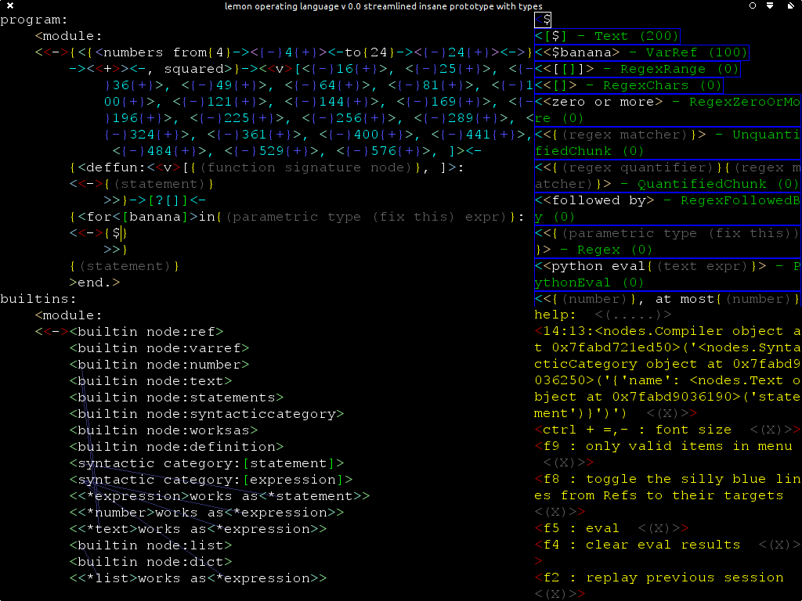
18.5:
still trying to add a type system…
18.4.14
trying to add a type system, reworking pyswip integration, builtins module, Syntaxed
removed some of the toys, like settings nodes, so i can focus on the main stuff, replaced them with optargs

http://journal.stuffwithstuff.com/2010/10/29/bootstrapping-a-type-system/
http://lambda-the-ultimate.org/node/3145

7.3.14
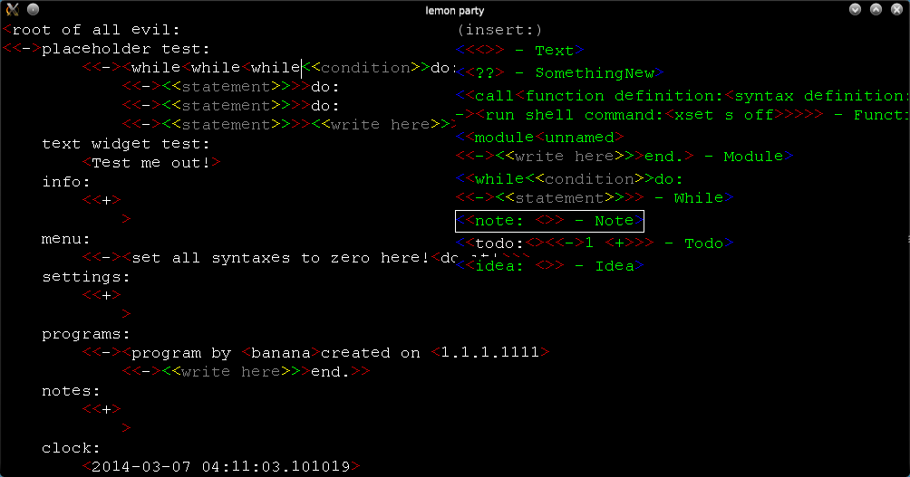
3.3.14
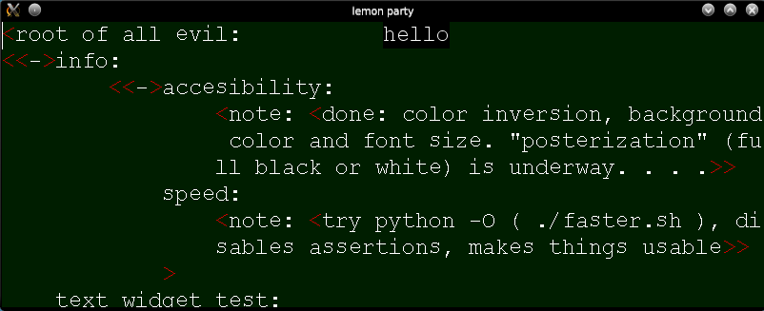
18.2.14
https://github.com/koo5/new_shit
current plan is to continue with "mock-up" language nodes
<sirdancealot> i started a crude replacement for pyglets text functions, and am rewriting stuff to fit with it and add some sanity
<sirdancealot> so if you get bored, currently its no logic programming, no compiler writing, no ACEs, no lisps, just python and the user interaction idea
<sirdancealot> im back from my detour into SICP and prolog :)
<sirdancealot> + spent two days playing around with eulergui and friends
<sirdancealot> not there yet, but maybe on the verge of being comfortable with my knowledge of those
<sirdancealot> i might have an idea how a basic "triple" node or somesuch would work in lemon....from the ui point of view, so far
<sirdancealot> a naive idea now is that the only remaining big topic i have to scratch is ML languages and coq
<sirdancealot> but thats hopefully for unforseeable future, should be able to implement a mockup type system without that
-> subtextual

introduction
structured editors are cool:
https://www.youtube.com/watch?v=F13wg2ApCdc
http://www.lighttable.com/2014/05/16/pain-we-forgot/
http://peaker.github.io/lamdu/

an experiment: i believe that a smart way of going about user (programmer) interaction in a projectional editor will allow the programming language built around it to reach new levels. The biggest inspiration is Inform 7.
lemon should become a structured editor / ide / base of an interface for a programming language / a knowledge management interface / a daily computer use language with some natural-like language features, plus the usual bells and whistles that projectional editors offer or promise. Ultimately, it will become a desktop environment and take over the world.
The design and nature of implementation of the language is still unclear. i have a lot of reading to do, and the editor should first be finished - as a proof of concept, and to show its strengths and weaknesses - the editor and the language should co-evolve.

current goal
basic projectional editor with unintuitive but working editing functionality
frontend: drawing text, menu, cursor, sending back events
interpreter: nice but not crucial for prototype, code generation easier?
core: tree element, widgets, tokens, grammars?, nodes, tags, placeholder
compilation, menu: lexical scope, recombination?, scoring of menu items.
type system how? - ML, coq, subtext research? -
syntaxes of nodes are kept inside node declarations for now,
must add child types to names, point to python classes or..
editing - menu driven system?could clarify the requirements of the frontend, possible operations etc
the frontend can be implemented in another language and its input and output can be fairly well defined, and it can take on more functionality, for example scrolling, or leave it to the core
moving widgets to the hipothetical frontend seems messy - they have to keep their own state. ultimately doable and maybe right, but some questions must be answered

why not use X instead of lemon

i7
would be the only option
CAN be made useful for general purpose programming, the toyness can be worked around, at least to have something working, (python wrapper)...something that could be used to create another language / whatever, at least. But youre still stuck with the quirkiness. and the unnecessary limits. it IS an option...might even end up the only one:)

ACE
is only data / rule description
again.a better editor for ACE would be awesome..
(currently looking into making some declarative-only nodes for a special-purpose app, with a RDF vocabulary)

add natural presentation to existing language?
maybe will be able to re-evaluate that option after learning more

editors
MPS: huge,different goals
eastwest: it’s embarassing but i dont know ocaml

related works / links

MPS jetbrains
http://www.jetbrains.com/mps/docs/tutorial.html
http://mbeddr.com/
C
https://www.google.cz/search?q=mps+jetbrains+semantic+web
cant find anything..

ProjecturEd
http://projectured.org/
maybe possible base, looks neat
as of 21.2, installation and running procedure is whacky, so not tried out yet, got to some tests, could use some help

alice pascal
http://www.templetons.com/brad/alice.html

subtext
http://www.subtext-lang.org/

Enough - Lamdu
http://peaker.github.io/lamdu/
https://code.google.com/p/enough
also:
https://groups.google.com/d/topic/enoughmail/qjpbdA8QYrI/discussion
contact this guy / write something to the list?
is the “enough” plan still where lamdu is headed?

larch
https://sites.google.com/site/larchenv/the-larch-env
http://www.ubiquitouslarch.com/get_it
has “the other” views, -> jump tables(subtext), ..?..
no support for the kind of AST editing we want..yet - would have to start creating that from scratch

eastwest
https://sites.google.com/site/rathereasy/eastwest/tutorial
ocaml library for creating structured editor for a language + sample languages
seems dead since 2010
http://code.google.com/p/oset/source/list
http://code.google.com/p/oset-curses/source/list

pivotal
http://www.cs.kent.ac.uk/projects/pivotal/index.html

SC
http://sclang.sourceforge.net/index.php?p=Media

natural language projects

ACE
http://attempto.ifi.uzh.ch/acerules_ti/
“Attempto Controlled English (ACE) is a controlled natural language, i.e. a rich subset of standard English designed to serve as knowledge representation language. “

SHRDLU
https://en.wikipedia.org/wiki/SHRDLU
http://www.semaphorecorp.com/misc/shrdlu.html
“ SHRDLU is often described as an initially impressive program that only appears to succeed because of the limited blocks world domain it understands. On the other hand, it's hard to find many subsequently implemented projects that were as ambitious or as general as SHRDLU. Considering how many applications could benefit from even limited intelligence, why is SHRDLU-style technology still so difficult to find or exploit? One popular excuse is that subsequent efforts to generalize SHRDLU techniques were supposedly not fruitful, with the result that SHRDLU-style projects fell out of favor. Or perhaps the complexity required in SHRDLU just to attain rudimentary intelligence scared off anyone who might attempt a more sophisticated system, because SHRDLU code already exceeded the design and engineering capabilities of most programmers. Creating a program that understands "pick up anything green, at least three of the blocks, and either a box or a sphere which is bigger than any brick on the table" is not an easy task. “

SHRDLU isnt a programming language..

inform 7
programming language + player command parser
http://www.ifwiki.org/index.php/Inform_7_for_Programmers/Part_1#In_a_Nutshell
“Easy To Read, Hard To Write. Empirically, Inform has proven to be easy to read but hard to
write. The natural language appearance can be a will-o-wisp at times, luring the author from
the path of clear grammar, as there are many phrasings that Inform "ought" to recognize, but
does not. Conversely, creating uncommented code beautiful enough to be worth publishing is
a viable sport. Such code can deliver its meaning even to those who aren't programmers.”
"The Amazing Interactive Turing Machine" by "J.D. Clemens"
https://gist.github.com/koo5/4129213
http://inform7.com/learn/man/WritingWithInform.txt
http://inform7.com/learn/documents/WhitePaper.pdf (§1b. The adoption of natural language)

more:

WhenAppsFly
http://www.whenappsfly.com/how-it-works/

PWCT
http://doublesvsoop.sourceforge.net/
Supernova: (not projectional)
http://sourceforge.net/projects/supernova/

more

link collections
https://delicious.com/vinodkd/pl-next
https://delicious.com/kirillosenkov/structurededitors

augmented programming mailing list
https://groups.google.com/forum/?fromgroups#!forum/augmented-programming

tunes
http://tunes.org/
http://groups.google.com/group/tunes-project (about 40 members)
IRC: irc.freenode.net #tunes (dead) (but you can find me there)
discussion: remedy thru a new os, vs remedy thru a new layer
tunes goes so much down low level. It seems user interface is just something to slap onto it. Some abstract blabs about the language: http://tunes.org/HLL/
[make this sound less like bashing tunes]
hll becomes the ui .. sorta correct, but how do we...
os rewriting is a popular sport. why i think fixing lower layers isn’t the way? (the vpri paper, minneron..)

David Barbour
https://groups.google.com/forum/#!topic/pilud/p_lNAicBseE

zigzag
http://users.jyu.fi/~antkaij/plinzz.html
+could be said working towards exactly my goal
?obsessed with some crazy data structure
docs http://www.nongnu.org/gzz/gi/gi.html (missing pics, complete in the source)
-dead since 2000

https://github.com/BradWBeer?tab=repositories
“Create a Document Object Model similar to modern web browsers DOM API. The ability to work with 2D and 3D with the same tools and a single language should produce a powerful system for displaying, editing and sharing documents of any kind. “
like limit theory?

http://spaciousness.org/
hash-adressability of stuff
“Spaciousness is also about HCI, with the goal to turn daily computer usage into high level programming”
“BaseParadigm [..] is [..] content addressable data management.
The Spaciousness Shell will be a graphical interface for browsing, authoring, and searching BaseParadigm graph data.“

tangentstorm in #learnprogramming on freenode.net
literate programming
https://gist.github.com/tangentstorm/4666614
https://github.com/minneron/minneron
http://tangentstorm.github.io/mr0.pas.html
tangentstorm also does a low level stack, building a pascal interpreter in a forth vm, building up to another language and ultimately the minneron environment?
everything goes in a relational database - common idea with spaciousness - relief in data adressing?(guiding visions)
relief in a one language environment?
something on lisp machines and how they died?

https://github.com/guitarvydas/vsh

http://www.jpaulmorrison.com/fbp/concepts.shtml

http://jeebox.org/

Cyrus:
http://duncan-cragg.org/blog/
http://the-cyrus.net/
https://github.com/DuncanCragg/Cyrus/blob/master/src/server/vm1/static.db

Amino Lang
https://github.com/joshmarinacci?tab=repositories
https://groups.google.com/forum/message/raw?msg=augmented-programming/QPQW776oz0Q/83hRW6WAEikJ

?
http://blogs.msdn.com/b/kirillosenkov/archive/2009/09/08/first-videos-of-the-structured-editor-prototype.aspx

Modeless Structure Editing
www.cs.ox.ac.uk/people/bernard.sufrin/edit.pdf

http://www.sikuli.org/
a code editor that can display some domain specific values in another way (images), and it creates a very concise story in the code, thanks to the guis of the scripted apps..

http://junkato.jp/picode/
another picture embedding one, this time controlling robots

http://snap.berkeley.edu/snapsource/snap.html
scratch clone in js
very well documented
smalltalk?
+both language and editor exist
getting tired of these, blockly, scriptblocks, snap, http://www.modk.it/ (personally this one would be neat for putting my Stellarises to use. Also check how it promises toggling between code and blocks view....the hardware tab is totally unrelated and disconnected, tho:()

http://leo.zwiki.org/LeoWiki
? when will they fix the colors ?

http://raptor.martincarlisle.com/raptor_picture.html
control flow diagrams visual programming
is there something like this for real C?

https://ifttt.com/
provides a kind of a visual language?
Utilizing public APIs to connect disparate services to automate tasks

http://en.wikipedia.org/wiki/Quartz_Composer
Quartz composer from Apple for the XCode IDE

http://developer.catrobat.org/
A visual programming language for android (typeless programming language)

http://livecode.com/
are there other current natural-likes?
...

visual languages papers:
http://www-ist.massey.ac.nz/plyons/776/VPL%20papers.html

http://norvig.com/adapaper-pcai.html
we will be lucky to evolve into making at least half-working less stinking piles of crap. AI comes above/after this imho. So this guy, in this article, is missing a step. Is what im saying. A programming language/system step. Yes. I know who he is. Yes, it is funny to say he is wrong. Yes, he is the head of google research now. Could he start with fixing google docs?

http://www.vpri.org/pdf/tr2011004_steps11.pdf
they rewrote the whole desktop environment or os in their own kinda J-like DSLs in their own language

http://www.lighttable.com/2014/05/16/pain-we-forgot/

http://blog.stephenwolfram.com/2010/11/programming-with-natural-language-is-actually-going-to-work/

http://research.microsoft.com/en-us/people/smcdirm/liveprogramming.aspx?2
http://research.microsoft.com/apps/pubs/default.aspx?id=201333

lunatic and historic notes
this is my working area, full of old notes and misunderstandings. It can provide insights into lemon, or cause confusion..

start something about:.....
nontextual or different projections
TwoDGraphicTag
dataflow?
use dataflow to connect larger blocks of code?
structured scribbles (
structural navigation (jumping from node to node..)

in case the projectional approach becomes too messy from the pov of programming the user interaction with nodes:
what are the advantages of:
textual projection and how to get them in a structured editor?
freedoms...
removing the projecting stage but still normalizing everything into the grid, keeping cursor
no messing with newlines, indent spaces

outdated - tight integration into picolisp
the plan is to start with a working language - picolisp for now, rewrite what worked in the last python prototype - from the bottom up to a working projectional editor
implement new constructs as lisp functions
allow editing of any (transformed) lisp
first just read-only text representations tho
hcml-hyper code markup language-text marked up with appearance and linked to ast nodes - what we fed to pyglet
bits - formerly templates - define the syntaxes of function calls
lemon as an EDSL in picolisp
http://c2.com/cgi/wiki?StumblingBlocksForDomainSpecificLanguages
- unless all the logic and reflection make us move to a logic programming language?
or migration to CL for libraries? can use java and c libraries
need metadata in ast nodes - wrapping of nodes
- another option is ast nodes as objects, and rolling our own eval loop
another layer of objects are the gui objects hierarchy

outdated, repo lemon-operating-language
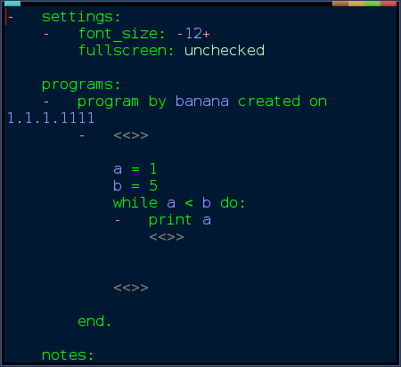
https://github.com/koo5/lemon-operating-language/blob/master/aside_gui.py
i didnt feel like advancing the ide prototype you see above, it was approaching a point of needing a rewrite dumping pyglets text module. There was no language functionality, just also mostly nonfuncional UI code. Realizing i have no idea how to practically go about building the language (the options man, the options!), i started learning PicoLisp. http://picolisp.com/
my first more serious venture into lisp and logic programming, this will take a while.
picolisp is: down to the metal: you can segfault it with bad lisp code
picolisp has: pilog, a built in prolog engine. Playing with Pyke was getting awkward.
picolisp is: minimal. perfect for me at this point.
current playground: https://github.com/koo5/lol

language “base” cluelessness of mine
how to do the right thing?
prolog or lisp?

TextNode
# value
NumberNode
# value
ListNode
# value
UseNode
# module, node, with(arguments)
syntax(): node.syntax()
SyntaxNode
#input->editing
DefinitionNode
# body,
ChildToken

builtins = UseNode(module = 'builtins', node = 'module', with =
{
'name' : TextNode("builtins module")
'body' : ListNode(
[
SyntaxNode(of = 'module', body = ListNode(
[
TextNode("module"),
ChildToken(TextNode("name")),
TextNode(":"),
ChildToken(TextNode("body"))
]? etc etc

homoiconicity, atoms, lists vs StatementsNodes...
shrug

unasked questions
what does lemon stand for?
Language Editor MONster!

semanticizing:
picolisp docs: done: https://github.com/koo5/lol/blob/master/scrape2.py
rosettacode: pondering,
https://github.com/acmeism/RosettaCodeData

this fucking document: depends on lemon:)

language features

http://en.wikipedia.org/wiki/Kaleidoscope_programming_language#Example

https://groups.google.com/d/topic/enoughmail/qjpbdA8QYrI/discussion

i7-like rules, rulebooks (AOP:p)
fsm block
boolean properties
what..does it mean..for the programming language? which part are we simplifying?

http://www.ifwiki.org/index.php/Inform_7_for_Programmers/Part_1#Boolean_Adjectives
repeat with associate running through every chatty not grumpy spiffy person begin; say "Hi [associate]."; end repeat;

knowledge bases - logic based programming

dataflow programming: http://www.jpaulmorrison.com/fbp/concepts.shtml
encapsulation
speed of rewiring?
i would like to differentiate myself from dataflow programming..it will be useful later, for certain cases...on higher levels, but its not the cure-all

like boolean function tables, but for everything...nice visualization

unification: generally acessible language? editing other languages?

Dataflow visualization:
Provide encapsulation through the metaphor of building blocks
Join blocks to create logic sequences
-as well as control flow

Problem:
How do you solve the problem of concurrent programming?
How do you represent complex tasks?

code completion
this is about the language object, and how it should be able to find all next legal tokens by a breadth-first search of the language syntax space - smarter than usual autocompletion - optimization of the menu

interesting discussion about this in the augmented programming mailing list, just ask there.

expression --> [banana].
expression --> [banana], ['*'], [banana].
%expression([banana|A], []).

http://www.ai.sri.com/~stickel/pttp.html
http://www.cs.sunysb.edu/~cram/cse637/Notes/README.html
https://www.usenix.org/conference/dsl-97/astlog-language-examining-abstract-syntax-trees
http://www.cs.bham.ac.uk/~pjh/sem1a5/pt3/pt3_vsp.html

||

http://www.cs.cmu.edu/afs/cs/project/ai-repository/ai/areas/reasonng/atp/systems/0.html
http://www-formal.stanford.edu/pub/clt/ARS/systems.html
http://en.wikipedia.org/wiki/Automated_theorem_prover
http://www.cs.ox.ac.uk/activities/machlearn/Aleph/aleph.html#SEC4
http://www.cs.unm.edu/~mccune/prover9/
btw...http://www.youtube.com/watch?v=7sk8hPWAMSw

&&&

http://web.engr.oregonstate.edu/~erwig/papers/Zurg_JFP04.pdf
http://www-ps.informatik.uni-kiel.de/~sebf/data/pub/atps09.pdf
https://github.com/mmirman/caledon
https://github.com/smichal/hs-logic

random notes
http://www.markwatson.com/opencontent_data/book_lisp.pdf

advantages of functional languages?
http://norvig.com/python-lisp.html
http://stackoverflow.com/questions/36504/why-functional-languages

LINQ
cshell.net

todo:
scrape & backup all links here

what people like Emacs?

+ #logger.info("key-handler")

https://github.com/tangentstorm/j
https://github.com/tangentstorm/coinops/blob/master/sha256.ijs

<sirdancealo2> inform 7 already exists and works pretty well, for how stupidly its
<sirdancealo2> built. If i slapped a good structure-aware (as is nowdays modern) editor
<sirdancealo2> onto it, 80% of the task would be accomplished. But im not sure inform
<sirdancealo2> would ever evolve the remaining 20%. So the logical thing to do is to
<sirdancealo2> build something new.
<sirdancealo2> you struggle with the idea of natural language programming. for one, you struggle with the english language. you probably had to adopt a different mindset to programming in a foreign language than native english speakers
<sirdancealo2> you percieve the language as a barrier
<sirdancealo2> english isnt my native language, but im an englophile
<sirdancealo2> i pretty often find myself thinking in english
<sirdancealo2> especially when it comes to programming or other topics i usually read about and discuss in english
<sirdancealo2> again, i think i7 is almost there. Yes the parser is complex, and employs concepts about time and space and uncertainity and linguistics, obviously
<sirdancealo2> but its there and it almost works, for my purposes
<sirdancealo2> i am trying to achive something similar. Maybe (and the best i can hope for), ill just push things a little bit forward. Maybe somebody smart will then come around and create inform 8:)
<sirdancealo2> so forget about thinking machines, think im just trying to merge two existing solutions that i think belong to each other

(21:36:03) ram boo: suppose you declare a banana object somewhere in your code
(21:36:43) ram boo: i want to follow i7 and give objects binary properties
(21:37:16) ram boo: there will be constructs for setting and testing them
(21:37:35) ram boo: "banana is yellow"
(21:38:01) ram boo: but the editor has to make much more sense from it
(21:38:51) ram boo: so thats where the interactivity comes in
(21:39:32) ram boo: by the time you typed banana, the banana you declared earlier remains in the palette as the only option
21:40
(21:40:10) ram boo: so if you dont do anything special and press spacebar to start typing the next word, the text transforms into a block
(21:40:58) ram boo: etc etc
(21:42:50) ram boo: you type "is", and maybe this time you have to press escape to differentiate it from another, longer word starting with "is"
(21:42:58) ram boo: and it transforms into a block again
(21:43:09) ram boo: and it knows it's the "is" keyword
(21:43:16) ram boo: which is kinda multipurpose but nvm
(21:43:33) ram boo: it knows its not a variable or anything else
(21:44:47) ram boo: it has never heard of "yellow", so theres some kind of interaction to estabilish it as a new thing
(21:44:58) ram boo: then when the sentence is complete, editor matches it with a pattern for setting binary properties
21:45
(21:45:36) ram boo: and you confirm it
(21:46:32) ram boo: and at this point the 3 words should become nodes of a new block
(21:47:28) ram boo: so im not sure if i wouldnt start fighting with blockly at this point
(21:47:50) ram boo: all i can imagine is that typing the sentence like this would lay parentless blocks one by one on the canvas
(21:48:22) ram boo: and the editor would have to remember they are associated
(21:48:33) ram boo: bleh
(21:49:11) ram boo: the example i was actually thinking first is testing for the properties
(21:49:27) ram boo: you write "if" and press space and an if block is created
(21:49:35) ram boo: cursor moves to its expression slot
21:50
(21:50:13) ram boo: you write banana and its a valid expression, so it joins into the slot
(21:50:55) ram boo: but cursor would have to move beyond banana and let you add more blocks in case you are intending a more complicated experssion starting with banana

<sirdancealot8> 1) An editor for lisp...a structured one, tree view
<sirdancealot8> 2) give every structure a descriptive structure that will shuffle around the order of its items (arguments)
<sirdancealot8> 3) remake some basic sentences from inform7
<sirdancealot8> 4) add to the descriptive structures a list of synonyms, have every program item surrounded by a cloud of those, allow to display one of the synonyms instead of the primary word
<sirdancealot8> 5) have the editor, when you type some word or synonym let you easily choose what you mean, choose the most probable meaning by default
<sirdancealot8> so you can be writing your program in almost-english and just confirming right meanings with spacebar
<sirdancealot8> typing "a house is an object": "a house" -> editor is clueless, offers "a house - something new", confirm
<sirdancealot8> "is an" -> editor perks up, matches "is an" with is, which is some function, also sees is is supposed to have something new on the left side and something known on the right
<sirdancealot8> object, known, voila, enter

“
I think that the biggest advance of the last 20 years has been sound and flexible polymorphic typing (parametric or template polymorphism). I say 20 years as a compromise between 30 years ago, when most of the work was done in academia, and 10 years ago, when you started seeing the results of this work in mainstream PLs. Right now "correct-by-construction" is the academic big thing; I expect to see real-world languages that support this concept reasonably about 2030 if I live that long.

To close where Markus opened: Underlying the idea that PLs need to be improved is the assumption that much of the difficulty and complexity of programming today is still what Brooks famously called "accidental": due to poor tools or processes rather than inherent in the problem to be solved. I don't know how true I believe this to be. More and more as I get older, I find that my bugs are from not understanding what I was trying to do, and my low productivity is because I'm solving hard problems. YMMV.

--Bart
“ ->http://adam.chlipala.net/cpdt/html/Intro.html
-> http://homepages.inf.ed.ac.uk/stg/NOTES/
“ The present state of programming
is that well-designed modern imperative languages such as Java [AG96] come close to offering
the type security and programming convenience which functional programming languages
offered in the 1970’s. The interest in and increasing adoption of this language should be
viewed as an encouraging, if slow, shift away from the miserliness which has bedevilled
programming practice since the inception of the profession."

text editor mode:
concrete syntax tree based
(vs eclipse text based and mps ast based)
mapping to text and back

markdown as a first language
c syntax mode
higher constructs should map to function calls

(old) python stuff

from the start its pretty obvious that sooner or later either I will hate to switch to lisp or lisp will have to switch to me:
http://hy.pault.ag/
potential engine:
http://blocky.io/
ElementTree
http://effbot.org/zone/element-index.htm
MiniDom
http://wiki.python.org/moin/MiniDom
http://programmers.stackexchange.com/questions/199534/homogeneous-vs-heterogeneous-ast-representation?rq=1
3

the pyglet gui
AnkhMorporkian_> thoughts i have though. there has to be a good message passing protocol defined between objects.

AnkhMorporkian_> it would be much easier to add syntax checking for each object and just report valid or invalid, so you could like color the offender red or something

AnkhMorporkian_> secondly, i think a lot can be done with decorators instead of creating a bunch of truly different GUI objects.

>> presentations

# Disable error checking for increased performance
pyglet.options['debug_gl'] = False

old stuff

data format: check
text inputting: check (phase 1)

option 0:
use blockly

option 1:
continue remaking blockly in python
slap a keyboard cursor and autocompletion onto it, make an editor for ACE (inside it). Im not comfortable with the idea of two and later more modes: the main, outer, AST blocks (scratch). A special mode inside an ACE block for editing ACE.
must learn ace + prolog...
where is RACE hidden? or how do we do the reasoning? how does it connect..

option 2:
spawn a new language with the phase 1 editor, must learn making parsers..
this is already a win here, because an unobtrusive semantic aware editor should allow for a better language than i7

option 4:
editor for i7

phase 1...
keyboard input, with autocompletion of individual tokens
editor has no idea about syntax -> syntax errors are possible
seamlessly confirming autocompleted words, or selecting from a menu
-> user is interactively “tokenizing” the code
programmers are used to editing text
beyond simple languages with restricted vocabulary, is keyboard not necessary?
effectivity, speed of work?
advantages over visual languages:
keyboard-oriented
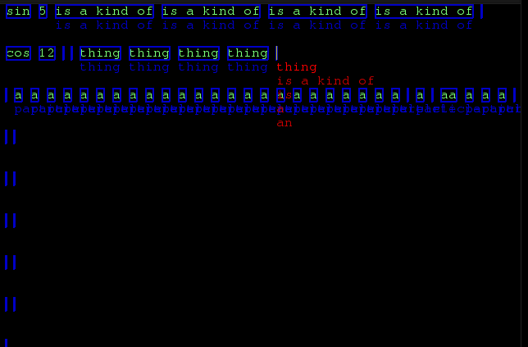

https://github.com/koo5/secret-banana/blob/8b448464a7f56c805d146e9c54ab7ab9bc9f47e9/main.py
abandoned after learning about parsers.
great testing out of the menu idea and splitting of tasks between language user and programmer, it seems sane.

phase 2
lets get fully visual, with syntax too, scratch style
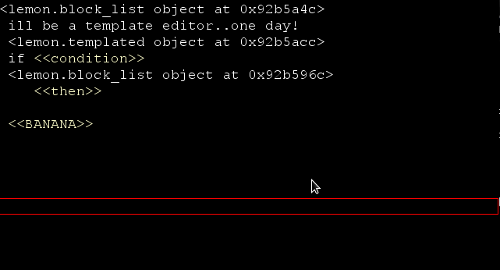
what’s done:
a tree of objects for the gui (control, label, textbox, list, block)
move cursor up and down

what’s missing:
move cursor left / right
focus element under cursor
highlight focused element

dummy object should have a type property, specifiing the type of blocks it accepts (within the language ast space)
dummy changes into inputty, text box + menu
menu is filled by the language object
chain nodes
attempt compilation
...

goals:
the AST of the program is given by the nesting of the gui elements
basic elements:
element
text
textbox

?
containers:
horizontal container - a line
vertical container - lines
indented lines

?
node - ast node base class
- children acessible by name
- presentation given by a nodetype node
nodetype:
presentation attribute -
later todo - presentation editor

simple way:
type

typetype:

either generic function call or a special node type
AppLaunch

do:
functioncall(lib=base, name=launchapp, ….
or
baselib.launchapp(s.lib,s.name,s.params)
presentations =
[
lines(line(s.icon, s.name))
lines(line(s.icon, text(“launch”), s.name))
]

setpos
getrect

event architecture?

still not happy with the blocks format, how about this:
would be nice to generate the language block descriptions from ACE texts...//->fuxi or pyke
pyswip-> prolog

phase 2a:
evaluate alice pascal and the jetbrains thingy
either continue recreating the basic visual language functionality in python or use google blockly
google blockly - a scratch clone - blocks in js. Possible base.
http://code.google.com/p/blockly/source/browse/trunk/language/common/control.js
add cursor and full keyboard control
add menu for adding blocks
also for ace words - extendable with other kinds of items

phase 3?
ace expression block:
contains subblocks - words
use the editor from phase 1?
makes words available in menu according to ace syntax and vocabulary -
http://attempto.ifi.uzh.ch/site/docs/authoring_tools.html
freakin javascript again..->blockly?
bnf block? math expressions. this should be but isnt(?) fully supported by ace

prolog and beyond
http://www.csupomona.edu/~jrfisher/www/prolog_tutorial/7_3.html
http://www.allisons.org/ll/Logic/Prolog/Examples/

http://en.wikipedia.org/wiki/Visual_Prolog
http://www.learnprolognow.org/lpnpage.php?pagetype=html&pageid=lpn-htmlse1

http://mitpress.mit.edu/sicp/full-text/book/book-Z-H-29.html#%_sec_4.4
http://en.wikipedia.org/wiki/Mercury_%28programming_language%29

http://aabs.wordpress.com/2010/03/10/programming-with-petri-nets/
https://www.google.com/search?client=ubuntu&channel=fs&q=reasoning+in+Common+lisp

21321
http://dslbook.org/
http://home.gna.org/oomadness/en/soya3d/index.html
http://sourceforge.net/projects/presage/?source=directory
https://www.mail-archive.com/picolisp@software-lab.de/msg04193.html

design document-sorta questions
What is the current problem?
ttp://tunes.org/papers/WhyNewOS/WhyNewOS.html

Why is visual programming a better alternative?
http://alarmingdevelopment.org/?p=680

Will the abstraction lead to a loss of control in what programmer's want to achieve?
AKA Does the visual nature of the language lead to a “dumbing” down of the possibilities that can be achieved?
Are visual languages predominantly object-oriented?

How do current implementations solve the above problems and what are the drawbacks?
visual languages:
scratch:: yeah, lets google that.
is not keyboard-friendly -> is not real programmer friendly
->its a learning language
various visual app creators targetting mobile os's:
falling back on c-like languages?
http://blockly-demo.appspot.com/static/apps/turtle/en.html
visual programming language workflow:
1)a menu of available constructs, click on one and drag it to the work area
2)connect more pieces
a person can reach a state of flow with mouse as well as with keyboard

4. What are the drawbacks of such systems?
scratch:
visual languages are either beginner languages, or constrained to a specific domain, or at least not adding any expressivity for the programmer to use...

haxe, everybodys different, dont give me macros, problems of livecoding

5. controlled natural languages

ACE and friends:
http://attempto.ifi.uzh.ch/site/docs/
"One of the problems of controlled natural languages is that the restrictions of the language have to be learned in order to write correct sentences. "
“A possible solution for this problem is to provide predictive authoring tools. Such an authoring tool guides the user during the creation or modification of sentences. It makes sure that only valid sentences can be created. Thus, parsing these sentences with the ACE parser will never lead to errors. “

IMPORTANT: I also realize your goal is to create a functional system and this approach might be more academic. Definitely try to push it in a way that is more hands-on rather than potential writing BS

build upon inform7 and make it writable:
get beyond code-completion
get beyond avoiding syntax errors by making a language mouse-only
#side stuff: what would be the easiest made ide for i7 solving its problems?
centering on usability
usability is not noob friendliness (scratch)

to research:
reasons of failures of natural language command systems

http://cmusphinx.sourceforge.net/
better start playing with this sooner than later, could affect the data structures of lemon
->phonemes(?) have probabilities…
->see emacs
https://wit.ai/
as a service
provide grammar or examples

“asimov’s laws in n3”:
http://en.wikipedia.org/wiki/Three_Laws_of_Robotics
http://en.wikipedia.org/wiki/OpenCog
http://www.amoon.ca/Roboethics/links/
http://en.wikipedia.org/wiki/Artificial_intelligence_systems_integration
https://sites.google.com/site/goaldrivenaiengine/
http://en.wikipedia.org/wiki/2APL

unified interface to (desktop) programs
database of / interface to existing programs, possibly with a frontend
usable by lemon and other projects
unified searchable access to: command line programs, daemons and gui programs.
examples: some power management daemon, bitcoin, pidgin, gimp --batch
(old) https://gist.github.com/koo5/5624786
could start building the database, but useless without an ui
idea of a basic ui:
no natural language understanding, just text search of database
command name: 'use'
$ use turn off monitor
$ use get package source picolisp
-> code snippets

https://github.com/chriskiehl/Gooey

betty.
https://github.com/pickhardt/betty/tree/dev

two-phase-ui:) : https://github.com/koo5/hackery/blob/master/hackery/getgit.py

desktop environment
http://telepatx.deviantart.com/gallery/43175155
hypothetical goal desktop environment:
apps made in various high level reflecting langs
compatibility on high level
what do you think gnome3 was about? what did it bring besides assholic UI experimentation and an api for an unified notification area

what did i learn, why do i need another "language"? #or restart lemon...in python..((minneron, vsh), ipython, pyke?)..?
user interface as high level programming, one language system, accessibility of a programming language/ide to programmers of all backgrounds...

I think im starting to see a common pattern here. The keywords are existing functionality and huge codebases unhackable by us mere mortals, and the undercurrent under our efforts for one-language desktops is desperation. If we only had the perfect language, we could rewrite it all ourselves and better, it would be hackable and awesome...

start building a common interface to existing code. A gui, even, a console of sorts, giving unified documented searchable access to: command line versions of programs (for example gimp) and running instances of daemons (for example bitcoin) and even gui programs (pidgin).

many programs are well suited for that, and the rest can be fun to hack in this way.
lemon 3 had several xscreensaver hacks chopped up and running in parallel in one opengl window. my focus is now empowering myself and other UX people, rather than inventing the perfect GUI right away.

zoom it!
http://eaglemode.sourceforge.net/philosophy.html

limit theory (“nodal” interface) http://www.youtube.com/user/LimitTheory

http://adamfurman.privatepage.sk/PythonOS/

http://webcredits.org/ micropayments(although agreggating might work too) as a solution to accesibility of useful APIs

http://blogs.gnome.org/aday/2014/07/23/sandboxed-applications-for-gnome-part-2/

i7 player command parser
...
power management, freedombox gui

http://sourceforge.net/projects/vwm/
http://sourceforge.net/projects/twin/

http://en.wikipedia.org/wiki/Comparison_of_command_shells#Command_builder

also look at unity, kde's "converged desktop", original gnome3 effort (they seem
to be doing the right things, like with GOA as opposed to UOA)
could even look into tighter integration of unity lenses with lemon.
but most of all, this seems to be the lowes common denominator, the mainstream attempt
at high level computing. We should plug ourselves there somewhere.
All these ideas here arent new ideas, but things tried and retried...
what does it all mean?

fish
http://fishshell.com/ https://github.com/bpinto/oh-my-fish
what coud be added: live/context sensitive keybindings display/help
snippets / command metadata, that is, autocompletion, searching, based on whats typed, a database of metadata/snippets with textual descriptions. For example: replace x with y -> sed…
whats needed: add an autocompletion function that searches stuff and calls other fish functions, a difference from the rest of fish autocompletion is that upon selection, the typed text (or some last part of it, like after a pipe) is deleted and replaced. i think zsh does this

bash syntax highlighting: i’d expect bash isnt that customizable and youd have a hard time hacking the internals to even show any color, so a new line editor might be better. I dont think theres much functionality to replicate, line editing, history, .. python cmd again or whatitwas?

high level computing in general
fish (above)
universal package manager(s)
https://www.youtube.com/watch?v=N8CZhlIssdk
gnome desktop app sandboxing
freedombox gui

other neat stuff:
browser filesharing?

plover
open source computer stenography
https://raw.github.com/FauxFaux/ploversearch/master/dict.json
https://plover.goeswhere.com/#test
https://docs.google.com/drawings/d/1Ff2X6xwHICfjn_SYd2RDleIb60OUASG3zSmhYdN-5Ss/edit
http://stenoknight.com/wiki/FAQ#How_does_it_work.3F

cringe time
http://www.gamedev.net/topic/54302-project-to-construct-consolidate-amp-unify-libraries-amp-tools-into-a-documented-suite/
lisp machines could go here too

acessing knowledgebases

https://github.com/acmeism/RosettaCodeData
https://github.com/lucjon/Py-StackExchange

software cartography
http://scg.unibe.ch/research/softwarecartography
http://www.memofon.com/

sketches of future code
currently two kinds of things here, the structures and the textual appearances
before you run off in a laughing disbelief, realize it isnt the language appearance but the one language - one desktop environment that is hard to believe
https://gist.github.com/koo5/6611262
https://gist.github.com/koo5/6551885
https://docs.google.com/document/d/1Qo9yanAmvdW9Oq5L0c2I9Ye2RP2PVq1rN4veQ1aKBN0/edit
https://github.com/koo5/cytron/blob/master/footnotes.txt

current best practices
how to stay sane

C
mbeddr
SC programming language

undefined behavior, static analyzers, valgrind, clang, lint
http://blog.llvm.org/2011/05/what-every-c-programmer-should-know.html
http://www.locklessinc.com/articles/obscurec/
https://docs.google.com/presentation/d/1h49gY3TSiayLMXYmRMaAEMl05FaJ-Z6jDOWOz3EsqqQ/preview#slide=id.gaf9c6eef_010

python
macropy: https://github.com/lihaoyi/macropy
hy: http://docs.hylang.org/en/latest/

editors:
http://ipython.org/notebook.html
http://www.reinteract.org/
http://www.ubiquitouslarch.com/
www.jetbrains.com/pycharm/

http://www.dabeaz.com/ply/
https://github.com/dabeaz/ply/blob/master/example/BASIC/basiclex.py

http://en.wikipedia.org/wiki/List_of_tools_for_static_code_analysis#Python

Datahaven
http://www.datahaven.net/automats.html
An inspirative piece of software. i like the (internal) feel of this app, designed in ms visio, generated python classes for fsms, you can, at runtime, inspect the state of each fsm, events, packets, logs.. Worth studying. They are working on version two, hopefully will be more useful.

logic programming in python
https://www.google.cz/search?q=logic+programming+in+python
http://en.wikipedia.org/wiki/Flora-2
http://pyke.sourceforge.net/about_pyke/index.html - not suitable
https://sites.google.com/site/pydatalog/ - maybe datalog by design isnt suitable
https://code.google.com/p/fuxi/ - not for mere mortals but im told the guy knows what hes doing
http://matthewrocklin.com/blog/work/2013/01/14/LogPy-Introduction/
http://minikanren.org/
unipycation seems good, albeit a temporary solution. Would complicate distribution of lemon but not a problem at this phase. And its a nice project, i want to play with it. Also get in touch with pypy, since rpython is what lemon might be in future rewritten to. Without unipycation, obviously. building unipycation: https://gist.github.com/koo5/393746b19624debb2472
Maybe move to yield python later?

dynamic objects in logic programming
strange question...
http://www.swi-prolog.org/packages/xpce/examples.html
http://www.swi-prolog.org/packages/xpce/UserGuide/sec-D.1.html
http://www.w3.org/TR/sparql11-update/
http://www.amzi.com/articles/prolog_fun.htm

stuff
http://coq.inria.fr/a-short-introduction-to-coq
http://adam.chlipala.net/cpdt/html/Intro.html
http://hyperpolyglot.org/ml#polymorphism
http://c2.com/cgi/wiki?WikiIde
http://dwave.wordpress.com/2011/06/01/learning-to-program-the-d-wave-one-introduction-to-binary-classification/ - another neural nets tutorial
http://stenoknight.com/wiki/Main_Page
http://en.wikipedia.org/wiki/Society_of_Mind
http://www.vivomind.net/
http://www.jfsowa.com/
http://forums.ltheory.com/viewtopic.php?f=6&t=1573
http://www.gnu.org/software/guile/
https://github.com/jashkenas/coffee-script/wiki/List-of-languages-that-compile-to-JS
http://home.pipeline.com/~hbaker1/ForthStack.html
http://en.wikipedia.org/wiki/Semantic-oriented_programming#SymADE - dead
https://news.ycombinator.com/item?id=7743002
http://docs.racket-lang.org/xrepl/index.html

Emacs! we need a paragraph about emacs!
http://www.emacswiki.org/emacs/EmacsVersor
http://shorttalk-emacs.sourceforge.net/
http://www.emacswiki.org/emacs/EmacSpeak
http://emacspeak.sourceforge.net/applications.html
http://emacspeak.sourceforge.net/publications/semantic-www.html
“The very nice Emacs philosophy of only working with text comes very handy here- Emacspeak can (and does) implement special voice enabling features for nearly every widespread major and minor mode.”
http://c2.com/cgi/wiki?EmacsAsOperatingSystem
“... and Emacs' buffers are a remarkably simple unified interface to everything on the earth, comparable to CommandLineInterface.”
http://www.damtp.cam.ac.uk/user/sje30/emacs/ell.html

Emacs is mis-marketing itself as a text editor. it is a lipsOS. so, lemon as a part of emacs? Lemmacs?

eulergui
jmv goes beyond describing business model, to describing more app functionality
(declarative guis) (x QML)
also relevant for N3 and reasoning as the possible base language…
and for use of ACE, to describe lemon object model maybe
also, advanced “semantic web browser” / search, triple editor. data store, basically lots of functionality that should one day be available from lemon gui

http://stackoverflow.com/questions/7634618/jena-tdb-in-python
http://code.google.com/p/python-graphite/
http://lawlesst.github.io/notebook/pyjniusvivo.html
https://jena.apache.org/documentation/tdb/commands.html#tdbquery

relevant linked data guis:
http://www.irisa.fr/LIS/ferre/sparklis/osparklis.html
http://www.irisa.fr/LIS/softwares/sewelis

general and/or philosophy and/or programming and/or interesting and/or fun reading
http://www.martinfowler.com/articles/languageWorkbench.html
http://rosettacode.org/wiki/Rosetta_Code
http://worrydream.com/LearnableProgramming/
http://prog21.dadgum.com/
http://alarmingdevelopment.org/
http://awelonblue.wordpress.com/
http://joshondesign.com/
http://www.everything2.com/index.pl?node_id=1406540
http://thedailywtf.com/Articles/An-IDE-Impostor.aspx
http://worrydream.com/dbx/
http://lambda-the-ultimate.org/node/4295
http://teebrz.wordpress.com/2013/07/20/on-holistic-programming-languages/
http://blog.samibadawi.com/2013/05/lisp-prolog-and-evolution.html
http://chriskohlhepp.wordpress.com/law-of-tangental-complexity/
http://junkato.jp/
http://en.wikipedia.org/wiki/Comparison_of_code_generation_tools

