CSS3 Keyframes Animation을 이용한 height 애니메이션 효과 구현

소스다운로드

[[http://i1.daumcdn.net/cfs.tistory/resource/1519/blog/image/extension/zip.gif](http://incblue.tistory.com/attachment/cfile5.uf@237C433654609E2F399265.zip) height.zip](http://incblue.tistory.com/attachment/cfile5.uf@237C433654609E2F399265.zip)





CSS3 Keyframes Animation을 이용한 font-size 애니메이션 효과 구현

소스다운로드

[[http://i1.daumcdn.net/cfs.tistory/resource/1519/blog/image/extension/zip.gif](http://incblue.tistory.com/attachment/cfile27.uf@2561B43A54609DB82B4061.zip) font-size.zip](http://incblue.tistory.com/attachment/cfile27.uf@2561B43A54609DB82B4061.zip)





CSS3 Keyframes Animation을 이용한 color 애니메이션 효과 구현

소스다운로드

[[http://i1.daumcdn.net/cfs.tistory/resource/1519/blog/image/extension/zip.gif](http://incblue.tistory.com/attachment/cfile6.uf@27375A3454609D302BA478.zip) color.zip](http://incblue.tistory.com/attachment/cfile6.uf@27375A3454609D302BA478.zip)





CSS3 Keyframes Animation을 이용한 box-shadow 애니메이션 효과 구현

소스다운로드

[[http://i1.daumcdn.net/cfs.tistory/resource/1519/blog/image/extension/zip.gif](http://incblue.tistory.com/attachment/cfile9.uf@2262E14D546095AD09AD21.zip) box-shadow3.zip](http://incblue.tistory.com/attachment/cfile9.uf@2262E14D546095AD09AD21.zip)





CSS3 Keyframes Animation을 이용한 box-shadow 애니메이션 효과 구현

소스다운로드

[[http://i1.daumcdn.net/cfs.tistory/resource/1519/blog/image/extension/zip.gif](http://incblue.tistory.com/attachment/cfile3.uf@257263505460955516E7E2.zip) box-shadow2.zip](http://incblue.tistory.com/attachment/cfile3.uf@257263505460955516E7E2.zip)





CSS3 Keyframes Animation을 이용한 box-shadow 애니메이션 효과 구현

소스다운로드

[[http://i1.daumcdn.net/cfs.tistory/resource/1519/blog/image/extension/zip.gif](http://incblue.tistory.com/attachment/cfile25.uf@227168505460950316C95D.zip) box-shadow1.zip](http://incblue.tistory.com/attachment/cfile25.uf@227168505460950316C95D.zip)





CSS3 Keyframes Animation을 이용한 border-width 애니메이션 효과 구현

소스다운로드

[[http://i1.daumcdn.net/cfs.tistory/resource/1519/blog/image/extension/zip.gif](http://incblue.tistory.com/attachment/cfile1.uf@265CB54E546094A33A8AF9.zip) border-width3.zip](http://incblue.tistory.com/attachment/cfile1.uf@265CB54E546094A33A8AF9.zip)





CSS3 Keyframes Animation을 이용한 border-width 애니메이션 효과 구현

소스다운로드

[[http://i1.daumcdn.net/cfs.tistory/resource/1519/blog/image/extension/zip.gif](http://incblue.tistory.com/attachment/cfile24.uf@236788485460942E308F54.zip) border-width2.zip](http://incblue.tistory.com/attachment/cfile24.uf@236788485460942E308F54.zip)





CSS3 Keyframes Animation을 이용한 border-width 애니메이션 효과 구현

소스다운로드

[[http://i1.daumcdn.net/cfs.tistory/resource/1519/blog/image/extension/zip.gif](http://incblue.tistory.com/attachment/cfile26.uf@2253BB4C546093D519BB4E.zip) border-width1.zip](http://incblue.tistory.com/attachment/cfile26.uf@2253BB4C546093D519BB4E.zip)





CSS3 Keyframes Animation을 이용한 border-radius 애니메이션 효과 구현

소스다운로드

[[http://i1.daumcdn.net/cfs.tistory/resource/1519/blog/image/extension/zip.gif](http://incblue.tistory.com/attachment/cfile2.uf@2125C14F546092D23A3950.zip) border-radius2.zip](http://incblue.tistory.com/attachment/cfile2.uf@2125C14F546092D23A3950.zip)

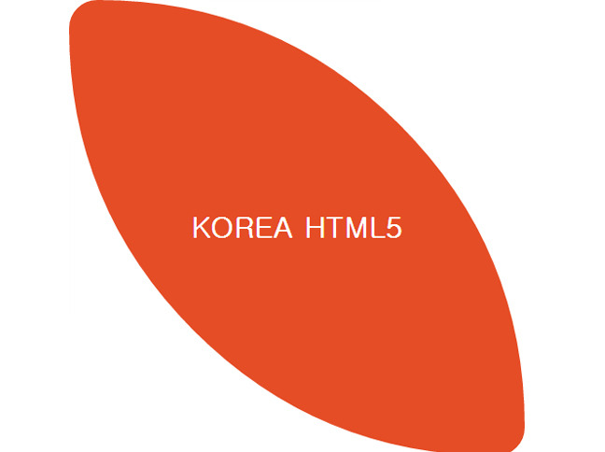



CSS3 Keyframes Animation을 이용한 border-radius 애니메이션 효과 구현

소스다운로드

[[http://i1.daumcdn.net/cfs.tistory/resource/1519/blog/image/extension/zip.gif](http://incblue.tistory.com/attachment/cfile2.uf@247B2A48546093090B5BEF.zip) border-radius1.zip](http://incblue.tistory.com/attachment/cfile2.uf@247B2A48546093090B5BEF.zip)

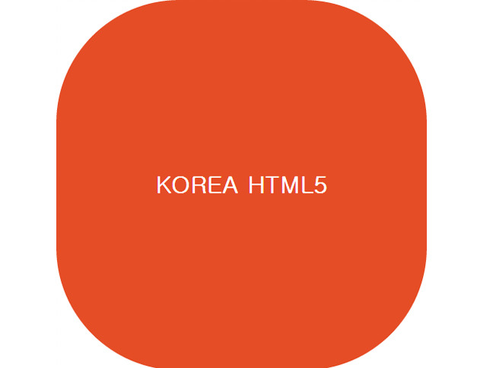



CSS3 Keyframes Animation을 이용한 background-size 애니메이션 효과 구현

소스다운로드

[[http://i1.daumcdn.net/cfs.tistory/resource/1519/blog/image/extension/zip.gif](http://incblue.tistory.com/attachment/cfile8.uf@24589B4C546091F707733B.zip) background-size.zip](http://incblue.tistory.com/attachment/cfile8.uf@24589B4C546091F707733B.zip)





CSS3 Keyframes Animation을 이용한 background-position 애니메이션 효과 구현

소스다운로드

[[http://i1.daumcdn.net/cfs.tistory/resource/1519/blog/image/extension/zip.gif](http://incblue.tistory.com/attachment/cfile3.uf@21261C4A5460916F1B4DCE.zip) background-position.zip](http://incblue.tistory.com/attachment/cfile3.uf@21261C4A5460916F1B4DCE.zip)





CSS3 Keyframes Animation을 이용한 background-color 애니메이션 효과 구현

소스다운로드

[[http://i1.daumcdn.net/cfs.tistory/resource/1519/blog/image/extension/zip.gif](http://incblue.tistory.com/attachment/cfile26.uf@215E224E546090D8256FDA.zip) background-color.zip](http://incblue.tistory.com/attachment/cfile26.uf@215E224E546090D8256FDA.zip)

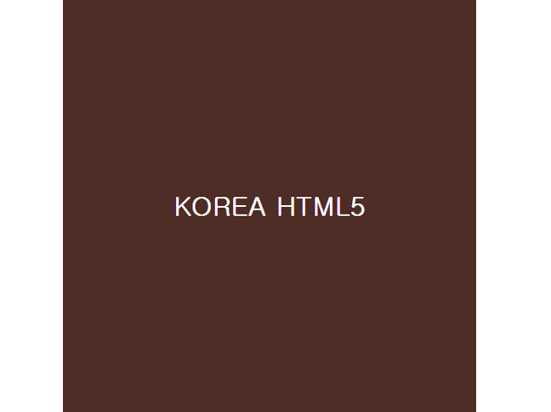



CSS3 Generator- html5 활용예제

"CSS3 속성중 Border Radius, Box Shadow, Text Shadow, RGBA, @Font Face, Multiple Columns, Box Resize,   
Box Sizing, Outline, Transitions, Transform, Selectors, Gradients 코드를 생성해주는 예제입니다."

소스다운로드

[[http://i1.daumcdn.net/cfs.tistory/resource/1519/blog/image/extension/zip.gif](http://incblue.tistory.com/attachment/cfile9.uf@263C694C5460906C307243.zip) css3generator.zip](http://incblue.tistory.com/attachment/cfile9.uf@263C694C5460906C307243.zip)

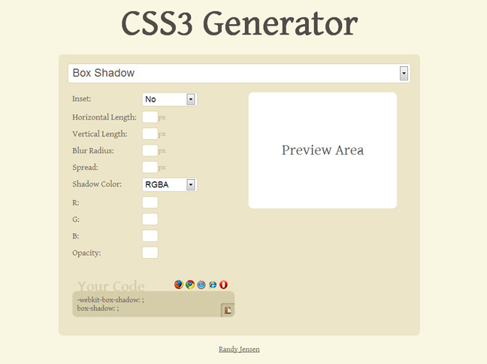



CSS3 border-radius 속성을 눈으로 직접확인하고 직접 쓸수있는 code를 제공하는 예제입니다.

소스다운로드

[[http://i1.daumcdn.net/cfs.tistory/resource/1519/blog/image/extension/zip.gif](http://incblue.tistory.com/attachment/cfile3.uf@2575153854608F1323F7BA.zip) border-radius.zip](http://incblue.tistory.com/attachment/cfile3.uf@2575153854608F1323F7BA.zip)

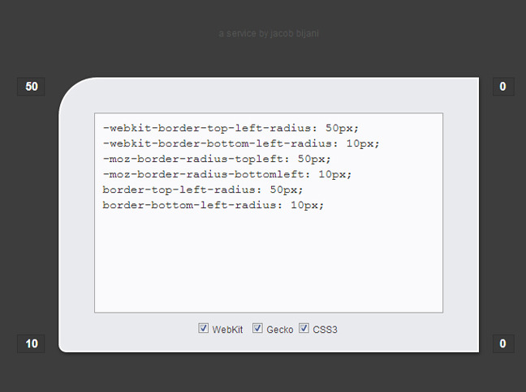



3D walking robot- html5 활용예제 CSS3를 이용한 로봇 구현 예제

소스다운로드

[[http://i1.daumcdn.net/cfs.tistory/resource/1519/blog/image/extension/zip.gif](http://incblue.tistory.com/attachment/cfile1.uf@23193D4A54608C2E13D402.zip) 3D_walking_robot.zip](http://incblue.tistory.com/attachment/cfile1.uf@23193D4A54608C2E13D402.zip)

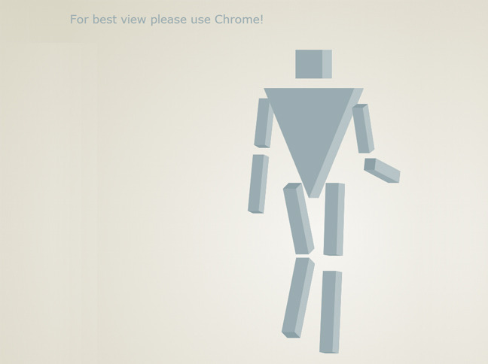



I decided my first experiment with 3D in CSS would be recreating the classic N64 I'm so fond of.

소스다운로드

[[http://i1.daumcdn.net/cfs.tistory/resource/1519/blog/image/extension/zip.gif](http://incblue.tistory.com/attachment/cfile9.uf@225A6D4B54608BAE0FD76A.zip) N64_Logo_in_CSS.zip](http://incblue.tistory.com/attachment/cfile9.uf@225A6D4B54608BAE0FD76A.zip)

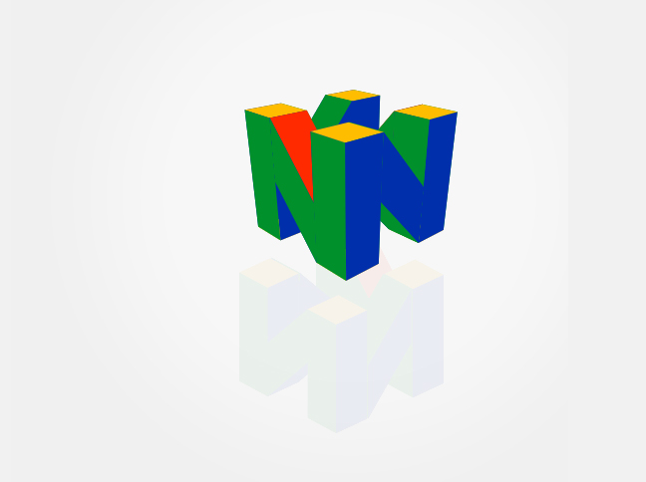



**CSS3 3D image animation- html5 활용예제**

more experimenting with displaying images in 3d slices    using css - development from   http://codepen.io/dehash/pen/mBnsG - practicing some more haml/scss too

소스다운로드

[[http://i1.daumcdn.net/cfs.tistory/resource/1519/blog/image/extension/zip.gif](http://incblue.tistory.com/attachment/cfile3.uf@232FC24754608B2A0E5F1B.zip) CSS3_3D_image_animation.zip](http://incblue.tistory.com/attachment/cfile3.uf@232FC24754608B2A0E5F1B.zip)

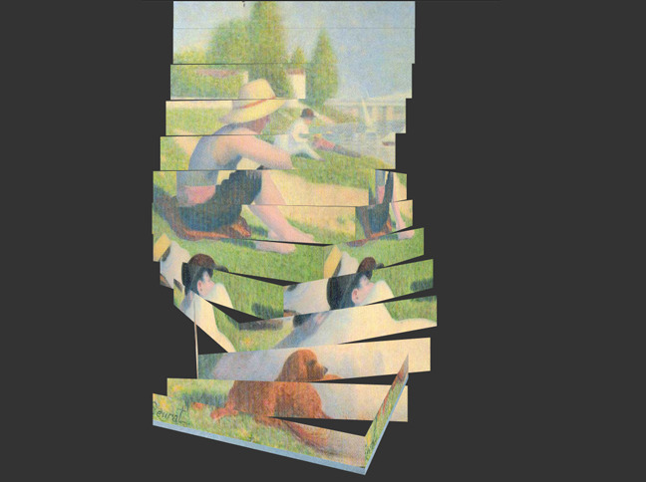



Canvas experiment inspired by Muscular Hydrostats (made by Soulwire) Hair- html5 활용예제

소스다운로드

[[http://i1.daumcdn.net/cfs.tistory/resource/1519/blog/image/extension/zip.gif](http://incblue.tistory.com/attachment/cfile2.uf@21504A4E54608A9C183616.zip) Hair.zip](http://incblue.tistory.com/attachment/cfile2.uf@21504A4E54608A9C183616.zip)

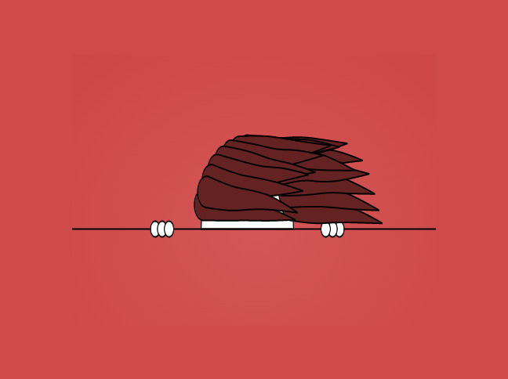



I wanted to demo the new HTML and CSS3 animations and transforms to a client using their own logo and only HTML / CSS. No javascript or flash was harmed in the making of this. I use a combination of gradients and a separate div to create the shader and glossy highlights.

- html5 활용예제

소스다운로드

[[http://i1.daumcdn.net/cfs.tistory/resource/1519/blog/image/extension/zip.gif](http://incblue.tistory.com/attachment/cfile30.uf@2473813854608A0A09827C.zip) Pure_HTML_CSS_3D_Animation.zip](http://incblue.tistory.com/attachment/cfile30.uf@2473813854608A0A09827C.zip)

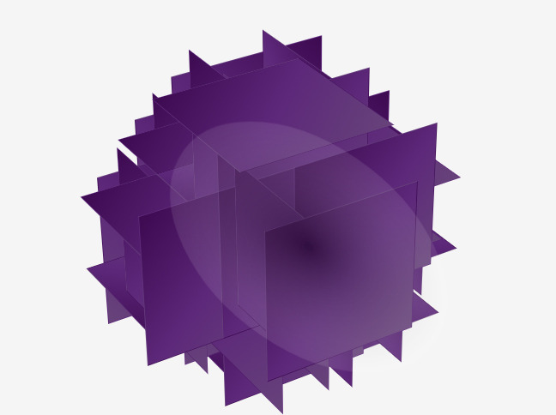



Metaball particle clock.- html5 활용예제- html5 활용예제

소스다운로드

[[http://i1.daumcdn.net/cfs.tistory/resource/1519/blog/image/extension/zip.gif](http://incblue.tistory.com/attachment/cfile22.uf@27340B3D54608985243DD8.zip) Metaball_particle_clock.zip](http://incblue.tistory.com/attachment/cfile22.uf@27340B3D54608985243DD8.zip)

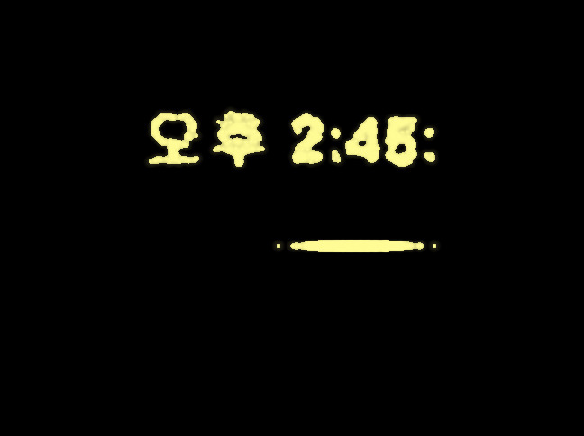



**Auto Type! (Pure CSS)- html5 활용예제**

a Auto Type with only CSS!

소스다운로드

[[http://i1.daumcdn.net/cfs.tistory/resource/1519/blog/image/extension/zip.gif](http://incblue.tistory.com/attachment/cfile27.uf@21469D485460873E1FBC54.zip) Auto_Type.zip](http://incblue.tistory.com/attachment/cfile27.uf@21469D485460873E1FBC54.zip)

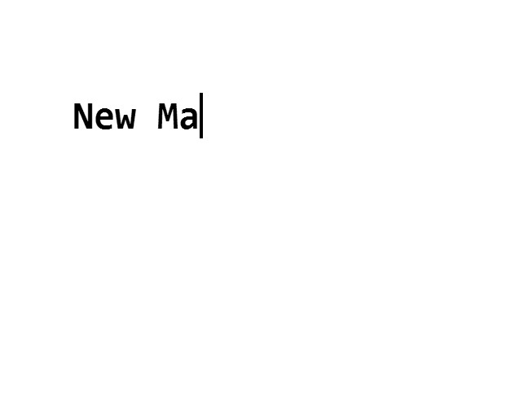



Blue Canvas Clock 파란시계- html5 활용예제

소스다운로드

[[http://i1.daumcdn.net/cfs.tistory/resource/1519/blog/image/extension/zip.gif](http://incblue.tistory.com/attachment/cfile29.uf@2319374C5460869133DBB7.zip) Blue_Canvas_Clock.zip](http://incblue.tistory.com/attachment/cfile29.uf@2319374C5460869133DBB7.zip)





Tunnel of Doom 둠과터널- html5 활용예제

소스다운로드

[[http://i1.daumcdn.net/cfs.tistory/resource/1519/blog/image/extension/zip.gif](http://incblue.tistory.com/attachment/cfile22.uf@233E054E546085721AC64B.zip) CSS3_Image_Tunnel.zip](http://incblue.tistory.com/attachment/cfile22.uf@233E054E546085721AC64B.zip)

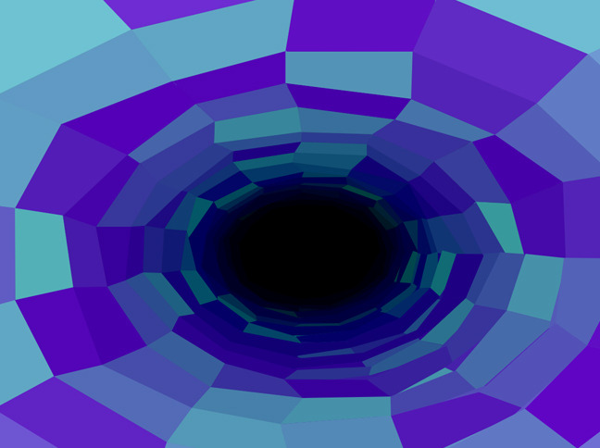



CSS3 Image Tunnel 이미지터널 - html5 활용예제

소스다운로드

[[http://i1.daumcdn.net/cfs.tistory/resource/1519/blog/image/extension/zip.gif](http://incblue.tistory.com/attachment/cfile9.uf@24338436546085181ABB92.zip) CSS3_Image_Tunnel(2).zip](http://incblue.tistory.com/attachment/cfile9.uf@24338436546085181ABB92.zip)

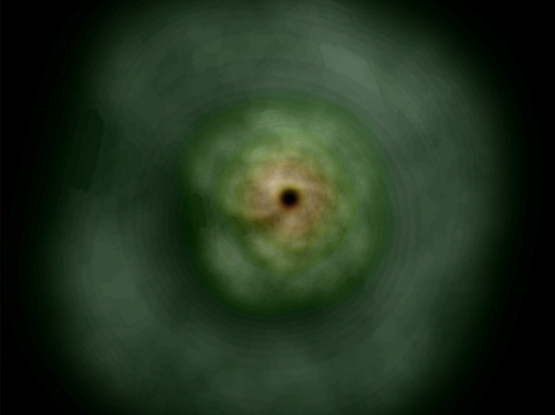



Will now move on to 3D :D /3D, GRAPHICS & EFFECTS- html5 활용예제

소스다운로드

[[http://i1.daumcdn.net/cfs.tistory/resource/1519/blog/image/extension/zip.gif](http://incblue.tistory.com/attachment/cfile7.uf@2637C435546084AB02D6D1.zip) Wohoo.zip](http://incblue.tistory.com/attachment/cfile7.uf@2637C435546084AB02D6D1.zip)

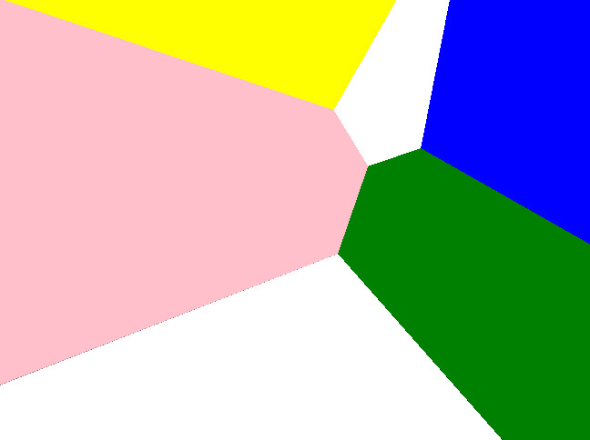



A sun to bring cheer to your day- html5 활용예제 태양그리기

소스다운로드

[[http://i1.daumcdn.net/cfs.tistory/resource/1519/blog/image/extension/zip.gif](http://incblue.tistory.com/attachment/cfile4.uf@252A9237546083BD349FEE.zip) Sun.zip](http://incblue.tistory.com/attachment/cfile4.uf@252A9237546083BD349FEE.zip)





[저작자 표시](http://creativecommons.org/licenses/by/4.0/deed.ko)

CSS로 만든 얼굴과 모자- html5 활용예제

소스다운로드

[[http://i1.daumcdn.net/cfs.tistory/resource/1519/blog/image/extension/zip.gif](http://incblue.tistory.com/attachment/cfile8.uf@271A4935546083242CE5E2.zip) Top_Hat_face_CSS.zip](http://incblue.tistory.com/attachment/cfile8.uf@271A4935546083242CE5E2.zip)





# Random effect 수동 그라데이션- html5 활용예제

소스다운로드

[[http://i1.daumcdn.net/cfs.tistory/resource/1519/blog/image/extension/zip.gif](http://incblue.tistory.com/attachment/cfile25.uf@21306A505460826B15C11A.zip) Random_effect.zip](http://incblue.tistory.com/attachment/cfile25.uf@21306A505460826B15C11A.zip)





New particle divs are constantly created via JS. The animation happens via CSS: transitioning the particles to random transform values

소스다운로드

[[http://i1.daumcdn.net/cfs.tistory/resource/1519/blog/image/extension/zip.gif](http://incblue.tistory.com/attachment/cfile27.uf@2557B034546081A3278F9F.zip) CSS3_3D_Particles.zip](http://incblue.tistory.com/attachment/cfile27.uf@2557B034546081A3278F9F.zip)





CSS3 transform 속성을 이용한 무지개 표현 예제- html5 활용예제

소스다운로드

[[http://i1.daumcdn.net/cfs.tistory/resource/1519/blog/image/extension/zip.gif](http://incblue.tistory.com/attachment/cfile5.uf@23173F3554608149282E85.zip) Rainbow.zip](http://incblue.tistory.com/attachment/cfile5.uf@23173F3554608149282E85.zip)

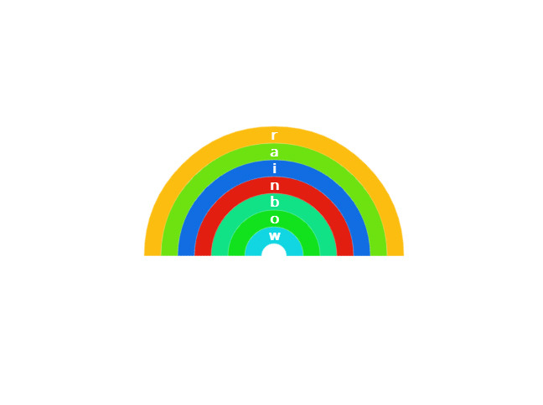



CSS3 transform 속성을 이용한 Guinea 국기 표현 예제- html5 활용예제

소스다운로드

[[http://i1.daumcdn.net/cfs.tistory/resource/1519/blog/image/extension/zip.gif](http://incblue.tistory.com/attachment/cfile24.uf@231CF13D5460805620DC5A.zip) Hoverable_flag_of_Guinea.zip](http://incblue.tistory.com/attachment/cfile24.uf@231CF13D5460805620DC5A.zip)

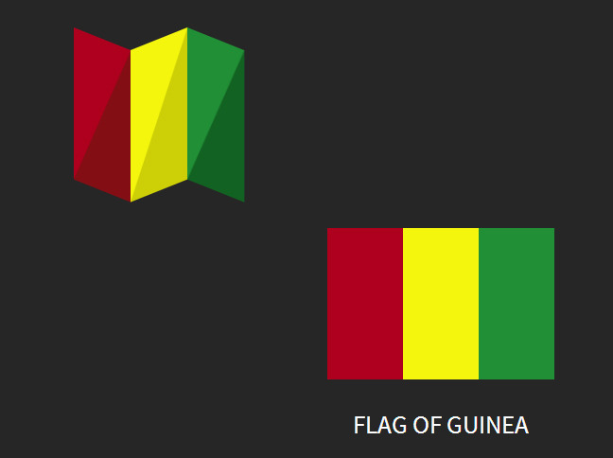



Learning the threejs particle system, this is a threejs demo can be found on the threejs.org site.  Don't use Internet Explorer if you want it to work…

- html5 활용예제

소스다운로드

[[http://i1.daumcdn.net/cfs.tistory/resource/1519/blog/image/extension/zip.gif](http://incblue.tistory.com/attachment/cfile4.uf@25139C4154607FB131F430.zip) Learning_Particle_system.zip](http://incblue.tistory.com/attachment/cfile4.uf@25139C4154607FB131F430.zip)

