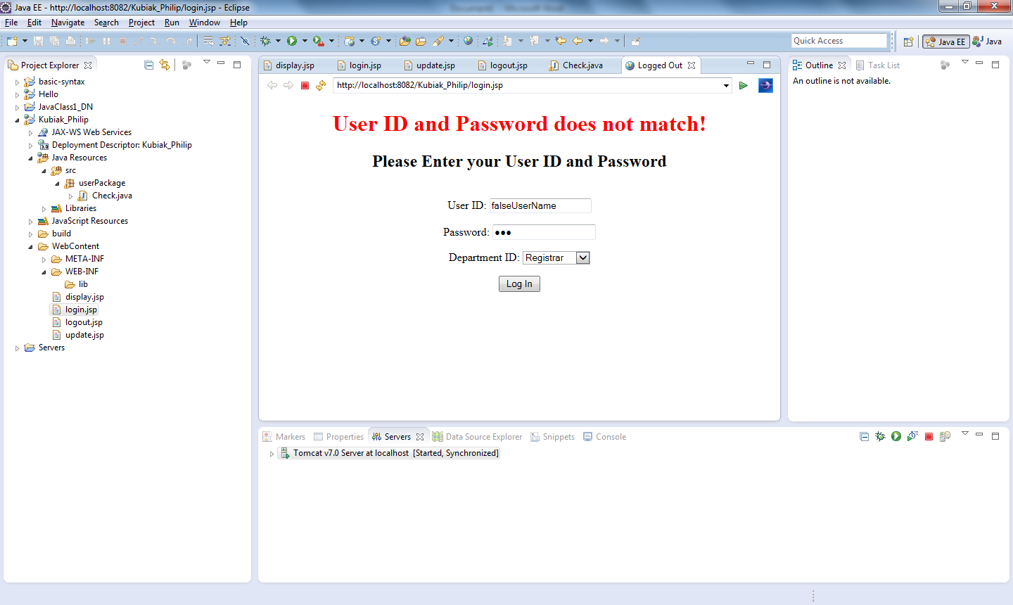

Redirects to Check servlet. The above input has incorrect user data. Check redirects to login.jsp (same page).

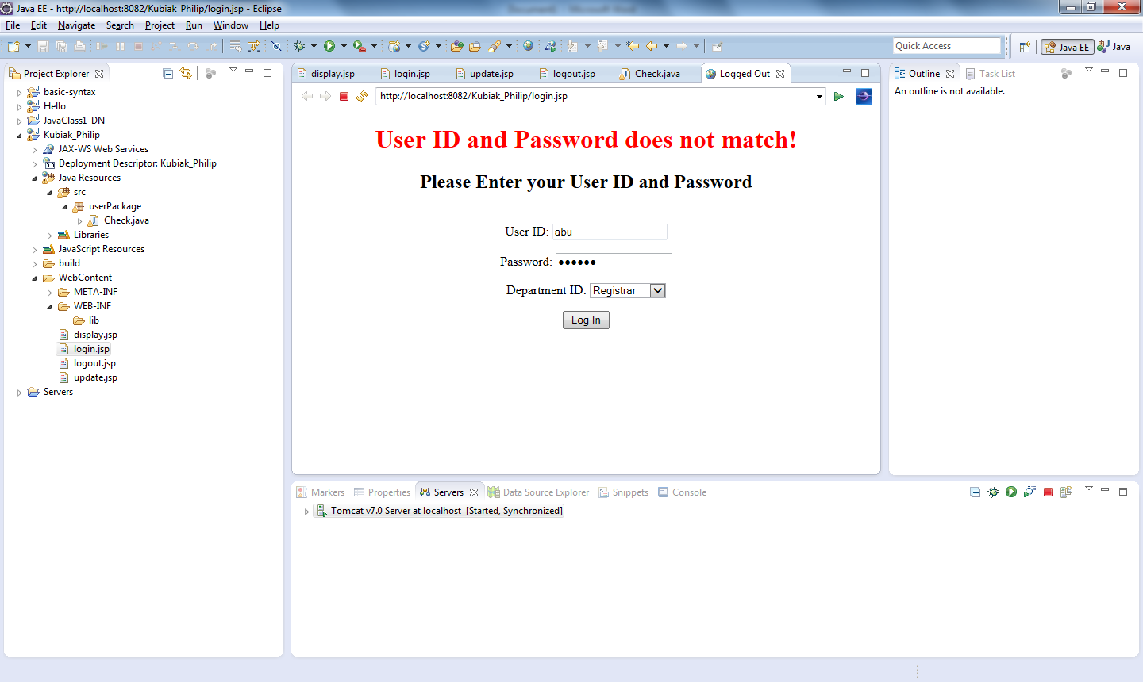

Redirects to Check servlet. The above input has correct username and password, but incorrect Department ID. Check redirects to login.jsp (same page).

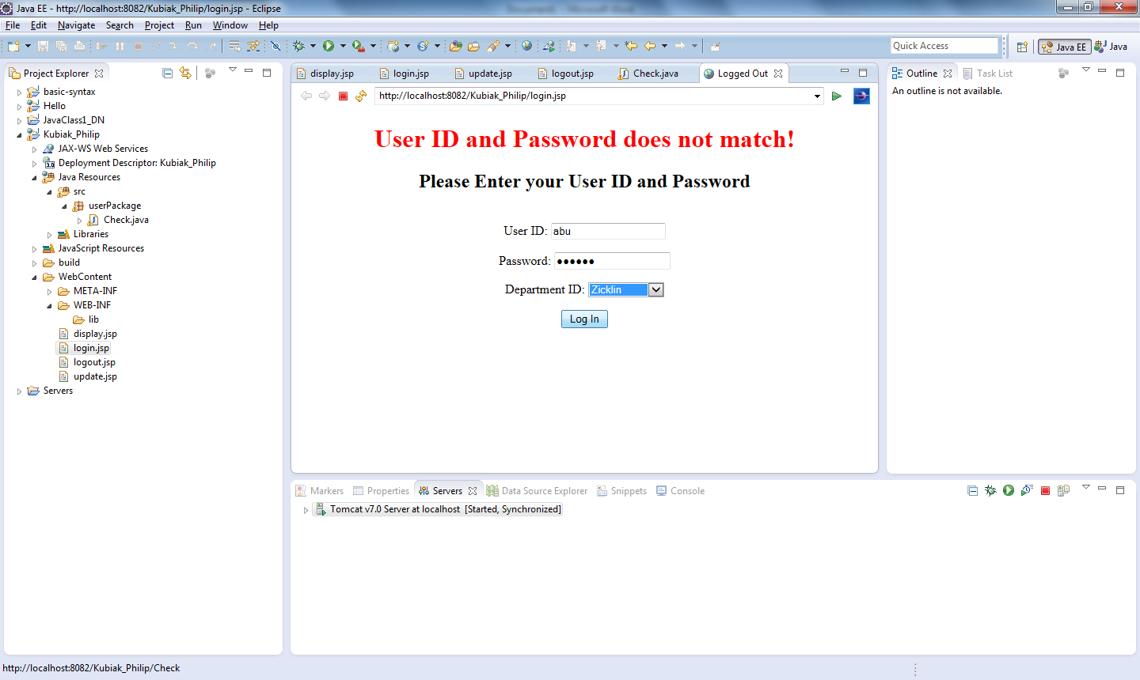

Redirects to Check servlet. The above input input is correct. Check redirects to update.jsp

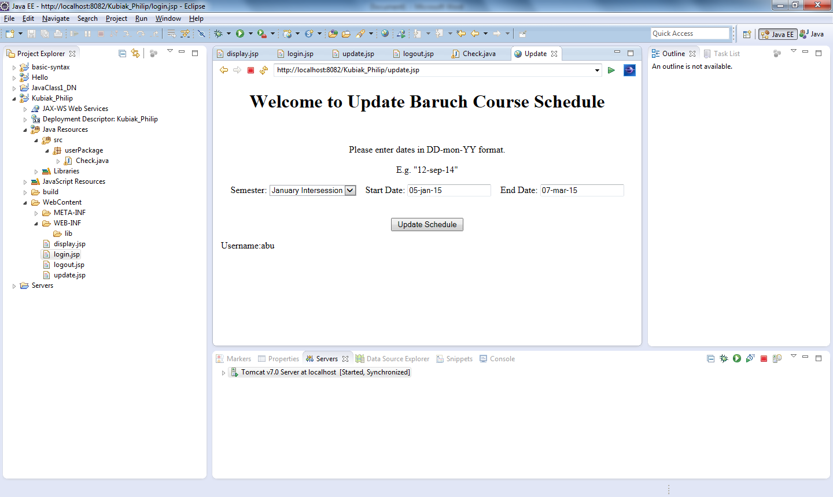

Showing user “abu” is logged in. The above input is sent with redirect to display.jsp

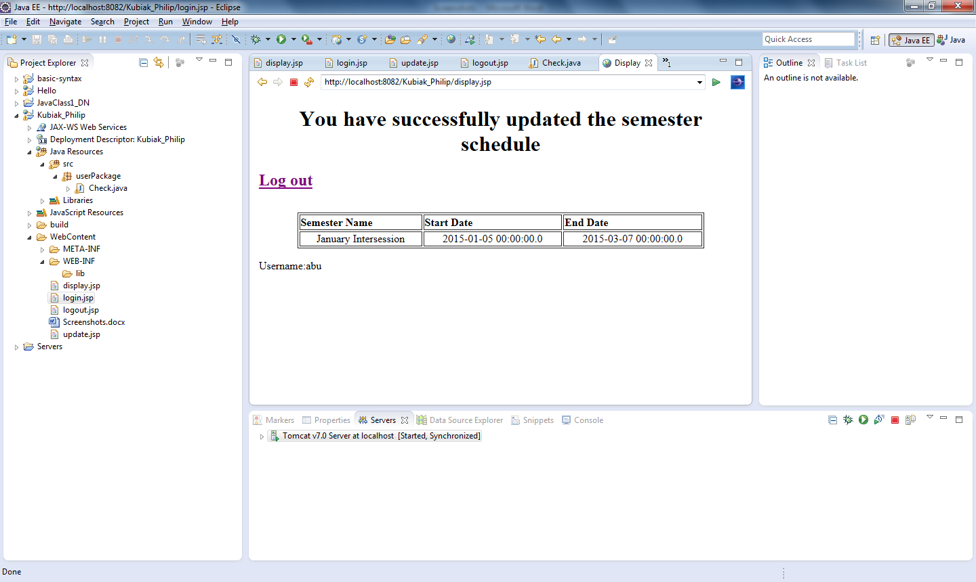

Success page. Updated information is queried from the database and displayed to ensure update was completed. User is still “abu”. Clicking on Logout link will invalidate session and user has option of logging back in.

