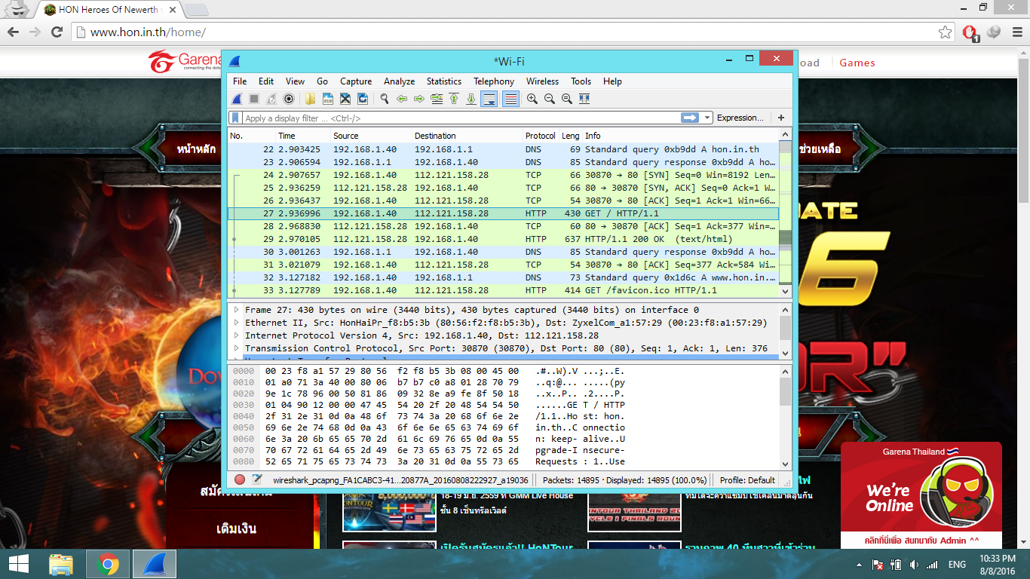

1. Three Protocol is DNS , TCP , HTTP

2. Deley time is 0.033109 s