LOGO

# 적외선 이미지에서 객제 인식

## 1.적외선 이미지란?

_____________

_____________

_____________

_____________

### html image example

### 2.객체 인식란?

_____________

_____________

_____________

_____________

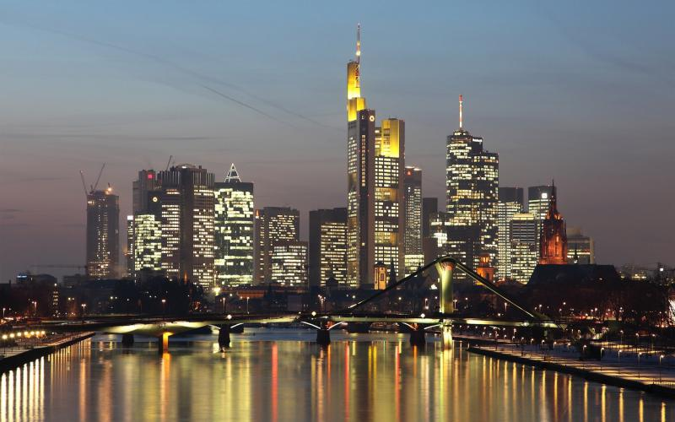

#### 3.왜 이 프로젝트인가?

_____________

_____________

_____________

_____________

##### 4.카매라 소개





