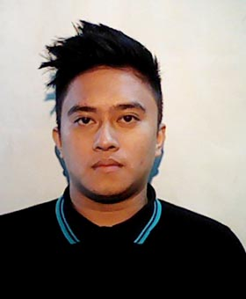

**CARLO STEPHEN A LADUA**

Brgy 16 Bacolod City, Negros Occidental, Philippines  
Contact Number: 09993674921| Email: Carlostephenladua@rocketmail.com

**Objective:**

**● to be one of the successful businessman in the future**

1. **Personal Information:**

Birthday : October 7, 1993

Birthplace : Bacolod City

Age : 22

Sex : Male

Height : 5’7”

Weight : 122 Lbs

Religion : Roman Catholic

1. **Family Background**

Father : Oscar Ladua

Occupation : Broadcaster

Mother : Marichu Ladua

Occupation : Businesswoman

1. **Education Background**

College : Bachelor of Science in Hospitality Management

University of Negros Occidental – Recoletos

Bacolod City

2013-2017

High School : NEGROS OCCIDENTAL HIGH SCHOOL

Bacolod City

2006-2010

Elementary School : ETCS-1

Bacolod City

2000-2006