University of Negros Occidental – Recoletos

College of Business and Accountancy

Hospitality – Tourism Department

FROOTY COOLY

A Business Plan

Presented to:

The Faculty of Business and Accountancy

In partial fulfillment

For the Subject

Course Code – Entrepreneurship

Dipol, Ladua 2017

**EXECUTIVE SUMMARY**

TABLE OF CONTENTS

BUSINESS NAME i

EXECUTIVE SUMMARY ii

TABLE OF CONTENTS iii

Chapter

1. COMPANY DESCRIPTION 1
   1. Business Mission 1
   2. Business Vision 1
2. PRODUCTS AND SERVICES 2
3. MARKETING PLAN
   1. Market Profile 3
   2. SWOT Analysis 3
   3. Product 4
   4. Pricing 4
   5. Place 4
   6. Promotion 5
4. OPERATIONAL PLAN
   1. Production Schedule 6
   2. Quality Control 6
   3. Personnel 6
   4. Inventory 7

APPENDICES

A. Frooty Cooly Flyer 8

B. Frooty Cooly Facebook Page 9

C. Carlo Stephen Ladua Resume 10

D. Gerard Raymond Dipol Resume 11

**COMPANY DESCRIPTION**

The proponents had thought of unique names that would possibly suit to the chosen business. One of the proponents suggested Frooty Cooly. Both liked the idea and agreed to go for the name. Partnership is the business structure of the proposed project. It obtains a minimum yet enough capital from the business stand yet offers affordable product and quality service to everyone. The proposed business is to be managed by Mr. Gerald Dipol and Mr. Carlo Ladua. Frooty Cooly is to be situated inside the University of Negros Occidental-Recoletos campus.

The proposed business started in the entrepreneurship subject. The teacher in-charged instructed to construct business plan with their very own product and business. The proponents decided to conceptualize a unique, easy-to-make and affordable product that everyone could avail. The product is made with freshly picked mixed fruits of high quality and all natural.

Frooty Cooly will not only benefit the visitors of the school but also their main target markets which are the students, faculty and staff. The target market will be convincing through direct sales, word-of-mouth and referrals. Benefits and positive features will be conveyed through promotional marketing. The advantages of Frooty Cooly against its competitors are that the product is easy to sell since no bad effects to the body. Our product is healthy, fresh and affordable. The location is also a mere advantage to the proposed project since it is easy to find, accessible since it is located inside the school campus.

**Mission**

To provide the best quality, most innovative and reasonable priced products in the food industry. To be the leader in our industry attained by a well-planned expansion through retail outlets and wide product distribution. To continuously generate awareness, interest and desire for our products resulting in frequent and repeat purchases. To established Frooty Cooly as a highly regarded international brand name.

**Vision**

The Company bears the vision of providing fun, deliciously appetizing food and beverage products while maintaining our commitment to uncompromised quality at economical rates with the heartening purpose. To cater the society’s needs tastes and preferences rather than simply convincing our customers to try and like whatever products we develop.

**PRODUCTS AND SERVICES**

Our product is a fruit salad that is made of fresh fruits. Our fruit salad is healthy and everyone in all ages can eat. We can give you the best service by attending to your needs so you won’t get tired of waiting. You can also eat our product in all kinds of season. You can order in our official website if you want. In the future, we plan to expand our business by selling new products like milk shake, cake and many more.

We are the one who makes our own product because we are just starting. In the future, we are planning to hire workers so it won’t be hard for us as owners. We and my partner already have the balance in our ingredients and in our flavoring so it will suit our customer taste. For delivery of our products, we can deliver door to door if your address is in just the city. Just give us your exact address, phone number and the direction to you address. For customers out of town, we have a minimum number of orders so that we won’t spend too much money for our transportation fair.

The difference between our product to others is that our product is just not made of ingredients. It is also made of hard work, passion and willingness to produce a product for our customers. That is our very advantage to others. We as a producer, we ensure to you our customers that our product will gave you a taste that only our product can give you the satisfaction. We also offer a door to door delivery for our valued customer who wants to order for their parties and more. If you have more questions just approach us.

**MARKETING PLAN**

**MARKET PROFILE**

University of Negros Occidental – Recoletos is one of the largest institutions at Bacolod City; hence, there is a great potential of the market. Frooty Cooly considers the students particularly the students of UNO-R, the faculty, staff and parents. The projected business will be marketed to the public through giving flyers and brochures to areas where there is great number of potential market such as the school cafeteria and school’s entrance. Moreover, the Frooty Cooly is marketable since the products offered specifically freshly mixed fruits that are of good quality and at a very reasonable price. As such, the business is feasible when it talks about marketing.

**SWOT Analysis**

|  |  |
| --- | --- |
| **STRENGTHS** | **WEAKNESSES** |
| * **Marketing**: Aggressive and focused marketing campaign. * **Team**: Together have wide product knowledge. * **Location**: Our location will draw customers and buyers. * **Uniqueness**: We stand out as unique against our competitors and offers high quality food. * **Safety**: Customers will be worry free for any threats since the business is located inside a secured campus. | * **New**: Doesn’t have the reputation or money for big advertisement and expansion. |
| **OPPORTUNITIES** | **THREATS** |
| * **Product Packaging**: Millennial appreciate high-end, attractive and new kind of labels | * **Competition**: Other competitor sells different kind of desserts and has loyal customers, as well as a relationship with businesses that regularly buy from them. |

**PRODUCT**

Frooty Cooly is definitely a dessert house designed to offer people with good quality service and wide varieties of sweetened mixed fruits. Great flavoured freshly mixed fruits from farm to table at a reasonable price is what Frooty Cooly endows to provide to its customers. This refreshing new kind of product will surely capture the attention of the consumers since most fruits are naturally low in fat, sodium and calories. Fruits are sources of many essential nutrients that are under consumed, including potassium, dietary fiber, vitamin C and folic acid. Eating foods such as fruits that are lower in calories per cup instead of some other higher-calorie food may be useful in helping to lower calorie intake. Another benefit in consuming fruits is rich in vitamins and minerals that help you feel healthy and energized. A great way replenished our strength in day to day activities

**PRICING**

Pricing of products will be based on the equalize quantity demanded by the consumers and the quantity supplied by the suppliers. Hence, there will be economic equilibrium of the price and quantity of products. Price represents the monetary value of goods and services rendered on the customers. However, the management of Frooty Cooly make sure that majority of customers can really afford the product being offered. Pricing of products will be primarily based on the cost of raw materials used together with the labour and at same time in accordance with the competitor’s price. Based on cost, contribution margin of mixed fruits is 33.3% and cost sale is 66.7% of the selling price. On the other hand, contribution margin of other drinks such as mineral water and other juices if 40% and cost of sale is 60% of the selling price. The buyer or consumer must pay depending on the price of the order. Since it is a self-service type of service, the customer will first have the order, the buyer or customer will pay and then serve the product. Customers can pay full in cash.

**PLACE**

Location or place is one of the main considerations in establishing a business. Good location must have great number of target markets and is easy to reach when it talks about accessibility. The proponents decided to put up the business at school’s canteen area. Frooty Cooly will not only benefit the customers who will be entering the said area but also the residents of University of Negros Occidental – Recoletos, specifically those students, faculty and staff on site. The location of the retailed-type project is situated near the CBA Building and HM Laboratory. Activities of the projected business will easily be recognized by the consumers and buyers. The major product which is fruit salad will be distributed through the process or method of direct distribution since the business is dealing and transacting person to person and selling the product direct to the consumer.

**PROMOTION**

Promotion is defined as advancement of the product, idea, or point of view through publicity and/or advertising. Promotional activities are divided into four areas which includes the advertising, public relation, sales promotion and personal selling.

In line with this, products of Frooty Cooly will advertised through these promotional activities:

1. Applying and showing good public relationship to the customers through effective quality of service.
2. Open public relation and humane treatment to the customers.
3. Tarpaulins
4. Flyers and brochures
5. Social Networking Sites such as Facebook

A good promotional strategy outlines the manner in which the marketing mix is used to attract and satisfy the target market and accomplished an organization’s objectives. The total investment cost of Frooty Cooly is Php50,000 pesos. It covers all the aspects of the business including the technical, marketing, management and the operating expenses which will be all needed in the operation of the proposed business.

**OPERATIONAL PLAN**

**PRODUCTION SCHEDULE**

The business Frooty Cooly will have a 10-hour production schedule so that it can able to cater the customers and buyers of University of Negros Occidental-Recoletos. A 10-hour production will be a great advantage for the business to acquire large number of customers because competitors inside the school cafeteria close earlier. The raw materials and the supplies to be used in the business are also one of the essential things that should be given attention before the formal operation starts. Since the business is located inside the school premise, building materials will no longer be under the establishment. The management will only renovate or improve the space provided for the business.

**QUALITY CONTROL**

There are plenty of activities to be undergone before the business will be fully operational. First and foremost is the survey which the proponents had been through, procurement of capital, permit to operate certifications and other necessary documents for legality. The management considers that all staff is knowledgeable enough in order to meet the needs and wants of the customers and buyers. Employees are obliged to follow all the policies of the business. Moreover, parts of concerns of the management are the proper sanitation and maintenance of the proposed project.

**PERSONNEL**

Frooty Cooly will be selecting and hiring proficient and responsible personnel for the business. Applicants will undergo the selection procedure process first before the hiring process takes place. The management will be responsible in checking all the necessary files and background pertaining to the applicants. They will proceed to the training and orientation method prior to operations. Training and orientation process will enhance the communication skills especially in dealing with customers and buyers. Employees must go through orientation so that they will be aware of the rules and regulations of the establishment.

**INVENTORY**

The raw materials and the supplies to be used in the business play a vital role in the proposed business. It should be given attention before the operation starts. For the supplier raw materials, please see table 1.0 below:

**Table 1.0: List of Suppliers**

|  |  |  |
| --- | --- | --- |
| **SUPPLIERS** | **ADDRESS** | **PRODUCTS OR UTILITIES TO BE SUPPLIED** |
| 1. SM City Bacolod | Negros South South Road, Bacolod City | * Heavy Cream * Cream Cheese * Sugar * Vanilla Extract * Plastic Spoon * Bottled Water * Paper Cups |
| 1. May’s Organic Garden | Araneta Street, Bacolod City | * Fresh Fruits |

Frooty Cooly will get its list of supplies to various suppliers producing good quality of raw materials.

**APPENDIX A**

Frooty Cooly Flyer

**APPENDIX B**

Frooty Cooly Facebook Page

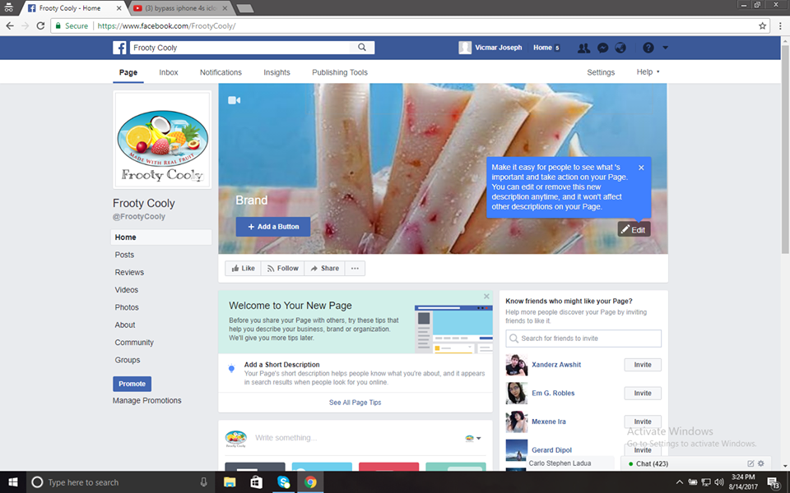

**APPENDIX C**

**CARLO STEPHEN A LADUA**

Brgy 16 Bacolod City, Negros Occidental, Philippines  
Contact Number: 09993674921| Email: Carlostephenladua@rocketmail.com

**Objective:**

**● to be one of the successful businessman in the future**

1. **Personal Information:**

Birthday : October 7, 1993

Birthplace : Bacolod City

Age : 22

Sex : Male

Height : 5’7”

Weight : 122 Lbs

Religion : Roman Catholic

1. **Family Background**

Father : Oscar Ladua

Occupation : Broadcaster

Mother : Marichu Ladua

Occupation : Businesswoman

1. **Education Background**

College : Bachelor of Science in Hospitality Management

University of Negros Occidental – Recoletos

Bacolod City

2013-2017

High School : NEGROS OCCIDENTAL HIGH SCHOOL

Bacolod City

2006-2010

Elementary School : ETCS-1

Bacolod City

2000-2006

**APPENDIX D**



**GERARD RAYMOND O. DIPOL**

Airport Subd. Bacolod City, Negros Occidental, Philippines  
Contact Number: 09950827570| Email: Gerard_dipol@yahoo.com

**Objective:**

**● to be one of the successful entrepreneur in the future**

1. **Personal Information:**

Birthday : May 23, 1995

Birthplace : Bacolod City

Age : 22

Sex : Male

Height : 6’4”

Weight : 190 Lbs

Religion : Roman Catholic

1. **Family Background**

Father : Gerardo Dipol Jr.

Occupation : Financer

Mother : Shiela Dipol

Occupation : Teacher

1. **Education Background**

College : Bachelor of Science in Tourism Management

University of Negros Occidental – Recoletos

Bacolod City

2014-2018

High School : Bacolod Taytung High School

Bacolod City

2008-2012

Elementary School : Bacolod Taytung High School

Bacolod City

2002-2008