Below is brief overview of assumptions, I have made.

* Company has video-on demand feature, like Netflix. Users have to pay to view a video. Hence **PCI complaint**.
* Company have users from EU. Hence, **GDPR compliant**.
* **No security measure** in place.
* Company’s popularity has grown exponentially. So new setup must cater to increase in load
* Assume company has **sufficient budget** for this task.
* Company’s is currently having team of 7 member. This includes two 3 in leadership roles and 4 in development role. **No plan to increase team-size**
* Details about web-application
  + Source code of web-app cannot be changed
  + Web-app uses MySQL for database.
  + Media for video-on-demand is stored locally in webserver.

# Current Website Architecture

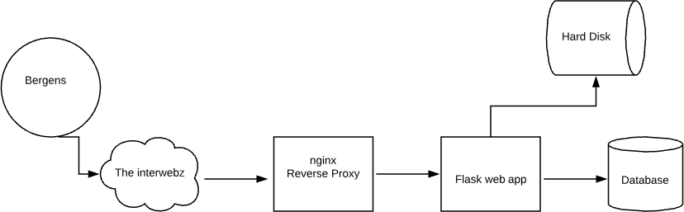

Customer comes over the Internet and connects to an nginx reverse proxy running on port 80. That forwards to the web app (written in Python with the Flask web framework) on port 5000. A MySQL database is running on 3306 for storage of queries. Media for the video-on-demand is stored locally on the hard drive of the web server. The code is also available here: https://github.com/kts262/enpm809j