Weather Web Application

* Technical Stack:
  + Information:
* The Weather web app base on myENV app.
* This application shows weather and tide information of each days
  + Everything needs to build app:
* ReactJS version 16.13.1
* NodeJS version 12.18.0
* Chart using HTML5 canvas
* Style using SASS
* Unit testing using ***Jest***, ***Enzyme*** and ***react-testing-library***

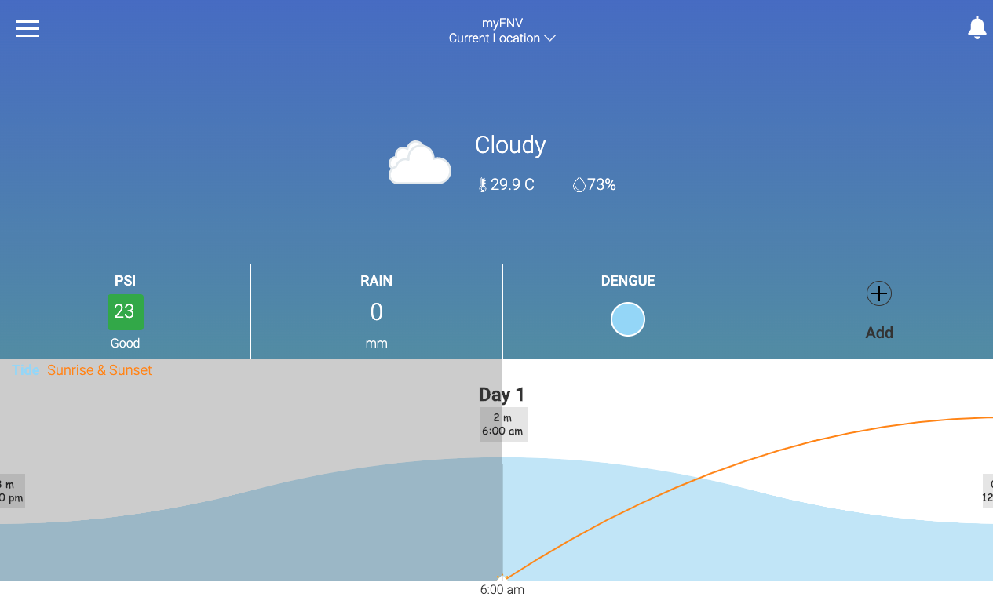

*Picture 1: Desktop view*

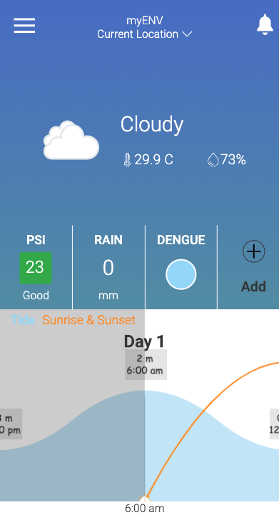

*Picture 2: mobile view*

* + Data:
* All the date in the app is static and was defined follow this structure:

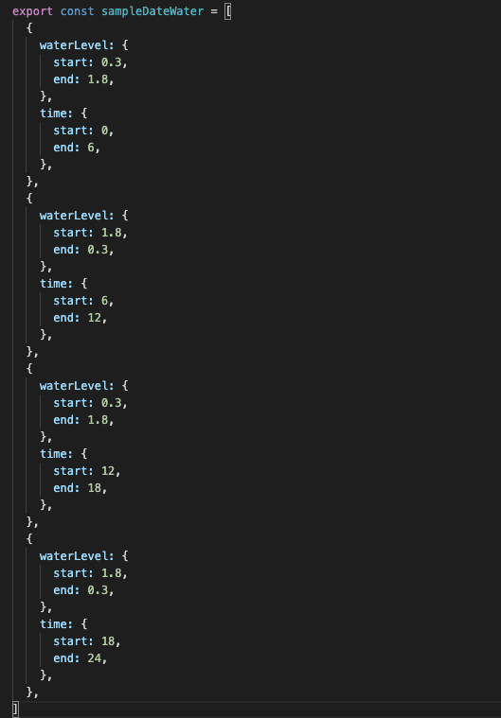

*Picture 3: data structure*

* + Unit testing: using Jest, enzyme and react-testing-library

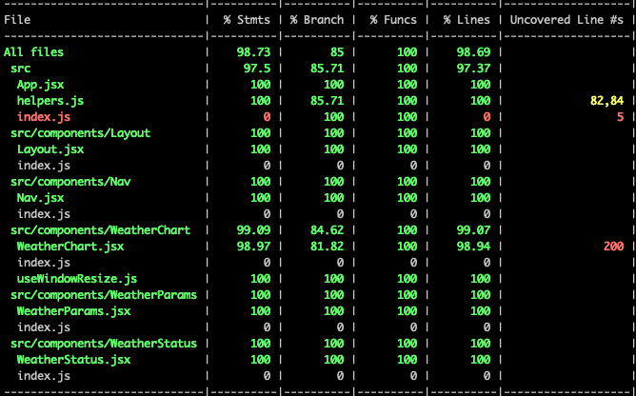

*Picture 4: testing result*

* Github repository:

<https://github.com/s3corp-github/SP_WeatherWeb_KietTran>

* Deploy link: <https://kooltran.github.io/chart-demo/>
* How to run:

This project was built from create-react-app

* + Requirement install environment:
* NodeJS ver >= 12
* After clone project please run this cmd ***yarn*** or ***npm install***
  + Available scripts:

In the project directory you can run:

* ***yarn start*** or ***npm run start*** to start the app on local server with url <http://localhost:3000/>
* ***yarn test*** or ***npm run test*** to launches the test runner in the interactive watch mode
* ***yarn build*** or ***npm run build*** to builds the app for production to the **build** folder