­

ព្រះរាជាណាចក្រកម្ពុជា

ជាតិ សាសនា ព្រះមហាក្សត្រ

សកលវិទ្យាល័យភូមិន្ទភ្នំពេញ

**Royal University of Phnom Penh**

កិច្ចការស្រាវជ្រាវ​៖​ មុខវិជ្ជា **Software Engineering**

ប្រធានបទ៖ **What is embedded software?**

រៀបរៀង និង​ ចងក្រងដោយ៖

6.​ 6. JOHN DARA

7. SEANG HEGSRUN

8. SROEURN KHAVY

9.​ PHY TYROT

1. LIM VOUCHLY

2. UY PHEREN

3.​ HENG HONGSEA

4. SITHY LALIN

5. BUN CHHUNLONG

បង្រៀនដោយ សាស្ត្រាចារ្យ

**POK LEAKMONY**

ឆ្នាំសិក្សា៖​ ២០២០-២០២១

រចនាសម្ព័ន្ធនៃការស្រាវជ្រាវ

មាតិកា

1. ​​​​​​​និយមន័យ - 3 -

2. រៀបរាប់អំពី Characteristics of Embedded software - 3 -

3. ឧទាហរណ៏ - 4 -

វិធីសាស្រ្តនៃការស្រាវជ្រាវ

1. ​​​​​​​និយមន័យ

Embedded software, computer programming or software, is used for controlling the specific functions of the hardware devices and system. It controls devices functions in the same way that a computer’s operating system does on software applications. The function can be activated by external controls. Almost any hardware devices contain embedded software like toasters and light bulbs. The embedded is not worked directly with users. Moreover, The devices have embedded software can be adjusted and diagnosed through connections that someone might attempt to hack.

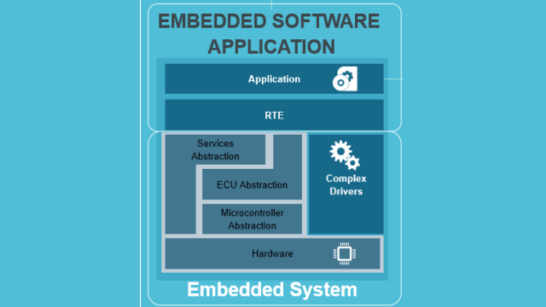

1. រៀបរាប់អំពី Characteristics of Embedded software

Even though there are many types of embedded systems, they all share the same beneficial features and design characteristics.

* All Embedded Systems are task specific. They do the same task repeatedly /continuously over their lifetime.

***Example: An mp3 player will function only as an mp3 player***.

* Embedded systems are created to perform the task within a certain time frame. It must therefore perform fast enough.
* They have minimal or no user interface (UI). A fully automatic washing machine works on its own after the program is set and stopped once the task is over.
* Some embedded systems are designed to react to external stimuli and react accordingly.

***Example: A thermometer, a GPS tracking device.***

* Embedded systems are built to achieve certain efficiency levels. They are small sized, can work with less power and are not too expensive.
* Embedded systems cannot be changed or upgraded by the users. Hence, they must rank high on reliability and stability. They are expected to function for long durations without the user experiencing any difficulties.
* Micro-controller or microprocessors are used to design embedded systems.

Embedded systems need connected peripherals to attach input & output devices.

* The hardware of an embedded-system is used for security and performance. The Software is used for features.

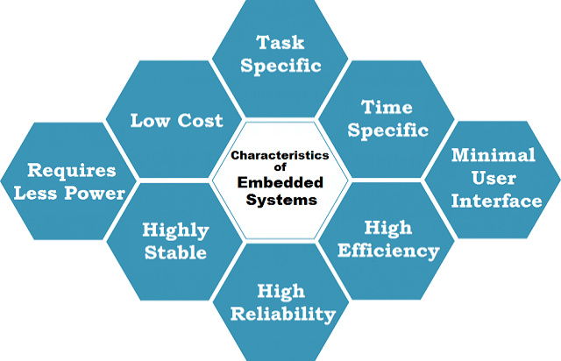

1. ឧទាហរណ៏

Here are common examples of embedded software application-based features include:

* Anti-lock braking systems found in automobiles – ***Example: A car’s brake system.***
* Image processing systems found in medical imaging equipments – ***Example: handheld, portable ,car based , High End Imaging.***

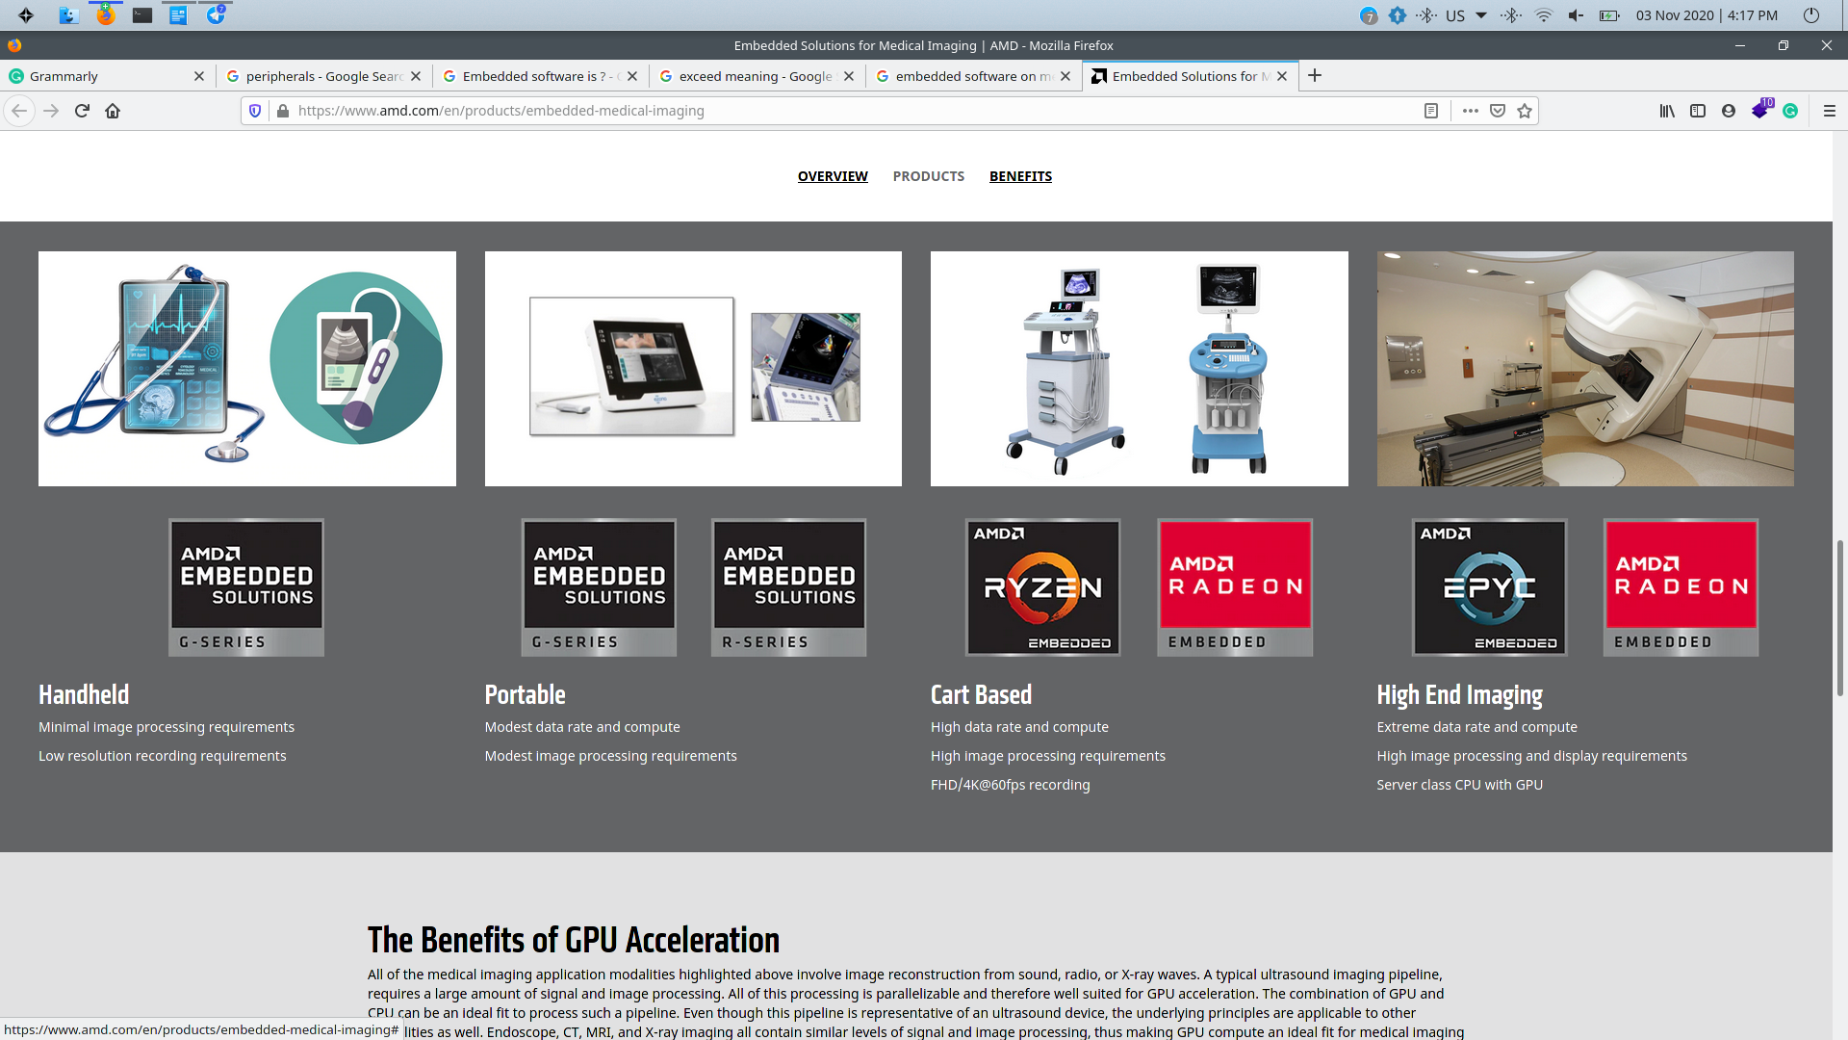

* Fly-by-wire control systems – ***Example: airplane’s embedded control systems ( take-off, stay in the air, and land).***
* Motion detection systems – ***Example: security cameras***.
* Traffic control systems – ***Example: Traffic lights.***
* Timing and automation systems – ***Example: smart home devices.***