Iris Dataset Analysis
Kell Koomson
2025-12-31

loading And Inspecting the Iris Dataset
Sepal.Length | Sepal.Width | Petal.Length | Petal.Width | Species
5.1 | 3.5 | 1.4 | 0.2 | setosa
4.9 | 3.0 | 1.4 | 0.2 | setosa
4.7 | 3.2 | 1.3 | 0.2 | setosa
7.0 | 3.2 | 4.7 | 1.4 | versicolor
6.4 | 3.2 | 4.5 | 1.5 | versicolor
6.9 | 3.1 | 4.9 | 1.5 | versicolor
6.5 | 3.0 | 5.2 | 2.0 | virginica
6.2 | 3.4 | 5.4 | 2.3 | virginica
5.9 | 3.0 | 5.1 | 1.8 | virginica

Descriptive Statistics
 | Sepal.Length | Sepal.Width | Petal.Length | Petal.Width | Species
 | Min. :4.300 | Min. :2.000 | Min. :1.000 | Min. :0.100 | setosa :50
 | 1st Qu.:5.100 | 1st Qu.:2.800 | 1st Qu.:1.600 | 1st Qu.:0.300 | versicolor:50
 | Median :5.800 | Median :3.000 | Median :4.350 | Median :1.300 | virginica :50
 | Mean :5.843 | Mean :3.057 | Mean :3.758 | Mean :1.199 | NA
 | 3rd Qu.:6.400 | 3rd Qu.:3.300 | 3rd Qu.:5.100 | 3rd Qu.:1.800 | NA
 | Max. :7.900 | Max. :4.400 | Max. :6.900 | Max. :2.500 | NA

Descriptive Statistics By group
 | n | mean | sd | median | min | max | range
Sepal.Length | 50 | 5.006 | 0.3524897 | 5.0 | 4.3 | 5.8 | 1.5
Sepal.Width | 50 | 3.428 | 0.3790644 | 3.4 | 2.3 | 4.4 | 2.1
Petal.Length | 50 | 1.462 | 0.1736640 | 1.5 | 1.0 | 1.9 | 0.9
Petal.Width | 50 | 0.246 | 0.1053856 | 0.2 | 0.1 | 0.6 | 0.5
Species | 50 | 1.000 | 0.0000000 | 1.0 | 1.0 | 1.0 | 0.0

 | n | mean | sd | median | min | max | range
Sepal.Length | 50 | 5.936 | 0.5161711 | 5.90 | 4.9 | 7.0 | 2.1
Sepal.Width | 50 | 2.770 | 0.3137983 | 2.80 | 2.0 | 3.4 | 1.4
Petal.Length | 50 | 4.260 | 0.4699110 | 4.35 | 3.0 | 5.1 | 2.1
Petal.Width | 50 | 1.326 | 0.1977527 | 1.30 | 1.0 | 1.8 | 0.8
Species | 50 | 2.000 | 0.0000000 | 2.00 | 2.0 | 2.0 | 0.0

 | n | mean | sd | median | min | max | range
Sepal.Length | 50 | 6.588 | 0.6358796 | 6.50 | 4.9 | 7.9 | 3.0
Sepal.Width | 50 | 2.974 | 0.3224966 | 3.00 | 2.2 | 3.8 | 1.6
Petal.Length | 50 | 5.552 | 0.5518947 | 5.55 | 4.5 | 6.9 | 2.4
Petal.Width | 50 | 2.026 | 0.2746501 | 2.00 | 1.4 | 2.5 | 1.1
Species | 50 | 3.000 | 0.0000000 | 3.00 | 3.0 | 3.0 | 0.0

Distributions Of Variables
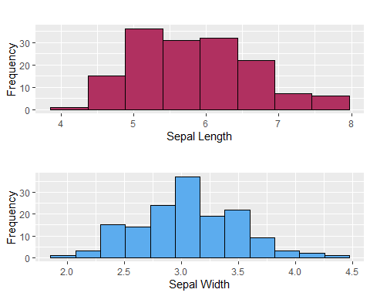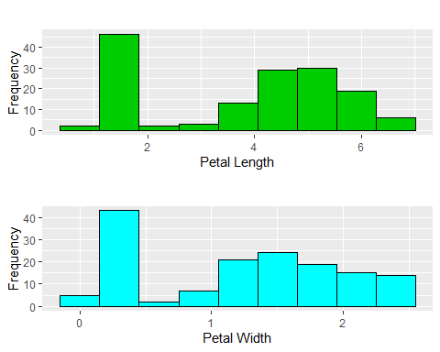

Distributions of Variables By group
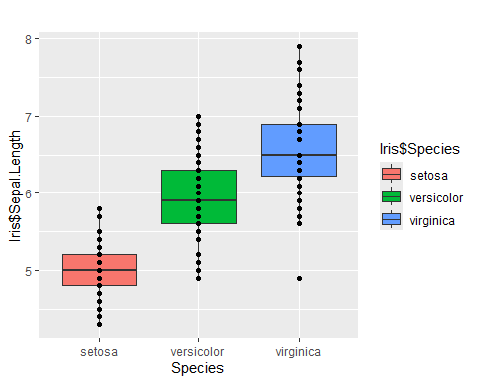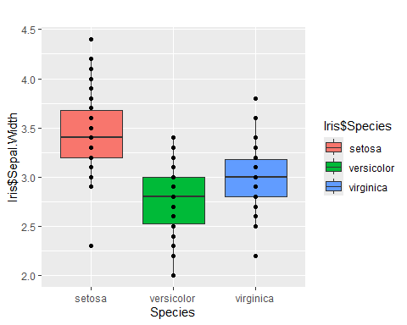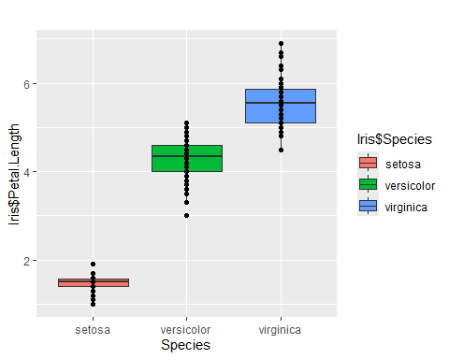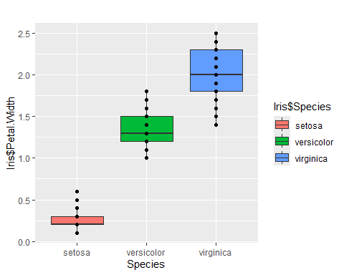

Relationship between numerical variables
