Gentraffic Documentation

Gentraffic refers to the process of generating daily playlist files. Playlist files are 24 hour blocks of time each representing a unique day. The files are named MMDDAUTO and are used by DAD (and WebDad) to handle overnight automation (local music mix) and the daily traffic mix.

The generation of the playlists is handled by a number of Python scripts. You can find the code here: https://github.com/koop-radio/gentraffic

The code is mostly self contained but relies on the use of several additional libraries not included in the standard Python installation. The libraries can be installed using pip after Python3 has been installed.

For dealing with DBF files
dbf
dbfread
For Google authentication, gmail, and fetching remote files from shared drives
google-api-core
google-api-python-client
google-auth
google-auth-httplib2
google-auth-oauthlib
googleapis-common-protos

The production machine is currently running on a VM at 10.42.13.15 and is part of the the hypervisor cluster. The user for the machine is debian and the gentraffic code installed in /home/debian/gentraffic/

The code can also be run locally by pulling the scripts from github and installing the above libraries. It should be installed in the current user’s home directory, typically in a sub-folder called gentraffic. The code should be run as the current user (i.e. debian) and not root. The gentraffic code has only been tested on Linux.

The code determines if it’s running on production by looking for mounted drives.

if exists('/mnt/DAD/DAD/Files/CUTS.DBF'):
prefix='/home/debian/gentraffic/'
on_production = True
else:
prefix='./'
on_production = false

To run the code locally you will need a copy of cuts.dbf. On the production machine this file is copied from a mapped drive. The file can be copied from the production machine:

scp debian@10.42.13.15:/home/debian/gentraffic/inputfiles/cuts.dbf inputfiles/

Gentraffic Documentation

If you need the most recent copy of cuts.dbf you should get it from the production PC in the studio.

The production machine is currently setup to run gentraffic daily at 8PM and again at 11:55 PM. This is accomplished via two crontab entries.

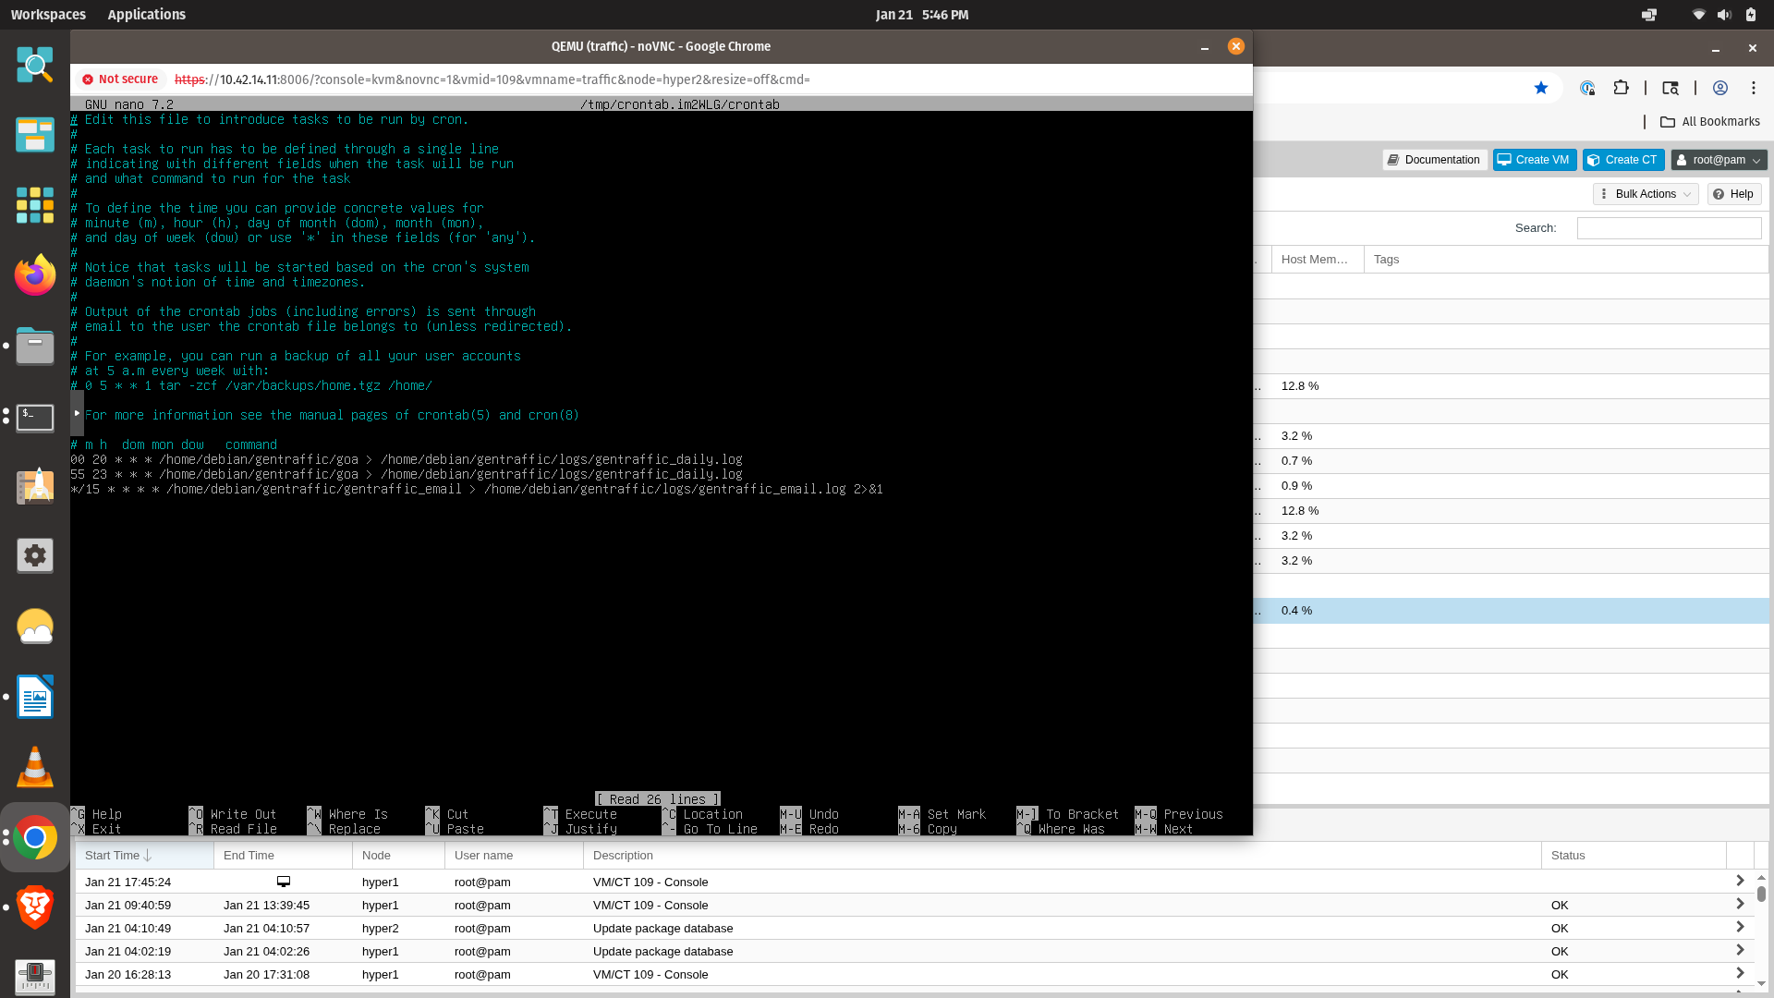

The main input file for gentraffic is a file called traffic.csv that is managed by the staff (Michelle or Melinda). This file is stored on a shared Google drive and is accessed via google API calls and an access token. The access tokens are not stored in the git repository and must be regenerated to run the code locally. The tokens are named:

pickle.jason – accessing the Google shared folder
token.jason – sending email
check_email_token.jason = checking email

The tokens can be downloaded from the production machine using the following command:

scp debian@10.42.13.15:/home/debian/gentraffic/pickle.jason.

Gentraffic Documentation

The tokens can also be regenerated if they are missing. Running the code without tokens should pop up a browser and prompt you for the Google account to use for authentication.
You should use an account that access to the shared folder where the traffic.csv files live when regenerating pickle.token. The email tokens should use remotepc@koop.org in order to check and send email.

Access tokens should never be checked to the git repository.

The main code to download the traffic.csv file is here: /gentraffic/google_tools/get_most_recent_file.py.

This code looks at the time stamp of this csv file to determine if any changes have been made since the file was last downloaded. The time stamp of the downloaded file is compared to the traffic.csv file in the /gentraffic/inputfiles/ folder. If the file in the shared folder is newer it is downloaded via google API calls and stored in the /gentraffic/inputfiles/ folder. This updates the time stamp of the local traffic.csv file.

The gentraffic code uses Monday as a starting day and creates playlists for Monday – Sunday. If the code runs Sunday night, and determines that changes have been made to the traffic.csv file, it will generate 7 days of playlist files. During the week, when the code runs, it will generate playlist files for the current day through Sunday if changes have been made.

Additionally the code utilizes a series of templates as input files. There is a template for each day of the week located in /gentraffic/templates/. The code uses the templates to determine when KOOP is on the air each day. When KOOP is not broadcasting on the FM airwaves the code will fill the playlist with local music and no traffic. When KOOP is broadcasting on the FM airwave the code will use the traffic.csv file to slot in the required traffic for each day.

The output of the script is a set of DBF files located in /gentraffic/outputfiles/. The files are named MONDAY.DBF - SUNDAY.DBF. Those files are renamed to MMDDAUTO.DBF based on the current date. If the script is running on the production machine the MMDDAUTO.DBF files are copied to /mnt/DAD/DAD/Files/PLAYLIST/. This is the folder that DAD uses to locate the current playlists.

If the script runs to completion an email is sent to the playout email list.
The email is titled: AutoGenTraffic Completed.

In the email, AutoGenTraffic Completed, is a list of traffic probability matches. If the probability is 1.0 that indicates a 100% match.

The email is sent every day at 8:00 pm if changes have been made to the traffic.csv since the script last ran. If additional changes are made after 8:00pm another email is sent at 11:55 pm.

Gentraffic Documentation

Weekly changes to the traffic.csv file are typically made on Sunday evenings. If no email goes out at 8:00pm on Sunday that is an indication that something may have gone wrong.
It’s also possible that the weekly changes to traffic.csv were not made by 8:00pm.

The first place to look for errors is in /gentraffic/logs/gentraffic_daily.log. This file contains the output of script. The most common reason for the script to fail are lost network connections or typos in one of the template files.

The script can be run manually by logging into 10.42.13.15 as debian, switching to home/debian/gentraffic/ and typing ./goa. The script output in the console can be very useful for debugging.

The timestamp of the local traffic.csv file may have to be changed in order for the script to run. You can use the Linux command touch -d '5 days ago' /inputfiles/traffic.csv to backdate the modified time of the file.

Editing and debugging the python scripts on the production machine is not recommended.
The code should be pulled from https://github.com/koop-radio/gentraffic and run locally on a Linux machine for debugging purposes.

Gentraffic can also be triggered via email. On the production server a crontab entry is setup to run the gentraffic_email script every 15 minutes. This script checks the email address remotepc@koop.org for an unread email with the subject UPDATE. If an unread email is found, it is marked as read and gentraffic runs.

Gentraffic Documentation

The email feature can also be triggered manually. Send an email to remotepc@koop.org with the subject UPDATE. Wait a minute and run the following command:
python3 ./check_email_and_run_auto_gentraffic.py from the console in the folder where gentraffic is installed.

Output from gentraffic_email is sent to /gentraffic/logs/gentraffic_email.log

Both running the script manually or firing it via email should send out a completion email.
If the script is run on a local machine, and not production, no email is sent.

