Final Project User Manual

Nick Boyd

SDEV 140-81W

2021/10/07

**User Manual:**

Thank you for considering Crazy Joe’s Amusements. We look forward to seeing you! This program can be used to purchase tickets and other services for your visit.

**Entering Order:**

The order form (shown below) is the window you will see when opening the program.

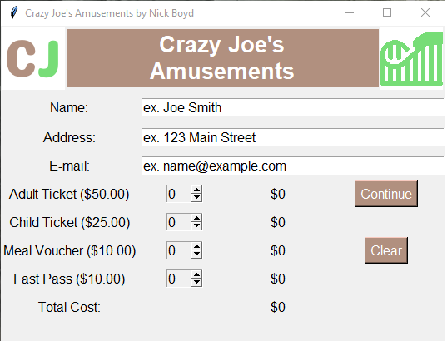

There are three required fields of entry:

* Name: Requires a first name and a last name
* Address: Requires an address in the correct form (ex. 123 Main Street)
* Email: Requires an email address in the correct form (ex. [jdoe@example.com](mailto:jdoe@example.com)

If any information in any of the fields is not submitted or is not in the correct form an appropriate error message will appear at the bottom of the screen.

Below the email field are the following items available for purchase

* Adult ticket ($50): A standard adult ticket.
* Child ticket ($25): A child ticket (under age of 12).
* Food Voucher ($10): Good for one meal at any of our restaurants or food kiosks.
* Fast Pass Ticket ($10): Each ticket is good for five uses to enter the Fast Pass line for any of our rides

At least one item must be selected in order to continue the purchase. A maximum of 30 of each item are available to purchase in a single order. Once you are ready to continue please click the Continue button, or click the Clear button to clear all fields.

**Confirming Order:**

After submitting all information and continuing you will see the confirmation window (shown below).

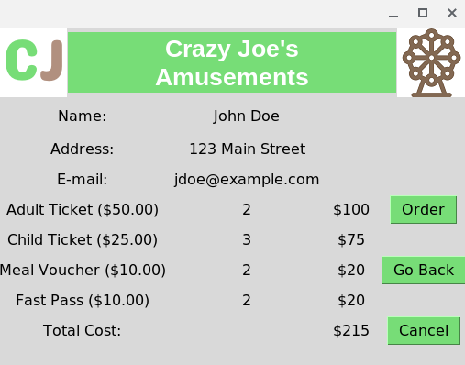

To confirm your order simply click the Order button. A message will appear on the bottom of the screen to verify that the order was completed. If you wish to change any information press the Go Back button to return to the order form and enter any corrections. Click the Cancel button to return to the order form with all information cleared.

**Write Orders in Text File:**

By default the program will record all orders to a text file. Upon running the program for the first time, a file called ‘CJ’s Amusements Orders.txt’ will be created in the same directory as the program. Each completed order will be recorded in the file with the following information.

* Name
* Address
* Email Address
* Adult Ticket purchase quantity
* Child Ticket purchase quantity
* Food Voucher purchase quantity
* Fast Pass Ticket purchase quantity
* Total Cost
* If the file already exists when the program is opened any new orders will be added to the end of the file. An example of the text file is shown below.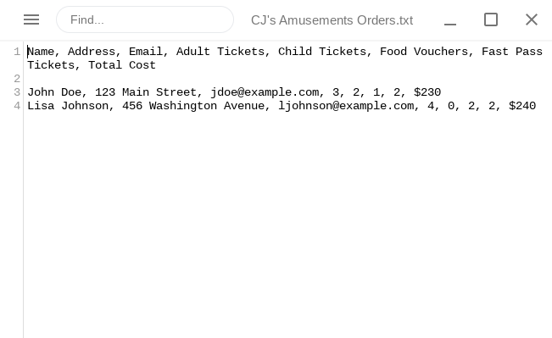

That’s all there is to it! Thank you again for selecting Crazy Joe’s Amusements!