Final Project Validation Testing

Nick Boyd

SDEV 140-81W

2021/10/06

**Testing Areas:**

My program has 3 entry boxes that have data that needs to be validated. There are 4 spinboxes for item quantity that, when changed, require calculating and displaying new labels with updated costs for that item and in total. There are two buttons on the Order Screen and three buttons on the Confirmation Screen that each have different functions. The program also writes order data to a file.

**Entry Boxes:**

The entry boxes require specific form.

* Name: Requires 2 blocks of text separated by a space (ex .John Doe)
* Address: A block of numbers followed by a space then 2 blocks of letters separated by a space (ex. 123 Main Street)
* Email: A block of letters/numbers, followed by ‘@’ followed by another block of letters/numbers, a ‘.’ then another block of letters (ex. [name@example.com](mailto:name@example.com))

**Spin Boxes:**

The spinboxes are set to read only so they can only be changed with the up and down areas and have a maximum value of 30.

**Buttons:**

There are 2 buttons on the Order Screen.

* Continue: Validates all of the entry boxes to be filled and to be the correct form. Ensures that at least one of the spinboxes is not set to 0. A message is displayed at the bottom of the screen if any of this validation fails
* Clear: Clears all entry boxes and resets spinboxes to 0 and displays message at bottom of screen

There are 3 buttons on the Confirmation Window.

* Order: Displays a message at the bottom thanking the user for the order. It also checks for an existing file of previous orders. If it is found it creates the file then adds the order data to it. Otherwise it reads the number of previous orders before writing the new data.
* Go Back: Closes the Confirmation Window without clearing the data on the Order Screen
* Cancel: Closes the Confirmation Window while clearing the data on the Order Screen

**File:**

The program creates a file called “CJ’s Amusements Orders.txt” which should include a header line with the fields collected, a blank line, then any order data.

**Test Data:**

For testing entry boxes I tested one field at a time while the others were correct

* Names: JohnDoe, John Doe1, John Doe$, blank - all failed to continue and displayed correct error
* Address: 123MainStreet, 123 Main1 Street, 123 Main Street$, 123A Main Street, blank - all failed to continue and displayed correct error
* Email: jdoe.example.com, jdoe@examplecom, jdoe$@example.com, jdoe@example$.com, blank - all failed to continue and displayed correct error
* Spin Boxes: Set all boxes to 0 - failed to continue and displayed correct error
* Continue, Clear, Go Back, Cancel Buttons: All seem to work as expected
* Order: Successfully created file or opened existing file as needed and wrote new data.

**Problems:**

I did not encounter any problems with the entry boxes, spinboxes or most of the buttons. The only error I found was if the user submits information into the Confirmation Window then clears the Order Window. On the Confirmation Window the spinbox quantities are changed but the entry box data are not, and confirming the order writes the cleared data into the text file. I did not fix this error because a real world program like this would simply not allow both windows to be active at the same time.

**Good Test Data:**

* John Doe
* 123 Main Street
* [jdoe@example.com](mailto:jdoe@example.com)
* 2 Adult Tickets
* 3 Child Tickets
* 4 Meal Vouchers
* 1 Fast Pass

**Screenshots:**

Before clicking Order Button

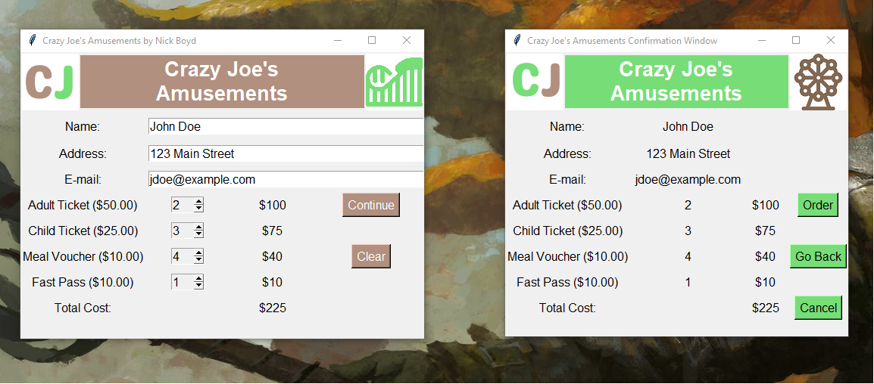

After clicking Order Button

