

International School
Capstone Project 1
CMU-SE 450 AIS - C1SE.27
Database Design
Version 1.0
Date: Nov 12th, 2025
Applying Large Language Models to Automatically Generate Surveys
Submitted by
Anh, Pham Thuc
Anh, Tran Viet
Linh, Ngo Nguyen Thuy
Quan, Nguyen Minh
Tuan,Pham Anh
Approved by
Ph. D Loi, Nguyen Van

Database Design Review Panel Representative:

Name Signature Date

Capstone Project 1 - Mentor:

Name Signature Date

PROJECT INFORMATION

Project acronym | ALLMTAGS
Project Title | Applying Large Language Models to Automatically Generate Surveys
Start Date | 18 Aug 2025 | End Date | 12 Dec 2025
Lead Institution | International School, Duy Tan University
Project Mentor | Ph. D Loi, Nguyen Van
Scrum master / Project Leader & contact details | Anh, Pham Thuc  Email: phamthucanh1314@gmail.com  Tel: 0768586906
Partner Organization | Duy Tan University
Project Web URL
Team members | Name | Email | Tel
 | Anh, Tran Viet | vietanhpyn@gmail.com | 0782729481
 | Linh, Ngo Nguyen Thuy | ngonthuylinh1@dtu.edu.vn | 0786756561
 | Quan, Nguyen Minh | 16.nguyenquan2004@gmail.com | 0378029323
 | Tuan, Pham Anh | ptuan7205@gmail.com | 0368853374

DOCUMENT APPROVALS

The following signatures are required for approval of this document.
Anh, Pham Thuc  Student ID: 28201103447  Scrum Master | Signature | Date
Anh, Tran Viet  Student ID: 28211144354  Team Member | Signature | Date
Linh, Ngo Nguyen Thuy  Student ID: 28201139984  Team Member | Signature | Date
Quan, Nguyen Minh  Student ID: 28214605702  Team Member | Signature | Date
Tuan, Pham Anh  Student ID: 28211102415  Team Member | Signature | Date

REVISION HISTORY

Version | Date | Comments | Author
1.0 | 12 Nov 2025 | Initial Release | C1SE.27

TABLE OF CONTENTS
Capstone Project 1 - Mentor: 1
1. Introduction 5
1.1 Purpose 5
1.2 Scope 5
1.3 Introduction about MySQL 5
2. Database Diagram 6
2.1 Table Overview 6
2.2 Entity Relationship Diagram 8
2.3 Table Relationship Diagram 9
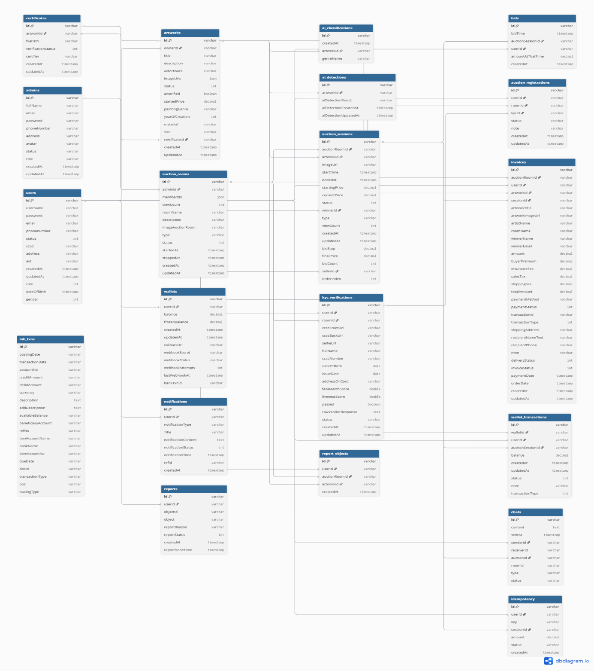 9
3. Database Design for Sprint 10
3.1 Table users 10
3.2 Table workspaces 10
3.3 Table artworks 10
3.4 Table workspace_invitations 12
3.5 Table workspace_activities 12
3.6 Table surveys 12
3.7 Table survey_templates 13
3.8 Table questions 14
3.9 Table question_types 15
3.10 Table question_options 15
3.11 Table survey_access 15
3.12 Table survey_collaborators 16
3.13 Table survey_collectors 16
3.14 Table collector_permissions 17
3.15 Table survey_invites 17
3.16 Table survey_responses 17
3.17 Table answers 18
3.18 Table generated_questions 19
3.19Table llm_interactions 19
3.20 Table analysis_results 20
3.21 Table visualizations 20
3.22 Table chat_conversations 21
3.24 Table notifications 22
3.25 Table audit_logs 22
4 . Hardware and software Requirements 23
4.1 Hardware Requirements 23
4.2 Software Requirements 23

Introduction
The Database Design maps the logical data model of the Auction System to the target database management system with consideration to the system’s performance requirements. The Database Design converts logical or conceptual data constructs to physical data constructs (e.g., tables or collections) of the target Database Management System.

Purpose
The purpose of this document is to provide a comprehensive and detailed specification of the database schema for the LLM-based Student Survey Application. It serves as the primary reference for developers, database administrators, and stakeholders to understand the data organization, integrity constraints, and relationships within the system. This document ensures that the database design supports the application's requirements for scalability, security, and advanced AI-driven features.

Scope
This document covers the design of the relational database system used by the application. It includes:
- Entity Definitions: Detailed descriptions of all 25 active tables.
- Attribute Specifications: Data types, constraints, and descriptions for every column.
- Relationships: Entity-Relationship Diagrams (ERD) and text-based association descriptions.
- System Requirements: Hardware and software prerequisites for the database environment.
The scope is limited to the backend database schema and does not cover frontend data state management or external API data structures unless they directly impact the database.

Introduction about MySQL
The system utilizes MySQL, a robust and widely-used open-source Relational Database Management System (RDBMS). MySQL is chosen for its:
- Reliability: Proven track record in handling critical data.
- Scalability: Ability to handle growing datasets and concurrent users.
- ACID Compliance: Ensuring data integrity through Atomicity, Consistency, Isolation, and Durability.
- Ecosystem: Strong support for Node.js via the Sequelize ORM.

Database Diagram

Table Overview
Table 1. Table Overview
Table Name | Short Description
users | Central entity for user identity, authentication, and profile information.
workspaces | Shared environments where teams collaborate on surveys.
workspace_members | Manages user membership and roles within a workspace.
workspace_invitations | Pending invitations sent to emails to join a workspace.
workspace_activities | Audit trail of all actions performed within a workspace.
surveys | The core entity representing a survey project.
survey_templates | Blueprints for creating new surveys.
questions | Individual questions associated with a survey or template.
question_types | Catalog of available question formats.
question_options | Pre-defined choices for closed-ended questions.
survey_access | Granular user-level permissions for private surveys.
survey_collaborators | Users with editing rights on a specific survey.
survey_collectors | Channels/Links for gathering responses.
collector_permissions | Advanced delegation of specific distribution channels.
survey_invites | Direct email invitations to respondents.
survey_responses | Represents a single submission session.
answers | Individual data points for each question.
llm_interactions | Log of all direct interactions with LLM providers.
analysis_results | Cached results of heavy analysis jobs.
visualizations | Saved chart configurations.
chat_conversations | Chat sessions between users and the AI assistant.
chat_messages | Individual messages in a chat conversation.
notifications | User alerts and notifications.
audit_logs | Security and compliance logs.

Entity Relationship Diagram

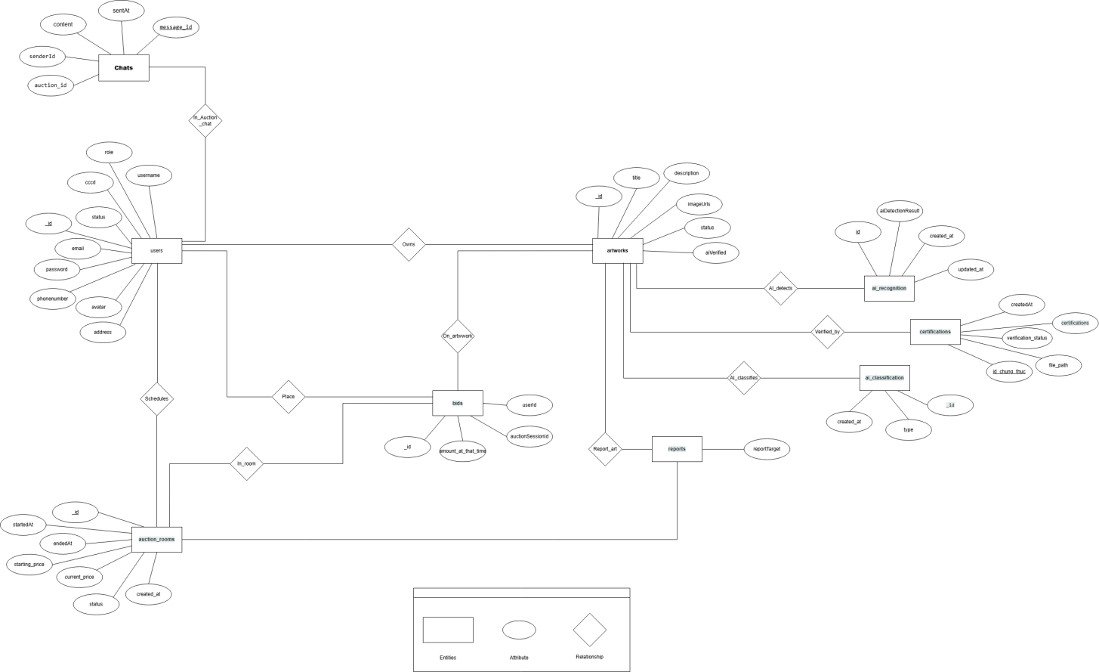

Image 1. Entity Relationship Diagram

Table Relationship Diagram

Image 2. Table Relationship Diagram

Database Design for Sprint

Table users
Table 2. Table users

users
Id | Field | Type | Constrain | Description
1 | id | INTEGER | PK, Auto Inc | Unique user identifier.
2 | username | STRING(50) |  | Login username.
3 | password | STRING(50) |  | Verified email address.
4 | email | STRING(100) |  | Bcrypt hashed password.
5 | full_name | STRING(100) |  | User's display name.
6 | role | ENUM | Default: 'user' | 'admin', 'creator', 'user'.
7 | created_at | DATE |  | Account creation timestamp.
8 | updated_at | DATE |  | Last update timestamp.

Table workspaces
Table 3. Table Workspace

Workspace
Id | Field | Type | Constrain | Description
1 | id | INTEGER | PK, Auto Inc | Unique workspace identifier.
2 | name | STRING(255) |  | Workspace display name.
3 | description | TEXT |  | Optional description.
4 | owner_id | INTEGER |  | Reference to users.
6 | is_active | BOOLEAN | Default: true | Soft delete/activation flag.
10 | createdAt | timestamp |  | Record timestamp.
11 | updatedAt | timestamp |  | Last update timestamp.

Table workspace_members
Table 4. Table workspace_members

workspace_members
Id | Field | Type | Constrain | Description
1 | id | INTEGER | PK, Auto Inc | Unique identifier.
2 | workspace_id | INTEGER | FK, Not Null | Reference to workspaces.
3 | user_id | INTEGER | FK, Not Null | Reference to users.
4 | role | ENUM |  | 'owner', 'collaborator', 'member', 'viewer'.
5 | is_active | BOOLEAN |  | Membership status.

Table workspace_invitations
Table 5. Table workspace_invitations

workspace_invitations
Id | Field | Type | Constrain | Description
1 | id | INTEGER | PK, Auto Inc | Unique identifier.
2 | workspace_id | INTEGER | FK, Not Null | Reference to workspaces.
3 | inviter_id | INTEGER | FK, Not Null | Reference to users (sender).
4 | inviter_email | STRING(255) |  | Reference to users (if exists).
6 | role | ENUM |  | Secure invitation token.
7 | Token | STRING(255) |  | Secure invitation token.
8 | status | ENUM |  | 'pending', 'accepted', 'declined', 'expired'.
9 | expires_at | DATE |  | Expiration timestamp.

Table workspace_activities
Table 6. Table workspace_activities

workspace_activities
Id | Field | Type | Constrain | Description
1 | id | INTEGER | PK, Auto Inc | Unique identifier.
2 | workspace_id | INTEGER | FK, Not Null | Reference to workspaces.
3 | user_id | INTEGER | FK, Not Null | Reference to users (actor).
4 | action | ENUM | Not Null | 'created', 'joined', 'survey_updated', etc.
5 | target_type | ENUM | Nullable | 'user', 'survey', 'workspace'.
6 | target_id | INTEGER | Nullable | ID of the affected entity.
7 | metadata | JSON | Nullable | Additional context data.

Table surveys
Table 7. Table surveys

surveys
Id | Field | Type | Constrain | Description
1 | id | INTEGER | PK, Auto Inc | Unique survey identifier.
2 | template_id | INTEGER | FK, Not Null | Reference to survey_templates.
3 | workspace_id | INTEGER | FK, Nullable | Reference to workspaces.
4 | created_by | INTEGER | FK, Not Null | Reference to users.
5 | title | STRING(255) | Not Null | Survey title.
6 | description | TEXT |  | Survey instructions.
7 | start_date | DATE | Not Null | Opening date.
8 | end_date | DATE | Not Null | Closing date.
9 | status | ENUM | Default: 'draft' | 'draft', 'active', 'closed', 'analyzed'.
10 | access_type | ENUM | Default: 'public' | 'public', 'public_with_login', 'private', 'internal'.
11 | target_audience | ENUM | Default: 'all' | 'all_users', 'specific_group', 'custom'.
12 | require_login | BOOLEAN | Default: false | Force authentication.
13 | allow_anonymous | BOOLEAN | Default: true | Allow anonymous responses.

Table survey_templates
Table 8. Table survey_templates
survey_templates
Id | Field | Type | Constrain | Description
1 | id | INTEGER | PK, Auto Inc | Unique identifier.
2 | title | STRING(255) | Not Null | Template name.
3 | description | TEXT | Nullable | Template description.
4 | created_by | INTEGER | FK, Not Null | Reference to users.
5 | status | ENUM | Default: 'draft' | 'draft', 'active', 'archived'.
6 | is_archived | TINYINT | Default: 0 | Soft delete flag.

Table questions
Table 9. Table questions

questions
Id | Field | Type | Constrain | Description
1 | id | INTEGER | PK, Auto Inc | Unique identifier.
2 | template_id | INTEGER | FK, Not Null | Reference to survey_templates.
3 | survey_id | INTEGER | FK, Nullable | Reference to surveys.
4 | question_type_id | INTEGER | FK, Not Null | Reference to question_types.
5 | question_text | TEXT | Not Null | The question content.
6 | label | TEXT | Not Null | Short label or code.
7 | required | BOOLEAN | Default: false | Is answer mandatory?
8 | display_order | INTEGER | Default: 0 | Sorting index.

Table question_types
Table 10. Table question_types

question_types
Id | Field | Type | Constrain | Description
1 | id | INTEGER | PK, Auto Inc | Unique identifier.
2 | type_name | STRING(50) | Unique, Not Null | e.g., 'multiple_choice', 'text', 'rating'.
3 | description | TEXT | Nullable | Usage guidelines.

Table question_options
Table 11. Table question_options

question_options
Id | Field | Type | Constrain | Description
1 | id | INTEGER | PK, Auto Inc | Unique identifier.
2 | question_id | INTEGER | FK, Not Null | Reference to questions.
3 | option_text | TEXT | Not Null | Display text.
4 | display_order | INTEGER | Default: 0 | Sorting index

Table survey_access
Table 12. Table survey_access

survey_access
Id | Field | Type | Constrain | Description
1 | id | INTEGER | PK, Auto Inc | Unique identifier.
2 | survey_id | INTEGER | FK, Not Null | Reference to surveys.
3 | user_id | INTEGER | FK, Not Null | Reference to users.
4 | access_type | ENUM | Default: 'respond' | 'full', 'view', 'respond'.
5 | granted_by | INTEGER | FK, Not Null | Reference to users.
6 | expires_at | DATE | Nullable | Access expiration.

Table survey_collaborators
Table 13. Table survey_collaborators

survey_collaborators
Id | Field | Type | Constrain | Description
1 | id | INTEGER | PK, Auto Inc | Unique identifier.
2 | survey_id | INTEGER | FK, Not Null | Reference to surveys.
3 | user_id | INTEGER | FK, Not Null | Reference to users.
4 | role | ENUM | Default: 'editor' | 'owner', 'editor', 'viewer'.

Table survey_collectors
Table 14. Table survey_collectors

survey_collectors
Id | Field | Type | Constrain | Description
1 | id | INTEGER | PK, Auto Inc | Unique identifier.
2 | survey_id | INTEGER | FK, Not Null | Reference to surveys.
3 | created_by | INTEGER | FK, Not Null | Reference to users.
4 | collector_type | ENUM | Default: 'web' | 'web_link', 'qr_code', 'email', 'embedded'.
5 | token | STRING(255) | Unique, Not Null | Unique URL token.
6 | name | STRING(255) | Nullable | Friendly name.
7 | is_active | BOOLEAN | Default: true | Active status.

Table collector_permissions
Table 15. Table collector_permissions

collector_permissions
Id | Field | Type | Constrain | Description
1 | id | INTEGER | PK, Auto Inc | Unique identifier.
2 | collector_id | INTEGER | FK, Not Null | Reference to survey_collectors.
3 | user_id | INTEGER | FK, Not Null | Reference to users.
4 | invite_token | STRING(255) | Unique, Not Null | Token for permission grant.
5 | status | ENUM | Default: 'pending' | 'pending', 'accepted', 'rejected'.

Table survey_invites
Table 16. Table survey_invites

survey_invites
Id | Field | Type | Constrain | Description
1 | id | INTEGER | PK, Auto Inc | Unique identifier.
2 | survey_id | INTEGER | FK, Not Null | Reference to surveys.
3 | created_by | INTEGER | FK, Not Null | Reference to users.
4 | email | STRING(255) | Not Null | Recipient email.
5 | token | STRING(255) | Unique, Not Null | Unique link token.
6 | status | ENUM | Default: 'pending' | 'pending', 'responded', 'expired'.

Table survey_responses
Table 17. Table survey_responses

survey_responses
Id | Field | Type | Constrain | Description
1 | id | INTEGER | PK, Auto Inc | Unique identifier.
2 | survey_id | INTEGER | FK, Not Null | Reference to surveys.
3 | respondent_id | INTEGER | FK, Nullable | Reference to users (if known).
4 | collector_id | INTEGER | FK, Nullable | Source collector.
5 | is_anonymous | BOOLEAN | Default: true | Anonymity flag.
6 | status | ENUM | Default: 'started' | 'started', 'completed', 'abandoned'.
7 | start_time | DATE | Nullable | Session start.
8 | completion_time | DATE | Nullable | Submission time.
9 | respondent_email | STRING | Nullable | Captured email (if not anonymous).

Table answers
Table 18. Table answers

answers
Id | Field | Type | Constrain | Description
1 | id | INTEGER | PK, Auto Inc | Unique identifier.
2 | survey_response_id | INTEGER | FK, Not Null | Reference to survey_responses.
3 | question_id | INTEGER | FK, Not Null | Reference to questions.
4 | option_id | INTEGER | FK, Nullable | Selected option (for choice types).
5 | text_answer | TEXT | Nullable | Open-ended text.
6 | numeric_answer | INTEGER | Nullable | Scale/Numeric value.
7 | createdAt | timestamp |  | Report submission timestamp.

Table generated_questions
Table 19. Table generated_questions

generated_questions
Id | Field | Type | Constrain | Description
1 | id | INTEGER | PK, Auto Inc | Unique identifier.
2 | question_text | TEXT | Not Null | The generated question content.
3 | question_type | ENUM | Default: 'text' | 'text', 'multiple_choice', 'likert_scale', etc.
4 | options | JSON | Nullable | Options for choice-based questions.
5 | keyword | STRING(255) | Nullable | Keyword used for generation.
6 | category | STRING(100) | Nullable | Category used for generation.
7 | source_model | STRING(100) | Default: 'trained_model' | AI model used.
8 | generated_by | INTEGER | FK, Not Null | Reference to users.
9 | is_used | BOOLEAN | Default: false | Usage flag.
10 | use_count | INTEGER | Default: 0 | Usage counter.
11 | quality_score | DECIMAL(3,2) | Nullable | AI or user feedback score.

Table llm_interactions
Table 20. Table llm_interactions

llm_interactions
Id | Field | Type | Constrain | Description
1 | id | INTEGER | PK, Auto Inc | Unique identifier.
2 | user_id | INTEGER | FK, Not Null | Reference to users.
3 | interaction_type | ENUM | Not Null | 'survey_generation', 'analysis', etc.
4 | model_used | STRING(50) | Not Null | e.g., 'gemini-1.5-flash'.
5 | prompt_id | INTEGER | Nullable | Reference to prompt template.
6 | custom_prompt | TEXT | Nullable | User's input prompt.
7 | response | TEXT | Not Null | AI generated output.
8 | tokens_used | INTEGER | Nullable | Cost tracking.

Table analysis_results
Table 21. Table analysis_results
analysis_results
Id | Field | Type | Constrain | Description
1 | id | INTEGER | PK, Auto Inc | Unique identifier.
2 | survey_id | INTEGER | FK, Not Null | Reference to surveys.
3 | analysis_type | ENUM | Not Null | 'sentiment', 'theme_extraction', etc.
4 | result_data | JSON | Not Null | Analysis output payload.

3.21 Table visualizations
Table 22. Table visualizations
visualizations
Id | Field | Type | Constrain | Description
1 | id | INTEGER | PK, Auto Inc | Unique identifier.
2 | survey_id | INTEGER | FK, Not Null | Reference to surveys.
3 | visualization_type | ENUM | Not Null | 'bar', 'pie', 'line', 'word_cloud'.
4 | title | STRING | Not Null | Chart title.
5 | config_data | JSON | Not Null | Configuration (axes, colors, data).
  - Table chat_conversations
Table 23. Table chat_conversations
chat_conversations
Id | Field | Type | Constrain | Description
1 | id | INTEGER | PK, Auto Inc | Unique identifier.
2 | user_id | INTEGER | FK, Not Null | Reference to users.
3 | title | STRING(255) | Default: 'New Chat' | Conversation topic.
4 | status | ENUM | Default: 'active' | 'active', 'archived', 'deleted'.
5 | last_message_at | DATE | Nullable | Sorting timestamp.
  - Table chat_messages
Table 24. Table chat_messages
chat_messages
Id | Field | Type | Constrain | Description
1 | id | INTEGER | PK, Auto Inc | Unique identifier.
2 | conversation_id | INTEGER | FK, Not Null | Reference to chat_conversations.
3 | sender_type | ENUM | Not Null | 'user', 'ai'.
4 | message | TEXT | Not Null | Message content.
5 | api_provider | ENUM | Nullable | 'gemini', 'super_dev'.
6 | response_time | INTEGER | Nullable | Latency in ms.
7 | tokens_used | INTEGER | Nullable | Cost tracking.
  - Table notifications
Table 25. Table notifications
notifications
Id | Field | Type | Constrain | Description
1 | id | INTEGER | PK, Auto Inc | Unique identifier.
2 | user_id | INTEGER | FK, Not Null | Reference to users.
3 | type | ENUM | Not Null | 'invite', 'response', 'system'.
4 | title | STRING | Not Null | Notification title.
5 | message | TEXT | Nullable | Notification body.
6 | is_read | BOOLEAN | Default: false | Read status.
7 | related_type | STRING | Nullable | Linked entity type.
8 | related_id | INTEGER | Nullable | Linked entity ID.

3.25 Table audit_logs
Table 26. Table audit_logs
audit_logs
Id | Field | Type | Constrain | Description
1 | id | INTEGER | PK, Auto Inc | Unique identifier.
2 | entity_type | STRING(50) | Not Null | 'survey', 'user', 'workspace'.
3 | entity_id | INTEGER | Not Null | ID of affected entity.
4 | action | STRING(50) | Not Null | 'created', 'updated', 'deleted'.
5 | performed_by | INTEGER | FK, Not Null | Reference to users.
6 | old_values | JSON | Nullable | State before change.
7 | new_values | JSON | Nullable | State after change.
8 | ip_address | STRING | Nullable | Client IP.
9 | user_agent | TEXT | Nullable | Client Browser/OS.

4. Hardware and software Requirements

4.1 Hardware Requirements
- Server:
  - CPU: 2 vCPU or higher recommended.
  - RAM: 4GB minimum (8GB recommended for AI processing).
  - Storage: 20GB+ SSD.
- Client:
  - Modern Web Browser (Chrome, Firefox, Edge, Safari).
  - Internet Connection.

4.2 Software Requirements
- Operating System: Windows / Linux (Ubuntu 20.04+ recommended for production).
- Database: MySQL 8.0 or higher.
- Backend Runtime: Node.js v18.x or higher.
- Frontend Framework: React.js.
- External Services:
  - Google Gemini API (for LLM features).
  - SMTP Server (for email invitations).

