PROPOSAL FOR ADOPTION
JCF DOCUMENT HUB
Mobile Access to Force Policies, Force Orders and Standard Operating Procedures

Prepared for
Jamaica Constabulary Force
Information & Communications Technology Division (ICTD)
Prepared by
Dwayne Aitken
dwayne.aitken@jcf.gov.jm

DOCUMENT CONTROL
Document Title | JCF Document Hub — Proposal for Adoption
Version | 1.0
Date Issued | 22 April 2026
Classification | Confidential — For JCF Internal Review
Status | For Approval

Table of Contents
1. Executive Summary 3
2. Background and Problem Statement 3
3. Proposed Solution 4
4. Authentication via JCF Webmail 5
5. Benefits to the Force 6
6. Security and Risk Considerations 7
7. Technical Overview 8
8. Proposed Rollout Plan 8
9. Request to JCF 9
10. Closing Statement 9
Appendix A — Document Categories 10
Appendix B — Glossary 11
Appendix C — Application Screenshots 12

1. Executive Summary
The JCF Document Hub is a mobile application that places the Force's policies, Force Orders, and Standard Operating Procedures directly in the hands of every serving officer — on duty, off duty, or at home. Officers sign in with their existing @jcf.gov.jm webmail credentials and gain immediate, searchable access to the entire policy library on their personal smartphone.
The application has been designed, built, and tested. It currently indexes 346 documents across 19 categories, including Force Orders, divisional SOPs, and national policing policies. This proposal recommends a controlled pilot with a single division, followed by Force-wide rollout under ICTD sponsorship.
No new infrastructure is required. The application leverages JCF's existing Microsoft 365 environment for authentication and can serve documents from JCF-controlled storage. There is no cost associated with the pilot phase.
2. Background and Problem Statement
Officers across the Jamaica Constabulary Force routinely require access to policy documents to perform their duties correctly and lawfully. Examples include:
- A patrol officer responding to a missing-person report consulting the Missing Person Investigation SOP.
- A station commander preparing a disciplinary review consulting the Administrative Review Policy and SOP.
- A traffic officer requiring the latest Traffic and Mobile Maintenance Division (TMMD) operating procedures.
- A constable preparing for a promotional examination by studying current Force Orders.
In the current operating environment, accessing these documents typically requires:
- Physical presence at a station with access to the JCF network.
- Requesting copies via email from a supervisor or colleague.
- Reliance on printed binders that risk falling out of date.
- Searching through informal channels (e.g. WhatsApp threads) for forwarded copies.
This friction costs officer time, increases the risk of acting on outdated guidance, and prevents officers from preparing or studying outside of duty hours.

3. Proposed Solution
The JCF Document Hub is a native Android application providing a single, authoritative point of access to all Force documentation, summarised below:
Feature | Description
Centralised library | All 346 policy documents in one place, organised into 19 categories including Force Orders, NPCJ, TMMD, CIB, PMMD, SOPs, PECC, PRDB, PMAS, FLPD, FIPT, DWTT, FIBUA, PPMU, ICTD and ICT.
Search | Full-text search by title across the entire library or within a specific category.
Integrated PDF viewer | Documents open directly within the application — pinch-to-zoom, page navigation, and bookmarks. No third-party reader required.
Read-aloud (Text-to-Speech) | Officers may have policy documents read aloud — beneficial during commutes, breaks, or for accessibility purposes.
Offline cache | Once a document has been opened, it remains accessible without an active data connection.
Always current | Documents are pulled from a single, ICTD-controlled source. When a policy is updated centrally, every officer's device reflects the new version on next refresh.

4. Authentication via JCF Webmail
It is proposed that the application be gated behind the officer's existing JCF webmail credentials (@jcf.gov.jm). This approach delivers significant operational and security advantages:
- No new password to manage — officers use credentials they already maintain.
- No parallel identity system — the JCF Microsoft 365 directory is the single source of truth.
- Immediate deprovisioning — when a webmail account is disabled, application access is automatically revoked. No separate offboarding step is required.
- Verified audit trail — every sign-in is associated with a confirmed JCF identity.
- Domain restriction — only @jcf.gov.jm addresses may authenticate; all others are rejected.
- Compliance inheritance — Microsoft 365 Conditional Access policies (multi-factor authentication, device compliance, geo-restrictions) apply automatically.
Implementation uses the Microsoft Authentication Library (MSAL) over OAuth 2.0 / OpenID Connect — the standard, supported method for integrating with Microsoft 365. No passwords are ever stored or transmitted by the application itself.

5. Benefits to the Force
5.1 For the Rank-and-File Officer
- Study Force Orders at home in preparation for promotional examinations.
- Confirm the correct procedure on scene without leaving the location.
- Access the policy library on personal time, on a personal device, securely.
5.2 For Supervisors and Station Commanders
- Confidence that every officer holds the current version of every policy.
- Elimination of printing, distribution, and acknowledgement chasing for paper-based policies.
- Simplified onboarding for new officers — the entire policy library is one download away.
5.3 For the Force as an Institution
- Measurable reduction in policy-knowledge gaps among serving officers.
- A modern, professional tool that signals investment in officer development and welfare.
- Centralised version control — when a policy changes, every device in the Force updates.
5.4 For ICTD
- Built on standard, supported technology (Flutter, OAuth 2.0, Microsoft 365).
- No new servers required for the document library — content can be hosted on existing JCF-controlled storage (e.g. SharePoint).
- Low operational overhead and a clear technology roadmap.

6. Security and Risk Considerations
Risk / Concern | Mitigation
Unauthorised access | JCF webmail (Microsoft 365) sign-in restricted to the @jcf.gov.jm domain. Multi-factor authentication enforced via Conditional Access.
Stale access for separated officers | Disabling the JCF webmail account immediately revokes application access. No separate offboarding action required.
Document leakage | Application-level controls — screenshot blocking, share restriction, and per-officer watermarking — to be enabled in Phase 2.
Document integrity | Documents served from a single ICTD-controlled source, signed and version-tracked. Officers cannot modify or replace documents within the application.
Lost or stolen device | Re-authentication required after a configurable idle period. Microsoft 365 Conditional Access (MFA, device compliance, remote wipe via Intune) applies automatically.

7. Technical Overview
Component | Detail
Target platform | Android (primary). iOS port available on request. A web build is also possible from the same codebase.
Application framework | Flutter 3 — single codebase, native performance.
Document storage | Documents are served from an ICTD-controlled document store. The application is storage-agnostic and integrates with JCF SharePoint or any approved internal document service.
Authentication (proposed) | Microsoft Authentication Library (MSAL) integrated with the JCF Microsoft 365 tenant.
Footprint | Approximately 60 MB install size. No background services. Negligible battery impact.

8. Proposed Rollout Plan
Phase | Scope | Duration
1. Pilot | ICTD staff plus one nominated division. JCF webmail sign-in enabled. Feedback collected. | 4 weeks
2. Hardening | Add screenshot blocking, watermarking, and audit logging based on pilot feedback. | 2 weeks
3. Force-wide release | Distribute via JCF-managed channel (Mobile Device Management or internal application catalogue). Training note circulated. | 2 weeks
4. Ongoing | ICTD assumes ownership of content updates. Quarterly application updates. | Continuous

9. Request to JCF
The author respectfully requests the following from the Jamaica Constabulary Force:
1. Approval in principle. Authorisation to proceed to a controlled pilot.
2. ICTD sponsorship. Registration of the application within the JCF Microsoft 365 tenant to enable webmail-based authentication.
3. A nominated content owner. Identification of the officer or unit authorised to add, update, and retire policy documents.
4. A pilot division. Identification of one division willing to use the application for four weeks and provide structured feedback.
No financial outlay is requested for the pilot phase. The application has been developed at the author's own expense, and the supporting infrastructure is leveraged from systems the Force already operates.
10. Closing Statement
Every serving officer carries a smartphone. Every serving officer is expected to know Force policy. The JCF Document Hub closes the gap between those two facts — securely, economically, and immediately.
I welcome the opportunity to demonstrate the application at the Force's convenience and to answer any technical or operational questions the Command may have.

Dwayne Aitken
Author and Developer
dwayne.aitken@jcf.gov.jm

Appendix A — Document Categories
The application currently organises 346 documents across the following 19 categories. Categorisation is automatic, based on document naming conventions.
Category | Description
Force Orders | Documents originating from JCF Headquarters governing operational conduct.
JCF Policies | General Jamaica Constabulary Force policies and standard operating procedures.
NPCJ | National Police College of Jamaica training and curriculum material.
TMMD | Traffic and Mobile Maintenance Division procedures.
PMMD | Public Morality and Major Decency Division procedures.
CIB | Criminal Investigation Branch procedures and guidelines.
PECC | Police Emergency Communications Centre procedures.
PRDB | Police Records and Data Branch procedures.
PMAS | Property Management and Administration Services procedures.
FLPD | Firearm Licensing and Permits Department procedures.
FIPT | Firearm Investigation and Prosecution Team procedures.
DWTT | Detective and Witness Testimony Training material.
FIBUA | Fighting in Built-Up Areas tactical material.
PPMU | Policy and Procedure Management Unit material.
ICTD | Information and Communications Technology Division procedures.
ICT | General Information and Communications Technology guidelines.
SOPs | Cross-divisional Standard Operating Procedures.
SIMU | Strategic Intelligence Management Unit procedures.
General | Statutes, Acts, and supporting reference material.
Note: Category descriptions are illustrative. Final descriptions to be confirmed with the nominated content owner.

Appendix B — Glossary
Term | Definition
JCF | Jamaica Constabulary Force.
ICTD | Information and Communications Technology Division (of the JCF).
SOP | Standard Operating Procedure.
Force Order | An official instruction issued by JCF Headquarters governing operational conduct.
OAuth 2.0 / OIDC | Industry-standard protocols for delegated authorisation and federated identity.
MSAL | Microsoft Authentication Library — the official client library for signing into Microsoft 365.
Conditional Access | A Microsoft 365 capability that enforces sign-in policies (MFA, device compliance, location restrictions).
MDM | Mobile Device Management — central management and deployment of applications to organisational devices.
Intune | Microsoft's MDM and endpoint compliance product.

Appendix C — Application Screenshots
The following screenshots were captured from the production build of the JCF Document Hub application running on an Android device. They illustrate the home screen, category navigation, document listings, and the integrated PDF viewer.
C.1 Home Screen and Category Overview
The home screen presents the officer with a summary of the entire policy library and a category grid for rapid navigation.
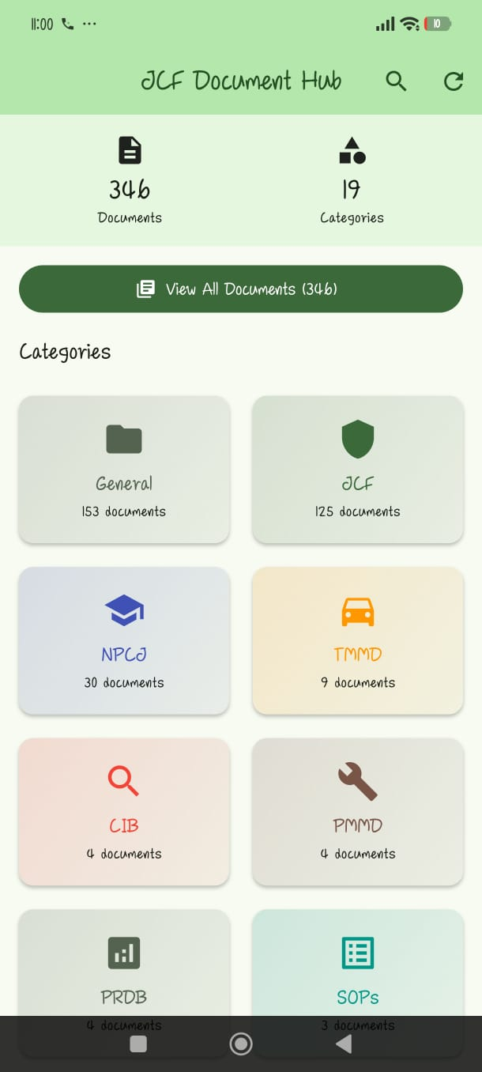 | 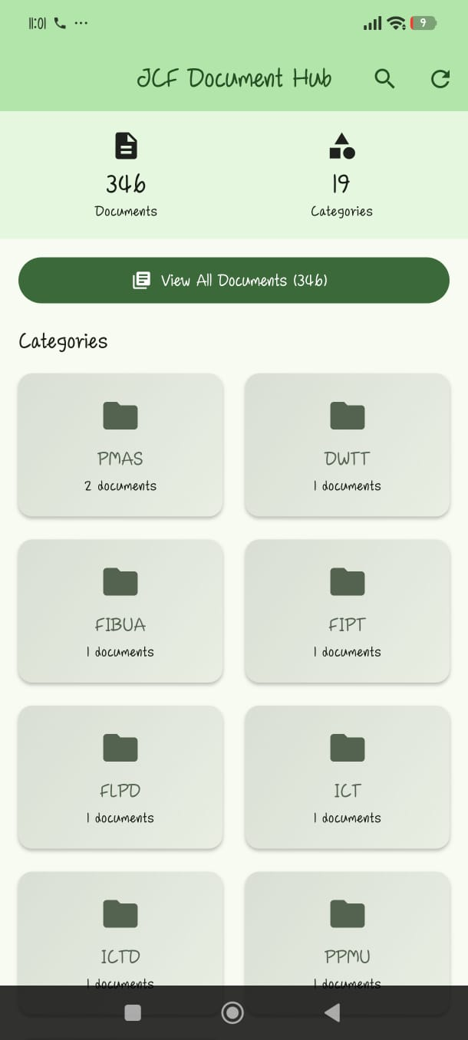
Figure 1 — Home screen showing 346 documents across 19 categories. | Figure 2 — Specialist categories (PMAS, DWTT, FIBUA, FIPT, FLPD, ICT, ICTD, PPMU).

C.2 Document Listings
Selecting a category opens a searchable, alphabetised list of every document in that category. The General category contains statutes and reference material; the JCF category contains all Force Orders and JCF-issued policies.
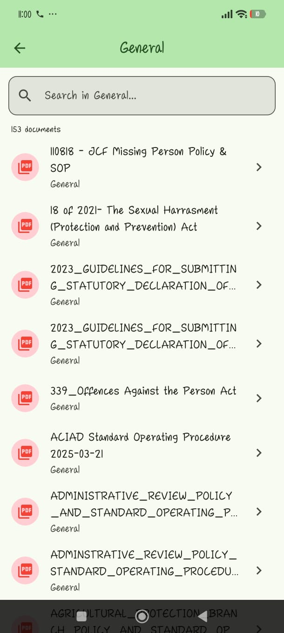 | 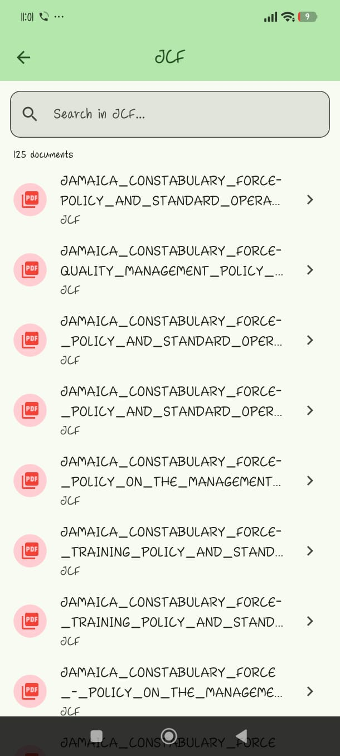
Figure 3 — General category (153 documents) including the Missing Person SOP and the Sexual Harassment Act. | Figure 4 — JCF category (125 Force Orders and JCF-issued policies).

C.3 Integrated PDF Viewer
Documents open inside the application — there is no need for a third-party PDF reader. Officers can read, zoom, and navigate the full document, and optionally have it read aloud via the built-in Text-to-Speech feature.
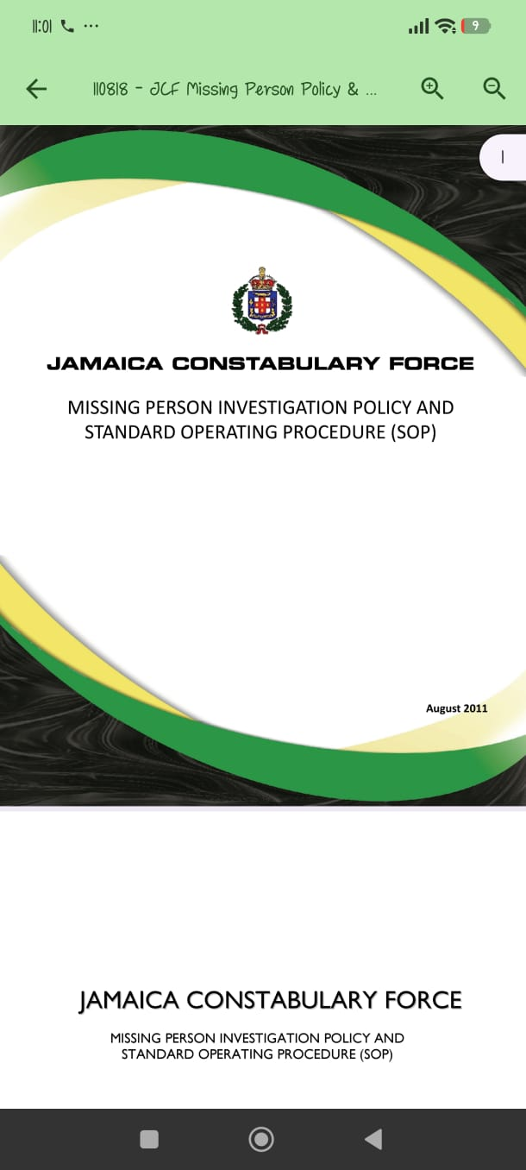
Figure 5 — Integrated PDF viewer displaying the JCF Missing Person Investigation Policy and SOP.

