Kopila Bhattarai  
11/13/2019  
IT FDN 100A  
Assignment 6

# Functions and classes

Introduction:

The assignment this week builds off of last week’s assignment, where the user is to pick from a menu of items for the program to create an interactive to-do list. The goal of this assignment to use functions and classes to create a to do list and add the list to a file.

We were provided with starter program where we were to add more functions and classes so that the user can see the existing data, add new to do items, remove an item, save data, reload the data and exit the program.

**Class FileProcessor:** This is the class that was provided in the starter file. I moved the functions from main body of the starter file so that the script is more organized and flows better.

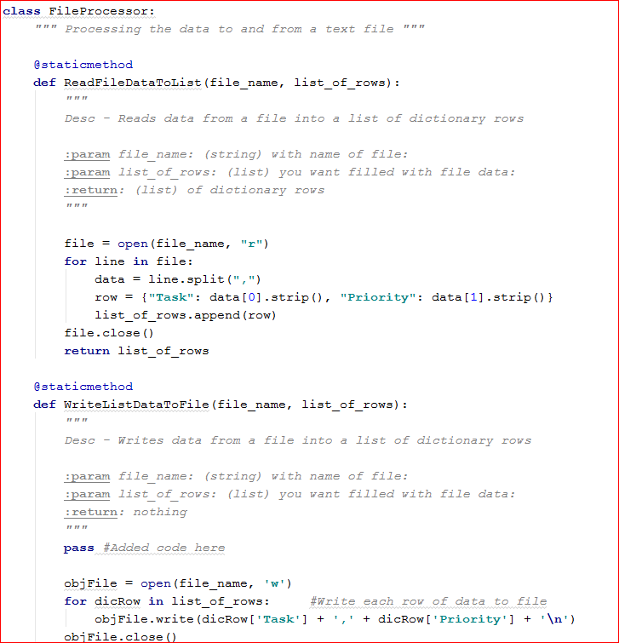

*Figure 1: Defining read data to list and write data to file functions*

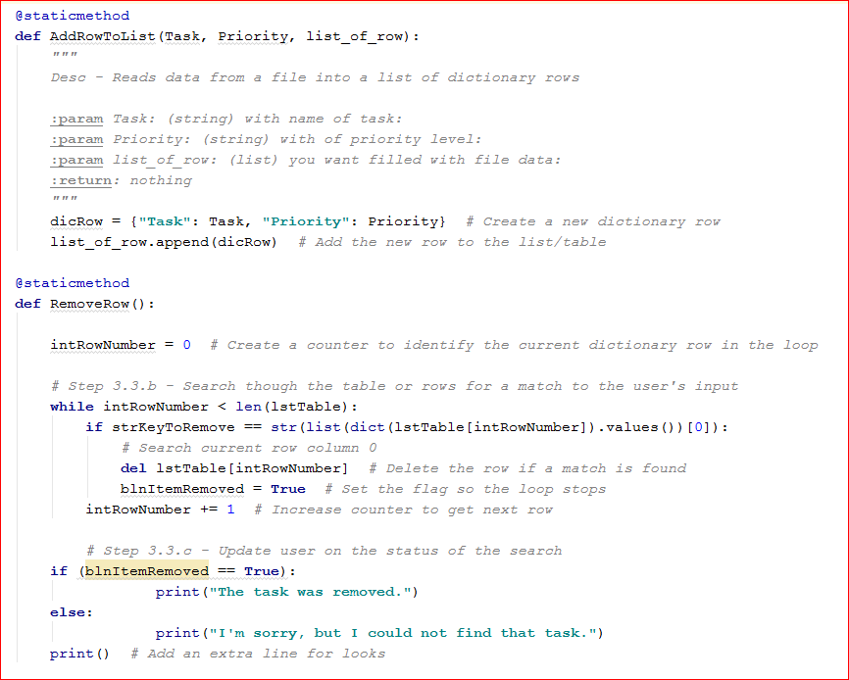

*Figure 2: Defining add to do items to list and removing to do items from list functions*

**Class IO:** This class is basically for input and output operation. It asks for user-inputs and depending on what the user-input is corresponding outputs are displayed. The first function created is OutputMenuItems. This gives users the menu of options where the user selects one options. Which feeds into InptMenuChoice function. Based on the choice made, the computer will perform one of the following functions:

1) Show current data  
2) Add a new item.  
3) Remove an existing item.  
4) Save Data to File  
5) Reload Data from File  
6) Exit Program

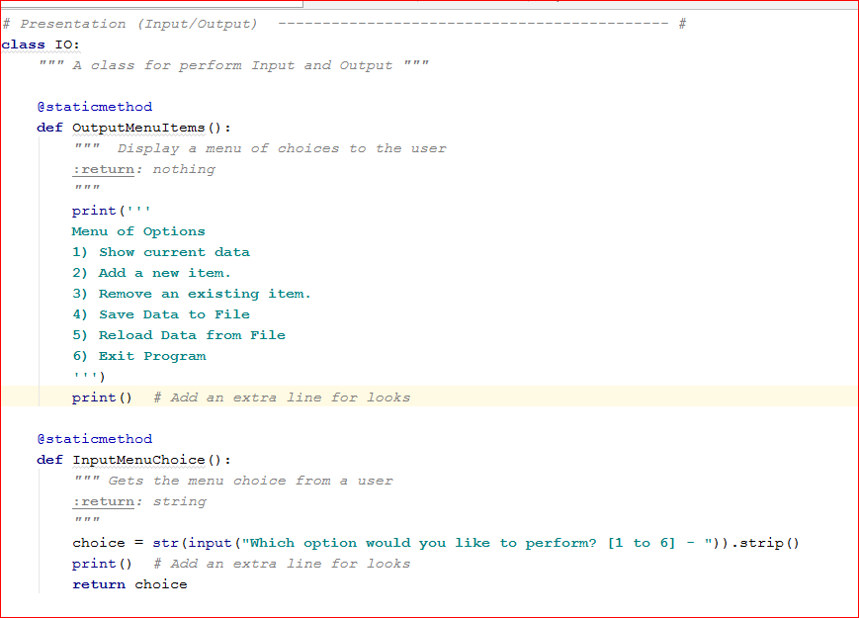

*Figure 3: Defining output menu items and input menu choice functions*

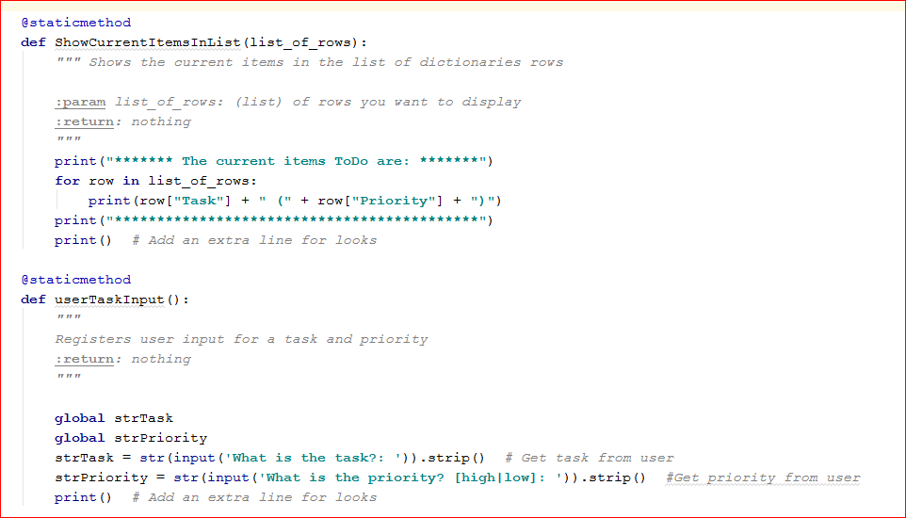

*Figure 4: Defining show current items in list and adding items to list functions*

**Main Body of the Script:** In this section, the functions and classes that were established previously will be called. To do this, I reorganized the starter file, where I moved the functions to functions section and only called them within this section. The following three figures show the calling of functions.

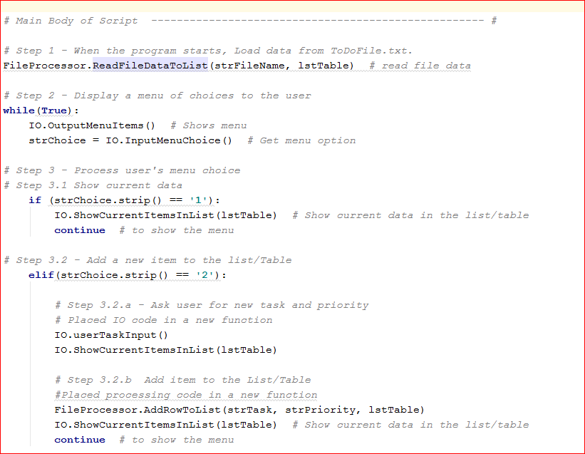

*Figure 5: Calling read data and adding more data functions*

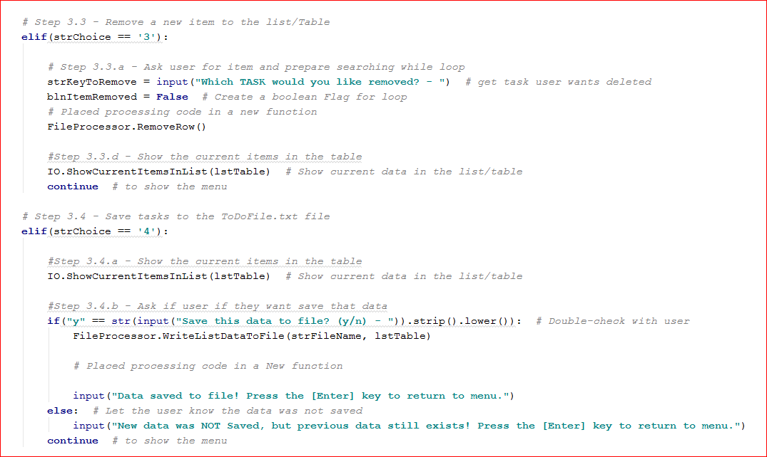

*Figure 6: Calling remove data and save data more data functions*

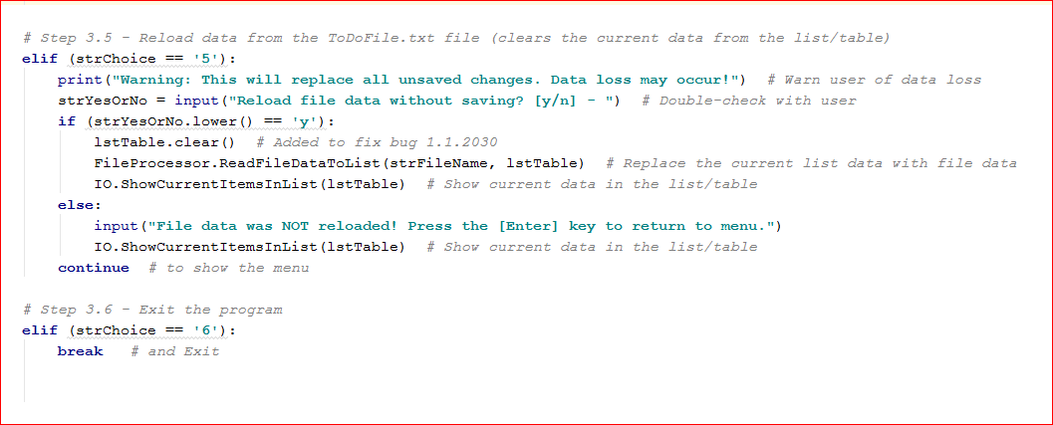

*Figure 7: Calling reload data and exit program functionalities*

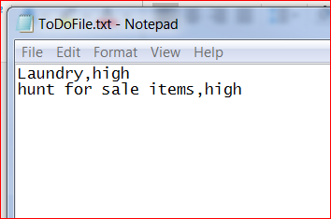

*Figure 8: To do list loaded into a text-file*

*Summary:*In summary this assignment helps us reinforce our understanding of defining and using classes and functions by creating interactive to-do list. Since the starter file was already there, the modifying of the script was relatively easier, however, organizing it was a little harder until I got my head wrapped around the entire code.