Kopila Bhattarai  
11/5/2019  
IT FDN 100A  
Assignment 5

# Documentation for To Do List Script

Introduction:

This document explains the working process of *To Do List program* script  
  
The script asks user to enter a choice from menu items (list of 1 through 5) where each choice accomplishes the following task:

1) Show current data,  
2) Add a new item,  
3) Remove an existing item,  
4) Save data to file and  
5) Exit program

When the program is run and if first choice is selected, it displays the existing to do list as shown in the following screenshot:  
  
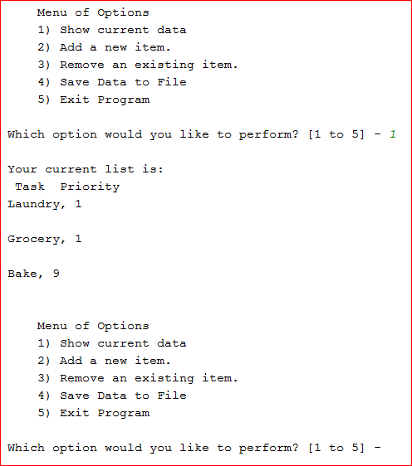  
Figure 1: Working Script in PyCharm when Option 1 is selected  
  
When choice 2 is selected, the program asks user-input for a new to do item and its corresponding priority value to be added to the list. Once that is added, the program adds that item to its existing to do list as displayed in the following screenshot:  
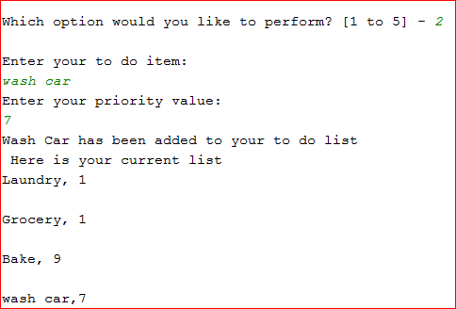  
Figure 2: Working Script in PyCharm when Option 2 is selected  
  
When the user selects option 3 (to remove last item), the program asks if the user wants to delete the last item (with choices between ‘y’ and ‘n’). If the user types ‘n’, the list is kept as it is. However, if the user types ‘y’, the last item from the to do list is deleted and current list and their corresponding values are displayed as displayed in the following screenshot:   
  
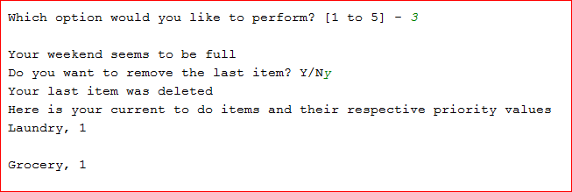  
Figure 3: Working Script in PyCharm when Option 3 is selected  
  
If the user selects option 4, the to-do list is saved to the ToDoList.txt file and a confirmation massage is generated as shown below.   
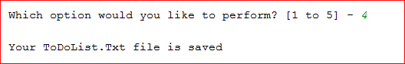  
Figure 4: Working Script in PyCharm when Option 4 is Selected  
  
The program ends when the user selects option 5.   
  
**The following discusses the documentation for To Do List program script in command shell**

When choice 1 is entered, the program displays existing to do list. When choice 2 is entered, the program asks for user for a new to do item and its respective priority value. Once entered, they are saved on the to do list as displayed in the following screenshot:

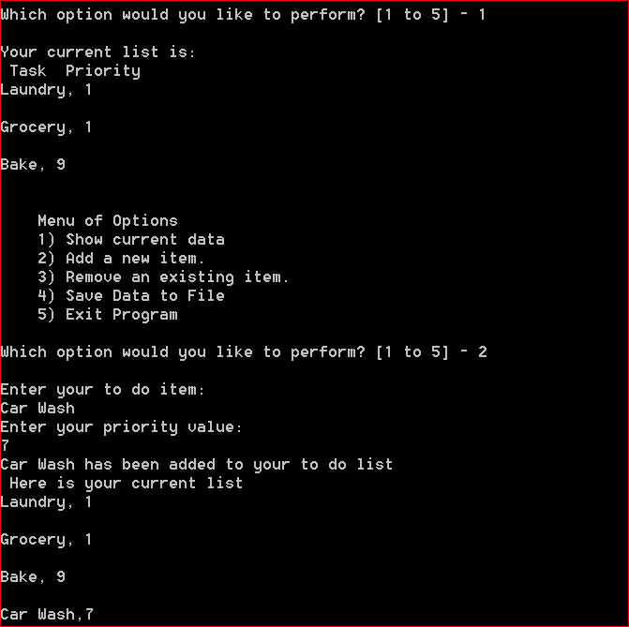  
*Figure 5: Working Script in PyCharm in Command Shell when Options 1 and 2 are Selected*

When user selects option 3, the program asks if the user wants to delete the last item. If the user confirms with a ‘y’, then the last item is removed from the to do list and a confirmation message is generated as displayed below:

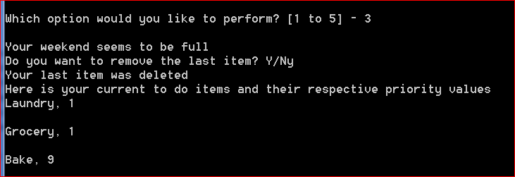  
*Figure 6: Working Script in PyCharm in Command Shell when Option 3 is Selected*

When option 4 is selected, the program saves current to do list on to a text file. When option 5 is selected, the program is ended. The following screenshot shows the output of options 4 and 5 respectively:

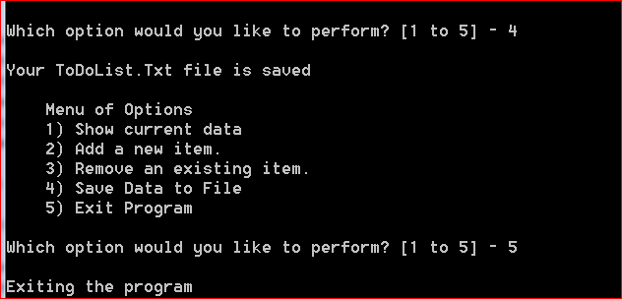  
*Figure 7: Working Script in PyCharm in Command Shell when Options 4 and 5 are Selected*

The to do list data is added in a text file as displayed in the following figure:

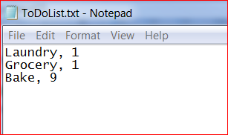  
Figure 8: User-input Data Added in a Text- File

Summary:  
In summary, this document explains what ToDoList script does.