Roche – LIS Challenge

**UML Diagrams**

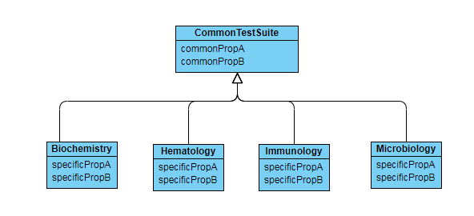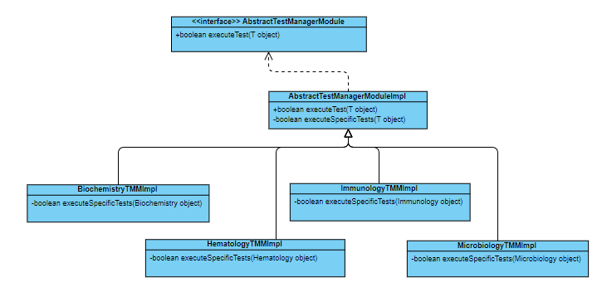

**Refactoring Strategy**

To test some Hematology type, you need to create a new instance of AbstractTestManagerModule<Hematology> and call executeTest.

This will execute common and specific test (if applies)

To add new types of tests, just need to create the new domain for this type, with specific attributes and a new implementation class like "NewTestTypeTMMImpl extends AbstractTestManagerModuleImpl<NewTestType>" and implement the executeSpecificTests with the specific behavior for this new type.

**Project Structure**

