UNIVERSITY OF LA VERNE
LA VERNE, CALIFORNIA

Spring 2018

SENIOR PROJECT REPORT

J2 INNOVATIONS’ AUTOMATIC RFID EMPLOYEE CLOCKING SYSTEM

A SENIOR PROJECT SUBMITTED TO:
THE FACULTY OF
COMPUTER SCIENCE AND COMPUTER ENGINEERING
IN CANDIDACY FOR THE DEGREE OF
BACHELORS OF SCIENCE
SOFTWARE / ENGINEERING

BY

KOPPANY HORVATH

Abstract
The purpose of this project is to design and implement an RFID based employee time tracking system for J2 Innovations, a building automation software company. The following hardware technologies were used: IOT enabled ESP 32 microcontroller, RFID scanner module, 3D printing, WiFi AP device configuration. In addition, a variety of software was used: Arduino IDE, NodeJS framework, Ractive library, AM Charts library, MySQL database. The user experience was greatly improved and user complaints were reduced to nearly none. Possible future expansions include handling different time zones for international employees, generating reports and charts for management, and scheduling days off and vacations through the UI.

Table of Contents
Abstract 1
Chapter I: Introduction 1
Introduction 1
Problem Statement 1
Purpose Statement and Rationale 1
Method 1
Need of such project 1
Contributions to society 1
Limitations 1
Chapter II: Literature Review 1
Chapter III: Analysis 1
Feasibility Study 1
Analysis of Findings From Previous Chapters 1
Hardware and Software Choices 1
Chapter IV: Design 1
Overview 1
Hardware 1
Software 1
Chapter V: Implementation 1
Hardware 2
Software 2
Chapter VI: Conclusion 2
Summary and Conclusion 2
Data 2
Discussion 2
Implications 2
Personal Reflection 2
Lessons Learned 2
If It Had To Be Redone 2
Future Research and Recommendations 2
Project Recommendations 2
References 2
Appendices 2
Appendix A: Proposal 2
Appendix B: Gantts Chart 2
Appendix C: Progress Report 1 2
Appendix D: Progress Report 2 2
Appendix E: Progress Report 3 3
Appendix F: Source Code 3
Appendix G: Diagrams 3
Appendix H: PowerPoint 3

Chapter I: Introduction

Introduction
When tasked with overseeing employee work times and productivity, how that data is obtained and managed can be the difference between a good or bad user experience. The point of this study is to design and implement a system that can improve how employees log their work hours and tasks, along with making it easy for management to manage that information. The proposed design directly relates to the problem in that it attempts to solve the problems present in the previous system for tracking employee work times. This study relates to previous work in that it uses RFID technology to acquire parts of the data, but it is applied to tracking the time of employees rather than tracking the locations of materials.

Problem Statement
The employees and management working for J2 Innovations, a building automation software company, are frequently annoyed by the current time tracking system being used. One of the biggest problems that management complains about is that the system is a third party service that requires monthly payment per registered employee, and is not flexible in terms of adding new features or correcting problems with the service. An issue that bothers the employees is that with the current system employees have to manually type in their starting time and ending time which sometimes results in inaccurate information if an employee can't remember their starting time accurately. The project manager is sometimes bothered by not being able to see what the general schedule is for part time employees who have very dynamic schedules through the web interface of the current system. Employees also don’t like having to submit a daily email containing their work for the day along with a weekly email containing not only the information from the daily emails, but what their times were for each day that they worked because the current system has no easy way for management to view this information.

Purpose Statement and Rationale
The purpose of this project is to design and build an RFID based employee time tracking system to address the issues caused by J2 Innovations’ current time tracking system. This new system will solve the problem of monthly payment by running on a local server rather than as a remote paid service and will solve the problem of being inflexible by being made open source and being designed to be easily modifyable. This system will also solve the problem of employees having to manually type their times by using RFID technology to automatically record that information by swiping an RFID card on an RFID node. The web interface for this system will also allow management to view the schedules of employees and view their times along with the tasks they did throughout the day.

Method
The method of this study consisted of doing initial research to see what previous approaches to the problem had been attempted. Then more research followed to investigate a good way to implement the server software which would work to manage data and route data where it needs to be. Then research was done to see what kind of IOT configurations are generally easy to use.
After research, software implementation testing followed to determine the effectiveness of the chosen implementation. Shortly after software implementation began, the focus changed to hardware testing to see how well the components would fit together and to learn the concepts of IOT programming which would be used in the final hardware product.
Following hardware and software testing, production level implementations began. Hardware had the highest initial priority, with software coming in second in order to provide any web API support that the IOT part of the hardware required. After hardware had been finished, it was tested in 2 physical locations to make sure it worked. The software implementation continued on after that to implement all basic functionality needed by the end users.

Need of Such a Project
This project was necessary in order to address the problems described in the Problem Statement section. Most important of those problems was to make a dynamic system that did not require payment to a 3rd party service which increases in proportion to the amount of employees using the system. This problem alone justifies the need for such a project as far as management is concerned. A quick poll of the employees also reveals that they collectively do not like the current system and even though they are skeptical about the effectiveness of this new system, they would still be willing to try the new system.

Contributions to Knowledge and Society
Unfortunately, due to the limited nature of the Senior Project, this project does nothing particularly special to contribute to humanity's collective knowledge. However, this project has been open-source since the start and is freely available on GitHub. It is hoped that this project might be used at other companies where a free employee time tracking system would be beneficial along with all the convenience features that it provides.

Limitations
The major limitations of this project in its current state are as follows. End users from different timezones other than the one that the server is being hosted at will notice that some of the timestamps will be incorrect. Management still doesn't have fine control over individual reports as the current implementation focuses on mass reports and data. From an IT standpoint, someone well versed in Linux based server systems will be required to install and maintain the server software. These issues are expected to be resolved in future updates of this project.

Chapter II: Literature Review

Historical Implementations
In conducting research, three notable implementations of digital employee time tracking systems were found. The first, Office Timesheet 2000, has the capability to clock workers in and out, along with being able to record time spent working on separate projects or tasks. The interface comes as a desktop application or as a primitive “web app”. Timesheet 2000 uses a client-server architecture with the ability to store data in a variety of database applications. This system also supports dynamic reports and the capability to send automatic email notifications (Feibus).
The second time tracking system, TimeSheet Pro, is very similar to Office Timesheet 2000 in its main features, but is designed to be more configurable. This system can either use database applications to store data, or it can store data locally. Like Timesheet 2000, TimeSheet Pro can track projects and tasks and be accessed through a web browser. Unlike Timesheet 2000, TimeSheet Pro is more configurable in terms of holidays, task rules, and pay rules. TimeSheet Pro is also considered more difficult to use due to poor design of the user interface (Feibus).
The third time tracking system is called Employee Proj Clock. This system is designed as a small desktop application that communicates with a server to retrieve and transfer information. Each user can only edit their own information, or an administrator can edit anyone's information. The interface is simple in that the basic inputs are the project to be worked on, who the user is, when they started, when they ended, and any comments the user might have. This information is sent to the server and recorded into a database. A custom reports tool allows reports to be built based on what information is required. It is reported that Employee Proj Clock improves productivity and accuracy of time records when switching over from traditional time cards or manual reporting (Gruber).

Modern Implementations
During research, three modern examples of employee time tracking systems were discovered. The first, Syspro ShopClock, is a real-time data collection system for employee time and attendance. ShopClock can also track the time spent on jobs and materials used in performing a task. This system gives management a GANTT chart that updates in real time to display the status of employees. ShopClock allows for shifts, labor rates, and overtime pay to be defined in advance. ShopClock can also integrate with barcode readers to update the materials used and current inventory. When employees are clocking in or out, ShopClock will alert the user if there is a problem with the information that they are inputting (Syspro).
The second system is Replicon's Cloud Clock, which is a cloud based time clock. This implementation is unique in that it uses an internet connected hardware clock that the users interact with while giving management the power to monitor who clocks in and when. Along with the hardware clock, Replicon offers its Cloud Clock software as a service. This allows management to validate attendance records and ensure compliance of work policy. Replicon reported that compliance for employees submitting completed timesheets increased by 85% while reducing payroll errors from 8% to just 1.9% in less than a year (Replicon).
The last example is the TSheets employee time tracking system. What is unique about this system is how much effort the developers put into making the system as fun and easy to use as possible. TSheets has moved away from relying on dedicated hardware for tracking time and instead uses a cloud based solution with phone apps and web apps so that employees can use any device they want to clock in and out. TSheets also logs employees locations as they use the system so that employees can't cheat on attendance reports because management will know that they weren't really where they said they were when they clocked in. TSheets even has a rating system so that they can know how satisfied employees are with the overall system and its features (Computers).

RFID Systems
Due to this project using RFID technology, research on examples of using RFID technology on humans was necessary. Unfortunately, using RFID for the purpose of tracking employee times does not seem to be something that has been reported in any journals, and thus the following examples are used for purposes other than employee time tracking. The first example is a study trying to determine the best way of utilizing RFID technology in a hospital setting to track tools and equipment throughout the building as well as patients. Of greatest interest in this study were the results and conclusions that the research group came up with while reviewing different RFID implementations. In the comparison between active and passive RFID technology, it was found that while passive RFID has a smaller detection range, it is still a better option due to the RFID tags being smaller and cheaper when compared to active RFID tags. During testing with actual passive RFID hardware, the researchers found out that the RFID tags could only be read when the face of the tag was parallel to that of the RFID reader, and it had trouble being read when in direct contact with a human body or when it was attached to some objects with a high liquid content. Eventually it was discovered that passive RFID technology has many limitations, but is acceptable because of the cost and size factors (Najera).
The second example is a study attempting to determine the effectiveness of RFID technology in collecting data from a construction site in order to be analyzed for better decision making to improve productivity. Like the previous study, the researchers in this study came to the same conclusion that passive RFID technology was better suited than active RFID technology because the tags are smaller and cheaper, even despite certain problems caused by RFID signals being attenuated by metal beams within the walls of the construction site. Also like the previous study, these researchers found that passive RFID technology has a relatively small detection range, but they were able to solve this problem by strategically positioning the RFID readers in places that would come as close as possible to where materials and workers with tags would be passing by such as doorways (Costin).

Chapter III: Analysis

Feasibility Study
In studying other works to determine the feasibility of this project, along with what requirements are needed for this project, a conclusion was reached in that this project is quite feasible. This conclusion was reached because all of the necessary hardware and software technologies could be found as commercial off-the-shelf modules and libraries that would make implementation of this project possible within the deadline of the Senior Project.

Analysis of Findings From Previous Chapter
Based on the research from the previous chapter, there are common patterns that seem to be standard of employee time tracking systems. The biggest commonality that stuck out was the use of client-server architecture when implementing such a system. One of the systems, TimeSheet Pro, had the ability to store data locally, but could also use a remote database if necessary. Otherwise, the other systems exclusively used a client-server setup to keep the stored data centralized on a server and give the end users either a web interface to work with, or API calls for desktop applications that interface with the server.
The next most common implementation feature was the use of a web page interface to interact with the employee time tracking system. With the exception of Employee Proj Clock, the other platforms at least offered some form of web interface, even if a desktop application was the main interface for that system. In comparing the more modern systems with the older systems, it appears that a web app style interface is preferred over a desktop application style interface.
One smaller common feature that was found to be common during research is adding features other than employee time tracking. This seems to give the system a greater market advantage because everything can be managed with one system as opposed to multiple systems. Examples of this are tying it into the inventory system as in SysPro's ShopClock. Another example is tying in physical time tracking hardware as in Replicon's Cloud Clock.
In terms of RFID technology implementation, a preference between the two RFID types was detected as well. With RFID technology, there are two kinds, active and passive. Active RFID transmits data from the RFID tag to the RFID scanner, passive RFID is powered by the RFID scanner and communicates through backscattering. Because active RFID transmits by itself, it requires a power source such as a battery, which when compared to passive RFID, makes it a very bulky option since passive RFID is capable of data transfer without having any on-board power. Unfortunately, since passive RFID is wirelessly powered through the RFID scanner and does not broadcast by itself, the data transfer distance is very short, usually a few centimeters for low cost off-the-shelf modules.

Hardware and Software Choices
After understanding the basics of an employee time tracking system along with the basics of RFID implementations, choices can now be made about the kind of hardware and software that would be needed to accomplish a project that combines both together. Because the software is going to be supporting the hardware in this project, it would be helpful to know about the hardware first. For RFID communication, a passive approach is preferred due to its low cost. The MFRC522 RFID module satisfies this requirement and is commercially available, even at the hobbyist level. Since the RFID node will also need some data processing capabilities along with network communication to send data to a main server, the decision to go with the ESP32 microcontroller was made. This microcontroller is relatively cheap, has WiFi networking capabilities, is easy to program, and is also commercially available.
With the main hardware components having been chosen, choosing what software to use comes next. Because of the need of a main server that the hardware will communicate to and that users will interface with, the Node.js framework was chosen. This allows for the customization of every aspect of the web server and the API that will be needed to manage everything. Since the server will also be used for serving up the web interface for the users, the standard languages of the web will be used, HTML, CSS, and JavaScript. In order to facilitate faster development of the interface, a dynamic template framework known as Ractive will be used on the client side as well. For data storage, a MySQL database will be used due to its proven reliability and ubiquity.

Chapter IV: Design

Overview
In order to put the pieces together and build this project, everything had to be designed first. Since there is an idea of how the users will use the system, that provides an entry point into the basic system design. The user will scan their RFID card with the RFID node. The RFID node will report to the server that the user has just scanned their card. The server will clock the user in for the day. From there the user can use the web interface from the server to interact with the data. A diagram of this basic architecture can be found in Appendix C as Figure 1.
Knowing what the architecture of this project is helps to generate a workflow for the users, which in turn will help to better design the software to meet the workflow. Figure 2 in Appendix C shows the basic workflow of the user. When users walk into work in the morning, they scan their RFID card with the RFID node. This clocks the user in and allows them to start working. As the user works on tasks or projects that they have been assigned, the user can use the web interface to log them individually. This gives management a better idea of what was done between clocking in and clocking out that day. Once the user has finished working for the day, the user scans his card as he walks out to indicate that he is clocking out. The next day the cycle is repeated and the system keeps track of it all.

RFID Hardware
Having defined the functionality of the hardware of this project, it can now be designed fully. The hardware, referred to as “the RFID node”, must be able to scan the user's RFID card when presented with it, and report this to the server for recording purposes. As is generally considered good design, the hardware should also provide some sort of feedback to the user if scanning and reporting to the server was successful or if it had failed.
In the Hardware and Software Choices section of Chapter III, two of the main hardware components were already described. The first was the MFRC522 RFID module, this is the part that will be able to read the unique serial number from an RFID card so that it knows which user has been scanned in. The second was the ESP32 microcontroller, this part interfaces with the RFID module, does whatever processing is required of the data, then packages it up and sends it to the server to be recorded.
However, more components are needed since these two alone do not provide feedback to the user, nor do they provide any form of reconfigurability of the hardware. To address the issue of feedback, it would be best to have both auditory feedback and visual feedback in the event that the user either can't hear the feedback (due to environmental noise) or cannot see the feedback (due to not having a line-of-sight) to the device. The simplest and most common choice for visual feedback is an LED, this would allow it to blink with certain patterns based on what type of feedback the RFID node is trying to convey. For auditory feedback a small speaker would work to provide different tones that hint at states like success or failure. This small speaker is chosen to be a piezoelectric disk speaker due to its extremely low profile and low power use.
To address the problem of hardware reconfigurability, buttons and switches are the simplest and most intuitive interfaces. In the case of this RFID node design, a 4-bit DIP switch would be sufficient for providing 16 total user-defined values to give the hardware a unique address. A momentary push button would also provide the mechanism with which to launch the RFID node into access point mode so that it can be configured over WiFi.
In Appendix C, Figure 3 is a block diagram that shows how all the hardware components will be connected together. Since this RFID node will be running on electricity, a power jack and voltage regulator have been added as well to supply the energy needed to run all parts of the RFID node. The diagram shows the LED and speaker as outputs of the system. The RFID module, DIP switch, button, and voltage regulator are shown as inputs to the system. The system itself is run by the ESP32 microcontroller which is shown in the center of the diagram. This is the piece which will be accepting the inputs and delivering the outputs.

RFID Firmware
Of course, the hardware cannot just automatically know how to work together when there is a microcontroller in the middle, therefore firmware is needed to tell the microcontroller how to coordinate everything. The firmware must be able to get the data from the RFID module, prepare it for transmission to the server, then send it to the server. While this is happening, the firmware must also be able to control the LED and speaker to alert the user as to the current state of the RFID node. Since the RFID node is designed to be configured over WiFi, an access point mode must also exist within the firmware that can be triggered from the normal operation mode.
Figure 4 in Appendix C is a flow chart that shows the basic operation of the RFID firmware. This flow chart does not include details about certain implementation details, or details about error handling modes. Initially, the mode of the RFID node doesn’t matter until after it boots up. On boot, the firmware gets the state of the DIP switch to get the user-defined 4 bit number in hexadecimal. Then the on-chip unique identifier gets read and has its least significant nibble replaced with the 4 bit DIP switch number. Then the firmware causes the speaker to make a generic beep to indicate that it successfully booted up.
After this point, the firmware looks into persistent memory to see which mode it should be in, either normal RFID scanning mode or access point configuration mode. If the mode is scanning mode, then the firmware reads the WiFi SSID, WiFi password, address of the time tracking server, and server port from the persistent memory and stores them into string variables. Then the firmware connects to the specified WiFi network. If connection is unsuccessful, then the firmware will give a failure beep and go into a loop where the LED blinks SOS in morse code and tries to connect to the WiFi over and over (this an error mode not in Figure 4).
Once a WiFi connection is established, the firmware will attempt to contact the time tracking server to get the current time. If the server cannot be reached, the firmware will make a failure beep and use a Unix timestamp of 0, it will periodically attempt to contact the server to get the current time (this is an error mode not in Figure 4). Then the firmware will create a queue to store up to 256 RFID scan records in the event that they could not be communicated to the server immediately (not in Figure 4).At this point there will be another general beep to alert the user that the RFID node is ready to start scanning RFID cards.
The firmware then enters a loop where it first checks to see if the access point configuration button has been pressed. If it has been pressed, then the firmware will set the mode record in persistent memory to be access point mode, then it will give a general beep 3 times to indicate that it is preparing to go into access point mode. Then it reboots the node so that it may go through the boot process and get to the point where it checks which mode to be in. More on the access point mode will be discussed after the general operation mode is discussed.
After checking the access point button, the firmware asks the RFID module if there is a card waiting to be scanned. If so, then the LED is turned off to show that the RFID card is being read, a scan beep is made, a RFID scan record is made containing the time the card was scanned along with the serial number of the card, the record is sent to the server, then the LED is turned back on. If the server replies that the scan was invalid, then an error beep is made. If the RFID scan record could not be sent to the server, it will be stored in the queue and an error beep will be made (this is an error mode not in Figure 4).
The firmware then continues the loop by checking to see if it has been an hour since the time was last updated or if the time was not updated during boot. If so, then the time is requested from the server and updated (not in Figure 4). Following this, the firmware checks the queue to see if there are any unsent RFID records and attempts to send them if possible (this is an error mode not in Figure 4). The loop then starts from the beginning after this point.
As stated above, the access point mode can be discussed after the general operation mode. After the first general boot beep, when the firmware is checking the mode to see which mode to start, if the mode is access point configuration mode, then the firmware runs the other half of the code. The first thing it does in access point mode is to generate an SSID with the form of “Arecs_Node_X” where X is the uppercase hexadecimal value of the DIP switch nibble (not in Figure 4). Then it generates a password with the form “passwordX” where X is the same uppercase hexadecimal value (not in Figure 4). With this SSID the firmware becomes a WiFi access point that broadcasts the SSID which can be connected to with the password.
After starting the access point, the firmware then sets up the web interface and all the API calls that are needed to support the web interface and apply configuration options. The web interface, which can be seen as Figure 5 in Appendix C, shows the modified unique identifier, inputs for the WiFi network to connect to, and inputs for the RFID server to connect to. The API calls that the web interface has access to can be seen in Figure 6 of Appendix C. The web interface uses a JavaScript AJAX call to “/getssids” to get a list of WiFi networks that the RFID node can connect to, this populates the WiFi network selector in Figure 5.
Once the configuration web interface has been filled out, clicking “Save Configuration” (Figure 5) will send the data as a POST request to the “/configure” API call. This will save the WiFi options if both password fields have been filled out. If the passwords do not match, then it will redirect to the web interface for correction (not shown in Figure 6). The “/configure” API will also save the RFID server parameters if the address of the server is filled in. Once finished, it will set the mode to be scanning mode and then return a web page to prompt a node restart in order to apply the changes. Clicking restart will call the “/restart” API call and restart the server so it may start up in scanning mode.
After defining the web interface and API calls, the firmware then starts up a DNS server. This is so that navigating to any website while connected to the access point will direct you to the configuration web interface page, this technique is known as a captive portal. The firmware will then cause a specific access point beep and blink the LED slowly to let the user know that the access point is up and ready to be connected to. The firmware continues this until the user submits the configuration and restarts the node.

RFID Enclosure
After the hardware had been designed, it was obvious that it would need to be put into an enclosure to protect it from the users and to give it a professional appearance. A tool-less approach to the enclosure was preferred as this would allow for ease of maintenance and configuration of the DIP switch without requiring tools or force to open the enclosure. With this tool-less requirement, a snap-fit mechanism seemed obvious for holding the enclosure together and making it easy to open without tools. It works by having a base with flexible beams with something like a hook at the end that gets caught in indentations in the lid (refer to Figure 7 of Appendix C). They can then be opened by pushing the beams inward to release the hooks from the indentations.
After a bit of design and testing of snap-fit mechanisms (more about this in the RFID Enclosure section of the Implementation chapter), a final snap-fit test piece was designed and made. The outline of the design of this test piece can be seen as Figure 7 of Appendix C, and the piece made from the design can be found as Figure 8. Unfortunately, this piece broke during a demonstration and was no longer considered a valid design, especially when combined with the failure of previous snap-fit tests (more on this in the Implementation chapter).
A new design was needed to replace the snap-fit concept, but that would still provide the tool-less features of the snap-fit mechanism. This new design was inspired by the snap-fit mechanism and a latch mechanism. The final version of this design can be found as Figure 9 of Appendix C. This new mechanism to hold the enclosure together is referred to as a pin-lock or pin-latch mechanism, but the true name of this mechanism is unknown since mechanisms similar to it could not be found. This mechanism also went through a few design and test stages before leading to this final version (more on this in the Implementation chapter).
The pin-latch mechanism works by having one side of the lid (light gray on the left of Figure 9) held down by something like a reinforced snap-fit joint that doesn't actually snap (dark gray on the left of Figure 9). The lid is able to somewhat hinge on and off of this reinforced snap when the pin (black on the right of Figure 9) is not present. When the pin is present, it prevents the right side of the lid from lifting off of the base (dark gray of Figure 9), and therefore it cannot hinge open and disengage from the snap on the left. The pin uses a snap-fit mechanism to hold itself in place, but this is not a load-bearing snap-fit joint. An image of a physical test piece using this design can be found as Figure 10 of Appendix C.
With the mechanism to hold the enclosure together figured out, the actual enclosure of the RFID hardware could finally be designed. The layout was designed by arranging the hardware components on a piece of paper until a compact and efficient layout was found (Figure 11 of Appendix C). The final design for this enclosure can be found as Figure 12 of Appendix C. The basic design consisted of a base where the electronics would be mounted on (green on Figure 12), a lid to cover everything up (gray on Figure 12), a riser to hold the RFID module close to the surface of the lid (blue on Figure 12), and the pins of the pin-latch mechanism (yellow on Figure 12).
The area of the base (green) was estimated based on how much space the hardware components took up from the layout in Figure 11 of Appendix C. The base also has holes on it for mounting to a wall, these were designed from measurements taken of the mounting holes of a household smoke detector. There is a hole roughly in the middle for the access point configuration button. There are also the reinforced snaps and the second set of holes for the pins that came from the test design. Finally, the base has a large protrusion between the two pin holes for mounting the power jack.
The lid (gray) has the two holes for the pins, along with a bigger hole in the middle for the power jack to stick out of. There is a hole to the side of the pin holes used for connecting a debug cable to the ESP32 microcontroller in the event that debugging or re-flashing of the firmware is required. The back of the lid has two slots for each of the snaps to hook into.
The pins (yellow) of the enclosure are the exact same design as used by the test piece. The riser (blue) for the RFID module is just a slanted flat surface (to give the crystal oscillator some space under the lid) with legs that have a little extra material at the bottom for gluing to the base.

Server and Web Software
Since the hardware is not designed to be a standalone product, a server is needed to process and handle the data generated by the RFID nodes. Since that data is also useless unless it can be accessed and manipulated, a front end to the server is required as well.
*talk about database design first
*server designed to be configured with db.key file
(elaborate on logic and how you programmed everything)
(the way everything works)
(flow charts, explain them)
(what algorithms and why)
Chapter V: Implementation
RFID Hardware
RFID Firmware
RFID Enclosure
*during implementation it was learned that pla plastic was too rigid to provide the flexibility for snap-fit
Server and Web Software
Chapter VI: Conclusion
Summary and Conclusion
Data
Discussion
Implications
Personal Reflection
Lessons Learned
If It Had To Be Redone
Future Research and Recommendations
Project Recommendations

References
Computers, software; employees and employers share the love with online time tracking. 2013. Computer Weekly News, May 02. http://0- search.proquest.com.leopac.ulv.edu/docview/1341082761?accountid=25355.
Costin, Aaron, et al. “Leveraging Passive RFID Technology for Construction Resource Field Mobility and Status Monitoring in a High-Rise Renovation Project.” Automation in Construction, vol. 24, July 2012, pp. 1–15., doi:10.1016/j.autcon.2012.02.015.
Feibus, Andy. 1999. Automated time-trackers. InformationWeek no. 742: 53-56, http://0- search.proquest.com.leopac.ulv.edu/docview/229141683?accountid=25355.
Gruber, Elizabeth M. 2001. Project time tracking. Modern Machine Shop 74, no. 1: 203, http://0- search.proquest.com.leopac.ulv.edu/docview/213704139?accountid=25355.
Najera, Pablo, et al. “Real-Time Location and Inpatient Care Systems Based on Passive RFID.” Journal of Network and Computer Applications, vol. 34, no. 3, May 2011, pp. 980–989., doi:10.1016/j.jnca.2010.04.011.
Replicon releases cloud clock for tracking employee time. 2011. Wireless News, http://0- search.proquest.com.leopac.ulv.edu/docview/904432535?accountid=25355.
Syspro rolls out real-time employee tracking solution. 2007. Wireless News: 1, http://0- search.proquest.com.leopac.ulv.edu/docview/210111631?accountid=25355.

Appendices
Appendix A: Gantts Chart
Appendix B: Source Code
Appendix C: Diagrams
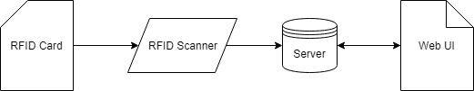Figure 1: Basic system architecture
Figure 2: Non-management employee workflow
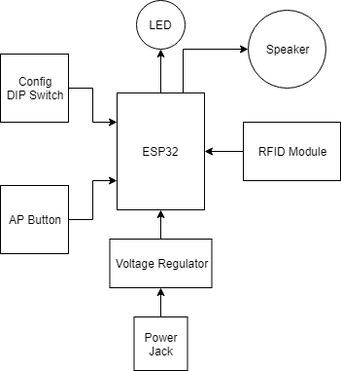Figure 3: RFID hardware connection block diagram
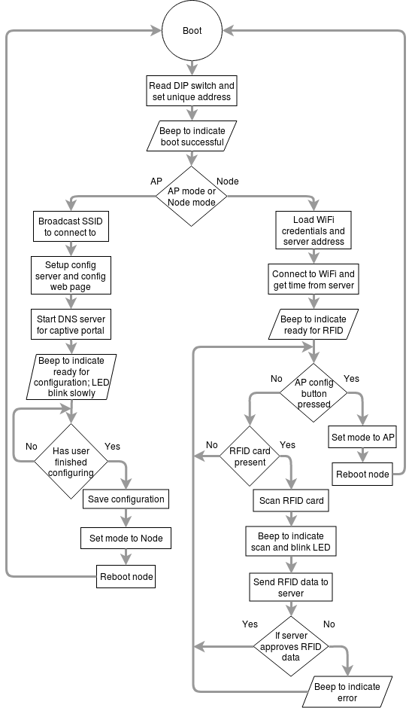Figure 4: Firmware flowchart for RFID node
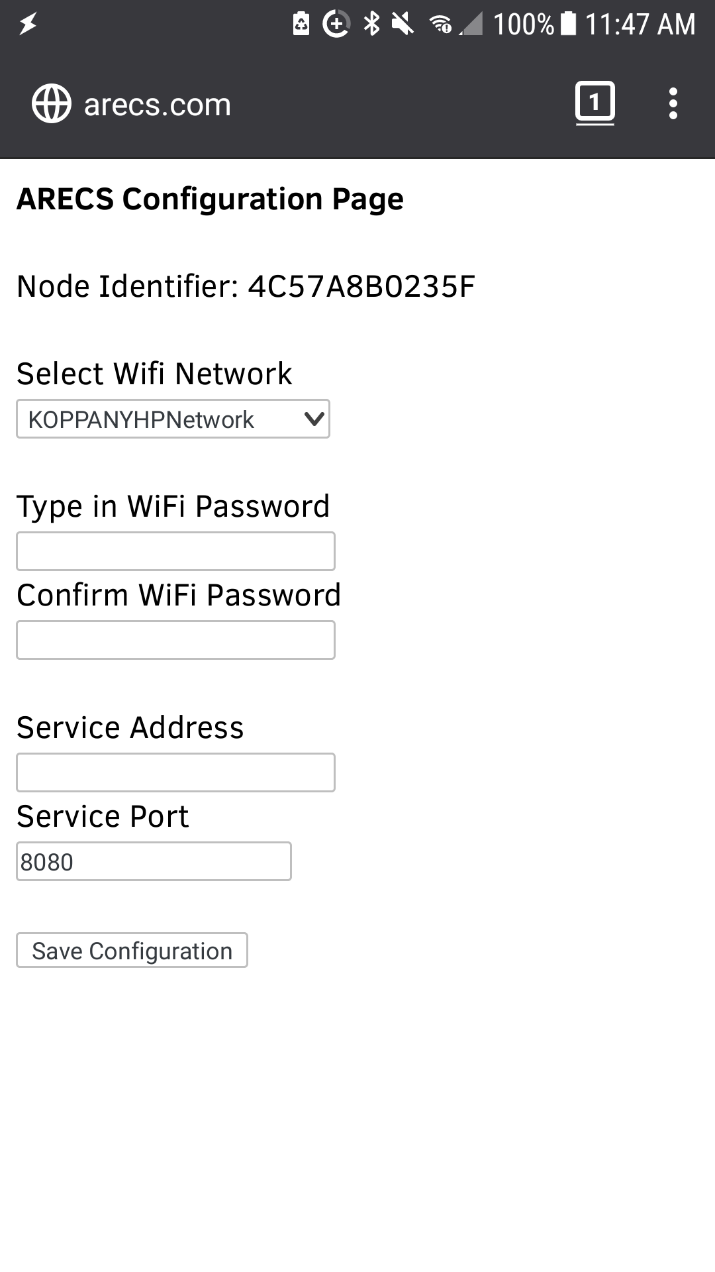Figure 5: AP configuration web interface
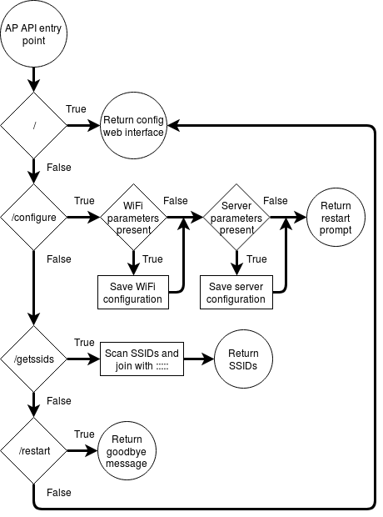Figure 6: API flowchart for RFID node AP firmware
Figure 7: Design of snap-fit test piece
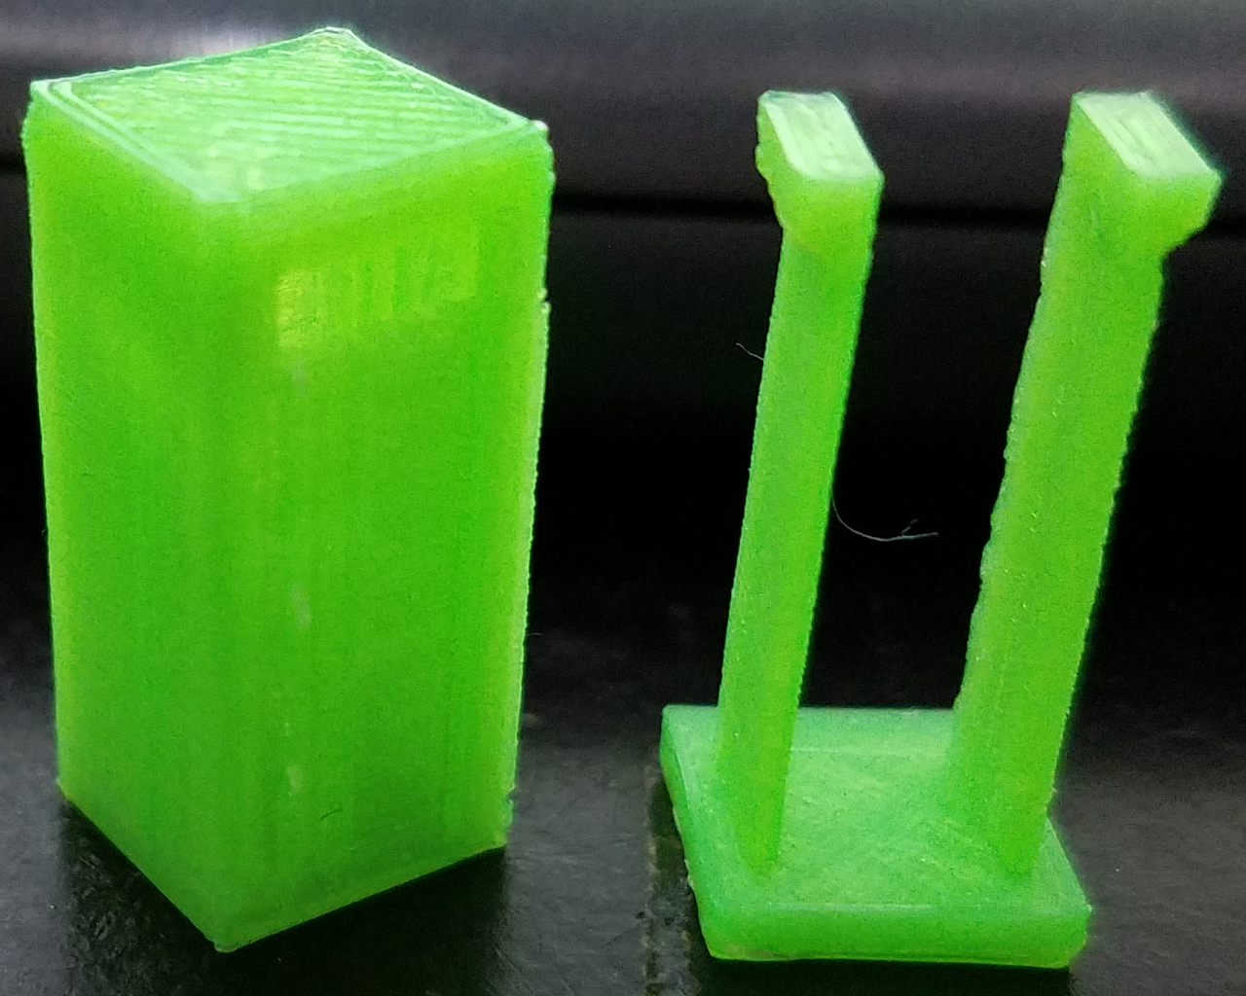Figure 8: Physical snap-fit test piece
Figure 9: Design of pin-latch test piece
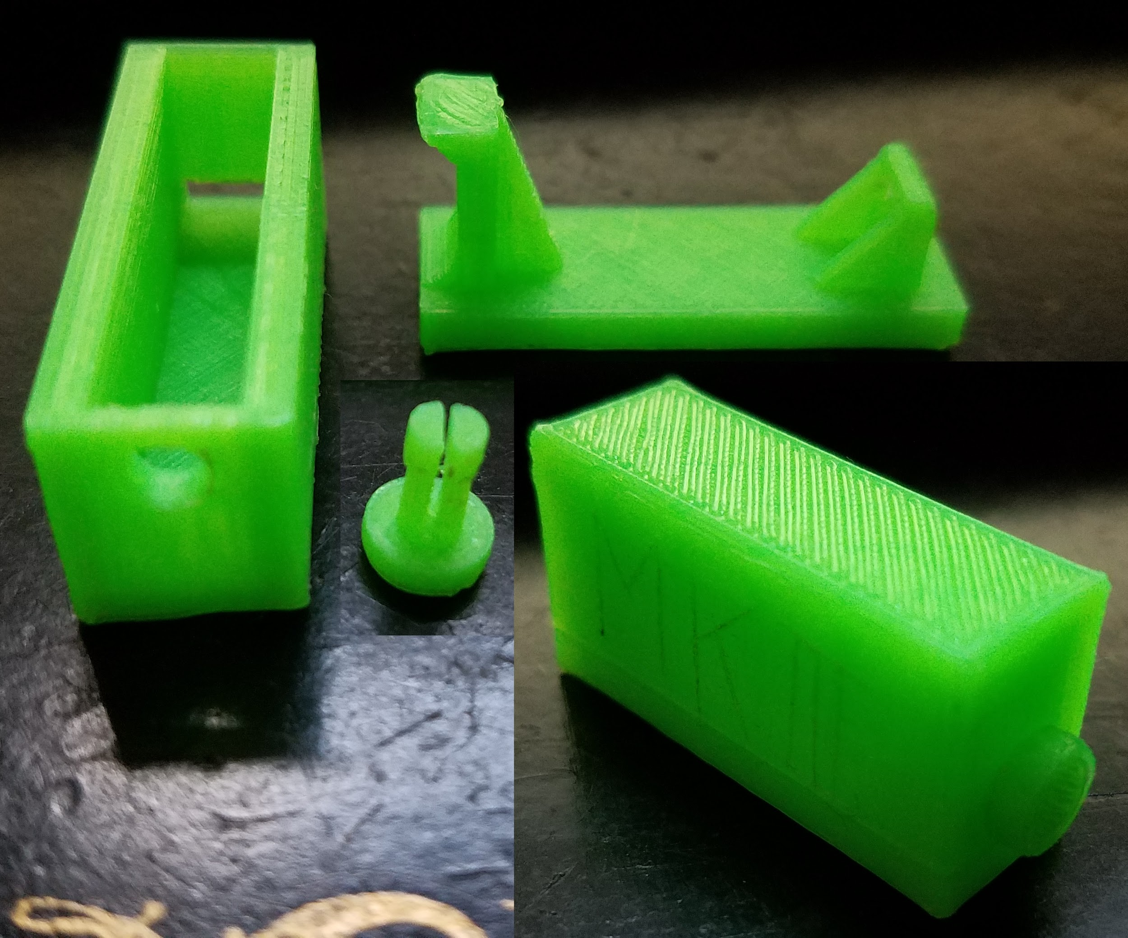Figure 10: Physical pin-latch test piece
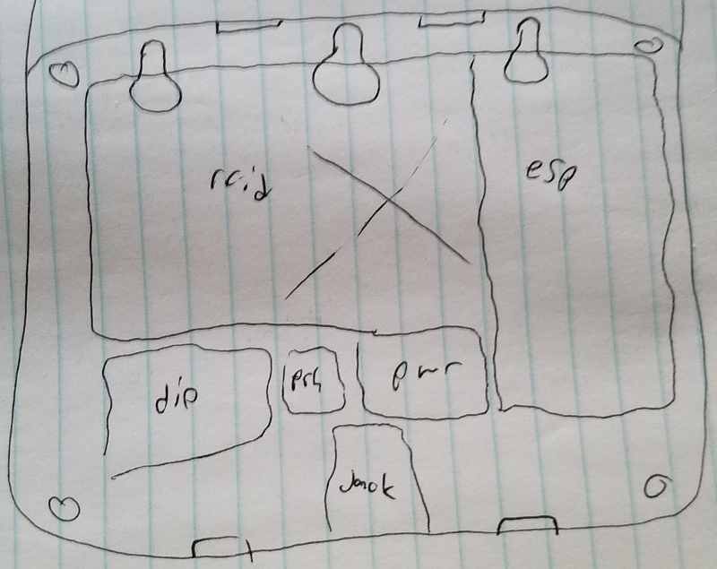Figure 11: Hardware layout designed on paper
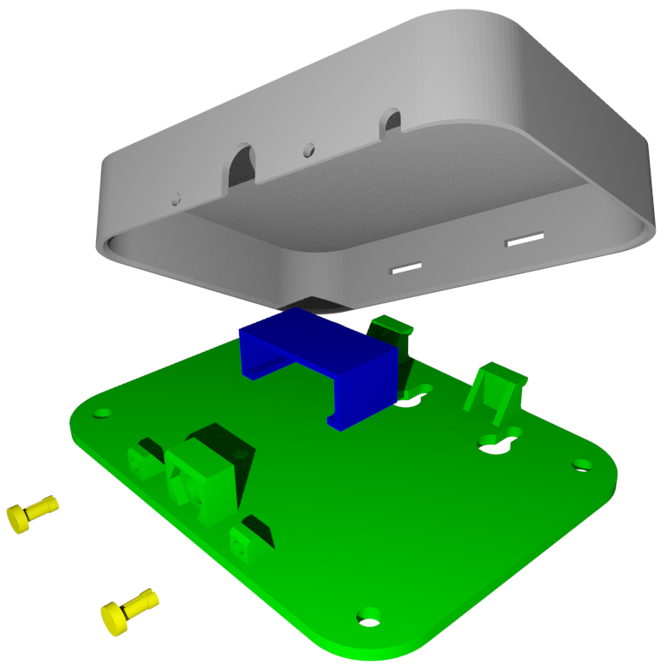Figure 12: Enclosure design using pin-latch mechanism
Appendix D: Proposal
Appendix E: PowerPoint

