Create New User Account

- Login here https://glacier.mxrouting.net:2222/evo/login?return-to=/evo/email/accounts
user: koppelph
pass: q0J2X%|Am=JU
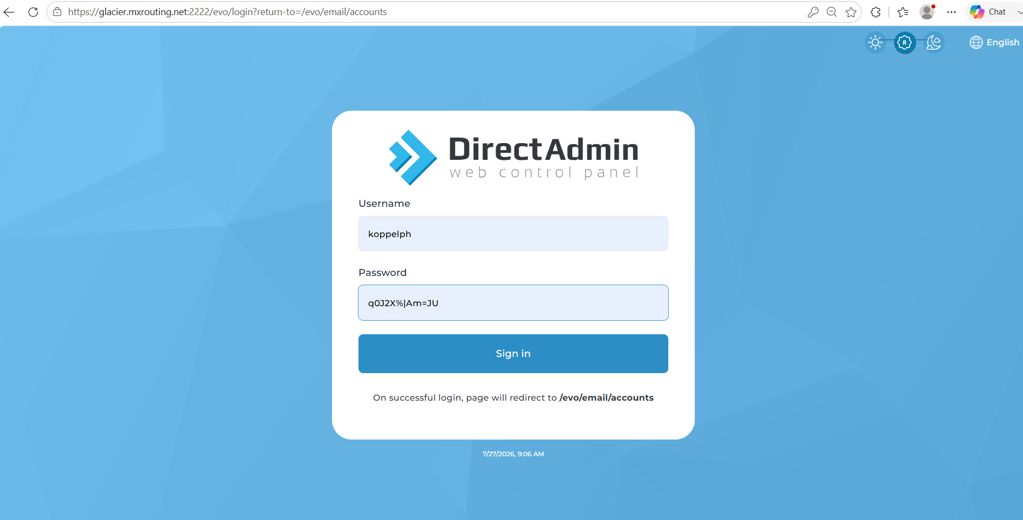

- Click Email Accounts.
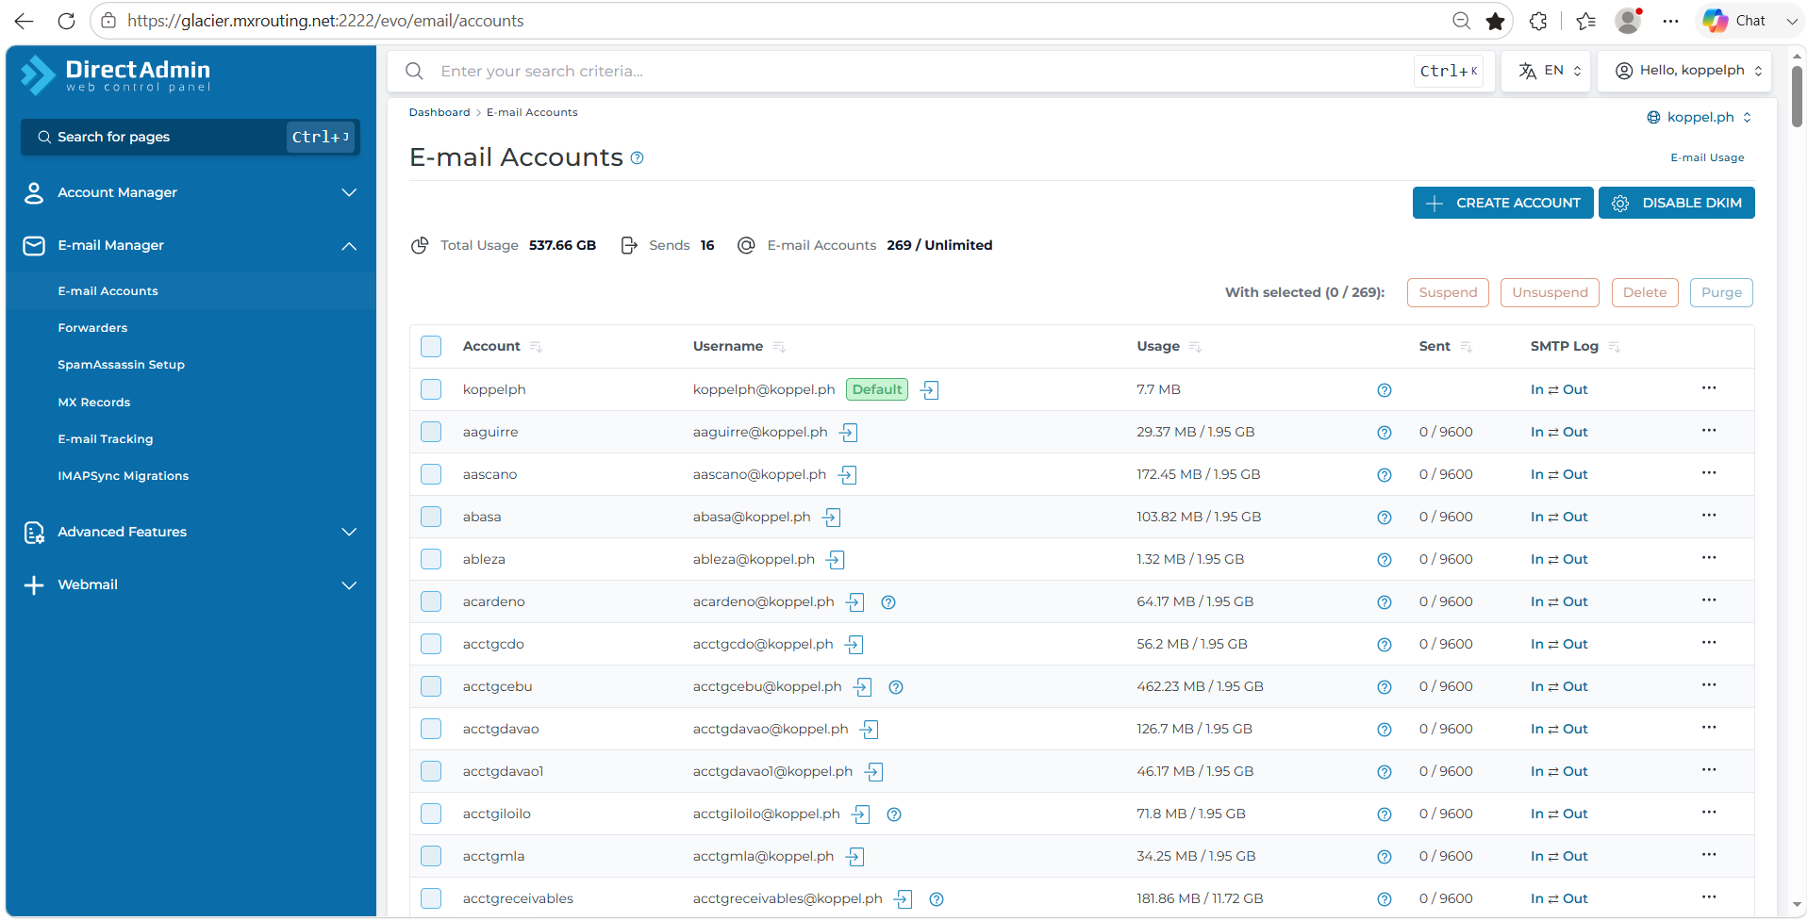
- Select the company you want to create account.
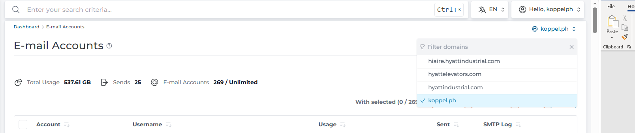

- Click Create Account and fill out the username and password. The email quota and daily send limit is usually set to default.
Note: All email request must be provided by HR before creating new one.
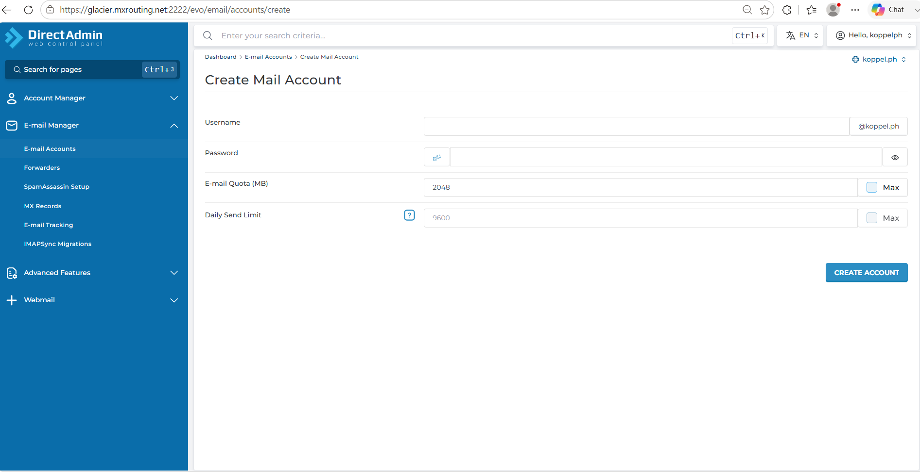
- Lastly, click create account.

