UPDATE CONTACT IN THUNDERBIRD

- ON THE UPPER LEFT OF THUNDERBIRD, CLICK THIS CONTACT ICON
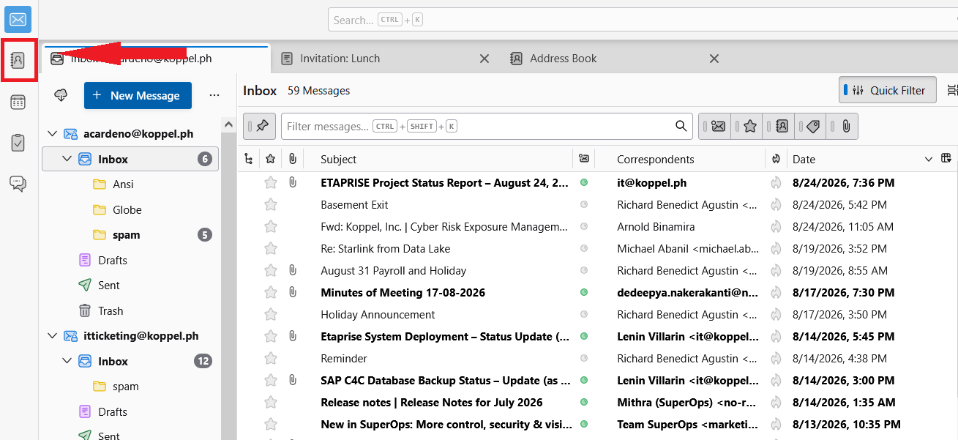
- AFTER THAT, SELECT THE NAME OF CONTACT YOU WANT TO UPDATE, THEN CLICK EDIT.
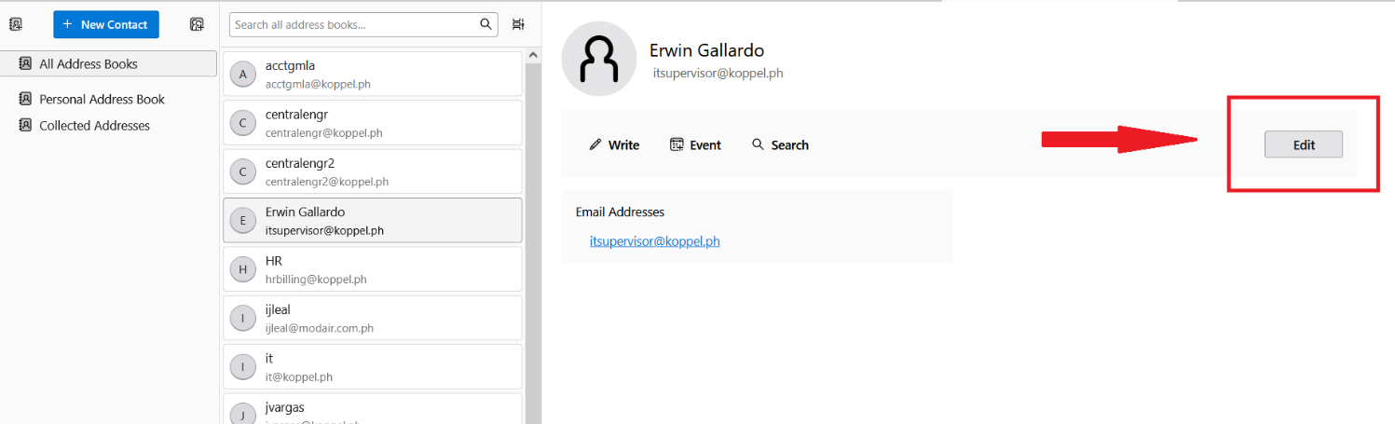
- LASTLY, EDIT THE DETAILS OF USER AND CLICK SAVE.
ss