- Due Date is Same for all AP Invoices
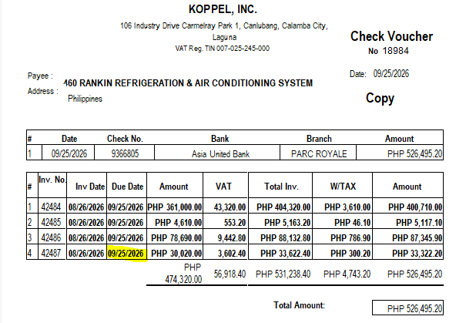
Check date captured should be 09 – 25 – 2026

- Due Date is different for Multiple AP Invoices
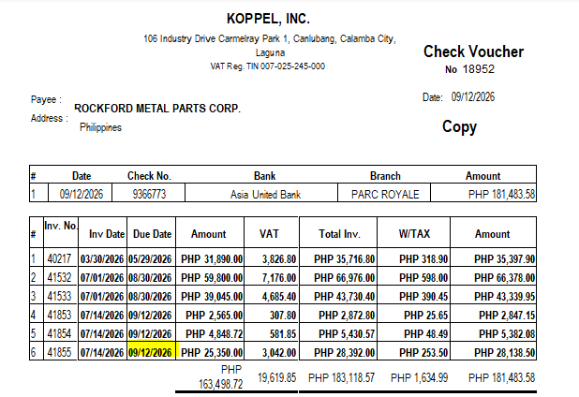
Check date captured should be 09 – 12 – 2026

Current Set up of Check Printing in SAP:
