# UNESCO World Heritage Site Analysis Using Tableau

## Activity 1.1: Countries per Region

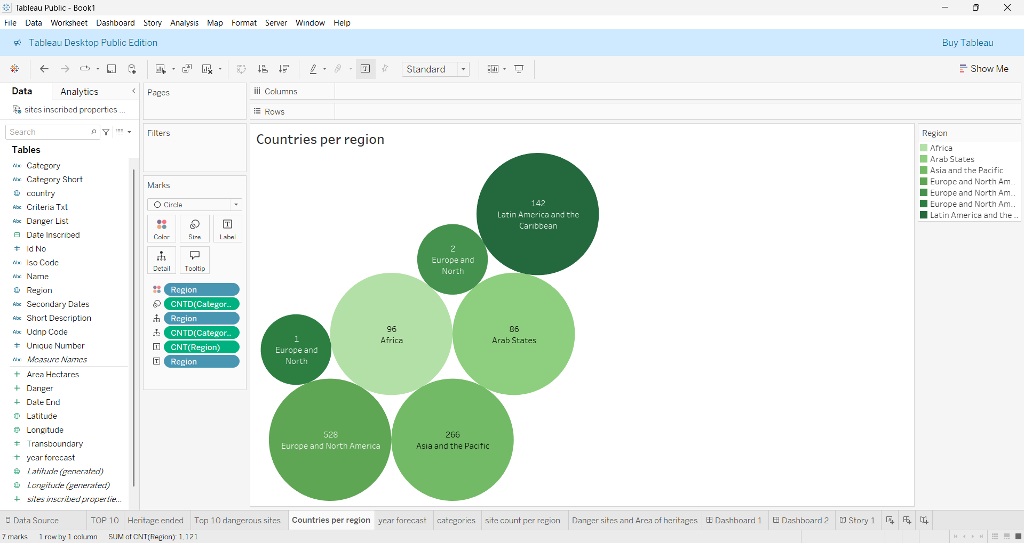

## Activity 1.2: Top 10 Regions by Area

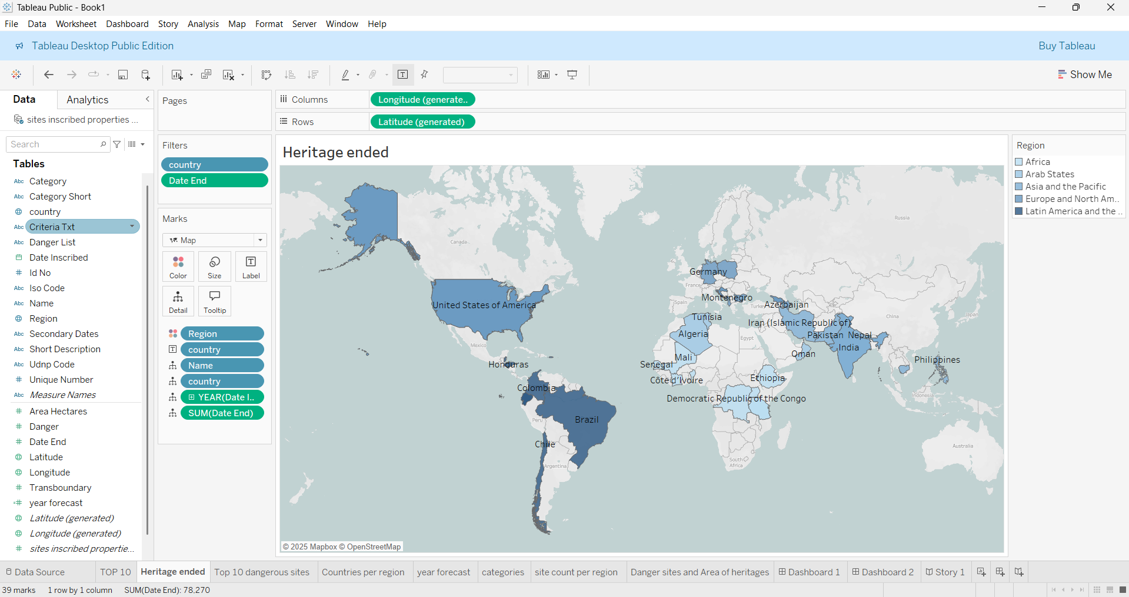

## Activity 1.3: Regions by Heritage Ended

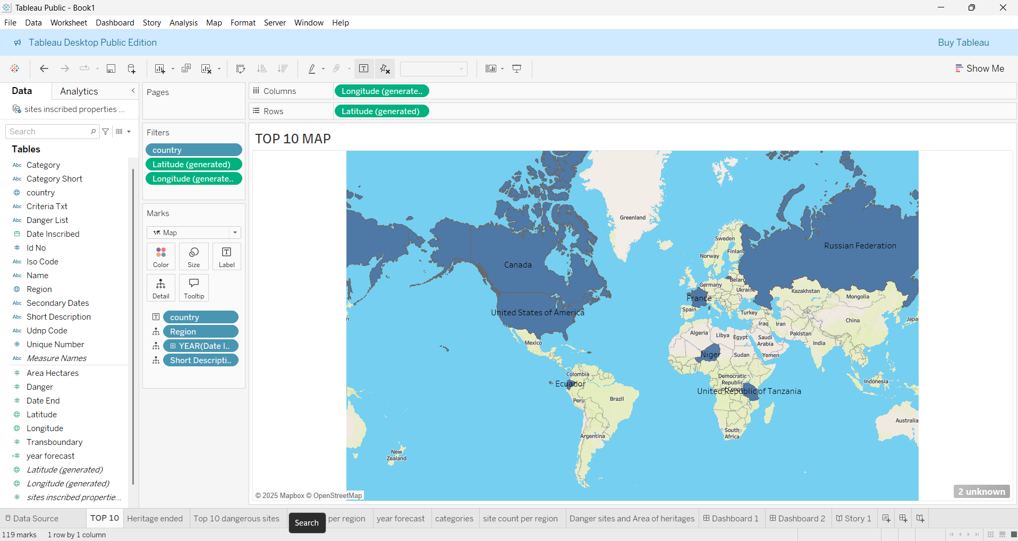

## Activity 1.4: Top 10 Danger Sites Prone to Extinction

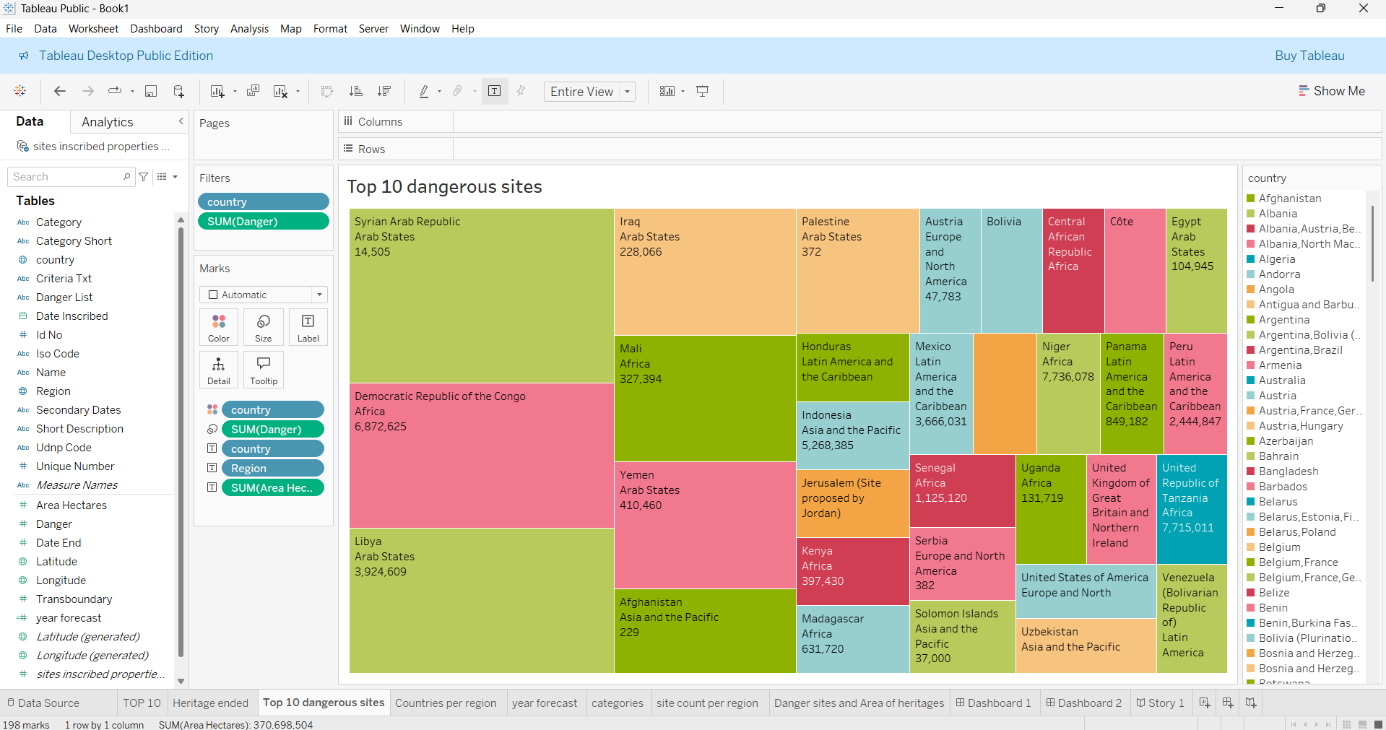

## Activity 1.5: Year Forecasting of Heritages

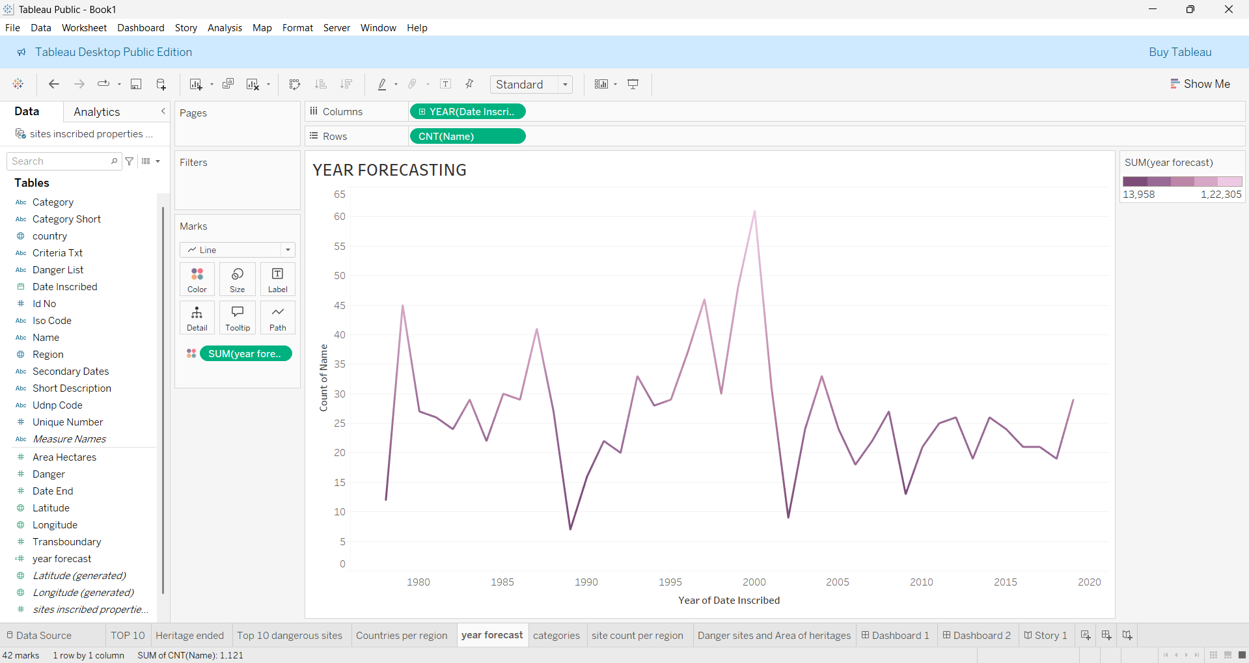

## Activity 1.6: Categories by Site Count

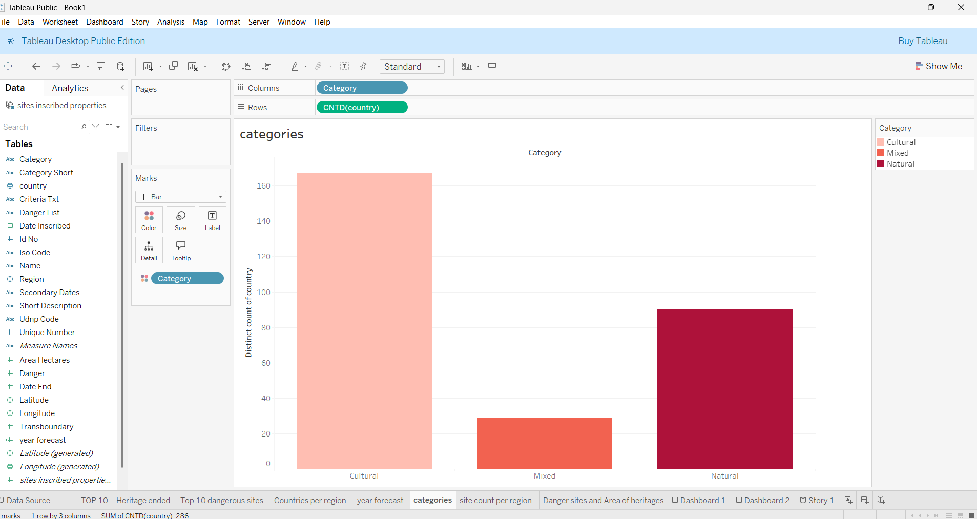

## Activity 1.7: Site Count per Region

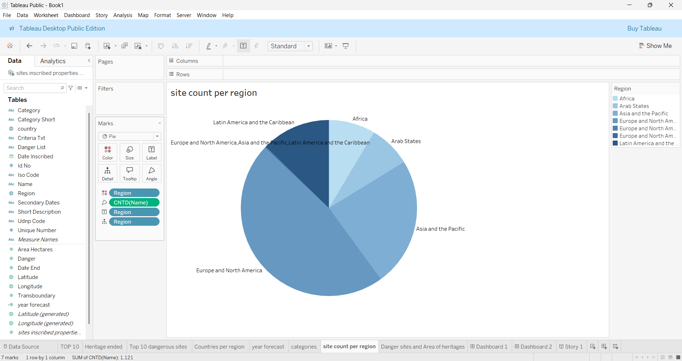

## Activity 1.8: Analysis of Danger Sites and Area of Heritages

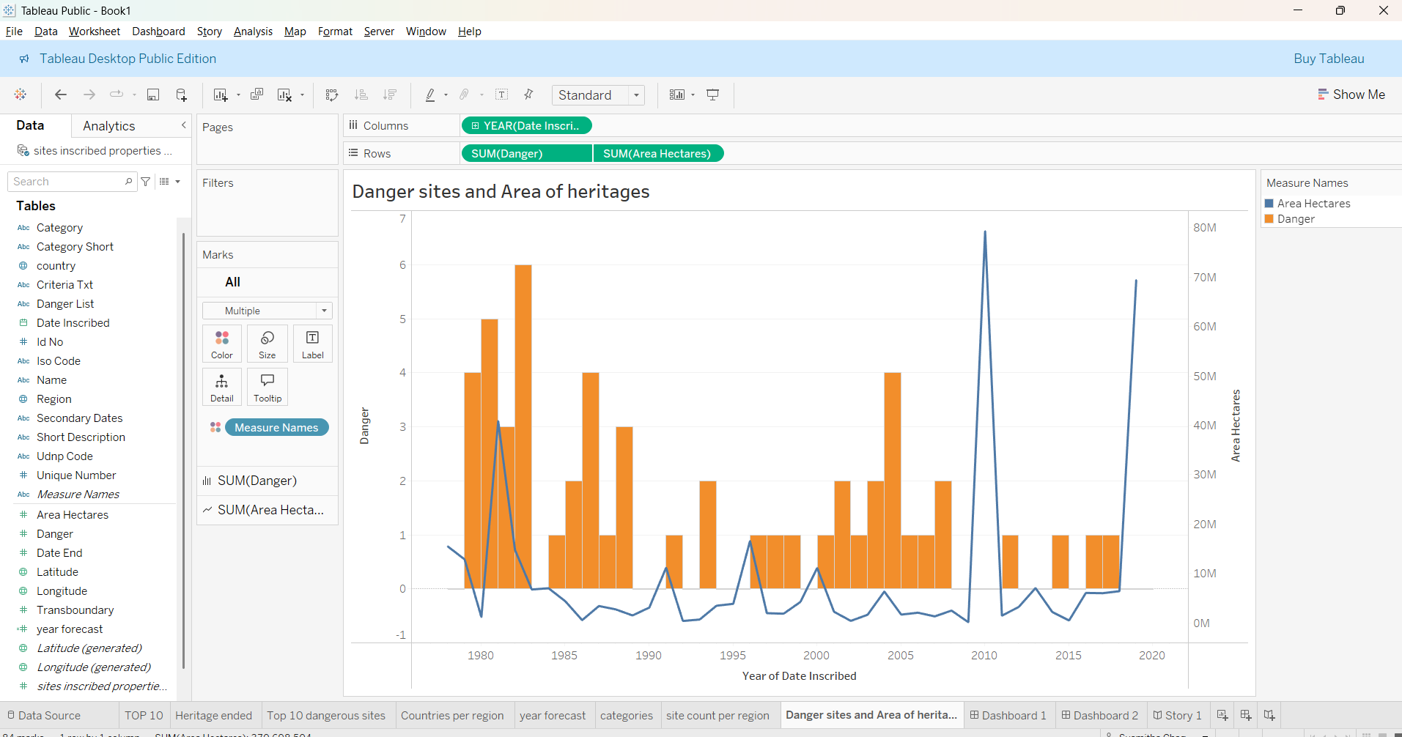

## Final Dashboard1 View

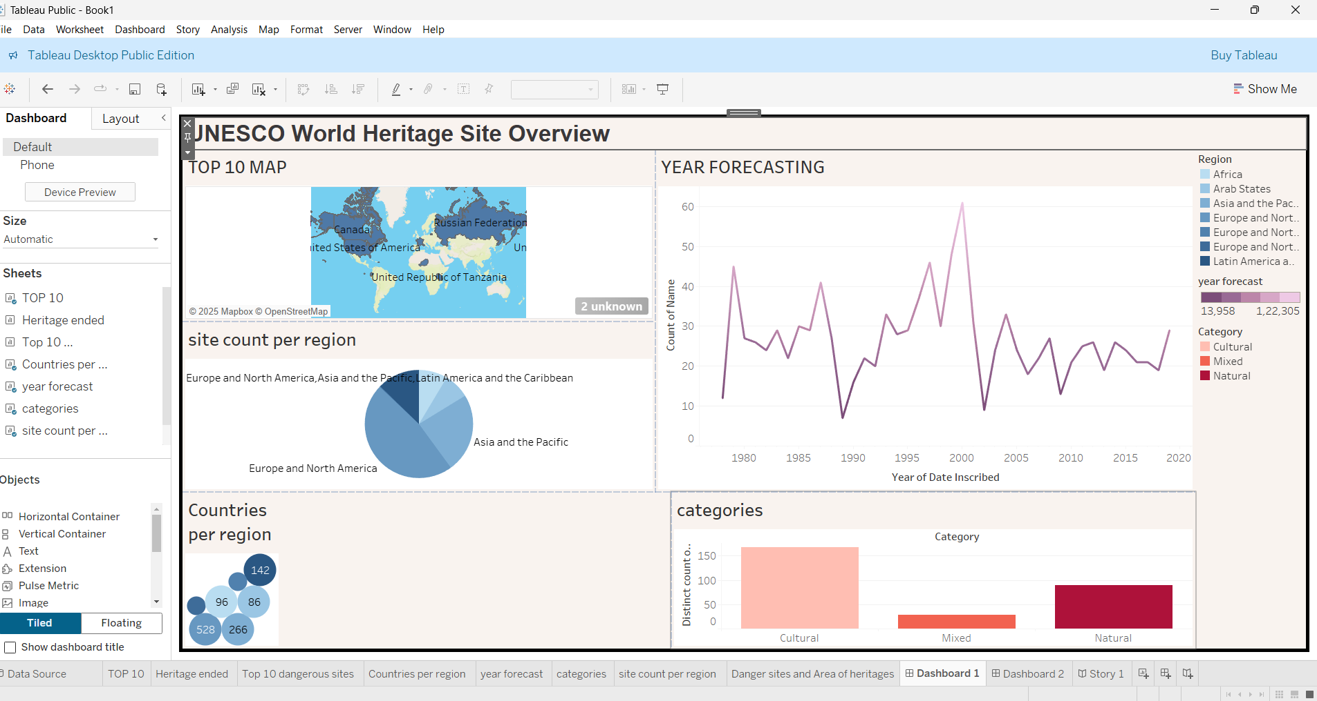

## Final Dashboard2 View

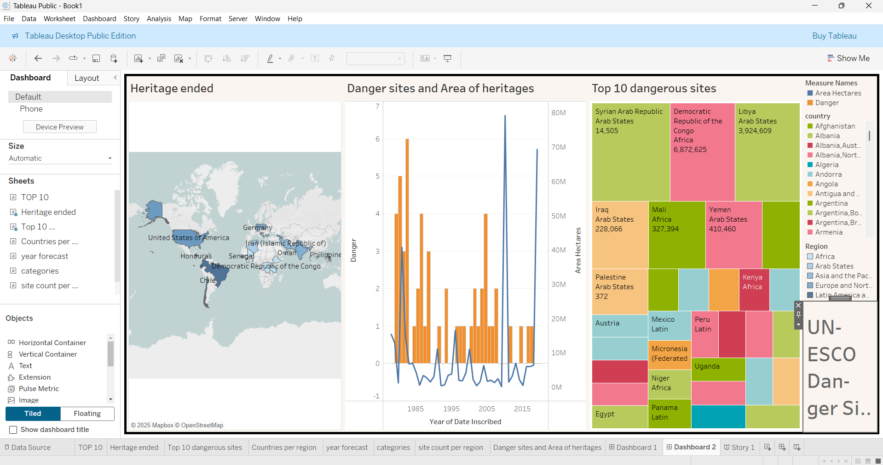

## Story View

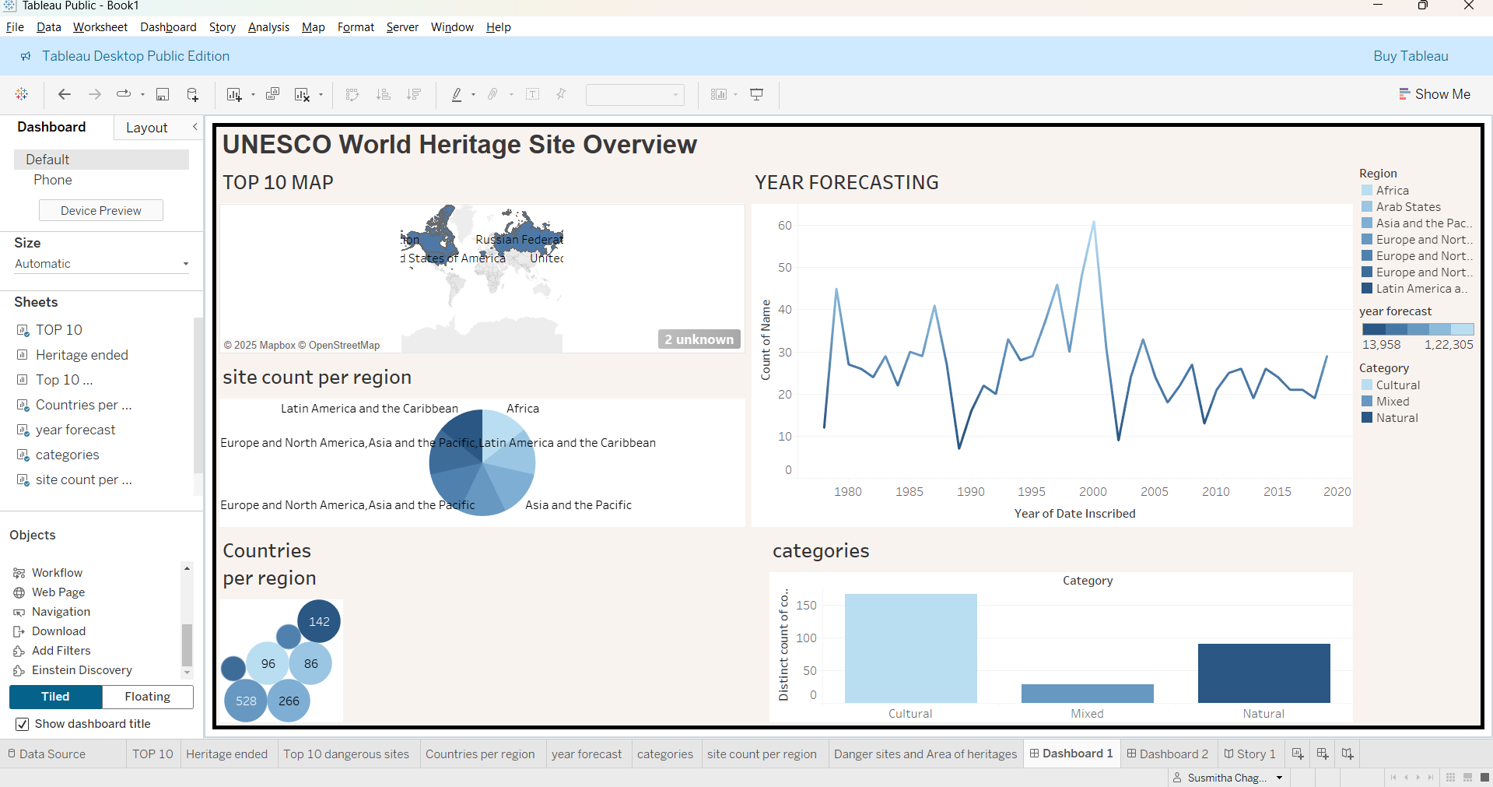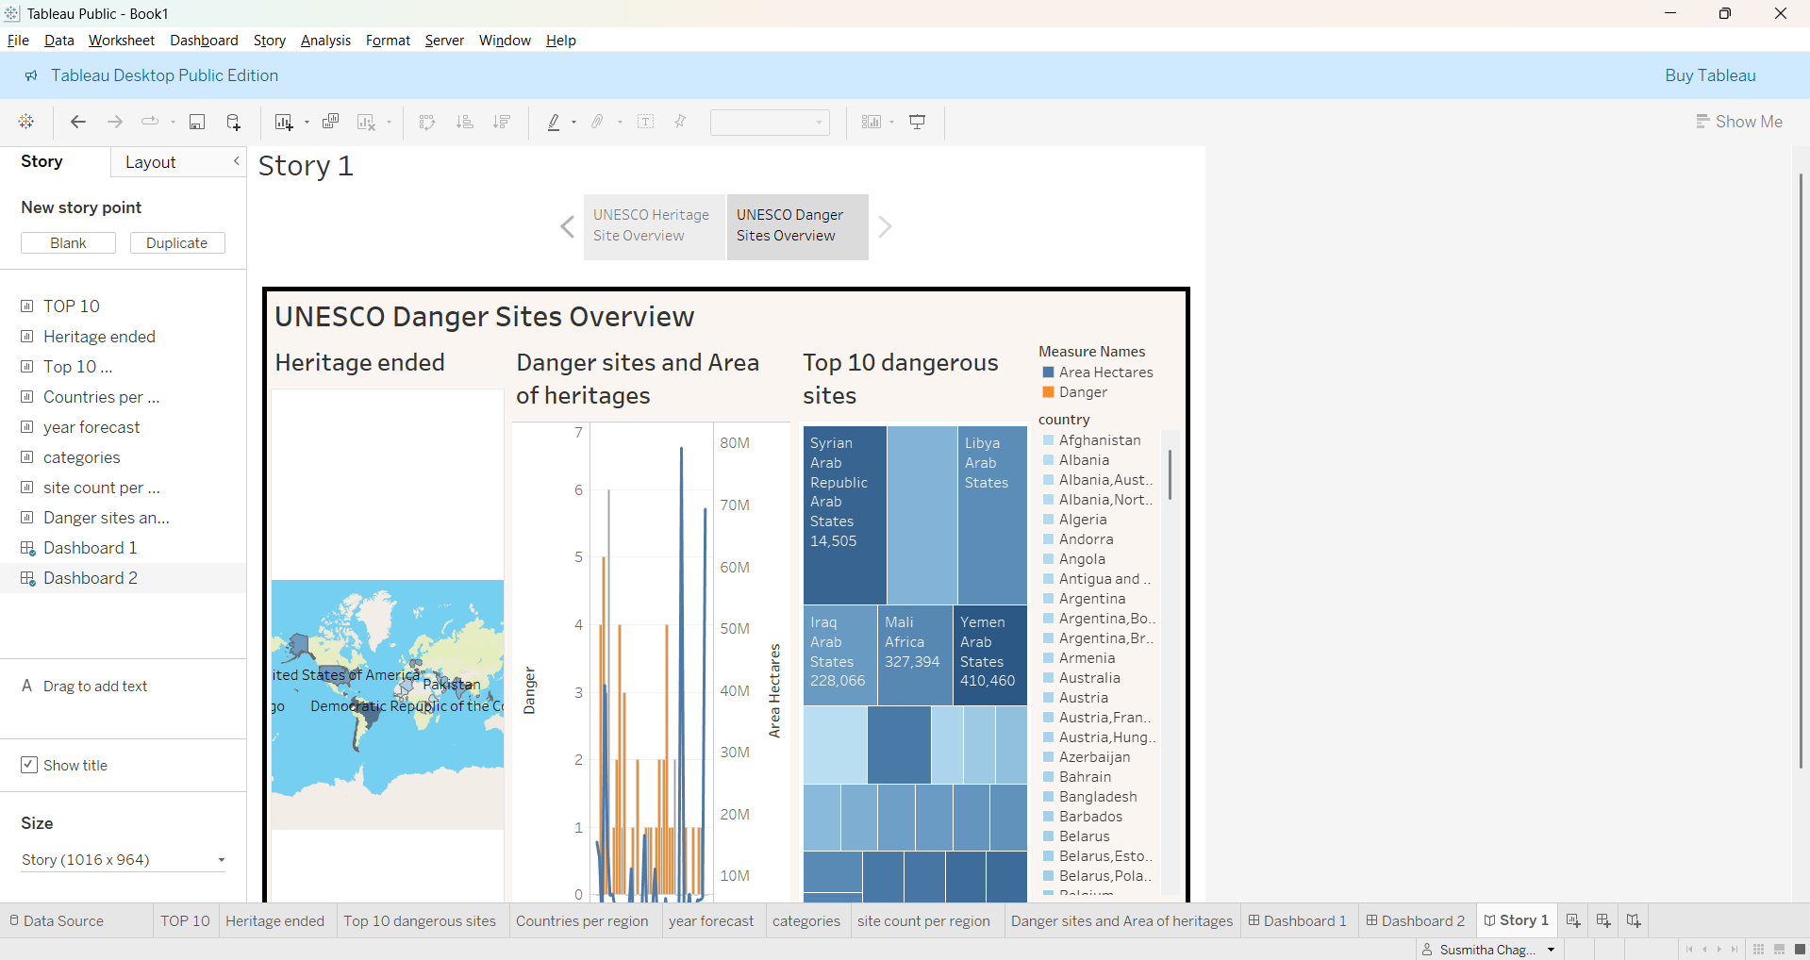

Note: All visualizations were created using Tableau Public and the UNESCO World Heritage Sites 2019 dataset.