
Department of Computer Science and Engineering
ALGORITHMIC PROBLEM-SOLVING HACKATHON (APSH 2026)
PROJECT DOCUMENTATION
Date: 03-10-2026 | Venue: 3rd Floor, A & B Blocks
Field | Details
Project Title | Student Subject Selection System
Team Name / Team No. | Team 11
Year / Semester / Section | II Year B.Tech / I Sem / CSM-E
Algorithm Paradigm Used | Dynamic Programming + 0/1 Knapsack
Programming Language / Tools | Python, Flask, SQLite, Bootstrap, HTML, CSS, Javascript
Faculty Mentor | Mrs. Vodije Mamatha
Team Members
S.No | Name of the Student | Roll No. | Role
1 | K. Naga Nithya | 25MVCSMR0406 | Team Lead
2 | C. Akanksha | 25MVCSMR0384 | Member
3 | G. Akshari | 25MVCSMR0397 | Member
4 | K. Niveditha | 25MVCSMR0407 | Member

1.Problem Statement

Students often have to select elective or optional subjects while considering several constraints such as available credits, workload, personal preferences, and academic benefit. Selecting subjects manually can make it difficult to identify the best possible combination.
The Student Subject Selection System is designed to help students select a suitable combination of subjects based on their available credit limit and preference scores.
The system uses the 0/1 Knapsack algorithm with Dynamic Programming to determine the combination of subjects that provides the maximum preference/benefit score without exceeding the student's allowed credit limit.
Each subject is treated as an item:
Weight: Credit value of the subject.
Value: Preference/benefit score of the subject.
Capacity: Maximum credits available to the student.
Selection: A subject can either be selected or not selected.
The system should generate an optimized subject selection and clearly display the subjects selected and the total credits and preference score obtained.
Inputs
The system takes the following inputs:
1.List of available subjects.
2.Credit value of each subject.
3.Preference/benefit score of each subject.
4.Maximum credit limit available to the student.
5.Student preferences or selection requirements.
Output
The system displays:
1.Recommended subjects.
2.Total credits selected.
3.Total preference/benefit score.
4.Subjects that were not selected.
5.Algorithm-related decision information showing how the final selection was obtained.
Constraints
The selected subjects must not exceed the maximum credit limit. Each subject can be either selected completely or not selected, following the 0/1 Knapsack model.

2. Objectives

>Maximize academic preference score while satisfying credit, workload and mandatory constraints.
>Apply 0/1 Knapsack so every elective is represented as a selected/not-selected decision.
>Use Dynamic Programming to solve overlapping subproblems efficiently and reconstruct the final subject set.
>Present selected subjects, total credits/workload, preference score and algorithm decisions clearly through a web interface.

3. Proposed Approach
The system models elective selection as a 0/1 Knapsack problem. Each subject is an item, its credit/workload is the item weight, its preference score is the item value, and the maximum allowed credit/workload is the knapsack capacity.
Dynamic Programming is selected because many subject/capacity combinations are overlapping subproblems. The DP table stores the best preference score obtainable for each prefix of subjects and each capacity. After the table is filled, the system traces the table backwards to reconstruct the subjects that produced the optimum.

This approach follows the source requirement that 0/1 Knapsack should treat each item as either selected or not selected and that Dynamic Programming should store the best results and reconstruct the final decision.
Alternative considered: a greedy strategy could choose the highest preference or highest score-to-credit subject first, but a locally best choice is not guaranteed to give the global optimum. Dynamic Programming is therefore used for the required optimization.

4. Algorithm / Pseudocode
Algorithm
1. Read all available elective subjects and their credits/workload and preference scores.
2. Read the student's maximum allowed credit/workload capacity.
3. Create dp[i][c], where i represents the first i subjects and c represents available capacity.
4. Initialize zero-capacity and zero-subject states to 0.
5. For each subject i and capacity c, check whether its credit/workload fits.
6. If it fits, compare excluding the subject with including the subject:
max(dp[i-1][c], value[i] + dp[i-1][c-weight[i]])
7. If it does not fit, copy dp[i-1][c].
8. After all states are filled, dp[n][capacity] is the maximum preference score.
9. Trace backwards through the DP table; when dp[i][c] differs from dp[i-1][c], mark subject i as selected and reduce c by its weight.
10. Validate mandatory rules and calculate final credits/workload and score.
11. Display the selected subjects and algorithmic decision information.

Pseudocode
SELECT_SUBJECTS(subjects, capacity)
n ← number of subjects
create dp[0..n][0..capacity] and fill with 0
for i ← 1 to n
weight ← subjects[i].credits
value ← subjects[i].preference_score
for c ← 0 to capacity
if weight ≤ c
dp[i][c] ← max(
dp[i-1][c],
value + dp[i-1][c-weight]
)
else
dp[i][c] ← dp[i-1][c]
selected ← empty list
c ← capacity
for i ← n down to 1
if dp[i][c] ≠ dp[i-1][c]
add subjects[i] to selected
c ← c - subjects[i].credits
return selected, dp[n][capacity]

5. Complexity Analysis
For n subjects and capacity C, the DP table contains(n+1)(C+1) states. Each state requires constant-time comparison, giving O(nC) time. A two-dimensional table requires O(nC) space and supports straightforward decision reconstruction. A one-dimensional optimization can reduce storage to O(C), but the full table is preferable when the project needs to visualize or explain decisions.
Complexity | Best Case | Average Case | Worst Case
Time | O(nC) | O(nC) | O(nC)
Space | O(nC) | O(nC) | O(nC)
6. Implementation

The prototype uses Flask as the Python web framework, SQLite for data storage, Bootstrap for responsive interface components, and HTML/CSS/JavaScript for the front end.
Main modules/functions:
Student module – accepts student information, preferences and selection limits.
Subject module – stores subject name, credits/workload, preference score and mandatory status.
Optimization module – constructs and evaluates the 0/1 Knapsack DP table.
Reconstruction module – traces the DP table to identify selected subjects.
Validation module – checks credit/workload and mandatory rules.
Database module – stores students, subjects and selections in SQLite.
Flask routes – handle forms, dashboard, subject list, optimization and results.
UI module – Bootstrap cards/tables/forms with custom CSS/JavaScript for hover effects, transitions and interactive result displays.
Data structures:
Student records/lists, SQLite relational tables, and a two-dimensional DP matrix dp[i][c]. A one-dimensional DP array may be used when only the optimum score is needed.

7. Results and Test Cases

The expected result is a feasible combination of electives having the maximum preference score under the specified credit/workload limit. The result page should show the selected subjects, total credits/workload, preference score and a concise decision trace.

Sample test input:
Subject Credits Credit Preference Mandatory Expected
AI Fundamentals 3 90 No Selected
Cloud Computing 4 85 No Selected
Cyber Security 3 3 80 No Selected
Data Visualization 2 60 No Not selected
Web Technologies 2 70 No Not selected

Assume maximum allowed credits = 10. The program evaluates feasible include/exclude combinations through Dynamic Programming and returns the feasible combination with the highest total preference score. The exact output should be captured from the implemented application and inserted as a screenshot in the final submission.

Performance comparison:
A naive recursive 0/1 Knapsack approach may repeat the same subproblems and has exponential worst-case time, approximately O(2ⁿ). Dynamic Programming reduces repeated work to O(nC), making it more practical for moderate capacity values.
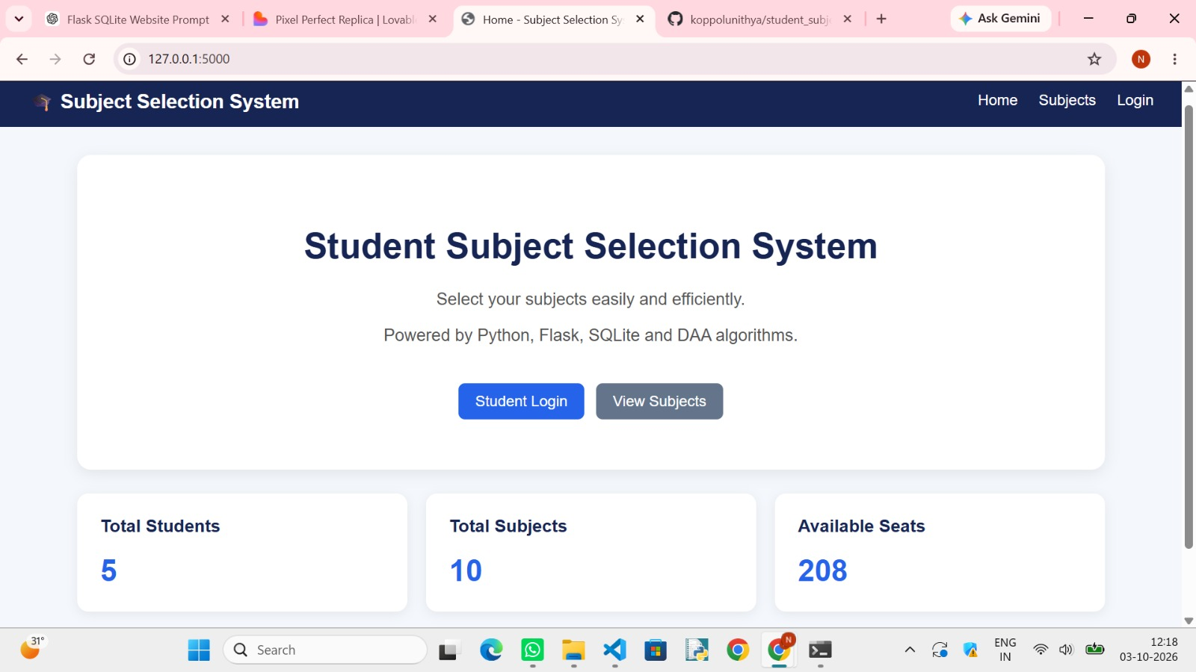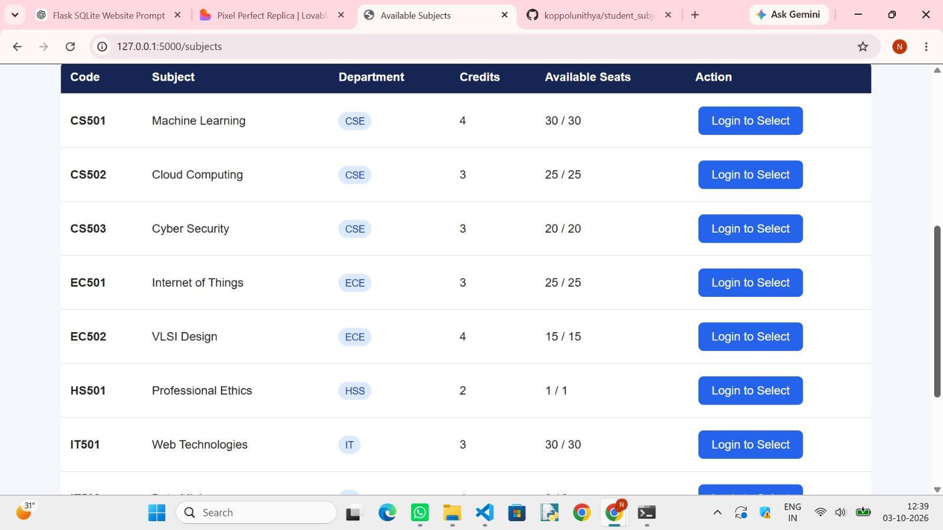
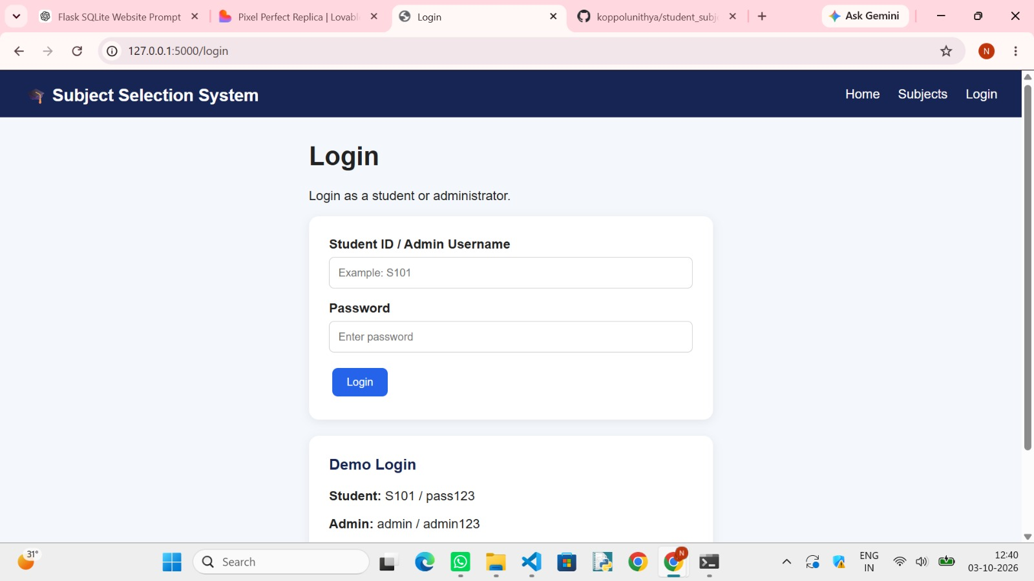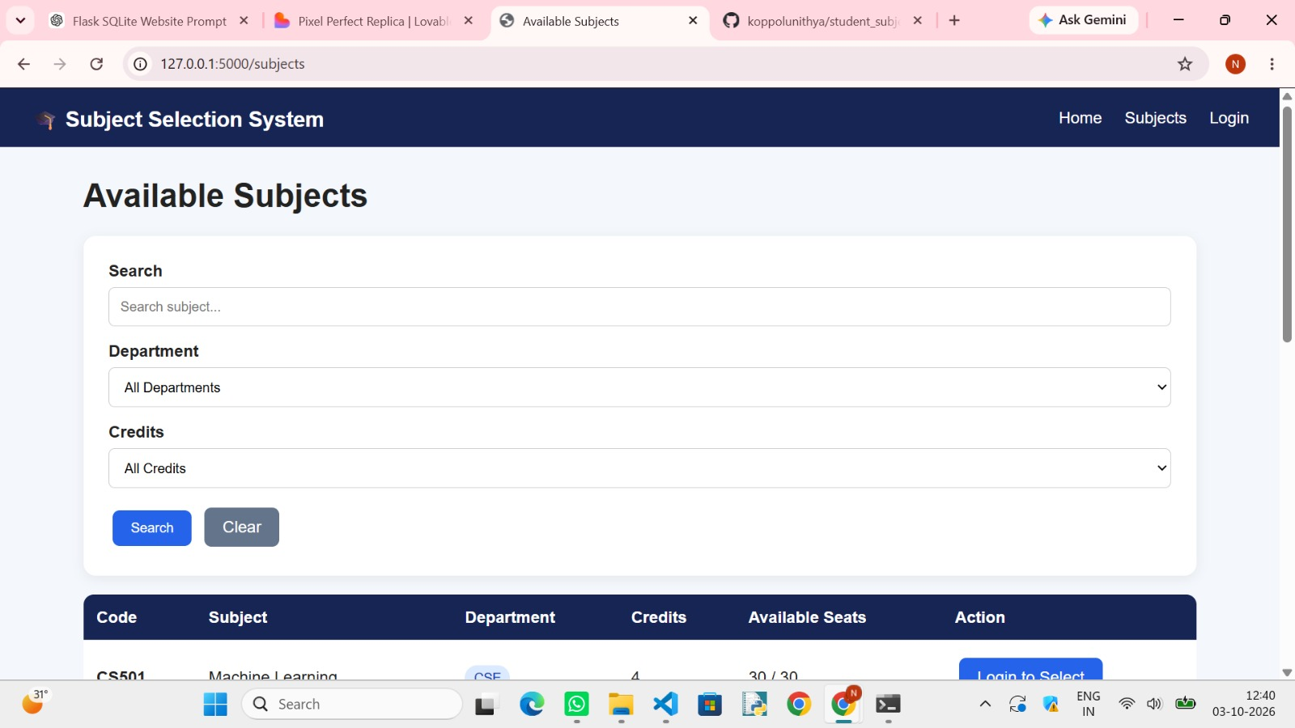8. Conclusion and Future Scope

The Student Subject Selection System provides an algorithm-centric way to recommend electives under academic constraints. By modelling each elective as a 0/1 decision and applying Dynamic Programming, the system can maximize the student's preference score while respecting available capacity. The web interface makes the result understandable by showing selected subjects, score, credits/workload and algorithmic decisions.
Future scope:
>Add prerequisites, department restrictions and timetable-conflict constraints.
>Allow students to rank or update subject preferences interactively.
>Compare Dynamic Programming with a greedy heuristic.
>Visualize the DP table and highlight states used during reconstruction.
>Add student/admin authentication and dashboards.
>Generate downloadable subject-selection reports.
>Use feedback data to improve preference scoring while keeping the optimization process transparent.

9. References

1. T. H. Cormen, C. E. Leiserson, R. L. Rivest and C. Stein, Introduction to Algorithms, MIT Press.
2. Python Software Foundation, Python Documentation.
3. Pallets Projects, Flask Documentation.
4. SQLite Documentation.
5.Bootstrap Documentation.

