FINAL PROJECT REPORT
STUDENT SUBJECT SELECTION SYSTEM

Core Algorithms: 0/1 Knapsack and Dynamic Programming
Technologies Used: HTML, CSS, JavaScript, Bootstrap, Python, Flask, SQLite

Project Team
Student Name | Roll number
K. Naga Nithya | 25MVCSMR0406
G. Akshari | 25MVCSMR0397
K. Niveditha | 25MVCSMR0407
C. Akanksha | 25MVCSMR0384
Department: CSE(AIML)
College: Malla Reddy Vishwavidyapeeth Demmed to University
Project Guide:
Academic Year: 2026–2027

2. ABSTRACT & INTRODUCTION
2.1 Abstract
The Student Subject Selection System is a web-based application developed to assist students in selecting elective subjects according to their academic requirements and personal preferences. Students often need to choose subjects while considering constraints such as maximum credits, workload, subject difficulty, mandatory subjects, and personal interest.
Selecting subjects manually can make it difficult to identify the most suitable combination, especially when the number of available subjects increases. A combination that appears attractive individually may exceed the allowed credit or workload limits when considered together.
The proposed system addresses this problem using 0/1 Knapsack and Dynamic Programming. Each elective subject is considered as an item that can either be selected or not selected. The system assigns a preference score to each subject and searches for a feasible combination that maximizes the total preference score while satisfying the student's academic constraints.
The application is developed using Python and Flask for the backend, SQLite for data storage, and HTML, CSS, JavaScript, and Bootstrap for the frontend. The system provides student authentication, subject management, preference management, optimization, result visualization, history, and analytics.
The project demonstrates how a real-world academic decision-making problem can be converted into an algorithmic optimization problem and solved efficiently using Dynamic Programming.
Keywords
Student Subject Selection, 0/1 Knapsack, Dynamic Programming, Flask, Python, SQLite, Elective Subjects, Optimization.

2.2 Introduction
Choosing appropriate elective subjects is an important task for students in higher education. Students may need to consider several factors simultaneously, including the number of credits, expected workload, difficulty level, personal interest, and mandatory academic requirements.
Traditional subject selection methods generally depend on manual comparison. This can become difficult when many subjects are available and each subject has different academic characteristics.
The Student Subject Selection System provides a computerized solution to this problem. It collects information about available subjects and the student's constraints and then applies an optimization algorithm to identify a feasible subject combination.
The system uses 0/1 Knapsack, where each subject is treated as an item, and Dynamic Programming is used to efficiently solve overlapping subproblems.
For the optimization problem:
- Subject credits represent a resource constraint.
- Workload represents another resource constraint.
- Preference score represents the benefit or value of selecting a subject.
- Mandatory subjects must always be included.
- Optional subjects are considered by the optimization algorithm.
The resulting system provides students with a clear explanation of the selected combination instead of simply displaying a numerical answer.

2.3 Purpose of the Project
The main purpose of the project is to develop an easy-to-use web
application that helps students make subject selection decisions while satisfying academic constraints.
The project also demonstrates the practical application of:
- Algorithm design
- Dynamic Programming
- 0/1 Knapsack
- Database management
- Web development
- Authentication
- CRUD operations
- Data visualization

3. PROBLEM STATEMENT, OBJECTIVES & SCOPE
3.1 Problem Statement
Students need to select elective subjects while satisfying limitations such as:
- Maximum number of credits
- Maximum workload
- Personal preferences
- Subject difficulty
- Mandatory subjects
- Department and semester restrictions
Manual selection may result in:
- Exceeding credit limits
- Excessive workload
- Ignoring mandatory requirements
- Selecting a lower-preference combination
- Difficulty in comparing multiple possible combinations
Therefore, there is a need for a system that automatically determines a feasible combination of subjects while maximizing the student's overall preference score.

3.2 Project Objectives
The main objectives are:
- To develop a web-based subject selection system for students.
- To store and manage subject information using SQLite.
- To allow students to specify credit and workload limits.
- To allow students to provide preference scores for subjects.
- To automatically include mandatory subjects.
- To implement the 0/1 Knapsack algorithm.
- To implement Dynamic Programming for efficient optimization.
- To maximize the total preference score within the specified constraints.
- To display the selected subjects and resource utilization clearly.
- To maintain selection history for future reference.
- To provide an understandable explanation of the algorithmic decision.

3.3 Project Scope
The project covers the following areas:
Student Management
Students can register, log in, and manage their profiles.
Subject Management
The system stores information such as:
- Subject code
- Subject name
- Credits
- Workload
- Preference
- Difficulty
- Department
- Semester
- Mandatory/optional status
Preference Management
Students can assign preference scores to available subjects.
Subject Optimization
The system calculates the optimal combination using Dynamic Programming.
Result Management
The optimized result can be displayed and stored in the student's history.
Analytics
The system can present credit, workload, and preference information through charts and progress indicators.

3.4 Target Users
The main users are:
Students
Students use the application to:
- View subjects
- Set preferences
- Define constraints
- Generate optimized selections
- View previous selections
Administrators
Administrators can:
- Add subjects
- Update subjects
- Delete subjects
- Manage subject information
Faculty/Academic Staff
The system can optionally be extended for academic staff to define subject information, mandatory requirements, and semester offerings.

4. FEATURES & FUNCTIONAL REQUIREMENTS
4.1 Main Features
The main features of the system are:
1. User Registration
Students can create accounts by providing personal and academic information.
2. User Login
Registered students can securely log into the system.
3. Dashboard
The dashboard provides a summary of:
- Total subjects
- Selected subjects
- Total credits
- Workload
- Preference score
4. Subject Listing
Students can view available subjects with their academic details.
5. Search and Filtering
Students can search subjects by:
- Subject name
- Subject code
- Department
- Semester
- Difficulty
- Mandatory/optional status
6. Preference Management
Students can assign preference scores between 0 and 100.
7. Constraint Management
Students can specify:
- Maximum credits
- Maximum workload
8. Automatic Optimization
The system calculates the feasible subject combination using 0/1 Knapsack and Dynamic Programming.
9. Result Explanation
The system explains:
- Which subjects were selected
- Which subjects were not selected
- Total credits
- Total workload
- Total preference score
10. Selection History
Previous optimization results are stored for future viewing.
11. Analytics
Charts and progress indicators display subject and selection statistics.

4.2 User Functionalities
Student
The student can:
- Register
- Login
- Logout
- View dashboard
- View subjects
- View subject details
- Set preferences
- Set credit limits
- Set workload limits
- Run optimization
- View optimized results
- View algorithm explanation
- View selection history
- Update profile
Administrator
The administrator can:
- Create subjects
- Read subject information
- Update subjects
- Delete subjects

4.3 CRUD Operations
CRUD stands for:
Create, Read, Update, Delete
Create
New student accounts and subjects can be created.
Read
Students and administrators can retrieve subject information.
Update
Subject details, student profiles, and preference values can be updated.
Delete
Administrators can delete outdated subjects, while users may delete stored selection history where permitted.

4.4 Authentication and Validation
The system uses Flask session-based authentication.
Validation is applied to:
- Email format
- Password
- Required fields
- Duplicate email
- Numeric credit values
- Numeric workload values
- Preference scores
The system also checks whether mandatory subjects can fit within the student's constraints before running optimization.
For example:
If:
Maximum Credits = 10
and mandatory subjects require:
12 Credits
the system displays an appropriate constraint warning instead of generating an invalid solution.

4.5 System Requirements
Hardware Requirements
- Computer/Laptop
- Minimum 4 GB RAM
- Dual-core processor or better
- Approximately 500 MB free storage
Software Requirements
- Windows/Linux/macOS
- Python 3.x
- Flask
- Web browser
- SQLite
- Code editor such as VS Code

5. ALGORITHMS & METHODOLOGY
5.1 System Workflow
The overall workflow is:
Student
↓
Register / Login
↓
Dashboard
↓
View Available Subjects
↓
Set Preferences
↓
Enter Credit Limit
↓
Enter Workload Limit
↓
Identify Mandatory Subjects
↓
Calculate Remaining Capacity
↓
Apply 0/1 Knapsack
↓
Dynamic Programming
↓
Reconstruct Selected Subjects
↓
Calculate Total Credits
↓
Calculate Total Workload
↓
Calculate Preference Score
↓
Display Result
↓
Save Selection History

5.2 0/1 Knapsack Algorithm
The project models each optional subject as an item.
For each subject:
Weight = Credits
Workload = Workload
Value = Preference Score
Each subject has two choices:
0 → Do not select subject

1 → Select subject
A subject cannot be partially selected or selected multiple times. Therefore, it follows the 0/1 Knapsack model.
The objective is:
$$Maximize Total Preference$$
Subject to:
$$Total Credits≤Credit Limit$$
and:
$$Total Workload≤Workload Limit$$

5.3 Dynamic Programming
Since two resource constraints are used, the system uses a three-dimensional DP state:
dp[i][c][w]
where:
- i = number of subjects considered
- c = available credit capacity
- w = available workload capacity
The state represents the maximum preference score possible using the first i subjects within capacities c and w.
Recurrence
If the subject fits:
$$dp\left[i\right]\left[c\right]\left[w\right]=max\left(d , p\left[i-1\right]\left[c\right]\left[w\right]value_{i}+dp\left[i-1\right]\left[c-credit_{i}\right]\left[w-workload_{i}\right]\right)$$
Otherwise:
$$dp\left[i\right]\left[c\right]\left[w\right]=dp\left[i-1\right]\left[c\right]\left[w\right]$$

5.4 Mandatory Subject Processing
Mandatory subjects are handled before optional subject optimization.
First:
Mandatory Credits
Mandatory Workload
are calculated.
Remaining resources are:
$$Remaining Credits=Maximum Credits-Mandatory Credits \\ Remaining Workload=Maximum Workload-Mandatory Workload$$
The optional subjects are then processed using Dynamic Programming.
This guarantees that mandatory academic requirements remain part of the final selection.

5.5 Example
Suppose the student has:
Maximum Credits = 10
Maximum Workload = 18
Available subjects:
Subject | Credits | Workload | Preference
AI | 4 | 6 | 90
Cloud Computing | 3 | 5 | 80
Cyber Security | 4 | 7 | 85
Data Science | 3 | 6 | 95
IoT | 2 | 4 | 65
One feasible combination is:
AI
Cloud Computing
Data Science
Its totals are:
Credits = 4 + 3 + 3 = 10

Workload = 6 + 5 + 6 = 17

Preference = 90 + 80 + 95 = 265
The system calculates combinations programmatically rather than using this example as a hard-coded result.

5.6 Why Dynamic Programming?
A brute-force solution could examine all possible subject combinations.
With n subjects, the number of possible 0/1 selections can be:
$$2^{n}$$
Dynamic Programming stores the best results for previously solved states, reducing repeated computation for the specified capacity-state formulation.
This allows the project to demonstrate:
- Overlapping subproblems
- Optimal substructure
- State representation
- Recurrence relations
- Solution reconstruction
5.7 Development Methodology
The project follows a structured development process:
Step 1 – Requirement Analysis
Identify student requirements, constraints, subject information, and optimization goals.
Step 2 – System Design
Design the user interface, database structure, application routes, and algorithm.
Step 3 – Database Development
Create SQLite tables for students, subjects, preferences, and optimization history.
Step 4 – Backend Development
Develop Flask routes and Python functions.
Step 5 – Algorithm Implementation
Implement 0/1 Knapsack and Dynamic Programming.
Step 6 – Frontend Development
Create responsive HTML pages using CSS and Bootstrap.
Step 7 – JavaScript Integration
Implement validation, filtering, interactions, and chart functionality.
Step 8 – Testing
Test authentication, database operations, optimization, validation, and UI functionality.
Step 9 – Deployment/Presentation
Run the application locally and demonstrate the complete workflow.
5.8 Data Flow
Student
|
↓
Login / Registration
|
↓
Flask Server
|
┌───────┴────────┐
↓ ↓
SQLite User Input
| |
└───────┬────────┘
↓
Optimization Module
↓
0/1 Knapsack
↓
Dynamic Programming
↓
Optimal Result
↓
Store in Database
↓
Display to Student

6. TECHNOLOGIES & IMPLEMENTATION
6.1 Frontend Technologies
HTML5
HTML is used to create the structure of the application pages.
Examples:
- Login page
- Dashboard
- Subject table
- Selection form
- Result page
CSS3
CSS is used for:
- Layout
- Colors
- Fonts
- Cards
- Spacing
- Responsive styling
- Navigation
Bootstrap 5
Bootstrap provides:
- Responsive grid
- Navigation
- Cards
- Buttons
- Forms
- Tables
- Alerts
- Progress bars
- Modal components
JavaScript
JavaScript is used for:
- Client-side validation
- Subject filtering
- Interactive forms
- Preference sliders
- UI interactions
- Charts
- Notifications

6.2 Backend Technologies
Python
Python is the main programming language used to implement:
- Business logic
- Optimization algorithm
- Database operations
- Validation
- Data processing
Flask
Flask is the web framework responsible for:
- URL routing
- Request handling
- Rendering HTML
- Session management
- Communication between frontend and backend

6.3 Database
SQLite
SQLite is used as the database because it is:
- Lightweight
- Easy to configure
- Serverless
- Suitable for a student project
- Integrated easily with Python
Main Tables
students
subjects
preferences
optimization_history
selected_ subjects
6.4 Tools and APIs
Development Tools
- Visual Studio Code
- Python
- Web Browser
- SQLite
External Resources
Bootstrap can be included through a CDN.
Chart.js can optionally be used through a CDN for analytics visualizations.
No external AI API is required for the core optimization functionality.
6.5 Implementation Details
The project can be organized as:
student_subject_selection/
│
├── app.py
├── requirements.txt
├── database.db
│
├── algorithms/
│ ├── __init__.py
│ └── knapsack.py
│
├── database/
│ ├── schema.sql
│ └── seed.py
│
├── templates/
│ ├── base.html
│ ├── login.html
│ ├── register.html
│ ├── dashboard.html
│ ├── subjects.html
│ ├── subject_details.html
│ ├── preferences.html
│ ├── selection.html
│ ├── result.html
│ ├── algorithm.html
│ ├── analytics.html
│ ├── history.html
│ ├── profile.html
│ └── about.html
│
└── static/
├── css/
│ └── style.css
└── js/
└── script.js

7. RESULTS, TESTING & PERFORMANCE
7.1 Project Results
The completed system provides a functional platform through which students can:
- Create an account
- Log in
- View available subjects
- View subject details
- Set personal preferences
- Specify credit limits
- Specify workload limits
- Run optimization
- View selected subjects
- View total preference score
- View resource utilization
- Review previous selections
The system demonstrates the practical use of 0/1 Knapsack and Dynamic Programming in an educational decision-making application.

7.2 Test Cases
Test Case 1 – Valid Registration
Input: Valid student information
Expected Result: Student account is created.
Result: Pass

Test Case 2 – Duplicate Email
Input: Email already registered
Expected Result: System displays duplicate-email message.
Result: Pass

Test Case 3 – Valid Login
Input: Correct email and password
Expected Result: Student is redirected to dashboard.
Result: Pass

Test Case 4 – Invalid Login
Input: Incorrect password
Expected Result: Error message is displayed.
Result: Pass

Test Case 5 – Subject Search
Input: Search for “Data Science”
Expected Result: Matching subject is displayed.
Result: Pass

Test Case 6 – Preference Update
Input: Preference score = 95
Expected Result: Preference is stored in database.
Result: Pass

Test Case 7 – Valid Optimization
Input:
Maximum Credits = 10
Maximum Workload = 18
Expected Result: System calculates a feasible optimized combination.
Result: Pass

Test Case 8 – Mandatory Constraint Violation
Input: Maximum credits lower than mandatory subject requirements
Expected Result: Constraint error is displayed.
Result: Pass

Test Case 9 – History
Input: Completed optimization
Expected Result: Optimization result is stored in history.
Result: Pass

Test Case 10 – Profile Update
Input: Updated student information
Expected Result: New information is stored in SQLite.
Result: Pass
7.3 Testing Methods
The following testing methods can be used:
Unit Testing
Test individual Python functions, especially the Dynamic Programming implementation.
Integration Testing
Verify communication between:
Frontend → Flask → Algorithm → SQLite → Frontend
Functional Testing
Check whether each application function behaves according to requirements.
Validation Testing
Test invalid inputs and boundary conditions.
UI Testing
Check page layout and responsiveness on different screen sizes.
Database Testing
Verify insert, select, update, and delete operations.
7.4 Performance Analysis
For the two-constraint Dynamic Programming implementation, let:
- n = number of subjects
- C = maximum credit capacity
- W = maximum workload capacity
The approximate time complexity is:
$$O\left(nCW\right)$$
The space complexity with a complete DP table used for reconstruction is:
$$O\left(nCW\right)$$
This approach avoids explicitly enumerating all 2^n subject subsets, although the DP state space depends on the capacities.
Performance depends on:
- Number of subjects
- Credit limit
- Workload limit
- Database size
- Hardware
For a typical college elective-selection dataset, the approach is practical for an academic prototype.

7.5 Screenshots / Output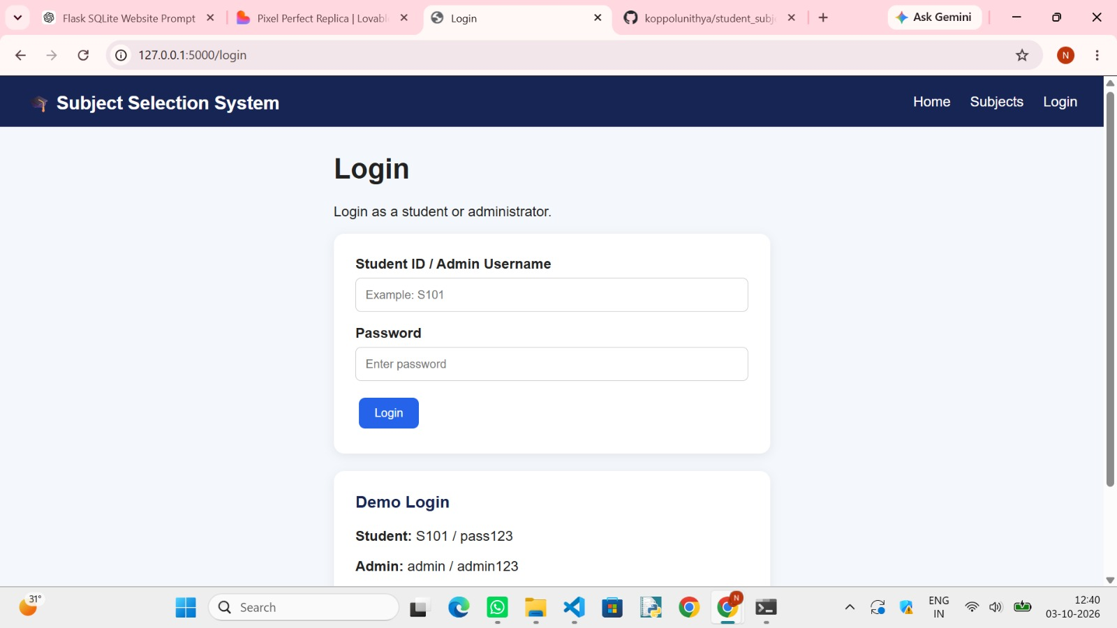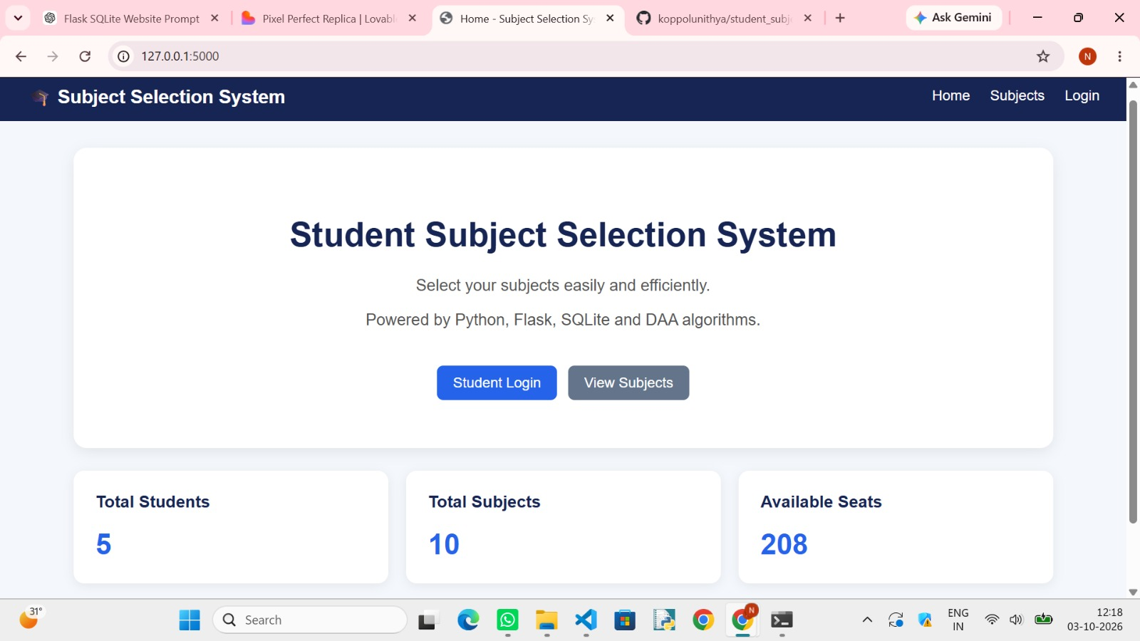
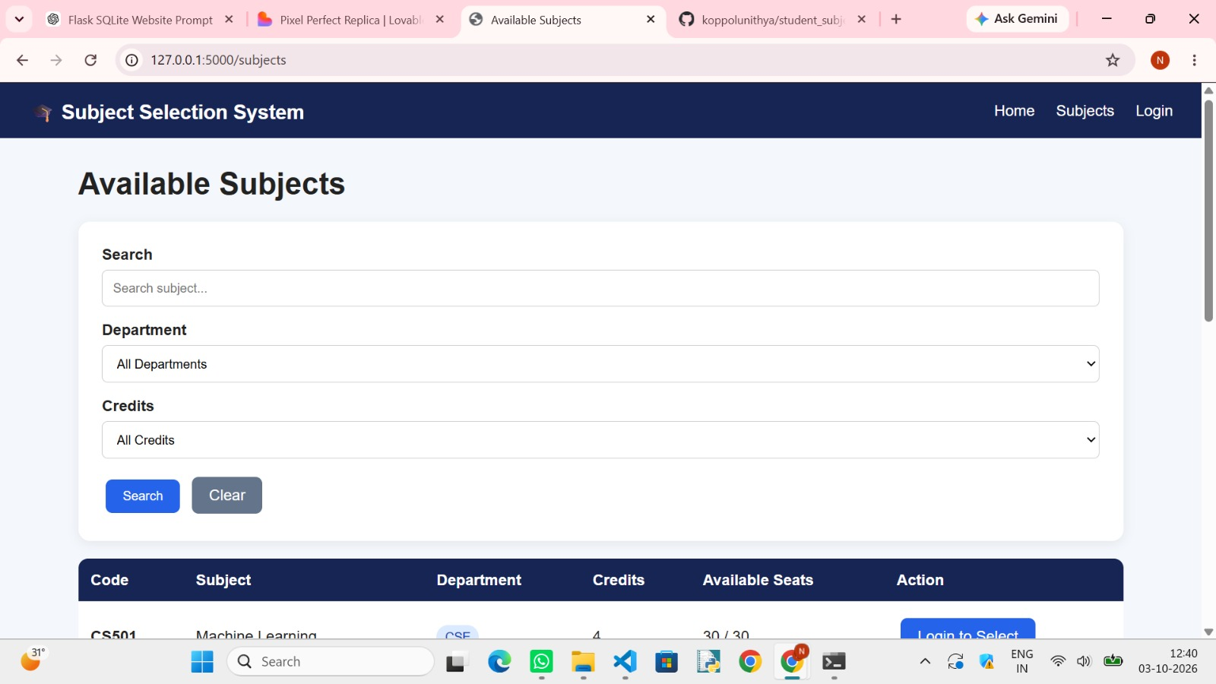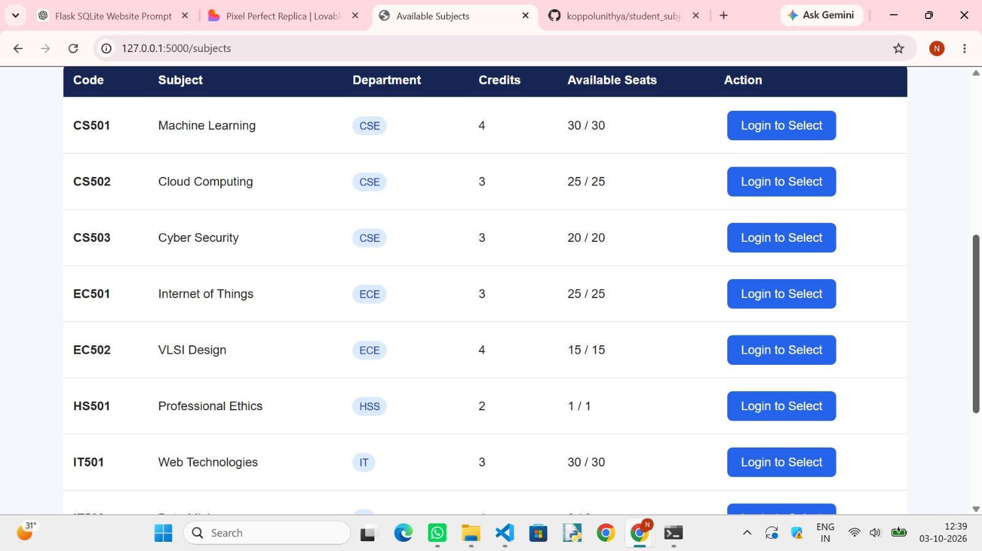

8. CONCLUSION, FUTURE SCOPE & REFERENCES
8.1 Conclusion
The Student Subject Selection System provides a practical solution for selecting elective subjects under academic constraints.
The project converts a real-world subject selection problem into an optimization problem using 0/1 Knapsack and Dynamic Programming. The system considers credits, workload, preferences, and mandatory requirements to calculate a feasible subject combination.
The use of Dynamic Programming allows the system to reuse solutions to overlapping subproblems and avoid unnecessary repeated calculations. The application also presents the selected subjects, total credits, workload, preference score, and algorithmic decisions in an understandable format.
The project successfully combines Data Structures and Algorithms with Web Application Development, demonstrating how theoretical concepts can be applied to solve a practical educational problem.

8.2 Future Scope
The system can be enhanced in several ways:
AI-Based Preference Prediction
The system could learn from previous selections and recommend subjects based on historical preferences.
Timetable Conflict Detection
Future versions can consider class schedules and prevent timetable clashes.
Faculty Recommendations
Faculty members could provide recommendations or prerequisite information.
Advanced Multi-Criteria Optimization
Additional constraints could be incorporated, such as:
- Class timing
- Instructor preference
- Previous grades
- Career interests
- Prerequisites
- Seat availability
Cloud Database
SQLite could be replaced with a cloud-based database for multi-user deployment.
Mobile Application
The system could be converted into an Android or cross-platform mobile application.
Personalized Recommendations
A recommendation engine could suggest subjects based on student interests, academic history, and career goals.
Administrator Dashboard
A complete administrator interface could be added for:
- Subject management
- Student management
- Reports
- Statistics
- Academic-year configuration

PROJECT SUMMARY
Project Name
Student Subject Selection System
Domain
Education / Academic Management
Core Algorithm
0/1 Knapsack with Dynamic Programming
Frontend
HTML, CSS, JavaScript, Bootstrap
Backend
Python, Flask
Database
SQLite
Main Input
- Available subjects
- Credit limit
- Workload limit
- Preference scores
- Mandatory subject requirements
Main Output
- Selected subjects
- Total credits
- Total workload
- Total preference score
- Selection decisions
- Optimization history
Complexity
Time: O(n × C × W)
Space: O(n × C × W)

FINAL PROJECT STATEMENT
The Student Subject Selection System is an algorithm-based web application that helps students select suitable elective subjects while satisfying academic constraints. By combining 0/1 Knapsack and Dynamic Programming with Python, Flask, SQLite, HTML, CSS, JavaScript, and Bootstrap, the project provides an understandable and practical solution to a real-world academic optimization problem.

