DevOps CI/CD Pipeline Implementation using Jenkins, Docker, GitHub and AWS EC2
Prepared By:
Sharath Koppula
Domain: DevOps Engineering

1. Project Overview
This project demonstrates the implementation of a DevOps Continuous Integration and Continuous Deployment (CI/CD) pipeline using Jenkins, Docker, GitHub, and AWS EC2.
The pipeline automates the process of retrieving application code from GitHub, building a Docker image, and deploying the application container on an AWS EC2 server.
The main objective of this project is to simulate a real-world DevOps automation workflow used in modern software development environments.

2. Tools & Technologies Used
Tool | Purpose
GitHub | Source code repository
Jenkins | CI/CD automation
Docker | Containerization
AWS EC2 | Cloud server hosting
Node.js | Web application runtime
Linux | Server operating system
Technologies used in the project:
- Jenkins
- Docker
- GitHub
- Amazon Web Services

3. System Architecture
Developer
│
▼
GitHub Repository
│
▼
Jenkins CI/CD Pipeline
│
▼
Docker Image Build
│
▼
Docker Container Deployment
│
▼
AWS EC2 Server
│
▼
Running Web Application

4. GitHub Repository
Repository URL:
https://github.com/koppulasharath/devops-cicd-pipeline
Repository contains the following files:
Dockerfile
app.js
package.json
These files are used by Jenkins to build the Docker image and deploy the application.
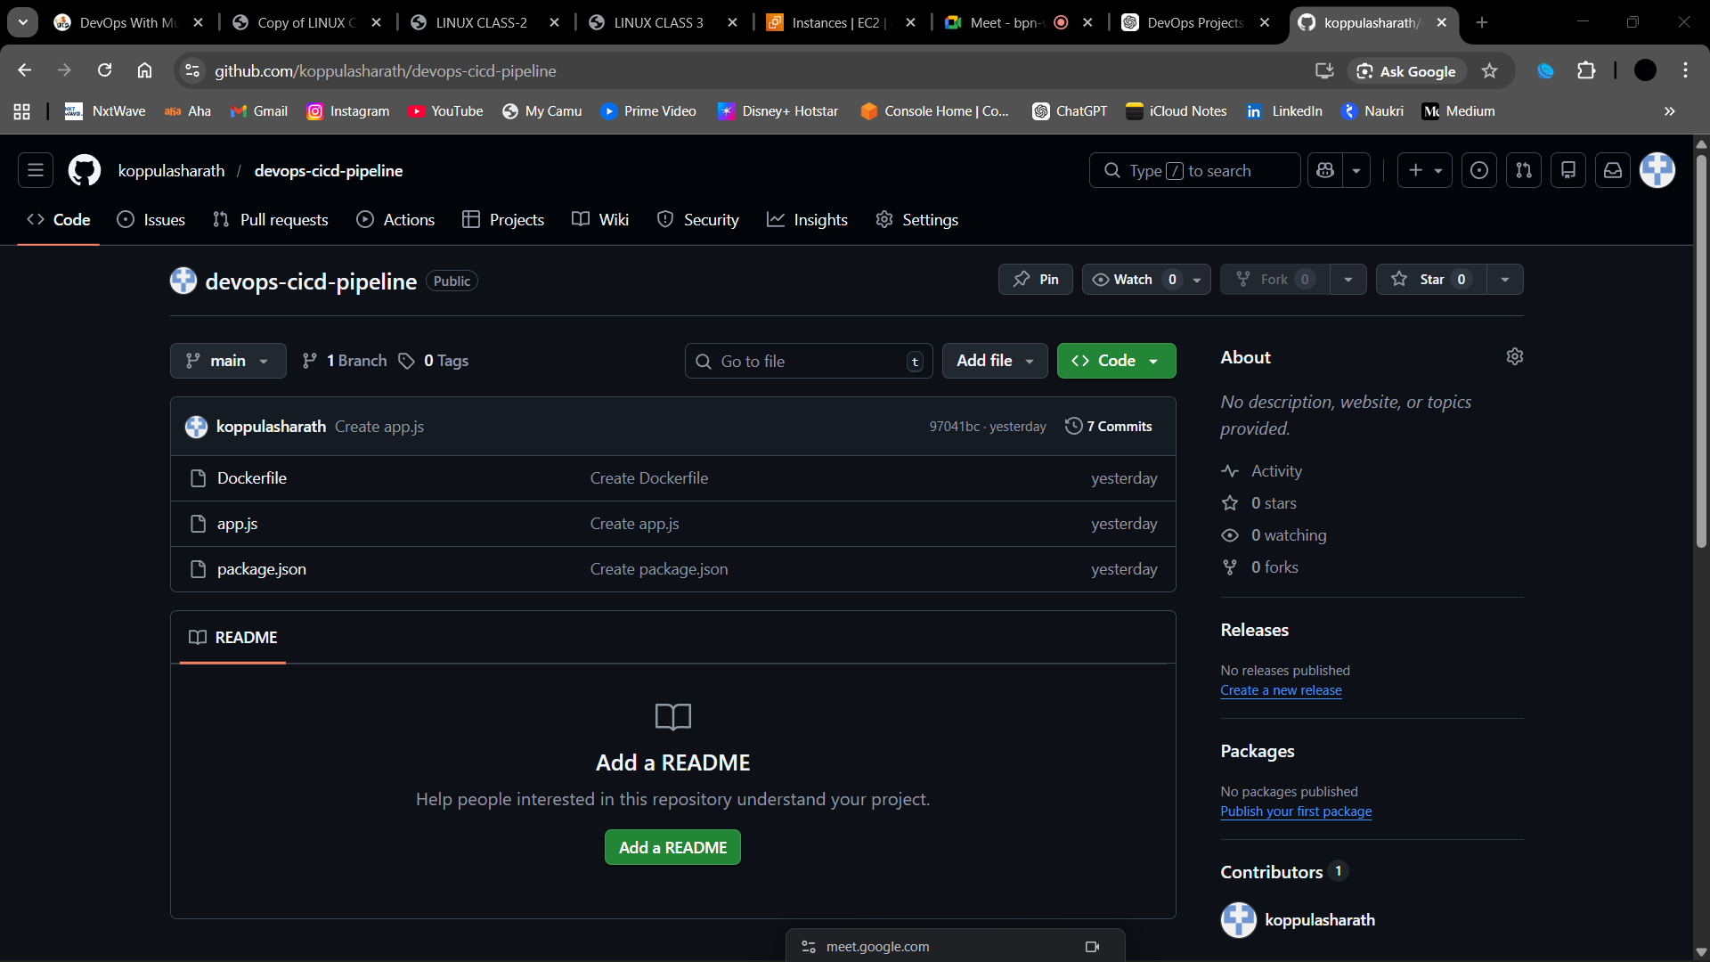

5. AWS EC2 Infrastructure
An EC2 instance was created in AWS cloud to host Jenkins and Docker.
Configuration:
- Instance Type: t3.micro
- Operating System: Amazon Linux
- Jenkins Port: 8080
- Application Port: 80
The EC2 server acts as the CI/CD build server where Jenkins executes the pipeline and deploys containers.
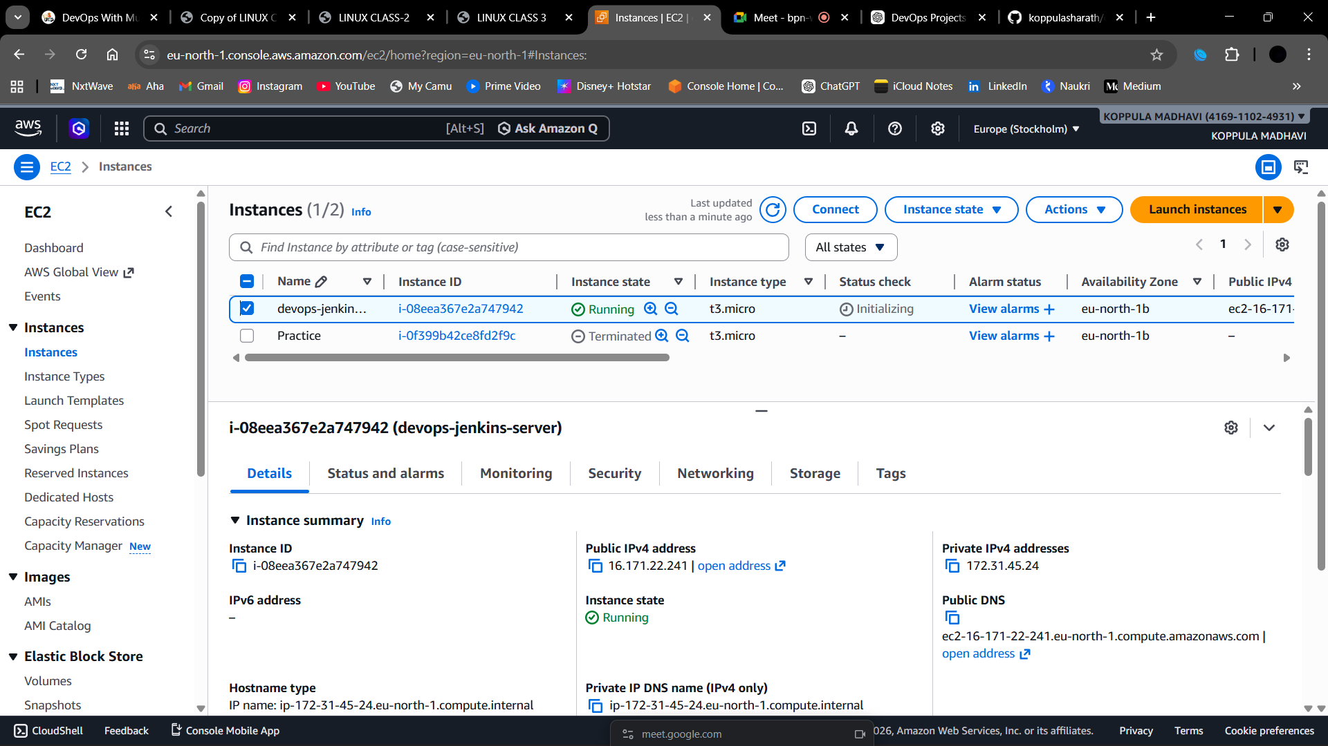
6. Jenkins Pipeline Configuration
A Jenkins pipeline job was created to automate application deployment.
Pipeline stages:
- Clone Repository
- Build Docker Image
- Run Docker Container
Jenkins automatically fetches the source code from GitHub and executes the pipeline.
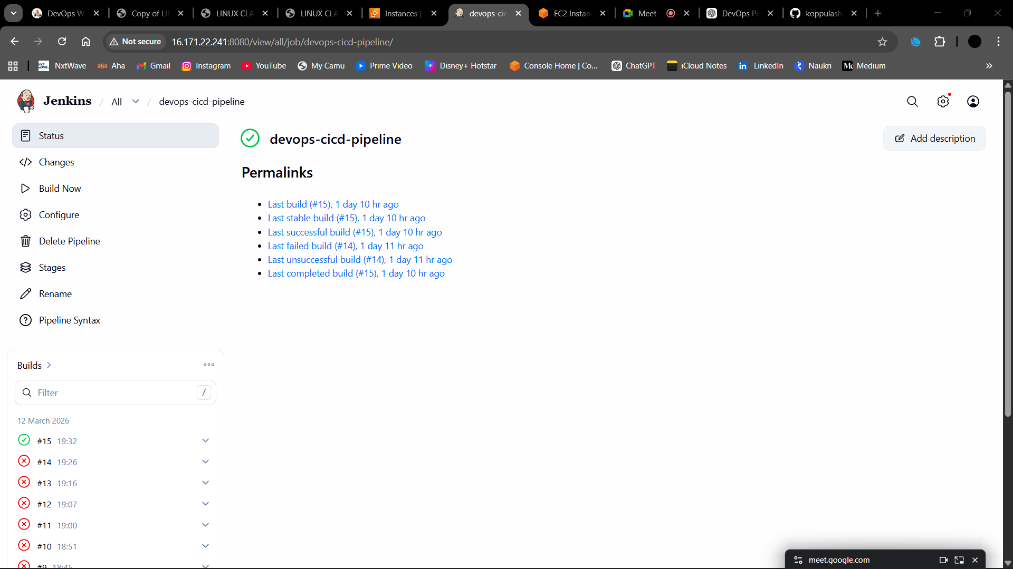
7. Jenkins Pipeline Execution Output
The Jenkins console output shows successful pipeline execution.
Started by user RIKKY
Stage 1: Clone Repository
Repository: https://github.com/koppulasharath/devops-cicd-pipeline.git
Branch: main
Stage 2: Build Docker Image
docker build -t devops-app .
Docker image successfully built.
Stage 3: Run Docker Container
docker run -d -p 80:3000 devops-app
Container ID:
465c3b41b4d7520f1a1148441af2641583600ba6c5478541019cff5bd79dcfef
Pipeline Result:
Finished: SUCCESS
This confirms the CI/CD pipeline executed successfully.

8. Docker Container Deployment
The container was verified using:
docker ps
Output shows:
devops-app container running
PORTS: 0.0.0.0:80 → 3000
This confirms that the application container is running successfully.
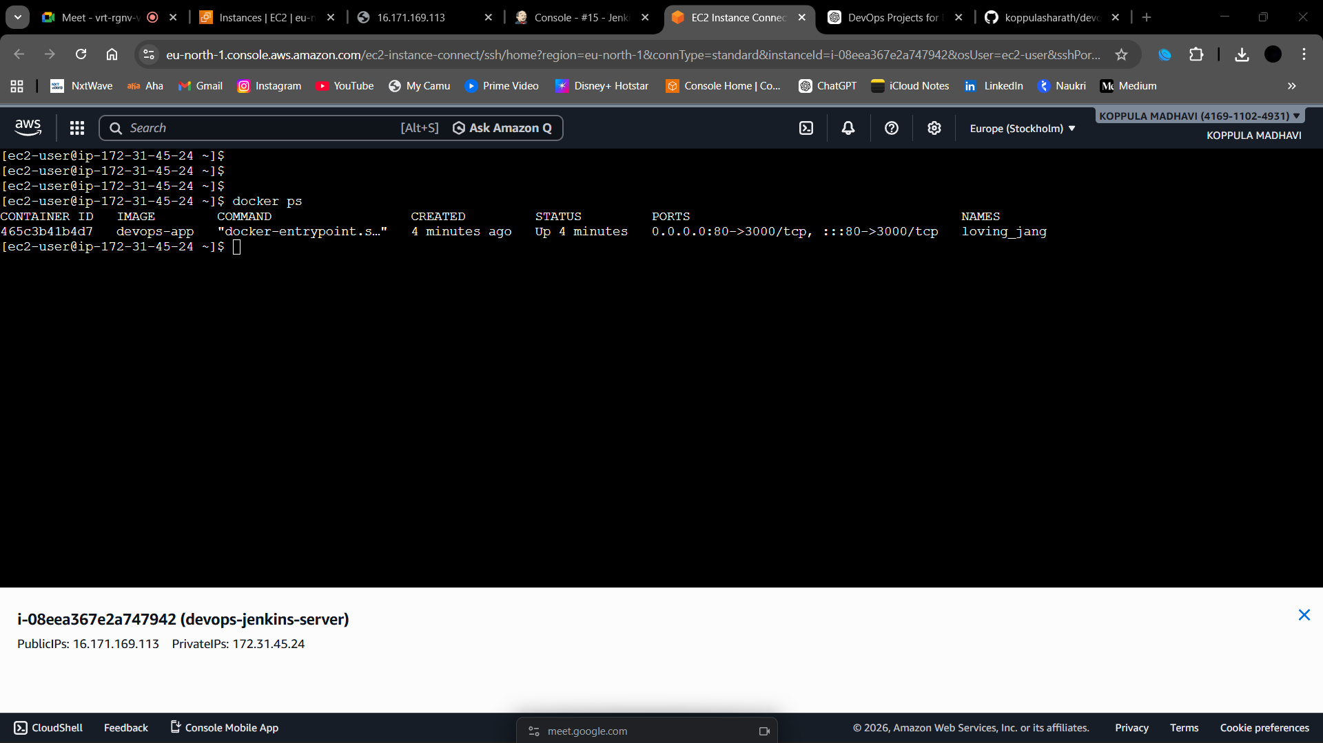

9. Application Deployment Result
The application was accessed using the EC2 public IP address.
Example:
http://16.171.xx.xxx
The web browser displayed:
DevOps CI/CD Project Running!
This confirms the successful deployment of the application.
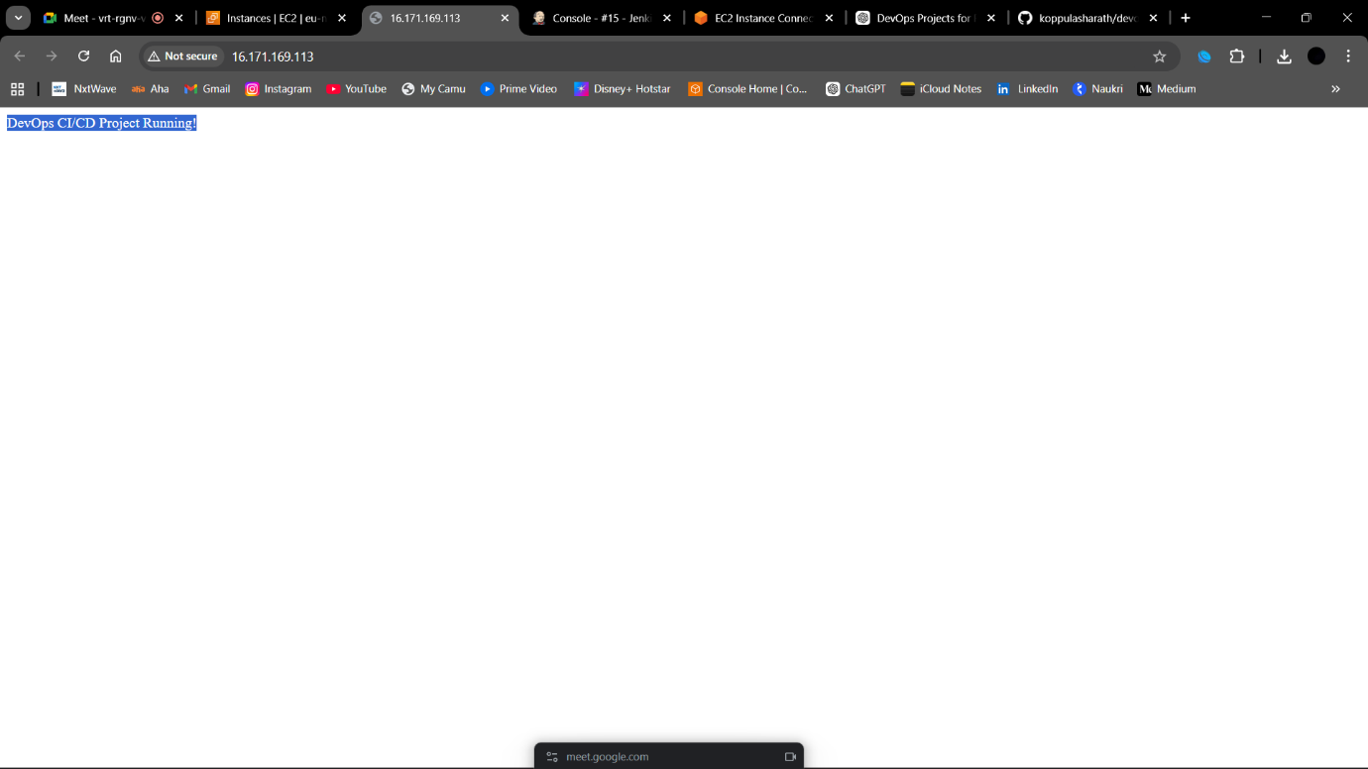

10. Linux Command Execution
During the setup process, the following commands were executed on the EC2 instance:
sudo yum update -y
sudo yum install docker -y
sudo systemctl start docker
sudo systemctl enable docker
sudo yum install java-17-amazon-corretto -y
sudo yum install jenkins -y
sudo systemctl start jenkins
sudo systemctl enable jenkins
sudo yum install git -y
docker ps
These commands installed and configured Jenkins, Docker, Java, and Git on the EC2 server.

11. Project Outcome
The CI/CD pipeline successfully automated the following processes:
- Cloning application source code from GitHub
- Building Docker image automatically
- Deploying the application container
- Running the application on AWS EC2
This project demonstrates a practical DevOps workflow used in real-world environments.

12. Conclusion
This project implemented a complete DevOps CI/CD pipeline using Jenkins, Docker, GitHub, and AWS EC2.
The automated pipeline improves deployment efficiency, reduces manual errors, and ensures faster software delivery.
This project reflects real-world DevOps practices used by modern development teams.

