1. Background
   1. Tree, Ground, Snowflakes, Pervertexcolor sky
2. Snowman
   1. I used distinct 4 3D objects to create it
   2. Building will be explained later
3. Animation
   1. Snowman has two main and several helper animations
   2. Several function moves in all 3 directions
4. Callback
   1. Click and keyboard keys callback implemented
5. Creativity
   1. Shaking camera
   2. Interaction with trees
   3. Trail Mode

Explanation on several shapes in geometry.cpp

1. Cube with translation: Multiply by translation matrix already given vertex set, and do the same as in Cube
2. Sphere: I used spherical coordinate representation of sphere $(\sin\left(θ\right),\sin\left(ϕ\right), cos⁡(θ)$. Make strips

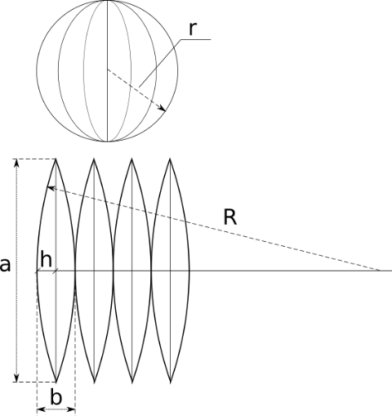of this form, and fill it with GL_TRIANGLE_STRIP.

1. Cone: Using cylindrical coordinates of form $(r*sin\left(θ\right), z-r,r* cos\left(θ\right))$, similar to sphere, divide cone into big triangle from bot to top and fill with strip.
2. Cylinder: Using cylindrical coordinates. Divide cylinder in small rectangles.
3. Snowflake: The same as in previous homework. Using Koch-snowflake algorithm calculate all points.
4. Pyramid: 2 triangles for base and 1 for each side.

Background:

Ground: rescaled cube of ash-white color.

Sky: rescaled cube, I used pervertexcolormaterial from previous homework to make it look like sky. The color changes linearly, from top to bottom.

Tree: cylinder is used as stump, and 3 pyramids on top of each other to mimic greenness of tree.

Snowflake: white colored snowflakes fall.

Snowman building: the snowman is build up from m_torso. m_body is attached to m_torso via AddParent, I attach hands and m_head to it. Facial features and hat are attached to m_head. For body parts sphere is used, for nose cone, for hat cylinder.

Animation: I have two main animations of snowman and several helpers. All functions are controlled by field m_action_counter, and switch command, whenever some condition is fulfilled animation progress to next state.

Main:

1. Jump: this function partitioned into 3 parts, and switches by means of m_jumping_phase, triggered by pressing any of WASD keys, which determines direction.
   1. 1st phase Snowman’s m_torso is scaled down and arms are rotated(explained later) so that it appears that snowman pull them closer to body and clench(explained later) his finger in fist.
   2. 2nd phase consist of changing y component upwardly of every main body part, torso also moves in direction of movement. Simultaneously hands and scale of torso goes to normal
   3. 3rd phase return back to previous height, and adjust all body parts
2. Poke: Function triggered by clicking on body of the snowman, this function switches as well.
   1. 1st phase: change z component of body and orientation of head. To look like click poked it.
   2. 2nd phase: go back to initial position
   3. 3rd phase: invokes helper angry function, to make snowman angry

Helpers:

1. Angry:
   1. 1st phase: rotate hands to specific position and clench fist
   2. 2nd phase: shake fist
   3. 3rd: go back
2. Clench: changes orientation fingers on hand to certain degree
3. Symmetric hand rotation: change orientation of hands to certain degree
4. Align, correct hands: make sure that all body parts stay at right postions

Note that jump makes move in all 3 direction, angry function rotates hand in planes x-y and y-z. So functions show that it is 3D object.

Callbacks:

MouseButtonCallback: is used to trigger poke, updates target status

MousePositionCallback: is used for Trail Mode, gets position and scale so that it tracks where cursor is.

CursorPosCallback: whenever WASD keys pressed it updates direction of jump, to prevent sudden change of direction, this callback also check whether action is happening right now.

Creativity:

Camera shaking: when snowman lands, camera starts to shake, to provide natural looking shaking I used oscillation with dumping trajectory. It is worthwhile, since any shaking will automatically provoke our brain to produce sound, so jump landing “hears” more naturally.

Interaction with tree: when snowman in proximity of tree, it falls and new one is appears somewhere on screen. It is just fun to push trees down.

Trail Mode: Snowflakes of different colors appear where cursor is. They simply fall down, and fades away after some time, I used GL_BLEND to gradually fade them. Activates by pressing T. Looks nice.