Extra texture and skybox

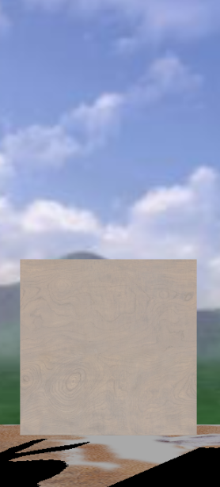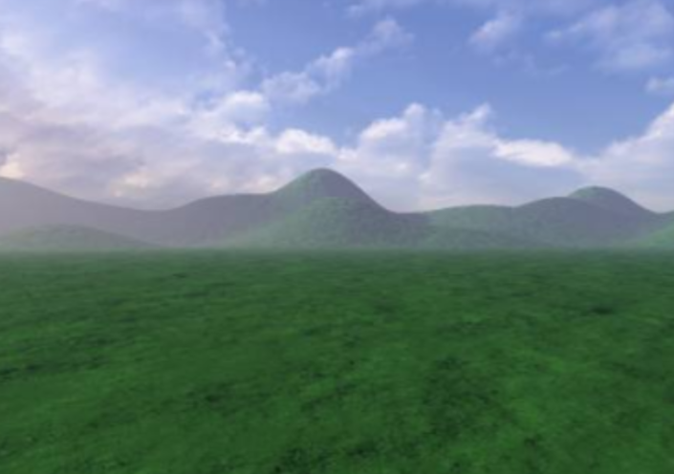

Normal Mapping

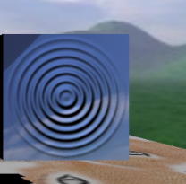

I bound normal map to new kind of material Normal Material. There I computed Bi-Tangent coordinates and with regard to this frame I set normal of fragment to be value from normal map. Rest is Phong model.

Shadow Map

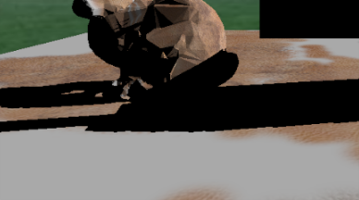

I have binded shadow_tex to shadow_fbo.

On first pass I changed all materials to Shadow Material. And rendered scene as normal.

To get right light coordinates I used ortho function for Projection and lookAt for orientation.

To get rid of artifacts I introduced bias in Fragment Shader, in function which determines whether function in shadow or not.

Creativity

Press P for Point light shadow Map.

Light rotates around scene to show full power of shadows.