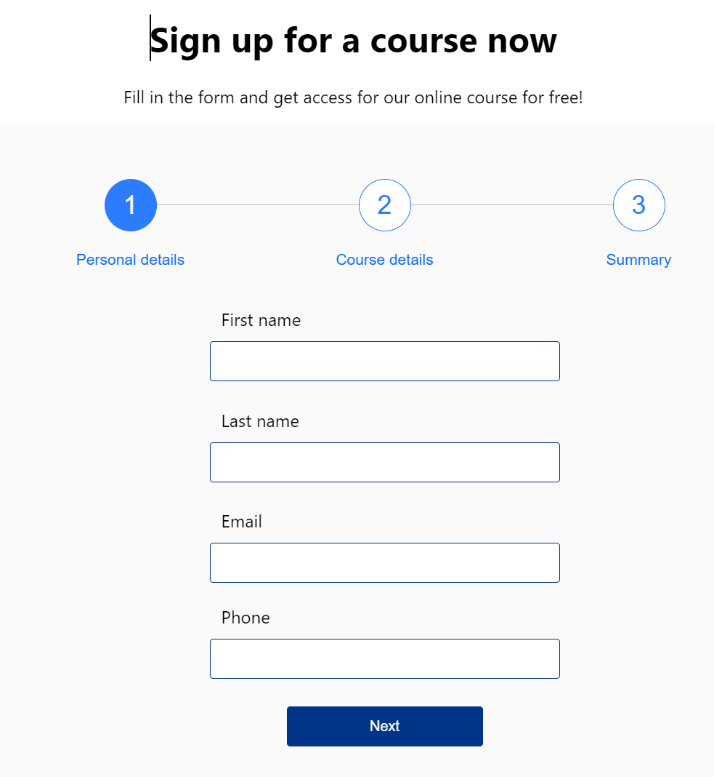

Questions

1. How would you split it into multiple pages.

2. How would you access the information? By clients via a link?

3. How would you like to be able to access the information page and the consultation page. Note that you can have multiple consultation records.

Client information

Consultation 1 date issue

Consultation 2 date issue

Consultation 3 date issue

Consultation 4 date issue