This is the URL to the Google play store: https://play.google.com/console/about/.

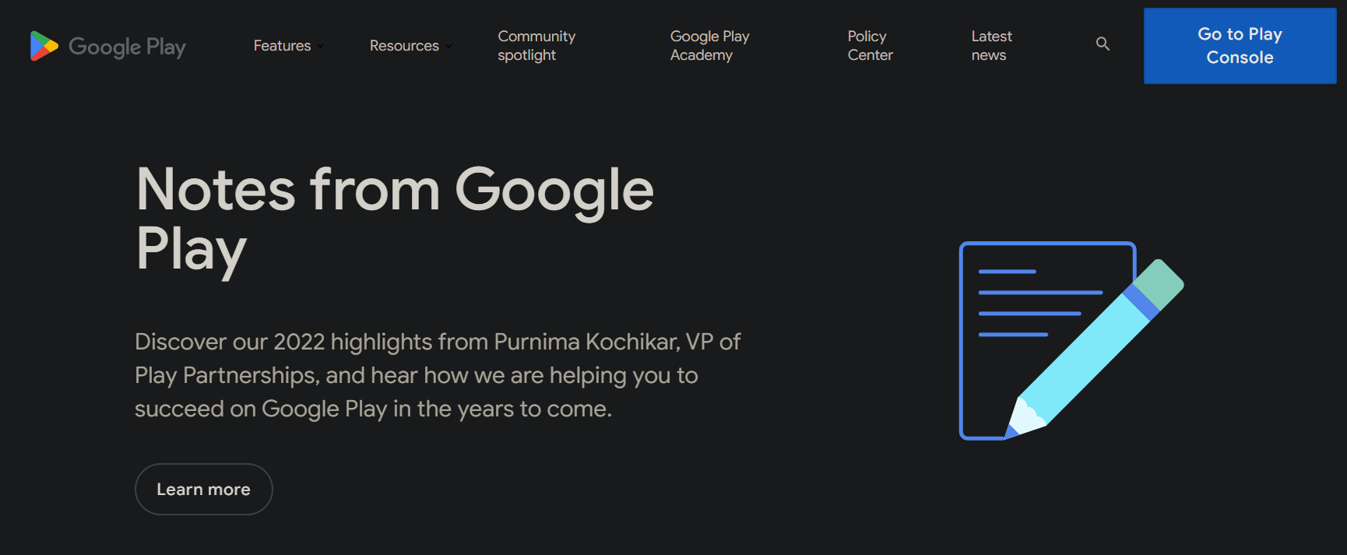

I’ve made multiple attempts to create an account on the “Play console” without any success.

I’ve paid the $25 membership fee.

My ID has also been verified.

I’m unable to reach the “Developer account section”.

I’ve sent emails to google pay but their response wasn’t very useful. I’d be great if you could help me on this issue.

