MySQL database creation

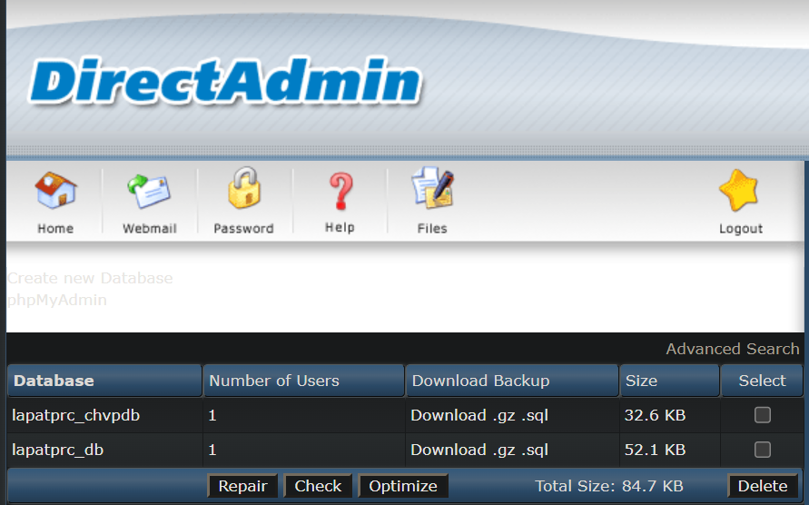

You’ve shown me a similar functionality on one.com.

When I access my webhosting with FileZilla, I have the following directories.

All of my program file as in the public_html directory.

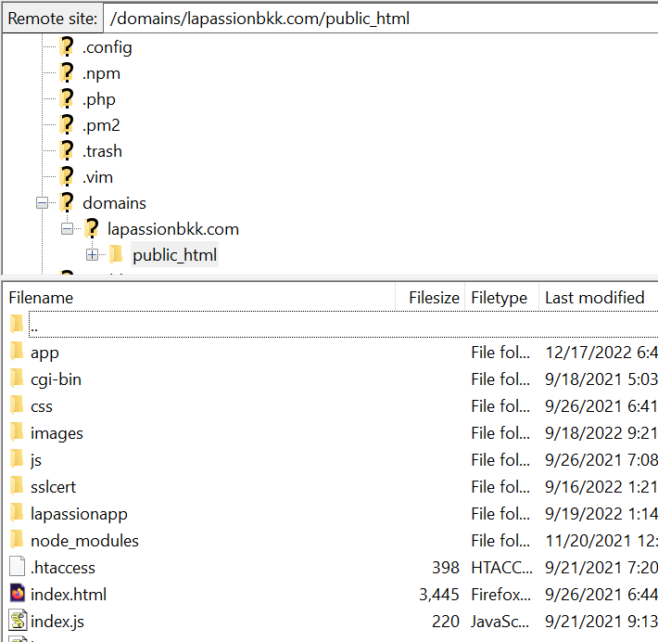

Since I’m hosting multiple applications, I’ve created an “app” directory when I have a directory for each backend application.

For the “lapassion-app”, I have a directory name “lap-portal” where I put all my PHP source and resources.

For the “healinghere” app, I’ll create a new directory call “healh-portal” which will contain the same PHP code as for “lapassion-app” but with different resource content. Therefore, I’d need to know where is the equivalent path to “domains/lapassionbkk.com/public_html” on your “one.com” web hosting.

Once I have it’ll put the backend code in with some sample service pictures and user. I’ll create a new mobile app on expo for “healinghere” so then you can play with it on your iPhone. Can you send me the logo and a picture so the I could put them on the Splash Screen page.