Avant tout je vais me donner les permissions pour agir sur tout les fichier .jpg en prenant en comtpe la casse :
find . -type f -iname "*.jpg" -exec chmod 700 {} \;

1 ) find . -type f -iname "*.jpg" -exec shasum {} \; | awk '{print $2":"$1}' > empreintes.txt
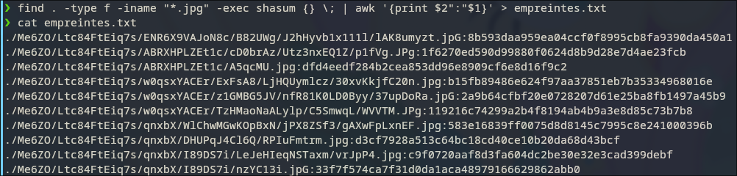
2 ) cat empreintes.txt | awk -F ':' '{print $1}' OR
awk -F ':' '{print $2}' empreintes.txt
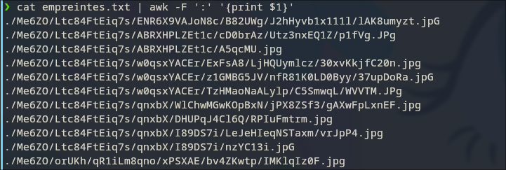
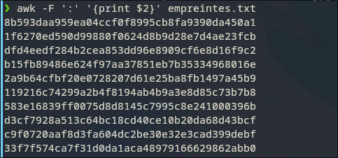

3 ) awk -F ':' '{print $1}' empreintes.txt | grep -io '[^/]*\.jpg'

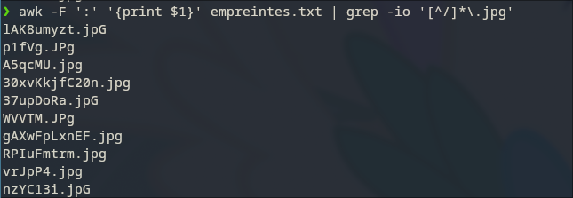
4 ) nano cpjpgfile.sh
#!/bin/bash
# Auteur : korasrar

mkdir -p Outputs
cpt=1

for file in $(find . -type f -iname "*.jpg");
do
filen=$(echo "$file" | grep -io '[^/]*\.jpg')
prefix3=${filen::3}
cp "$file" "Outputs/fichier_${prefix3}_num_${cpt}.jpg"
cpt=$((cpt+1))
done
chmod +x cpjpgfile.sh
./cpjpgfile.sh
ls Outputs
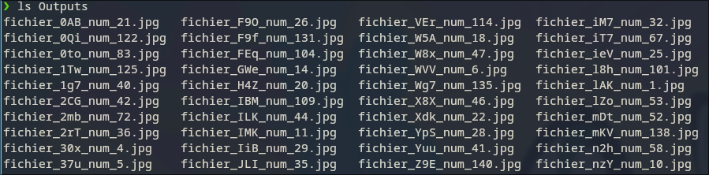
Avant tout il faut se donner les permissions sur tout les fichier de type image pour la commande shasum :
find . -type f \( -iname '*.jpg' -o -iname '*.tif' -o -iname '*.bmp' -o -iname '*.gif' -o -iname '*.png' \) -exec chmod 700 {} \;

5 ) dico=$(find . -type f -exec file {} \; | grep 'image' | awk -F : '{print $1}' | xargs shasum | awk '{print$2":"$1}')
or
dico=$(find . -type f \( -iname '*.jpg' -o -iname '*.tif' -o -iname '*.bmp' -o -iname '*.gif' -o -iname '*.png' \) -exec shasum {} \; | awk '{print $2":"$1}')

echo $dico
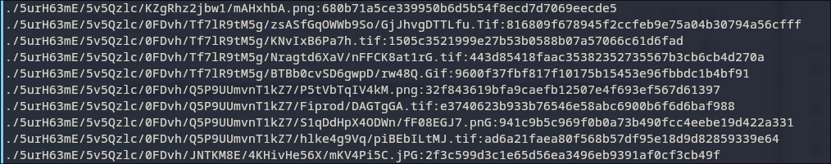

8 ) nano cpimageall.sh
chmod +x cpimageall.sh
./cpimageall.sh
#!/bin/bash
#Auteur : korasrar

mkdir -p Outputs
cpt=1

declare -A name

for file in $(find . -type f -exec file {} \; | grep 'image' | awk -F : '{print $1}');
do
res=$(shasum "$file" | awk '{print $1}')
if [[ -z "${name["$res"]}" ]]; then
filen=$(basename "$file")
prefix3=${filen::3}
output="Outputs/fichier_${prefix3}_num_${cpt}.jpg"
magick $file $output
cpt=$((cpt+1))
name["$res"]="$file"
fi

done

9 ) mogrify -gravity center -crop 200x260+0+0 Outputs/*jpg
10 ) montage Outputs/*.jpg -tile 10x -geometry 200x260 ./mosaique.jpg

SOURCES :
pour awk et sed
https://unix.stackexchange.com/questions/113515/how-to-modify-output-in-bash-command-pipeline

