# Readme Description

What is my code?

This code is python script (.py) that simulate coin flip.

What are my packages/libraries?

You need to have python numpy, scipy, pandas and matplotlib in your local machine.

Adjustable Input?

The variable “n_flip” is set to 3 (meaning in 1 set 🡪 flipping 3 coins)

“n_sim” is another one that can be adjusted. Originally set to 5000 iterations of simulation

Output?

Besides the printed text you might get in terminal, you will get 1 CSV file and 1 PNG file for the simulated result file and graph file. In will appear in your same folder as the py file. Note that Head = 1 and Tail = 0.

pseudo code?

Part 1 Simulation (how random samples data CSV file is generated)

|  |
| --- |
| Set number of flips  Set number of iterations  Start loop for as same as number of iterations   * Make an array of result for 1 set = [coin1, coin2, coin3] * Append Result of 1 set to a big list   Turn the big list to DataFrame  Export the DataFrame to CSV file |

Part 2 Visualization (how histogram PNG file is generated)

|  |
| --- |
| Make new column “Total” in the DataFrame = sum of [coin1, coin2, coin3]  Turn that new column to an array of number  Plot histogram using that array of number  Export the plot to PNG file |

Graph?

The following histogram is generated from the code.

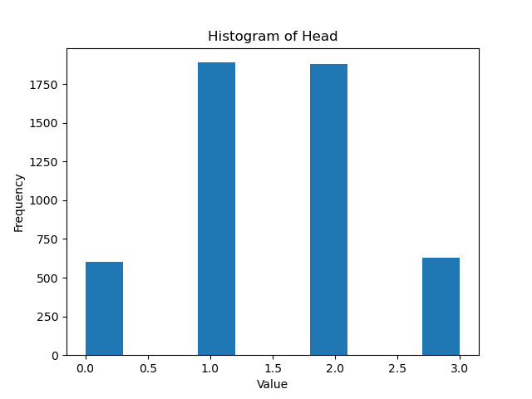

Note that Value here means how many heads in each set. (As explained in pseudo code)

Where is the actual code?

In appendix as well as the uploaded script file.

# Appendix

##

import numpy as np

from scipy.stats import binom

import pandas as pd

import matplotlib.pyplot as plt

#Input

n_flip = 3

result_1set = list(range(n_flip))

prob_HT = 0.50

n_sim = 5000

result_list = []

#Begin binomial distribution (beacuse it discretely will return 0 or 1)

print("I set coin probability =", prob_HT)

print("My sign convention are: Tails = 0, Heads = 1")

for iter in range(0, n_sim):

    result_1set = binom.rvs(1, prob_HT, size=n_flip)

    result_list.append(result_1set)

result_a = np.asarray(result_list)

print(result_list)

print("Head Count: ", np.count_nonzero(result_a == 1))

print("Tail Count: ", np.count_nonzero(result_a == 0))

df = pd.DataFrame(data = result_a)

df.to_csv('results_kkavee.csv', index=False,header=False)

#Visualise

df["Total"] = df.sum(axis=1)

data_to_plot = df["Total"].to_numpy()

plt.hist(data_to_plot)

plt.title("Histogram of Head")

plt.xlabel("Value")

plt.ylabel("Frequency")

plt.savefig('histogram_kkavee.png')

#plt.show()

##