GIS Final Project

Restaurant closures due to COVID-19 pandemic in Pittsburgh

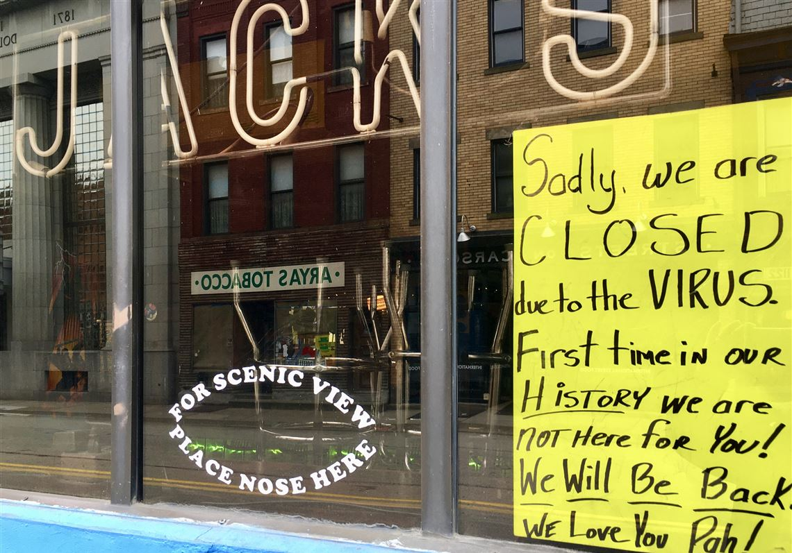

Korawich Kavee

[kkavee@andrew.cmu.edu](mailto:kkavee@andrew.cmu.edu)

90834 Health Care Geographical Information Systems

Professor Kristen Kurland [kurland@andrew.cmu.edu](mailto:kurland@andrew.cmu.edu)

Carnegie Mellon University (CMU)

Pittsburgh, Pennsylvania.

This Page Intentionally Left Blank

Table of Contents

Introduction 1

Methodology 2

Results 3

Conclusion and future work 4

Images & Data sources 5

# Introduction

# Methodology

# Results

# Conclusion and future work

# Images & Data sources

# References