COVID19 and restaurant’s closure in Pittsburgh –

A GIS analysis for restaurant’s owners

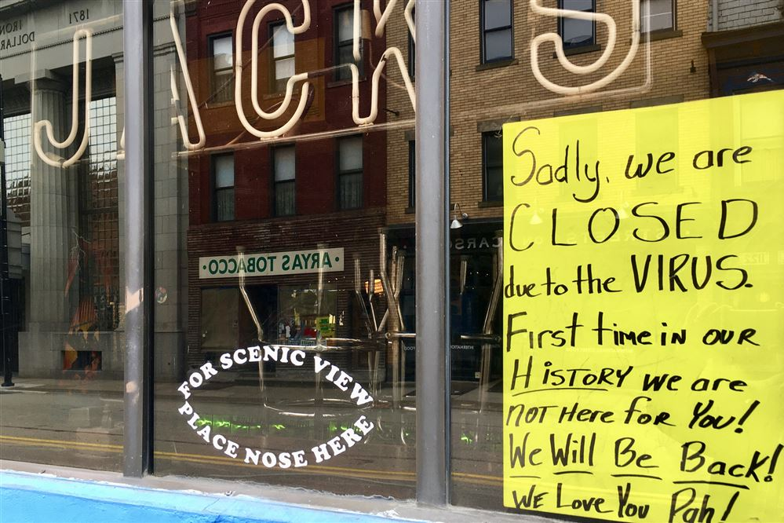

Korawich Kavee

(Navigation on)

# Introduction

The coronavirus 2019 has disrupted people’s livelihoods and economic growth around the globe. Dinning industries, like many other industries, has received a drastic economics impacts due to coronavirus pandemic, Work-From-Home (WFH) policy, as well as the COVID-19 lockdowns. Normal activity such as eating out or social gathering was not possible for a significant period, resulting in loss of revenue for many restaurants and cafes.

# Pittsburgh, like many other cities in the US, have seen restaurant closure due to this reason. **Pamela’s Diner** in Squirrel Hill, for instance, has been confirmed to be closed permanently on Dec 28, 2021[1], following by Squirrel Hill **Eat'n Park** on Jan 4, 2022[2]. Some places are still operating but with different method, like **Roundabout Brewery** in Lawrenceville that is not close but now offer only to-go[3].

This GIS analysis aims to provide more insight of how restaurants, bars, or cafes were affects differently based on their spatial location during the frame from 2019 to 2021. The primary target audience of this article is a group of business owners who currently running a restaurant in Pittsburgh, Pennsylvania.

# [Pamela’s Diner is closing in Squirrel Hill, but its other locations will remain | TribLIVE.com](https://triblive.com/lifestyles/food-drink/pamelas-diner-is-closing-in-squirrel-hill-but-its-other-locations-will-remain/)

[Squirrel Hill loses two longtime popular diners in one week's span | Food | Pittsburgh | Pittsburgh City Paper (pghcitypaper.com)](https://www.pghcitypaper.com/pittsburgh/squirrel-hill-loses-two-longtime-popular-diners-in-one-weeks-span/Content?oid=20873512)

# [Surging covid prompts some Pittsburgh-area restaurants to cancel holiday service | TribLIVE.com](https://triblive.com/lifestyles/food-drink/surging-covid-prompts-some-pittsburgh-area-restaurants-to-cancel-holiday-service/)

# Methodology

(Where I got the data?) (Scope?)

The main datasets for this project are historical business data from Data Axle Reference Solutions (Formerly known as ReferenceUSA). This access was possible via Carnegie Mellon University Library portal. Due to the selected time scope, most of restaurants/café/bar have 3 consecutive rows in the dataset. If there is no record for a certain year, that row will not be found. Some places also change their business’s name result in having multiple rows in the same year. For a case of recently close places like Pamela’s Dinner mentioned above was still counted as active business due to the very recent closure (relative to the time of this study being conducted)

The data was merged, cleaned and rearranged with Python3. For more information, please follow the coding on GitHub at

* [GIS-Restaurant_COVID_Walkable_PGH/RestaurantSeperator.py at main · korawichkavee/GIS-Restaurant_COVID_Walkable_PGH (github.com)](https://github.com/korawichkavee/GIS-Restaurant_COVID_Walkable_PGH/blob/main/RestaurantSeperator.py)
* [GIS-Restaurant_COVID_Walkable_PGH/PivotYear.ipynb at main · korawichkavee/GIS-Restaurant_COVID_Walkable_PGH (github.com)](https://github.com/korawichkavee/GIS-Restaurant_COVID_Walkable_PGH/blob/main/PivotYear.ipynb)

After preprocessing the data, the mapping and geocoding was done within ArcGIS Pro 2.8.

# Active Restaurants

The first stage of this analysis is to explore active restaurants in Pittsburgh. The duration scope of this analysis focus on the year 2019, 2020, and 2021, therefore the following map are placed according to emphasis the changes throughout the timeline.

(Build a sidecar) (3 maps)

2019 Restaurants Pittsburgh

How many restaurants were open during 2019 in Pittsburgh

Business,Restaurants,Pittsburgh,Café

2020 Restaurants Pittsburgh

How many restaurants were open during 2020 in Pittsburgh

Business,Restaurants,Pittsburgh,Café

2021 Restaurants Pittsburgh

How many restaurants were open during 2021 in Pittsburgh

Business,Restaurants,Pittsburgh,Café

Closure and Competitor Analysis

Foodservice that dies off during the pandemic

Business,Restaurants,Pittsburgh,Café, pandemic

In 2019, there were 1132 open restaurants. They were located mostly in the downtown area (201) and Southside Flats (110).

As an international student at CMU myself, it is reasonable to see Shadyside, Squirrel Hill South, Central & North Oakland with moderate number of business (66, 56, 55, 40 accordingly).

From the mentioned statistics in 2019, 81 restaurants were begun to close in 2020 (and close for 2021 as well). The overall number of restaurants surprisingly remain 1132 since there were new places that was born during the year. The concertation pattern remained relatively the same. (CBD contained 196)

The overall number of restaurants decreased to 1106, with 175 in CBD. Some neighborhoods such as Bloomfield now has 66 places.

Based on the 3 maps above, Figure 1 was made to illustrate the top 10 neighborhoods and their changes before and after the pandemic. (Sorted by the 2019 statistics)

Figure-1 Bar charts showing summarizing the number of active restaurants in 2019, 2020, 2021 of the top 10 neighborhoods in Pittsburgh.

Another way to look the changes is to calculate the different. Figure-2 emphasize such different between 2020-2019, 2021-2020, and 2021-2019.

Figure-2 bar charts of the different calculated based on statistical number of 2019,2020,2021 (Sorted by the smallest (largest negative) number within each neighborhood.

# Restaurant Closures during the pandemic

Figure-3 Bar chart of closure ratio as a percentage, treated as the competition index.

Still, the CBD is dramatically impacted during the year of pandemic. This is sensible founds since there is a lower demand for making a trip into downtown (especially driving dur to lockdown and WFH). The pattern would result in people visiting their restaurants in a walkable distance from their household instead of performing eat-out activities in the core of the city. Besides walking, active transport such as biking can be another great way to draw more revenue to the restaurant[4].

From the number of closures during the pandemic in 2020 & 2021, the next step is to normalize the statistics. Although the number of restaurants can already be meaningful to the topic, understand the statistic of closure relative to the remaining places as a percentage would provide density and level of competitive in each neighborhood. If a restaurant is in a remote area, it would be the only option for consumers in that area there wouldn’t much of a local consumer. In contrast, a high-density commercial zone would be a great catchment of customers, but it wouldn’t be the only restaurant there in the market. To understand how much competition effort (e.g., marketing campaign/ uniqueness of food & drink) a business owner has to put in the work for each neighborhood, Figure-3 shows the ratio of no. of close business out of restaurants counted in 2019, revealing that although CBD has the highest decreases as discussed earlier, that lost is actually 20% = 40/201.

Crawford-Roberts and South Oakland face a dramatic loss, 3 out of 4 and 2 out of 2 accordingly. The reason can be that these neighborhoods have low populations[5], [6] and geographically surround by other well-known neighborhoods.

(Walkable area and Competition)

The blue polygons represent the walking area away from the closed restaurant points (5- and 10-min polygons). When the remaining open restaurants are spatially counted within the proximity, 101 points are within the 0-5-min area and 841 points are within 5-10-min area, aggregated to be 942 in 51.63 square km (= 19.93 square mile). This means that within 1 square mile of zone with high walkability, 47.25 restaurants must compete to survive, specifically 9.57 restaurants per mile^2 if only focus on 5-min pedestrian access.

(Build a sidecar) ()

(How hard/ easy to survive)

# Conclusion & Future Works

In this analysis, historical business datasets are examined and geo-processed to find if there are neighborhoods that have been affected by COVID more critical than other neighborhoods in Pittsburgh. The following statements can be concluded.

* Originally, regardless of the pandemic, many restaurants are located in the CBD (Downtown) area, as well as in suburbs e.g., Strip District, North & Central Oakland, Shadyside and very few in other areas.
* Although there are some new businesses born in the 2020-21, the overall number of restaurants in Pittsburgh is now decreased.
* By the number, CBD is the most affected area. The main reason is likely to be the change in transportation pattern during the pandemic.
* By the percentage, Crawford-Roberts and South Oakland are the most affected area. The main reason is likely to be the lack of customers in the area and demands being pulled to other nearby area.
* In terms of sidewalk network near the closed business, any restaurants within these area must find a way to compete with others, specifically about 10 other places in a sq.mile of waling proximity.

A future work should be able access more in-depth data collection. A survey of the reason of closure and the exact date of closure would be more robust than this project. The collection of how the restaurants is serving food such as dining-in, take home, or delivery via food applications (Uber Eat, Door dash, Grub Hub, in-house delivery) is also important as it is related to the pandemic. A web scrapping from social food-critics platform like Google Map, TripAdvisor, Yelp, etc. can also filter out some places that may have other problems and not just COVID.

# Images and Data Sources

Cover image was taken by Korawich Kavee at Kiin Lao & Thai Eatery (Dec 2021) (Also available on Google Map)

Data of Restaurants was downloaded from the U.S. Historical Business Database @ Data axle reference solutions. (Access via CMU Library license)

Shapefile of Neighborhood and other relates GIS feature classes of Pittsburgh are provided within the coursework and ArcGIS 2.8 tutorial’s material.

# Acknowledgement

Although this project is just a part of my course “90834”, I do hope this story map is useful for your restaurant, bar, or café in this city. I did this project out of love for some of my favorite local places here in Pittsburgh.

# Reference

[1] M. Tomasic, “Pamela’s Diner is closing in Squirrel Hill, but its other locations will remain,” *TribLIVE.com*, Dec. 28, 2021. https://triblive.com/lifestyles/food-drink/pamelas-diner-is-closing-in-squirrel-hill-but-its-other-locations-will-remain/ (accessed Apr. 27, 2022).

[2] A. Waltz, “Squirrel Hill loses two longtime popular diners in one week’s span,” *Pittsburgh City Paper*. https://www.pghcitypaper.com/pittsburgh/squirrel-hill-loses-two-longtime-popular-diners-in-one-weeks-span/Content?oid=20873512 (accessed Apr. 27, 2022).

[3] M. Guza, “Surging covid prompts some Pittsburgh-area restaurants to cancel holiday service,” *TribLIVE.com*, Dec. 31, 2021. https://triblive.com/lifestyles/food-drink/surging-covid-prompts-some-pittsburgh-area-restaurants-to-cancel-holiday-service/ (accessed Apr. 27, 2022).

[4] “(1) Economic benefits of dining parklets, bike parking and car parking | LinkedIn.” https://www.linkedin.com/pulse/economic-benefits-dining-parklets-bike-parking-car-alison-lee/ (accessed Apr. 28, 2022).

[5] “Living in South Oakland,” *Niche*. https://www.niche.com/places-to-live/n/south-oakland-pittsburgh-pa/ (accessed Apr. 28, 2022).

[6] “Living in Crawford-Roberts,” *Niche*. https://www.niche.com/places-to-live/n/crawford-roberts-pittsburgh-pa/ (accessed Apr. 28, 2022).

*This project is a part of 90834-A: Heath Geographic Information Systems. Instructor: • Professor Kristen Kurland*