**REPUBLIC OF TURKEY**

**HASAN KALYONCU UNIVERSITY**

**FACULTY OF ENGINEERING**

**COMPUTER ENGINEERING DEPARTMENT**

**Mobile Based Network Monitoring System**

**GRADUATION PROJECT REPORT**

**(Kebab Group)**

**Seda MARANGOZ**

**Koray GÖRKEM**

**Armanc ÇAĞER**

**Supervisor**

**Dr. Öğr. Üyesi Mohammed Madi**

**GAZİANTEP**

**2020**

**TABLE OF CONTENTS**

**1.INTRODUCTION** **4**

1.1. Background 4

**1.2. Scope** **5**

1.3. Problem Statement 5

1.4. Solution Statement 6

**2. LITERATURE REVIEW** **7**

2.1. INTRODUCTION 7

2.2. RELATED WORKS 7

figure 2.2.1. (Related works ) 8

figure 2.2.2. (Related works ) 9

figure 2.2.3. (Related works ) 10

**2.3. CONCLUSION** **10**

**3. SOFTWARE REQUIREMENTS SPECIFICATION** **11**

3.1. Introduction 11

3.1.1. Purpose 11

3.1.2. Intended Audience And Reading Suggestions 12

3.1.3. Product Scope 12

3.2. ARCHITECTURAL DIAGRAM OF PROPOSED SYSTEM 12

Figure 3.2: System architectural scheme 13

3.3. FLOW OF THE APPLICATION 13

figure 3.3. (application flow) 14

3.4.1. Functional (System) Requirements 14

3.4.1.1. Net View 15

3.4.1.2. Tutorials 15

3.4.1.3. Process List 15

3.4.1.4. Read 15

3.4.1.5. Open File 15

3.4.1.6. Broadcast Messages 15

3.4.1.7. New File 15

3.4.1.8. Activate Process 15

3.4.1.9. Controller Panel 16

3.4.2. Non Functional Requirements 16

3.4.2.1. Performans Requirements 16

3.4.2.2. Reliability 16

3.4.2.3. Security 16

3.4.2.4. Availability 17

3.4.2.3. Usability 17

3.5. External Interface Requirements: 17

3.5.1. User Interfaces: 17

3.5.2. Hardware Interfaces: 17

3.5.3. Software Interfaces: 17

3.5.4. Communications Interfaces: 18

**4. SYSTEM DESIGN SPECIFICATION** **19**

4.1. System Architecture: 19

**4.1.1. Use case diagram:** **19**

figure 4.1.1. (use case diagram) 20

4.1.2. Class diagram: 21

figure 4.1.2. (class diagram) 21

**4.1.3. Flow chart of the system:** **22**

figure 4.1.3. (flow chart of the system ) 23

**4.1.4. ER diagram:** **24**

figure 4.1.4. ( ER diagram ) 24

**4.1.5. Sequence diagram:** **25**

**figure 4.1.5. ( Sequences diagram )** **25**

**4.2. Overview of the Mobile Based Network Monitoring System** **26**

**figure 4.2(Overview of the Mobile Based Network Monitoring System )** **26**

4.3. Mockup modeling for the application design: 27

figure 4.3.0(mockup modelling ) 27

figure 4.3.1(mockup modelling ) 28

figure 4.3.2(mockup modelling ) 29

figure 4.3.3(mockup modelling ) 30

**4.4-Mobile Application Interfaces** **31**

**4.4.1-Login Page Interface** **31**

**4.4.2-Main Page Interfaces** **32**

**4.4.3-Devices Page Interfaces** **33**

**4.4.4-Topology Page Interfaces** **34**

**4.4.5-Users Page Interfaces** **35**

**4.4.6-Network Settings Page Interfaces** **36**

**References** **37**

# **1.INTRODUCTION**

## **1.1. Background**

Today, as a result of the rapid development of technology, our world has started to turn into a digital system. This pushes us into many software systems. One of the most important of these systems today is the network management system. A system and method for network support that addresses the needs of a cellular phone system which handles large volumes of information **[1]**.This means managing the networks of many electronic items, and this can be done in many different ways today.One of the efficient and practical ways is a mobile based network monitoring system. Mobile Agents (MAs) have been proposed as a solution for distributed Network Management (NM) **[2]**. With the developing technology, we can handle many of our jobs instantly from a phone. Having a portable system saves us time. But other than that, network management systems can be made with many methods, The present embodiments provide methods, systems and apparatuses for use in managing content on at least a local network **[3]**, but mobile based network monitoring system is cheaper than other methods and it saves us time. Unlike other systems, it eliminates the necessity of being in a certain position because we can easily connect to our remote system wherever there is internet and do our work without being in that location. Generally, Lan is a field network that connects computers to each other. Clients dependent to LAN (Local Area Network) are monitored by the server. When the administrator needs to access the data on the computer, he must be in that area. It is also very dysfunctional and time-consuming, it reduces the manager's job performance and provides loss. However, with the mobile-based application it will be possible to access the data on the computer from a remote location. This will save a great deal of time and also increase the business performance. This application can be used in the government sector, universities and many other sectors. Our choice of mobile based application is more secure, cheaper and more comprehensive than other options.

## 

## **1.2. Scope**

Mobile Based Network Monitoring System is a system that we can provide remote control without disrupting the security and quality in network management. A mobile device may have more than one concurrent communications session **[4]**. The importance of this project is notice in big network systems. This system can be used in education areas such as colleges, universities, industrial or state sectors. The user can access the data on his computer connected to Lan safely with server pin code.

## **1.3. Problem Statement**

With the development of technology, computers and other technological tools have become a part of our lives. But when we want to control these technological tools, we use them manually with these tools. However, in today's digital age, artificial intelligence has many services that intelligence offers to us. Artificial intelligence (AI), as the name implies, is the name given to systems that have the features that we associate with intelligence, which is an active role in human behavior. The theory and practice of the development of these systems enters the fields of Science and Engineering. **[5]**. For example, there are many ways to access the data on a remote computer from the mobile system, but most of them have many problems.There are many disadvantages to monitoring the network via e-mail and SMS. These may be cost of SMS is high and failure may occur due to low balance also due to the unavailability of SMS service **[6]**. E mail also has a connection problem. In SMS, the cost is very large. Today, many wireless technologies have been developed, one of which is Bluetooth. Bluetooth is a free system, but the biggest shortcoming is that it has a limited space.This system cannot monitor Lan from a remote location.As it is seen, there are many wireless technology systems, some of which are cheap and dysfunctional, the other part is flexible and also costly. There are many problems like this. Our aim is to eliminate these problems with the application we will do.

## **1.4. Solution Statement**

When we read the above mentioned articles, we see that most of the remote monitoring systems are web based systems, GSM based systems and hardware. In our project, with the development of an Android based Lan, Lan is the system that it can monitor. In this Android application, it is a secure system where the person can login to the system with their username and password to see the remote data. This system is not as costly as other expensive wireless technologies, but its coverage is not limited like other tools. The user can access the data on the computer connected to Lan from anywhere with the Internet.

# **2. LITERATURE REVIEW**

## **2.1. INTRODUCTION**

Time to time we need to see and control our network from far. The purpose of our project is to control and monitor the network using mobile phones from anywhere we have Access to the internet. Think that you have a LAN setup at your office. And you need to learn or manage the LAN status of your office. You don't have to spend time going to your office or you don't have to be in your office for such situations. You can just open the application on your mobile then check it.

In our literature research, we saw many different methods about Mobile Based Network Monitoring System.We read many articles that provide remote access to computers connected in LAN. There are many different systems on this subject **[8].** We aim to provide detailed information about our topic by applying in research articles.In this way, we will see how large the area of ​​this subject (, so, Mobile Based Network Monitoring System).

## **2.2. RELATED WORKS**

One of the most important rules of the network monitoring systems is to mitigate the workload on network devices, which in turns decrease the network traffic, and improve the quality of service and the network performance. The proposed system consists of a unit that initiates a point-to-multipoint connection between one head device and a group of managed network devices. This connection passes across a broadcast channel that acts as the distributing point of multiple connections. One more unit is responsible for transmitting a status message that reveals info on the current status of the devices in case a status change is detected in the monitored device. The above mentioned status messages transmitted through the broadcast channel toward multiple monitoring devices in the system. In order to unify the format of the status message, it should go through a format conversion unit before reaching the destination. Therefore the message will be suitable for the recipient monitoring devices.

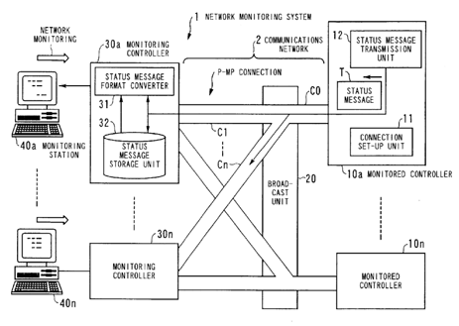

###### Figure 2.2.1: Related works

As we mentioned in other sections, the administrator will be able to control the networks in the system. The administrator does not need to be in the area where this network is located to manage or control these computer networks. It is able to provide system management and control from a remote point. The work [9 ] admin can send messages to LAN networks to provide management of computer networks.

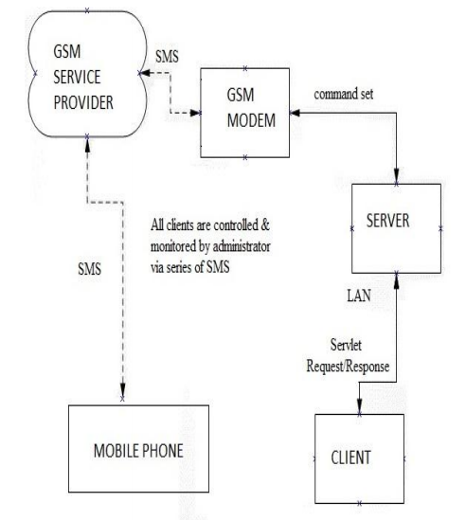

###### Figure 2.2.2: Related works

Managing and monitoring the network devices would be easy and not a challenging task, while being in the main office. However, the challenges and difficulties lie in monitoring and controlling the network remotely , i.e. while being away from the office, as there is a need for third parties in order to collect information on the monitored devices. Therefore, the best way is to use a mobile device in order to access the network remotely and monitor the devices remotely. The proposed system in [10] allows the admin to get detailed information on the network via mobile device.

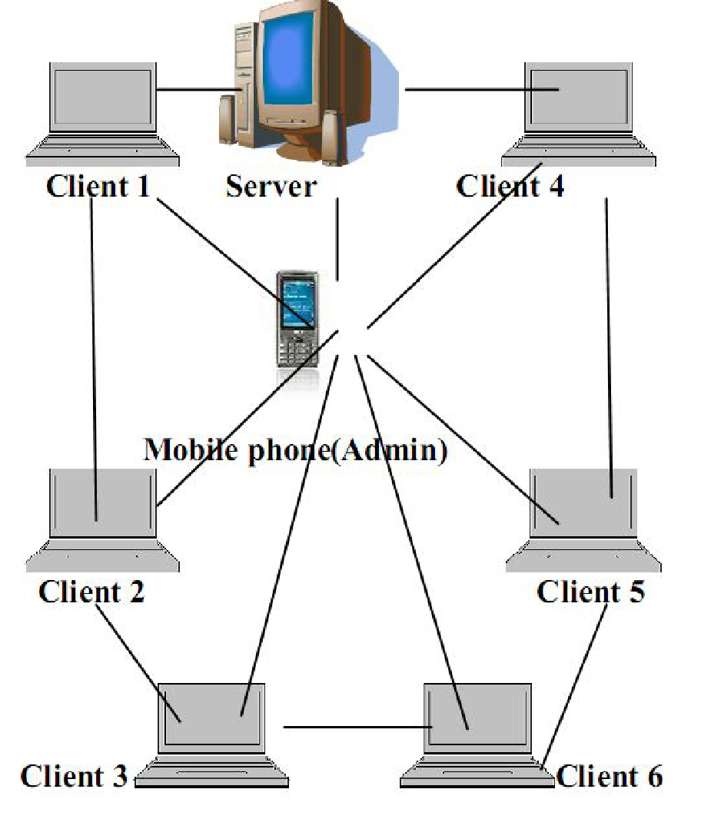

###### Figure 2.2.3: Related works

## **2.3. CONCLUSION**

As a result, we have gained the experience of working on such an application as well as having detailed information about the Mobile based network monitoring system. Although it was a bit tiring, it was a great experience to start our first project in a network management application. Of course, there will be some features that we cannot add in our mobile-based network monitoring application, but we tried to equip our application with the best and useful features we could. For example, there are many features such as get devices list, update network, get network, get overall network health, send messages etc, in our Mobile based network monitoring application. Along with the application development process, we had many experiences such as teamwork and remote project development even during a difficult process such as a pandemic. As a team, we think that we are progressing our project well with good task sharing. For example, our friend, who was keen on design and was interested in this subject, worked on this subject. We learned how to develop our application in the best way and what we should pay attention to in application interface and codes. We gained the ability to create a detailed report about our application. And we believe these gains will be of great use to us in the future.

# **3. SOFTWARE REQUIREMENTS SPECIFICATION**

## **3.1. Introduction**

In this SRS part, we will explain technical details about network management projects. Mobile network monitoring system is a method in which a remote network can be monitored and controlled by a user from anywhere using a mobile based application. LAN (Local Area Network) is a type of computer network that can connect computers in a limited area. To do this, these computers connect to the server. There are some necessary features for this system. For example, this system should be able to transmit and manage data safely and quickly. It should be able to provide dynamic and easy use as a design. This system should be able to support management and control of complex data flow. These intermediaries communicate with each other and thus collect the necessary information so that we can monitor the system. This system will help us when we need to manage the network when we are in a remote area to the LAN. So it will give users some mobility they need.

### **3.1.1. Purpose**

This project allows the user to remotely control the network's activities using a mobile-based application. It will be able to use many different features in a simple way with remote control in this system.

### **3.1.2. Intended Audience And Reading Suggestions**

This document is a guide for mobile network users. you will understand the necessity of this mobile based network monitoring software better with this document. The person responsible for managing this project development process will refer to this document to manage each of this team.

### **3.1.3. Product Scope**

This Project can help anyone who needs to know about the network they’re connected to.

## **3.2. ARCHITECTURAL DIAGRAM OF PROPOSED SYSTEM**

The system is divided into three parts; these are major clients, servers and android phones. The administrator logs into the application only once (it enters pin code to connect to the server). The mobile phone will be sufficient for the administrator to send his request to the server. The message transmitted to the server is recognized by the server ,and the server then recognizes the client machine which the administrator wants to monitor and control. The administrator is equipped with an Android phone GUI based application to send commands instantly. Server sends according to the command received from the Mobile phone to the client like start process, shut down process, kill process, create file , delete file, Process List. If the admin chooses a view feature, namely view client list, then all active clients will be displayed. The clients are connected to the server which in turn is connected to the mobile device.

We have enabled all clients to be controlled and monitored by the administrator. But clients do not control anyone. Only the administrator can give command to the clients. While admin can send commands to clients, clients cannot send commands to the admin. So communication is one-way for clients.

This system allows the administrator to remotely control the LAN with his mobile phone. It will be able to control the system even if he is at the remote place. The administrator also checks the load on the LAN ,so it can shut down the server that creates a load on Lan. If there is any problem on the Client , it will be able to check it with his cell phone.

This situation clearly appears in the diagram below:

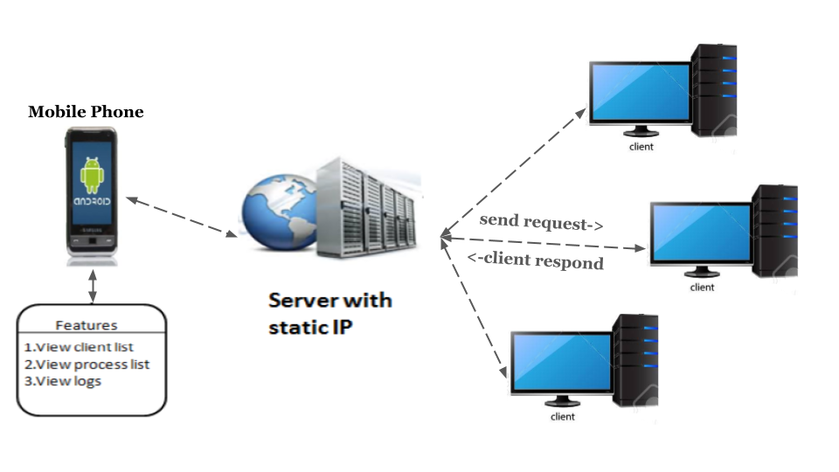

###### Figure 3.2: System architectural scheme

## **3.3. FLOW OF THE APPLICATION**

Once the application runs, the welcome screen will be displayed. This screen shows the logo of the application and the name. The administrator logs into the application only once. It enters pin code to connect to the server. You can now take action on the command screen.

Users can control the LAN network via AT command or using menu driven commands. For example, file transfer function allows clients to get any requested file from the server after checking the rights and conditions by the admin. The admin can control the server remotely and give permissions to transfer specific files.

Shutdown function, allows the admin to shutdown clients who were doing unauthorized access or perform an action that affects the traffic on the network. Therefore, the client’s device will be turned off remotely.

Several operations can be implemented using our proposed system, namely start process, shut down process, broadcast process, process list, delete files process, and create file process. For the purpose of storing data, we are going to use SQLite as a database management system.

The flow of the proposed application is illustrated in the following figure:

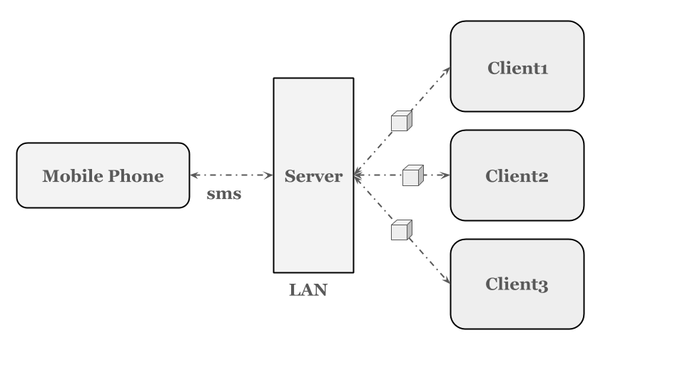

###### Figure 3.3: Application flow

### **3.4.1. Functional (System) Requirements**

This section contains some detailed pieces of information about user requirements, how the system should react to particular inputs, statements of services the system should provide, and how the system should behave in particular situations in terms of system requirements.

#### **3.4.1.1. Net View**

Provides control of the connected PCs in LAN from the mobile. It displays the list of all clients connected to the LAN and active. In case that the client got offline, it will be deleted from the list.

#### **3.4.1.2. Tutorials**

There will be scrollable sections that the user can scroll and see the next tutorial about the application itself in the tutorials page. Application user manual will be available.We think that even adding simple information is necessary for application intelligibility.

#### **3.4.1.3. Process List**

Get and display all the processes that are running on a specific client.

#### **3.4.1.4. Read**

This service allows the admin to browse the drives, folders, files that are located on a specific client or server on the network. And it provides the list of all the processes of the connection monitors in Lan.

#### **3.4.1.5. Open File**

It provides the ability to open the file based on any of the computers or the server machine.You can view a small text with the application on your phone.

#### **3.4.1.6. Broadcast Messages**

You can broadcast messages to clients with a cell phone.

#### **3.4.1.7. New File**

Save the new document you created on the mobile phone to the server or client monitor.

#### **3.4.1.8. Activate Process**

Activate a specific process in a specific device on the network.

#### **3.4.1.9. Controller Panel**

There will be controller panel fields in the login page.It will controls application network system.The basic page of our application is this page.Because the purpose of our application is to control the network

### **3.4.2. Non Functional Requirements**

A non-functional requirement defines usability, effectiveness and the quality attribute of a software system ,so failing to meet non-functional requirements can result in systems useless. This section explains the non-functional requirements.

#### **3.4.2.1. Performance Requirements**

Performance requirements are situations where we can measure system performance briefly. For example, in certain conditions, how well their feedback performs for certain transactions. Examples of these measurements are yield, processing time, response rate, and storage capacity. We will achieve high performance by designing a program compatible with many performance scales such as reliability, robustness, security and usability as well as availability, interoperability, safety, efficiency and flexibility.

#### **3.4.2.2. Reliability**

The whole development process is under TDD (test-oriented development) principles, we will test each module separately to avoid crashes.

#### **3.4.2.3. Security**

Security is the most crucial criteria in the mobile based network system management application.

#### **3.4.2.4. Availability**

Availability can be evaluated by how accessible it is to your system.It can be expressed as a probability percentage.however you may also define it as a percentage of time the system. Availability is important and a must have for many applications.

#### **3.4.2.3. Usability**

Usability means that a user learns to practice and can easily use it.Control and ease of use will be provided for the application to be good in terms of usability. Nobody wants to spend time learning an app.

## **3.5. External Interface Requirements:**

External interface requirements specify hardware, software, or database elements with which a system must interface.These are the parts to be written for the system to communicate properly with external components.

### **3.5.1. User Interfaces:**

It have view client list, view process list ,view log.It have button labels to turn off clients and send messages in the view process list.The screen layout will be simple and understandable.

### **3.5.2. Hardware Interfaces:**

React-native software will be used to make android applications. In addition we will take advantage of android studio and node js library.The database will be used to record data history.

### **3.5.3. Software Interfaces:**

React-native software will be used to make android applications. In addition we will take advantage of android studio ,frameworks ,npm and node js library.

### **3.5.4. Communications Interfaces:**

Network communication protocols will be found as in TCP and IP.Your emails will be in the format of formatting the selected message ,and this right belongs only to the manager.

# 

# 

# 

# 

# **4. SYSTEM DESIGN SPECIFICATION**

## **4.1. System Architecture:**

It is the conceptual model that defines the structure, behavior and formality of this system.

It is a standard description of relationality organized to support logicality about the system's structures and behavior.There are many types.

### **4.1.1. Use case diagram:**

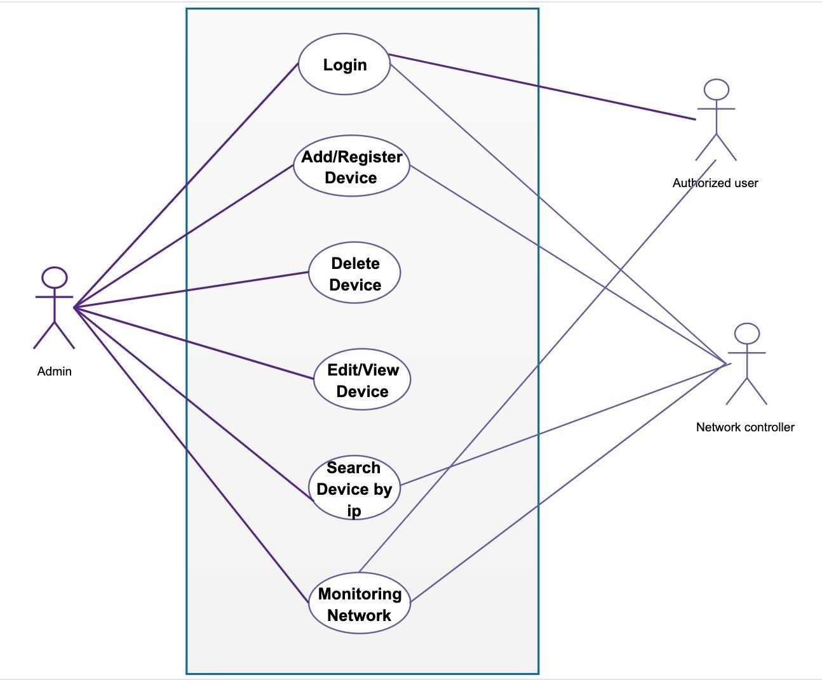

###### Figure 4.1.1: Use case diagram

UML defines the operations that users want to perform on the system through a function. As you can see in the use case diagram, our Mobile Based Network Monitoring System has many features for user convenience and ease of use.

### **4.1.2. Class diagram:**

As seen, in the class diagram of the Mobile based monitoring system, the relationships between the classes in the software are designed in this way.

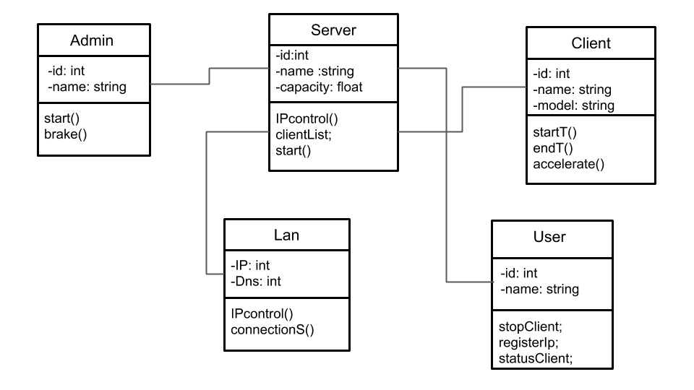

###### Figure 4.1.2: Class diagram

### **4.1.3. Flow chart of the system:**

Our flow chart for our project is a solution to many complex problems such as managing, documenting, designing and analyzing processes and applications in various fields in our application.

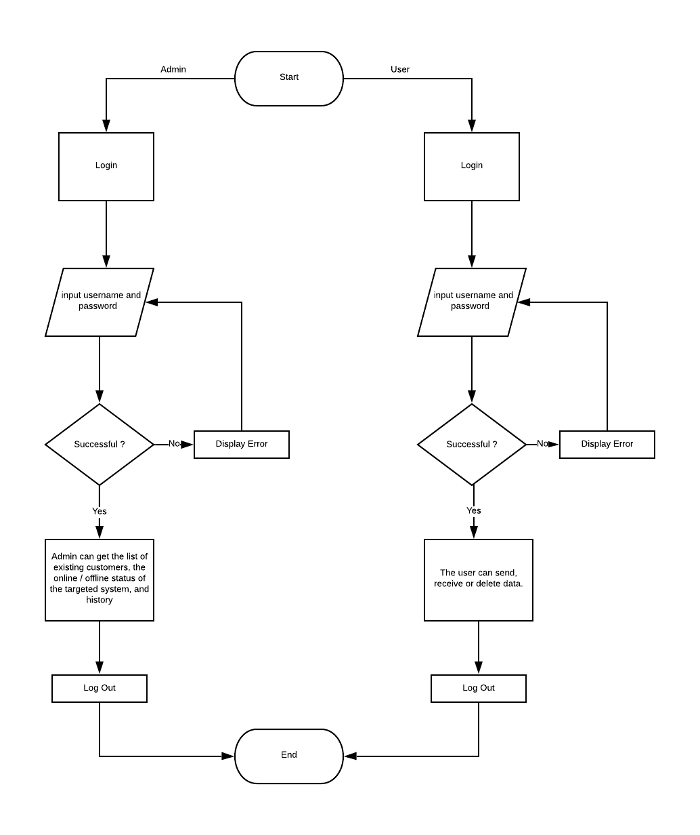

###### Figure 4.1.3: Flow chart of the system

### 

### **4.1.4. ER diagram:**

We drew the ER (entity relationship model) diagram of your project with a modeling technique that shows real life objects and their relationships.

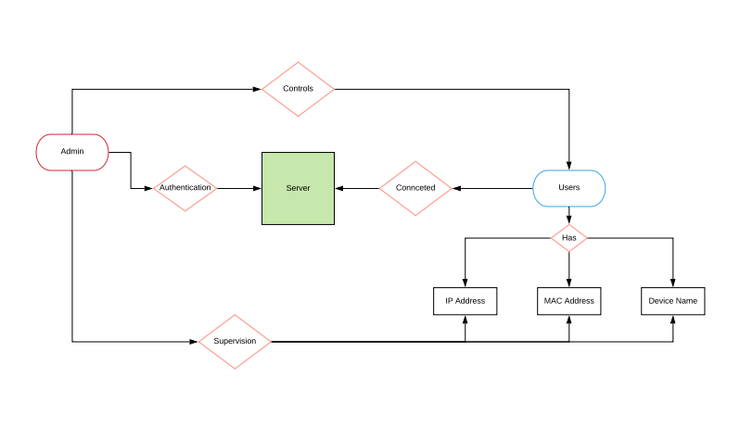

###### Figure 4.1.4: ER diagram

### **4.1.5. Sequence diagram:**

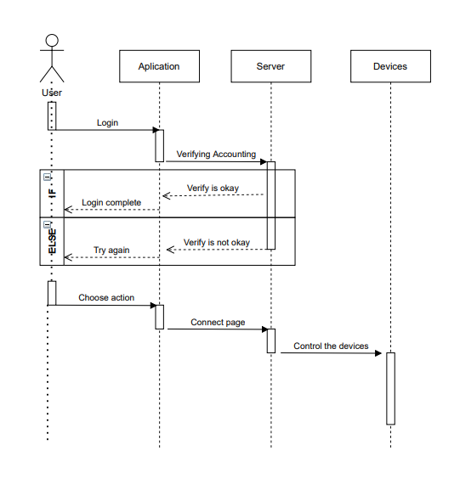

###### Figure 4.1.5: Sequences diagram

## **4.2. Overview of the Mobile Based Network Monitoring System**

The purpose of our project is to control and monitor the network using mobile phones from anywhere we have Access to the internet.



###### Figure 4.2: Overview of the Mobile Based Network Monitoring System

## **4.3. Mockup modeling for the application design:**

As you can see below, our mockup models are drawn by taking into consideration ease of use and functionality.

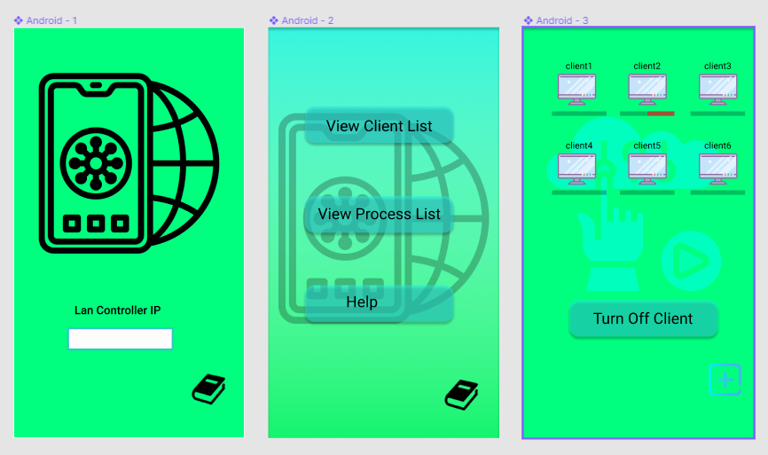

###### Figure 4.3.0: Mockup modelling

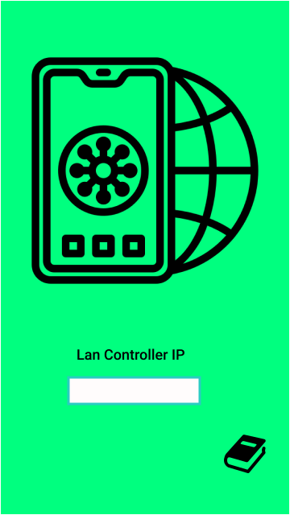

###### Figure 4.3.1: Mockup modelling

Our login screen application allows us to connect to the LAN. You only need to make this login link once.

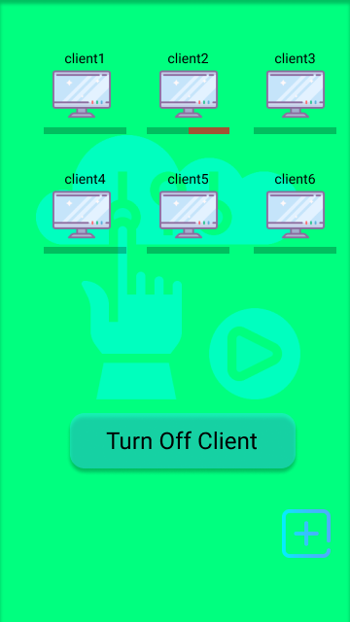

###### Figure 4.3.2: Mockup modelling

On this screen, we can select the user we want to close and end his task easily. If there is a new client that we want to add to the LAN, we can save it with the addition button.

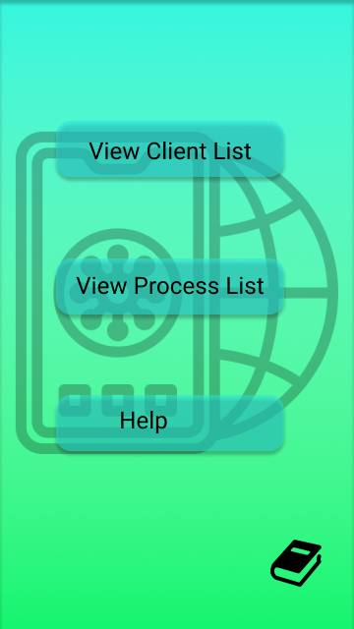

###### Figure 4.3.3: Mockup modelling

This page is our function screen in general, we can say on the main screen. With this screen we can view the client list , process list, or can receive help. For example, when clicking on the view client list button will send you directly to the client list.

## **4.4. Mobile Application Interfaces**

Interfaces in our application are designed in the most useful way.

### **4.4.1. Login Page Interface**

When we first open the application, the login screen will appear.If you registered, you can login with your username and password, if you don't register, you can easily register with the register button.

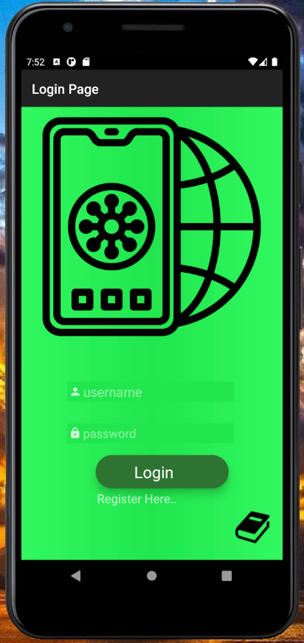

###### Figure 4.4.1: Login Page Interface

### **4.4.2. Main Page Interfaces**

We have buttons such as devices, topology, users, and network setting on our homepage. You can choose according to the process you want to do.

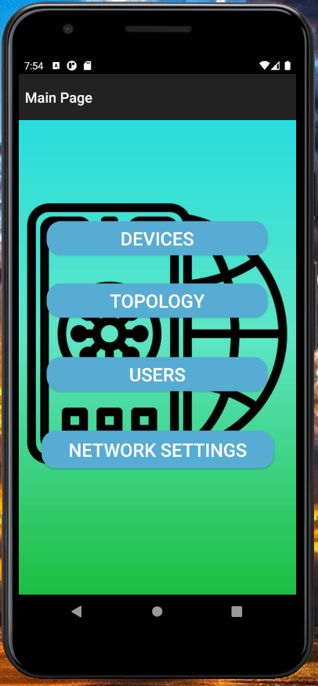

###### Figure 4.4.2: Main Page Interfaces

### **4.4.3. Devices Page Interfaces**

On the Devices screen, you can find the operations you want to do about the device.

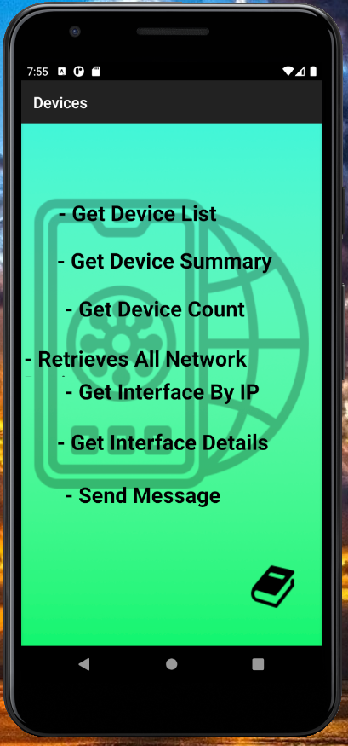

###### Figure 4.4.3: Devices Page Interfaces

### **4.4.4. Topology Page Interfaces**

You can control overall network health on this page.

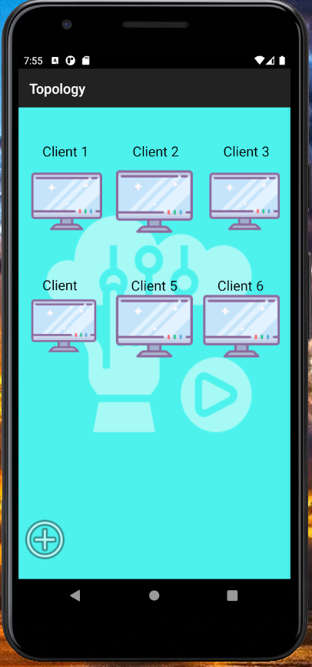

###### Figure 4.4.4: Topology Page Interfaces

### **4.4.5. Users Page Interfaces**

On this page, you can access user settings such as adding and deleting users.

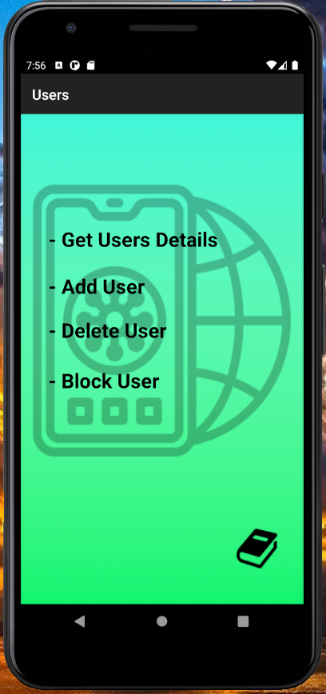

###### Figure 4.4.5. Users Page Interfaces

### **4.4.6. Network Settings Page Interfaces**

You can use this page for network settings.

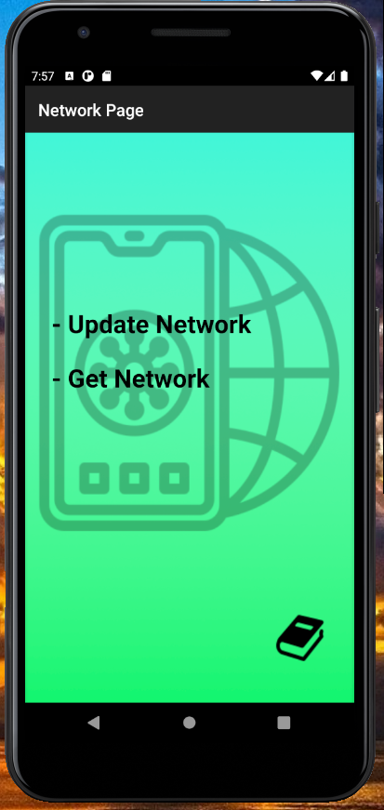

###### Figure 4.4.6: Network Settings Page Interfaces

You can learn the parts you do not understand from the tutorials in the lower right corner of each page.

# **References**

1. Network monitoring system, monitored controller, and monitoring controller (Kazuhiro NakashimaShigeru Nakagawahara)
2. Mobile Based LAN Monitoring And Control, Prof. P.S. Dhotre, Anuradha Kadam, Pooja Satav & Vishakha Salunkhe
3. GSM Based LAN Monitoring System, Bhawesh Chavan ,Omkar Salgaonkar, Akshay Deokar , Suresh Choudhary
4. Network monitoring system, monitored controller, and monitoring controller , Kazuhiro Nakashima; Shigeru Nakagawa Hara, both of Fukuoka (JP)
5. Network monitoring system and method ,Ghobad Heidari-Bateni, San Diego, CA (US)
6. Network monitoring system with build-in monitoring data gathering , Richard C. Walker, Palo Alto, CA (US); Bharadwaj Amrutur, Santa Clara, CA (US); Peter Mottishaw, West Lothian (GB); C. Steven Joiner, Cupertino, CA (US); Larry A. Chesler, Loveland, CA (US); Ian Hardcastle, Sunnyvale, CA (US)
7. Network management system , Jerry W. Sprecher Donald J. Winters , Jr. Amirali S. Rajwany Michael W. DodsonGene R. PenningDarryl F. Harrington Smon Chou
8. Mobile based network monitoring system , D.Gavalasa D.Greenwoodb M.Ghanbaria
9. Methods and system for use in network management of content , Allan B. Lamkin Gregory I. Gewickey Todd R. Collart
10. Mobile communications network monitoring systems , Jeffrey Blair Atkins Robert William Albert Dobson Simon Bone
11. Artificial intelligence ,Gheorghe Tecuci Learning Agents Center and Computer Science Department George Mason University, Fairfax, VA 22030
12. Android Based LAN Monitoring System ,Karishma Gidge , Kalyani Patil, Priyanka Wadnere