W272 Notes:

- When State Machine is used, it may cause undesirable situations, which may cause the state machine to not be active again or to receive incorrect values.
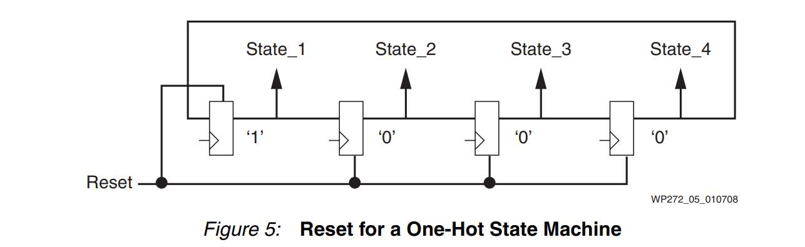
- In circuits that use feedback (e.g., state machines or IIR filters), the reset needs to be carefully managed.
- It is pointless to use reset in circuits without feedback because the system becomes stable after a few clock pulses.
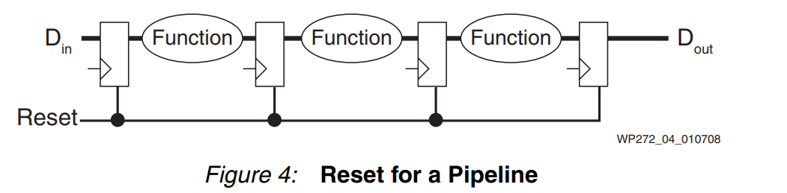

- In circuits operating in different clock domains, failure to release the reset simultaneously may cause metastability problems.
- A local, synchronous reset network should be used only for the necessary flip-flops.

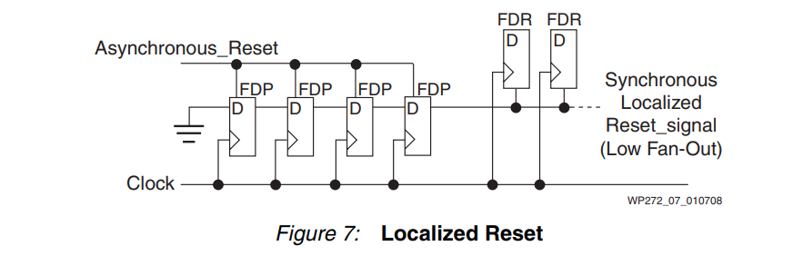
- It causes the use of more resources than should normally be used.
- Global reset is not required on Xilinx FPGAs. After configuration, the flip-flops and RAMs are already in the correct initial state.

