Section 8 : Names

Section 8.1 General

- Names in VHDL are used to define objects, values, methods, or attributes and can be explicitly or implicitly declared.

- Types of names: Simple names, selected names, indexed names, slices, and attribute names.

- Prefix: Can be a name or a function call. If the prefix is a function call, it refers to an element, slice, or attribute of the function result.

- Static names: Fully determined during compilation, such as an array with a fixed index.

- Non-static names: Contain values that can change over time, like an index defined by a signal.

- Static prefix: The longest static part of a non-static name.

- Ambiguous names cause compilation errors. Using null access values in function calls is invalid.

- Examples:
  - array(2) is static
  - array(index) is dynamic
  - record.element is a selected name.

Section 8.2 Simple Name

- Simple name in VHDL is an identifier that refers to an entity, configuration, package, procedure, function, or architecture as defined in their declaration. It serves only to identify the entity without any additional effects.
- Alias in VHDL is a shorthand or alternative name for an existing object, such as a signal, variable, type, or subprogram. It allows easier access or more descriptive naming for parts of a design.

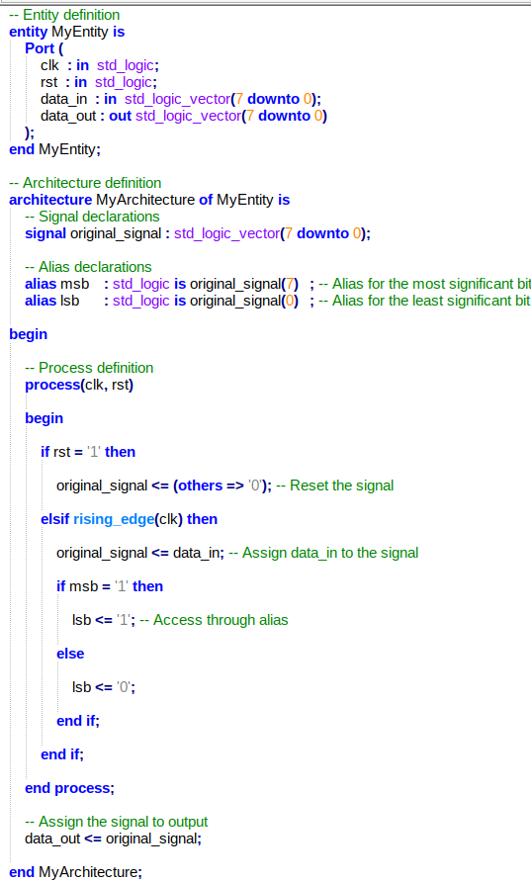

Section 8.3 Selected Name

- Selected name in VHDL is used to reference a named entity defined
  - In another named entity : record, package etc.
  - In a design library

- Selected name fallows the syntax : selected_name ::= prefix.suffix

  - Prefix, Indicates the container (e.g., a library, package, record, or access type).
  - Suffix, Indicates the specific item (e.g., a field in a record, all elements in a package).
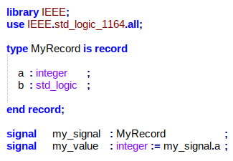
Section 8.4 Indexed Names

- indexed name denotes an element of an array.
  - indexed_name ::= prefix ( expression { , expression } )

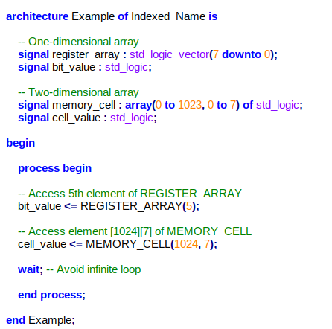

Section 8.5 Slice Names

- Slice name refers to a subset of consecutive elements from a one-dimensional array. It is defined by a prefix (the array) and a discrete range (the index range). The slice can have an ascending or descending range, and it inherits the base type of the array.

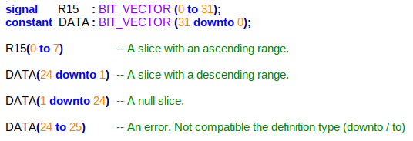
Section 8.6 Attribute Names

- In VHDL, attribute names are used to access specific properties of named entities, such as signals, constants, or types. They provide useful details like the size of an array, the left most index of an array, or the path of a signal.
  - Predefined Attributes: These include attributes like 'LEFT, 'PATH_NAME, and 'DELAYED, which return details like the leftmost index of an array, the path of a signal, or a delayed signal value.

  - Aliases: Attributes can also be used with aliases. The alias refers to the attributes of the original entity.

  - Function Attributes: These attributes return values based on functions, such as the size of an array.

Section 8.7 External Names

- External name refers to an object declared in a design hierarchy. It can represent a constant, signal, or variable declared outside the current scope but within a reachable region. The object is identified by an external pathname, which can be an absolute, relative, or package pathname. An external name allows referencing external constants, signals, or variables in VHDL designs, ensuring that objects can be accessed from different parts of the design hierarchy. If an object does not match the specified type or is not found in the designated region, it results in an error.

Section 12 : Scope and Visibility

Section 12.1 Declerative Region

  - Declarative region defines where a declaration (signal, variable, function, etc.) is valid.
- In nested regions, the innermost region takes precedence.

Structures Treated as a Single Declarative Region
- Entity + Architecture
- Subprogram (Function/Procedure)
- Package (Declaration + Body)
- Process, Loop, Block, Generate
- Record and Protected Types

Root Declerative Region
- Encompasses the fundamental units of a design.
- Contains no declarations initially.

Library Declerative Region
- Each library forms its own declarative region.
- Units within the library are accessible from this region.

Continuity of Text
- The declaration and its body, even if separated in the text, are considered part of the same declarative region.

Section 12.2 Scope of Declerations

Scope Definition
The scope of a declaration is the part of the code where its name (signal, variable, constant, etc.) is valid.

Immediate Scope
A declaration is valid within its enclosing block or region.
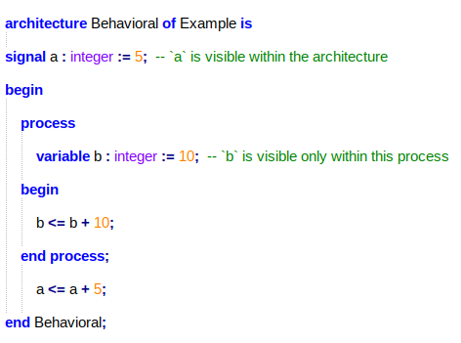

Extended Scope
Some declarations, such as package contents, generics, and ports, extend beyond their immediate scope into configurations or library usage.

Library and Configuration Scope
Declarations in libraries or configurations can extend their scope to other parts of the design using use clauses or configurations.

Section 12.3 Visibility
Direct Visibility:
A declaration is directly visible within its immediate scope unless it is hidden by a homograph in an inner scope.
Visibility by Selection:
A declaration is visible through selection when referenced using a prefix (e.g., library name, package name, or hierarchical name).
Hidden Visibility:
A declaration is hidden if a homograph exists in an inner scope or due to specific rules (e.g., subprograms hiding their own names or predefined operations being overridden).
Extended Visibility:
Visibility extends to configurations and block configurations under certain conditions, such as use clauses or associations in port and generic mappings.

Section 12.4 Use Clauses
The use clause in VHDL is used to make specific declarations from a package or library visible in the current design unit's scope. It allows selecting individual declarations or all declarations (use <package_name>.all). The visibility starts immediately after the use clause and extends to the end of the current declarative region. However, a declaration may be hidden by homographs (declarations with the same name) within the same scope. Explicit declarations take precedence over implicit ones, and the use clause cannot make declarations from an uninstantiated package visible.

Section 12.5 The Context of Overload Resolution
Overload resolution determines the correct interpretation of overloaded entities (such as names, subprograms, or operator symbols) when multiple meanings are possible due to visibility rules. It considers all visible declarations, and the occurrence is legal only if there is exactly one interpretation in the context. The rules applied during overload resolution include syntax, scope, visibility, and type compatibility, among others. For overloaded subprograms, the resolution also takes into account parameter types and result types.

Section 13 : Design Units and Their Analysis

Section 13.1 Design Units

In VHDL design, there are two main types of design units: primary units, such as entity, package, configuration, and context, and secondary units, such as architecture and package body. Each design unit is analyzed independently and stored in a design library, where naming rules ensure uniqueness. Specifically, each primary unit within the same library must have a unique name, and every architecture associated with a given entity must also have a unique name to avoid conflicts.
A critical component of design units is the context clause, which specifies the required libraries and packages. However, for context declarations, the context clause must remain empty. Additionally, secondary units, such as architecture, are always linked to their corresponding primary units, such as entity, and this relationship is verified during the analysis process.
These rules ensure proper organization, reusability, and error-free compilation of VHDL designs, making them fundamental for successful hardware description.

Section 13.2 Design Libraries

In VHDL, design libraries store analyzed units and are categorized into working libraries (for storing units) and resource libraries (referenced during analysis). Libraries are defined using a library clause like library ieee, work;. The STD and WORK libraries are implicitly included in each design unit. Logical names like STD refer to specific libraries, and secondary units must be placed in the same library as their corresponding primary units, ensuring proper organization.

Section 13.3 Context Decleration

Context declaration is used to define library and use clauses that can be reused across design units. The name in the declaration must be the same at both the beginning and the end. Additionally, it is an error to define or reference the WORK library within a context. This structure helps maintain clean and reusable code.

Section 13.4 Context Clauses
Context clauses in VHDL define the environment (libraries and visibility rules) in which a design unit is analyzed. They consist of library clauses, use clauses, and context references.
Library clauses specify logical library names to be referenced.
Use clauses make specific declarations visible within the design unit.
Context references refer to other context declarations and expand their contents (libraries and use clauses) into the current context.

Section 13.5 Order of Analysis
A primary unit referenced in a design unit must be analyzed before the design unit itself.
A secondary unit must be analyzed after its corresponding primary unit.
If an error occurs during the analysis of a design unit, the analysis is rejected and does not affect the current working library.
A library unit is affected by changes in any referenced library unit.
A secondary unit is affected by changes in its primary unit.
If a library unit is changed (e.g., through reanalysis), all dependent units become obsolete and must be reanalyzed before use.

Section 15 : Design Units and Their Analysis
Section 15.2 Character Set
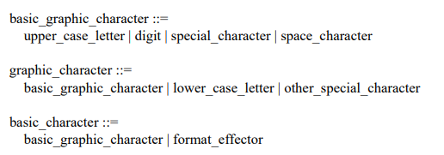

The basic character set is sufficient for writing any description.
The usable characters are same the VHDL2002.

Section 15.3 Lexical elements, separators, and delimiters
Lexical Elements:
Includes delimiters, identifiers (reserved words included), literals (abstract, character, string, or bit-string), comments, and elements defined for tool directives or PSL (Property Specification Language).
PSL (Property Specification Language) is a formal language defined in IEEE Std 1850 used to describe the behavior and properties of hardware designs. It enables specifying and verifying functional requirements, often in simulation or formal verification tools. PSL is compatible with multiple hardware description languages (e.g., VHDL, Verilog) and ensures a design meets its intended specifications.
The delimiter is either one of the special characters(VHDL2019) :
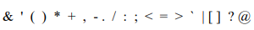

The delimiter is either one of the special characters(VHDL2002) :
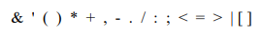
The compound delimiter is either one of the special characters(VHDL2019) :
The compound delimiter is either one of the special characters(VHDL2002) :

Section 15.4 Identifiers
In VHDL 2019, an identifier is a name used to represent objects like variables, signals, constants, processes, or entities. It must follow these rules:
Basic Identifiers:
Start with a letter (A-Z, a-z)
Contain only letters, digits (0-9),and underscores (_)
Cannot end with an underscore or have consecutive underscores
Reserved keywords cannot be used
Extended Identifiers:
Enclosed in backslashes (\) for special characters or reserved keywords
Can include spaces, symbols, or VHDL keywords
Case sensitive (\Signal\ ≠ \SIGNAL\)

Section 15.5 Abstract Literals

In VHDL-2019, abstract literals are general numerical expressions that are independent of type and are converted to an appropriate data type based on context.
- Decimal literals include integers and floating-point numbers in base 10.
- Based literals are written in a format specifying a base and value but support only integer values.

Section 15.6 Character Literals

In VHDL, a character literal represents a single character enclosed in single quotes (') and can include any of the 191 printable ASCII characters, such as letters, digits, symbols, the space, and the nonbreaking space. The single quote character itself is represented as ''''. Character literals belong to the character type and are used to define single characters in constants, variables, or signals.

Section 15.7 String Literals

In VHDL, a string literal is a sequence of characters enclosed in double quotes (").
To include a double quote inside, use two adjacent double quotes ("").
The length is the number of characters, counting doubled quotes as one.
String literals are used for messages, text processing, or initializing character arrays.

Section 15.8 Bit String Literals

A bit string literal in VHDL is a sequence of characters enclosed in quotation marks, preceded by a base specifier (e.g., B, O, X) and optionally an integer specifying the length.
It represents a bit value with digits (0-1 for binary, 0-7 for octal, 0-F for hexadecimal) and may include underscores for readability.
The base specifier determines how the digits are interpreted (binary, octal, hexadecimal, etc.).
The value of a bit string literal is a string formed from the bit value, removing underscores and expanding the bits as needed.

Section 15.9 Comments

In VHDL, comments can be single-line (--) or delimited (/* ... */).
Comments do not affect the validity of the VHDL description and are used solely for documentation purposes.

Section 15.10 Reserved Words

List of reserved words that were introduced in VHDL-2019, which are not part of VHDL-2002:

procedural
Introduced for more control over processes and procedural aspects in VHDL-2019. It provides additional flexibility when defining and managing procedural blocks.

reference
Added in VHDL-2019 to work with reference types. It allows for referencing objects or data structures directly without copying, improving memory management and performance, particularly for complex data types.

vmode, vprop, vunit
These are simulation-related keywords introduced in VHDL-2019, allowing greater flexibility for specifying simulation modes, properties, and units of measurement.

Section 23 : VHPI Function Reference

Section 23.1 General

VHPI functions define the required arguments, the operations they perform, and the results they return. These functions typically return a pointer to a string or a structure.

The returned data can be either permanent or transient. Permanent data is securely stored in memory and can be referenced later using a pointer. Transient data, however, is preserved only until the next call to the same function or until the control thread returns to the tool, after which it may be overwritten.

If transient data is needed for a longer period, the VHPI program must copy the data. Additionally, strings are represented as null-terminated character arrays. These details are critical for understanding and correctly implementing the data management rules of VHPI functions.

Section 23.2 vhpi_assert

The vhpi_assert function is used to report error messages, similar to the report statement in VHDL. The severity argument specifies the severity level of the error, while formatmsg defines the message content using the C printf format.

The function returns 0 if it executes successfully or 1 if an error occurs. If the severity level is critical, such as VHPI_FAILURE, the simulation may stop.

vhpi_assert(VHPI_FAILURE, "Error: Signal 'clk' is not '1'.");
This function makes it easier to detect and report errors during simulation.

Section 23.3 vhpi_check_error

The vhpi_check_error function checks if the previous VHPI function call raised an error. If an error occurred, it returns error information in the structure pointed to by the error_info_p argument. This structure includes details such as the error severity, message, associated VHDL source file and line number, and other implementation-specific information.
If no error occurred, the function returns 0. If an error occurred and error_info_p is not NULL, the error information is written into the structure, and the function returns 1. The memory for the error information structure must be allocated by the VHPI program before calling the function.

int vhpi_check_error(vhpiErrorInfoT *error_info_p);
This function checks if the previous VHPI function call resulted in an error. It fills a provided vhpiErorInfoT structure with error details if an error occurred, or returns 0 if no error occurred.

Section 23.4 vhpi_compare_handles

The vhpi_compare_handles function compares two VHPI handles (handle1 and handle2) to check if they refer to the same object. Since handles may have different representations, the == operator cannot be used for comparison.

The vhpi_compare_handles function returns 1 if the two handles refer to the same object, and 0 if they refer to different objects.

Section 23.5 vhpi_control

The vhpi_control function is used to request specific control actions from the VHPI tool. These actions include stopping, finishing, or resetting the simulation. The first argument specifies the desired action, while additional arguments provide any extra details needed by the tool.
If the command is vhpiStop, the simulation stops after the current operation and waits for further user directives. For vhpiFinish, the tool transitions to the termination phase, ending the simulation. The vhpiReset command resets the simulation state entirely. If a command outside these three is given, the tool performs an implementation-defined action.
The function can only be used during the simulation phase for the commands vhpiStop, vhpiFinish, and vhpiReset. If called outside this phase, or if the requested action is unsupported, the function raises an error. Additional arguments are optional; if omitted, the tool performs a default action.
The return value indicates success or failure: 0 for a successful operation and 1 for an error. Errors may also occur if multiple control actions are queued, but the order of execution remains implementation-defined.

Below is an example of usage, where the vhpi_control function is called with the vhpiFinish command to end the simulation:
void user_app() {
// Perform operations
...
vhpi_control(vhpiFinish); // End the simulation}
Section 23.6 vhpi_create

The vhpi_create function creates objects (processStmt, driver, driverCollection, anyCollection) or appends objects to collections based on the kind argument and provided handles.

For vhpiProcessStmtK, it creates a processStmt linked to an archBody with IsForeign=True.For vhpiDriverK, it creates a driver for a basicSignal, optionally linked to a processStmt.For vhpiDriverCollectionK, it creates or updates a driverCollection with drivers or collections specified by handle2. For vhpiAnyCollectionK, it creates or updates an anyCollection with objects or collections referenced by handle2.

The function returns a handle to the created/updated object or NULL on error. Errors occur outside supported phases, with conflicting drivers, or incompatible driverCollection elements.

Section 23.7 vhpi_disable_cb

The vhpi_disable_cb function is used in VHPI programs to prevent the execution of a callback function. When a specific trigger event occurs, the callback function is disabled and will not execute. This function is used to prevent unnecessary callback executions and helps control the simulation flow.

int vhpi_disable_cb(vhpiHandleT cb_obj);
If the object referred to by the cb_obj argument is an enabled callback, the function disables it, thus preventing execution of the callback function when the callback trigger event occurs.

Section 23.8 vhpi_enable_cb

vhpi_enable_cb enables a previously disabled callback. It allows the callback function to execute when the trigger event occurs. It takes a handle (cb_obj) to the callback object. It returns 0 if successful, or 1 if there is an error. If the callback is already enabled or mature, it does nothing and raises a vhpiWarning.

int vhpi_enable_cb (vhpiHandleT cb_obj);
If the object referred to by the cb_obj argument is a disabled callback, the function enables it, thus allowing call of the callback function when the callback trigger event occurs.

Section 23.9 vhpi_enable_cb

The vhpi_format_value function is used to convert the format of a value. The input value (in_value_p) is converted to the specified format, and the output value (out_value_p) stores the result. If the result is a scalar, it is written to the value member of the output structure. If the result is an array, string, or custom representation and value is NULL, the function does not write the value but returns the required memory size.

For physical or time values, a scale factor is added to the unit member of the output structure. The function returns 0 if the conversion is successful. If the result requires an array or string format, the required memory size is returned. If the conversion is not possible, a negative value is retuned.

The function raises an error if either the input or output structure is NULL or if the conversion cannot be performed.

Section 23.10 vhpi_get

The vhpi_get function retrieves the value of an integer or Boolean property of an object. The property argument specifies the property, and the object argument refers to the object containing the property. The function returns the value of the specified property; if it cannot be read, it returns vhpiUndefined. In some cases, error checking with vhpi_check_error may be required.

vhpiIntT vhpi_get(vhpiIntPropertyT property, vhpiHandleT object);

Section 23.11 vhpi_get_cb_info

The vhpi_get_cb_info function retrieves information about a registered callback. The object parameter is a handle to the callback object, and the cb_data_p parameter is a pointer to a callback data structure. The function fills the structure with information about the callback, similar to the data provided during registration. It returns 0 if successful, or 1 if there is an error.

Section 23.12 vhpi_get_data

size_t vhpi_get_data(int32_t id, void * dataLoc, size_t numBytes);

The vhpi_get_data function reads saved data during the restart phase. The id parameter specifies the identifier for the saved data set, while the dataLoc parameter is the memory address where the read data will be written. The numBytes parameter indicates the number of bytes to read.

The function reads up to numBytes from the saved data set and writes them to the memory location specified by dataLoc. If there is insufficient data, the remaining space is filled with zeros. The function returns the number of bytes actually read.

This function can only be called during a vhpiCbStartOfRestart or vhpiCbEndOfRestart callback. An error is raised if the id is invalid or if there is a reading issue.

Section 23.13 vhpi_get_data

int vhpi_get_foreignf_info (vhpiHandleT hdl, vhpiForeignDataT *foreignDatap);

The vhpi_get_foreignf_info function retrieves information about a foreign model or application. It takes a handle (hdl) to the foreign object and a pointer to a data structure (foreignDatap). The function populates the structure with details like the type of object, elaboration and execution function pointers, and model/application name. It returns 0 on success or 1 on error. Errors occur if the foreign model or application isn't properly registered or bound.

Section 23.14 vhpi_get_next_time

int vhpi_get_next_time (vhpiTimeT *time_p);

The vhpi_get_next_time function retrieves the time of the next simulation cycle. It returns vhpiNoActivity if there is no activity, otherwise, it returns the time value. It can only be used during the simulation phase.

Section 23.15 vhpi_get_phys

vhpiPhysT vhpi_get_phys (vhpiPhysPropertyT property, vhpiHandleT object);

The vhpi_get_phys function retrieves the value of a physical property of an object. The property parameter specifies the physical property to be read, while the object parameter represents the object that has the corresponding physical property. The function returns the value of the property. If the property cannot be read, it returns an unspecified value.
Section 23.16 vhpi_get_real

vhpiRealT vhpi_get_real (vhpiRealPropertyT property, vhpiHandleT object);

The vhpi_get_real function retrieves the real (floating-point) property value of an object. The property parameter specifies the real property to be read, while the object parameter refers to the object that has the corresponding property. The function returns the value of the property. If the property cannot be read, it returns an unspecified value.

Section 23.17 vhpi_get_str

const vhpiCharT * vhpi_get_str (vhpiStrPropertyT property, vhpiHandleT object);

The vhpi_get_str function retrieves the value of a string property of an object. The property parameter specifies the string property to be read, and the object parameter refers to the object that has the corresponding property. The function returns a pointer to the string representing the value of the property. If the property cannot be read, it returns NULL.

Section 23.18 vhpi_get_time

void vhpi_get_time (vhpiTimeT *time_p, long *cycles);

The vhpi_get_time function retrieves the current simulation time and, optionally, the number of delta cycles. The time argument stores the simulation time, and the cycles argument stores the number of delta cycles that have occurred. If time is NULL, only the cycle count is retrieved, and if both arguments are provided, both values are filled. The function must be called during the initialization or simulation phases, and an error occurs if both arguments are NULL.

Section 23.19 vhpi_get_value

int vhpi_get_value (vhpiHandleT expr, vhpiValueT *value_p);

The vhpi_get_value function retrieves the formatted value of an object, given a handle to that object (expr). The result is stored in a value structure, where the format is specified. The function can handle scalar values or arrays, strings, and other internal representations. If necessary, it can also allocate storage for the value. The return value is either 0 (if the operation completes successfully), the required storage size, or a negative integer if an error occurs. Errors may include invalid access permissions, incorrect format, or insufficient storage for arrays or strings.

Section 23.20 vhpi_handle

vhpiHandleT vhpi_handle (vhpiOneToOneT type, vhpiHandleT referenceHandle);

The vhpi_handle function retrieves a handle to the target object in a one-to-one association. The type argument specifies the association role, and the referenceHandle argument is the handle to the reference object. If the association has a target object, the function returns a handle to the target object; otherwise, it returns NULL. This function is used to navigate object relationships in VHDL design hierarchy.

Section 23.21 vhpi_handle_by_index

vhpiHandleT vhpi_handle_by_index (vhpiOneToManyT itRel, vhpiHandleT parent, int32_t indx);

The vhpi_handle_by_index function is used to access a target object in an ordered one-to-many association. The itRel parameter specifies the type of the association, while the parent parameter represents the reference object in the association. The indx parameter indicates the index of the target object within the one-to-many association. If there are more target objects than the specified index, the function returns a handle to the target object at that index; otherwise, it returns NULL.

Section 23.22 vhpi_handle_by_name

vhpiHandleT vhpi_handle_by_name (const char *name, vhpiHandleT scope);

The vhpi_handle_by_name function retrieves a handle to an object identified by its name. The function uses a search string to locate an object that has the FullName property matching the search string. It allows for case-insensitive searches unless the string contains an extended identifier. The scope argument defines the search context, either a specific region or lexical scope, or NULL to search the entire library or design hierarchy.
If the search string is an absolute library or design hierarchy search string, the search is limited to a specific region or hierarchy. If it's a relative search string, the function modifies the search based on the scope's FullName property. If multiple objects match the search, the result may be ambiguous. The function returns a handle to one object or NULL if no match is found or if the search is ambiguous.

Section 23.23 vhpi_is_printable

int vhpi_is_printable( char ch )

The vhpi_is_printable function checks whether the character code of the given ch argument represents a graphic character. It returns 1 if the character is a graphic character, and 0 otherwise.

Section 23.24 vhpi_iterator

vhpiHandleT vhpi_iterator (vhpiOneToManyT type, vhpiHandleT referenceHandle);

The vhpi_iterator function creates an iterator for a one-to-many association. It takes a type argument, which defines the association role, and a referenceHandle argument, which refers to the reference object in the association. If the association has target objects, the function initializes an iterator that points to the first element and returns a handle to the iterator object. If no target objects exist, it returns NULL. In an ordered association, the elements in the iterator are arranged in the same order as the target objects.

Section 23.25 vhpi_printf

int vhpi_printf (const char *format, ...);

The vhpi_printf function writes a formatted message to one or more tool output files. It takes a format string and additional arguments, similar to the C printf function. The function formats the string based on the format and arguments, then writes it to the output file(s). The number of characters written is returned, or -1 if an error occurs.

Section 23.26 vhpi_protected_call

int vhpi_protected_call (vhpiHandleT varHdl, vhpiUserFctT userFct, void *userData);

The vhpi_protected_call function is used to execute a function on a shared variable of a protected type with exclusive access. It takes a handle to the variable (varHdl), a pointer to the function (userFct), and optional user data (userData). The function ensures that exclusive access to the variable is secured before calling the user-defined function, passing the variable handle and user data as arguments. After the function execution, the exclusive access is released. The function returns the value returned by the user-defined function. Accessing the protected variable outside this function call is considered erroneous.

Section 23.27 vhpi_put_data

size_t vhpi_put_data (int32_t id, void * dataLoc, size_t numBytes);

The vhpi_put_data function saves data during the tool's save phase. It takes an identification number (id), a pointer to the data location (dataLoc), and the number of bytes to save (numBytes). The function writes the specified number of bytes from dataLoc to a saved data set identified by id. If called multiple times with the same id, data is written sequentially after the previous write. This function must be called during the save phase and returns the number of bytes actually written or 0 if the write fails. Using an invalid id or calling it outside the save phase is an error.

Section 23.28 vhpi_put_value

int vhpi_put_value (vhpiHandleT object, vhpiValueT *value_p, vhpiPutValueModeT mode);

The vhpi_put_value function is used to update the value of an object or provide the return value of a foreign function call. It takes three arguments: object, which is a handle to the object to be updated; value_p, a pointer to a value structure specifying the new value; and mode, which defines how the update is performed. The function updates the object value according to specific rules. It returns 0 if the operation is successful, or a non-zero value if an error occurs. Errors can occur if the object cannot be updated, if the mode is inappropriate, or if the function is called at an incorrect time in the simulation cycle.

Section 23.29 vhpi_register_cb

vhpiHandleT vhpi_register_cb (vhpiCbDataT *cb_data_p, int32_t flags);

The vhpi_register_cb function registers a callback function with the VHPI tool. It takes two arguments: cb_data_p, a pointer to a callback data structure containing callback information, and flags, which specifies how the callback should be registered.

The function handles two callback flags: vhpiReturnCb, which determines whether the function returns a handle to the registered callback, and vhpiDisableCb, which controls whether the callback is enabled or disabled. If the callback is disabled, the function can later be enabled by using the returned handle.

The function returns a handle to the registered callback or NULL if the callback isn't registered. Errors occur if an unsupported callback reason is used. The tool doesn't retain references to the callback data after registration.

Section 23.30 vhpi_register_foreignf

vhpiHandleT vhpi_register_foreignf (vhpiForeignDataT *foreignDatap);

The vhpi_register_foreignf function registers a foreign model or application using a foreign data structure. It specifies the type of foreign object (e.g., architecture, function, or application) and provides necessary functions for elaboration and execution. The function returns a handle to the registered foreign object or NULL if an error occurs. Errors can happen if the function is called outside the registration phase or with an invalid kind value.

Section 23.31 vhpi_release_handle

int vhpi_release_handle (vhpiHandleT object);

The vhpi_release_handle function releases a handle that refers to an object. It takes a handle as an argument and frees it. The function returns 0 if the operation is successful or 1 if an error occurs. In the example, it releases handles obtained from an iterator, stopping before releasing the handle to an object of class blockStmt.

Section 23.32 vhpi_remove_cb

int vhpi_remove_cb (vhpiHandleT cb_obj);

The vhpi_remove_cb function removes a previously registered callback. It takes a handle to the callback as an argument and invalidates it once removed. The function returns 0 if successful or 1 if there is an error.

Section 23.33 vhpi_scan

vhpiHandleT vhpi_scan (vhpiHandleT iterator);

The vhpi_scan function retrieves a handle to the current object in an iterator and advances the iterator to the next element. If the iterator has no more elements, it returns NULL and releases the iterator handle. If there are more elements, it returns a handle to the current element and moves to the next.

Section 23.34 vhpi_schedule_transaction

int vhpi_schedule_transaction (vhpiHandleT drivHdl, vhpiValueT *value_p, uint32_t numValues, vhpiTimeT *delayp, vhpiDelayModeT delayMode, vhpiTimeT *pulseRejp);

The vhpi_schedule_transaction function schedules a transaction on a driver or driver collection, using the specified values, delay, and delay mode. It takes a handle to a driver or driver collection, a pointer to a value structure (or array), the number of values, and an optional delay and pulse rejection time. The function returns 0 if successful, or a non-zero value if there's an error. Errors can occur if the function is called at the wrong time in the simulation cycle or if the driver does not have the vhpiWrite flag set for access.

Section 23.35 vhpi_vprintf

int vhpi_vprintf (const char *format, va_list args);

The vhpi_vprintf function works similarly to the C vprintf function, writing a formatted character string to one or more output files based on the provided format string. The output file(s) to which the string is written are determined by the application. The function returns the number of characters written, or -1 in case of an error.

