WP 275 NOTES

- The best lut usage is the minimum possible lut usage due to both delay and space occupied.

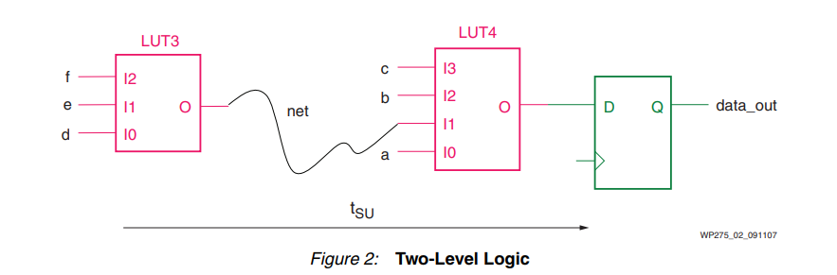
- General Reset is used especially in Simulations, but it is unnecessary to reset after configuring in Xilinx FPGAs.

- While writing code, attention should be paid to a code software that can be easily adapted to the FPGA. If not, additional resource usage may be observed.
- Do not mix synchronous and asynchronous rests.
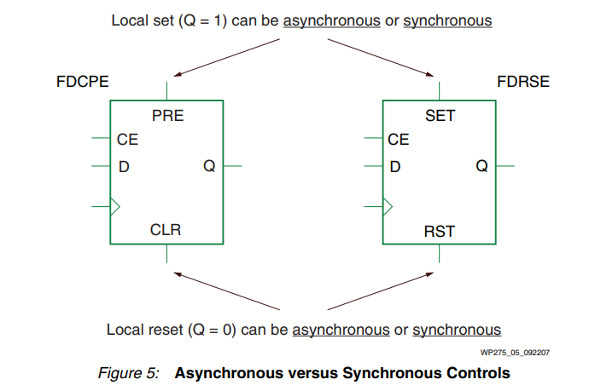
- Asenkron reset ekstra LUT harcar. Eğer global reset asenkron ve yerel reset senkron ise bu performasn ve kaynak kaybına sebep olur.

