Section 8 : Names

Section 8.1 General

- Names in VHDL are used to define objects, values, methods, or attributes and can be explicitly or implicitly declared.

- Types of names: Simple names, selected names, indexed names, slices, and attribute names.

- Prefix: Can be a name or a function call. If the prefix is a function call, it refers to an element, slice, or attribute of the function result.

- Static names: Fully determined during compilation, such as an array with a fixed index.

- Non-static names: Contain values that can change over time, like an index defined by a signal.

- Static prefix: The longest static part of a non-static name.

- Ambiguous names cause compilation errors. Using null access values in function calls is invalid.

- Examples:
  - array(2) is static
  - array(index) is dynamic
  - record.element is a selected name.

Section 8.2 Simple Name

- Simple name in VHDL is an identifier that refers to an entity, configuration, package, procedure, function, or architecture as defined in their declaration. It serves only to identify the entity without any additional effects.
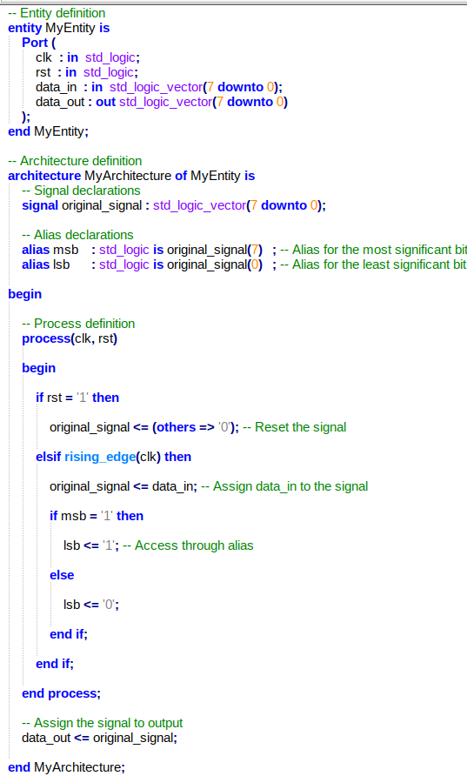
- Alias in VHDL is a shorthand or alternative name for an existing object, such as a signal, variable, type, or subprogram. It allows easier access or more descriptive naming for parts of a design.

Section 8.3 Selected Name

- Selected name in VHDL is used to reference a named entity defined
  - In another named entity : record, package etc.
  - In a design library

- Selected name fallows the syntax : selected_name ::= prefix.suffix

  - Prefix, Indicates the container (e.g., a library, package, record, or access type).
  - Suffix, Indicates the specific item (e.g., a field in a record, all elements in a package).
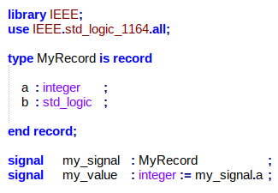
Section 8.4 Indexed Names

- indexed name denotes an element of an array.
  - indexed_name ::= prefix ( expression { , expression } )

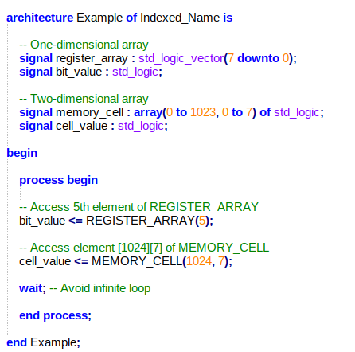

Section 8.5 Slice Names

- Slice name refers to a subset of consecutive elements from a one-dimensional array. It is defined by a prefix (the array) and a discrete range (the index range). The slice can have an ascending or descending range, and it inherits the base type of the array.

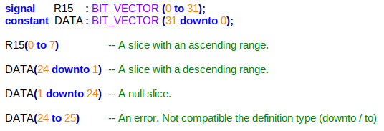
Section 8.6 Attribute Names

- In VHDL, attribute names are used to access specific properties of named entities, such as signals, constants, or types. They provide useful details like the size of an array, the left most index of an array, or the path of a signal.
  - Predefined Attributes: These include attributes like 'LEFT, 'PATH_NAME, and 'DELAYED, which return details like the leftmost index of an array, the path of a signal, or a delayed signal value.

  - Aliases: Attributes can also be used with aliases. The alias refers to the attributes of the original entity.

  - Function Attributes: These attributes return values based on functions, such as the size of an array.

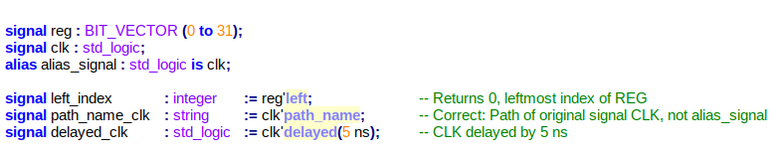

Section 8.7 External Names

- External name refers to an object declared in a design hierarchy. It can represent a constant, signal, or variable declared outside the current scope but within a reachable region. The object is identified by an external pathname, which can be an absolute, relative, or package pathname. An external name allows referencing external constants, signals, or variables in VHDL designs, ensuring that objects can be accessed from different parts of the design hierarchy. If an object does not match the specified type or is not found in the designated region, it results in an error.

